# DD

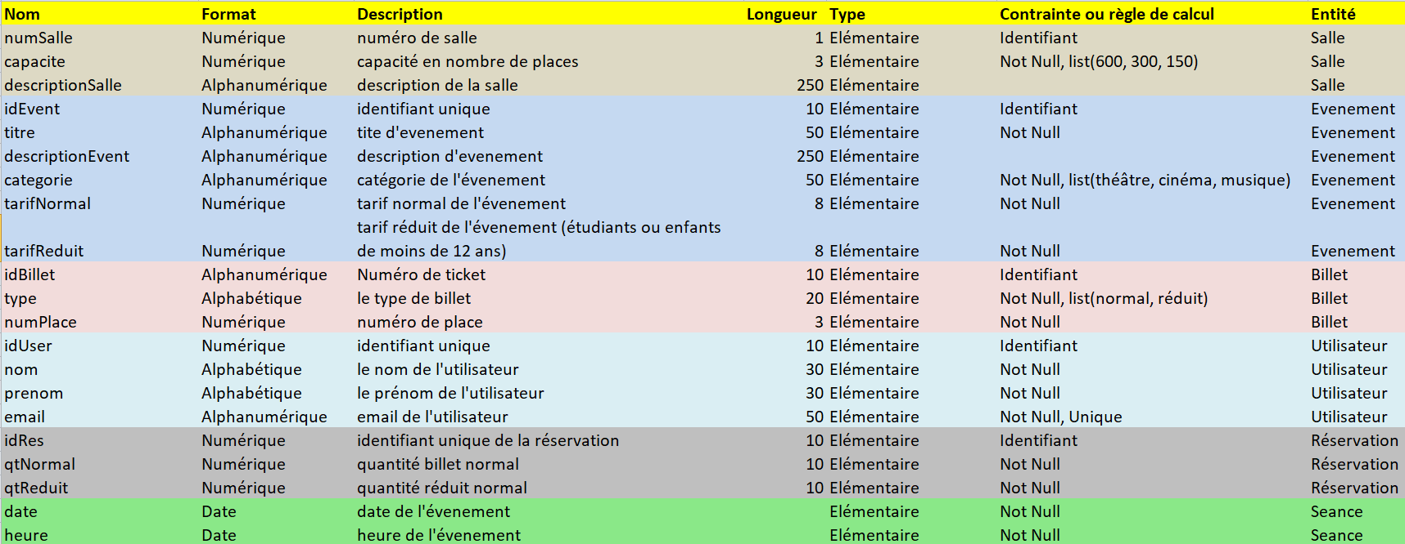

# MCD

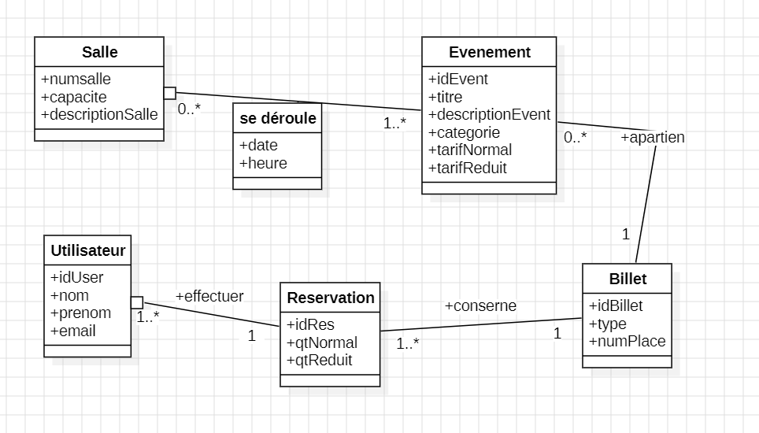

# MLD

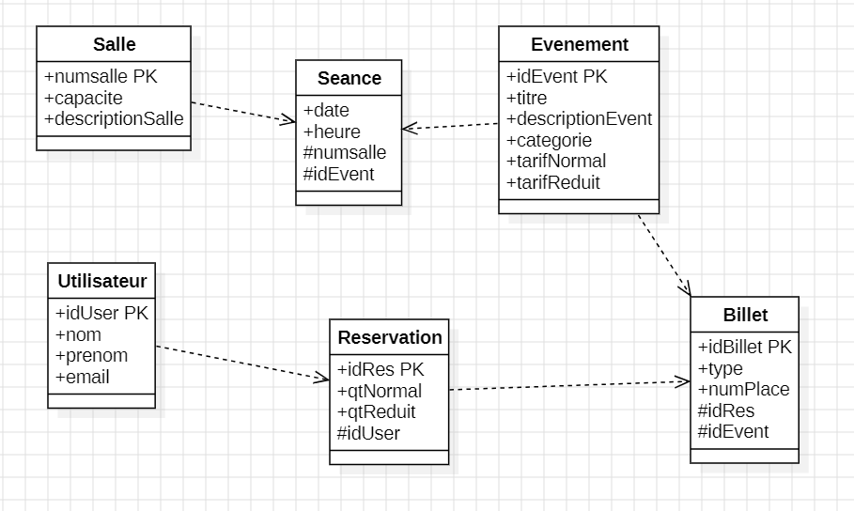

# Code SQL

[CREATE](http://localhost/phpmyadmin/url.php?url=https://dev.mysql.com/doc/refman/8.0/en/create-database.html) [DATABASE](http://localhost/phpmyadmin/url.php?url=https://dev.mysql.com/doc/refman/8.0/en/create-database.html) Evenements;

USE Evenements;

[CREATE](http://localhost/phpmyadmin/url.php?url=https://dev.mysql.com/doc/refman/8.0/en/create-table.html) [TABLE](http://localhost/phpmyadmin/url.php?url=https://dev.mysql.com/doc/refman/8.0/en/create-table.html) Salle (

numSalle INT AUTO_INCREMENT PRIMARY KEY,

capacite INT CHECK (capacite [IN](http://localhost/phpmyadmin/url.php?url=https://dev.mysql.com/doc/refman/8.0/en/comparison-operators.html%23function_in) (600, 300, 150)),

descriptionSalle VARCHAR(250) );

[CREATE](http://localhost/phpmyadmin/url.php?url=https://dev.mysql.com/doc/refman/8.0/en/create-table.html) [TABLE](http://localhost/phpmyadmin/url.php?url=https://dev.mysql.com/doc/refman/8.0/en/create-table.html) Evenement (

idEvent INT AUTO_INCREMENT PRIMARY KEY,

titre VARCHAR(50) [NOT](http://localhost/phpmyadmin/url.php?url=https://dev.mysql.com/doc/refman/8.0/en/logical-operators.html%23operator_not) NULL,

descriptionEvent VARCHAR(250),

categorie VARCHAR(30) [NOT](http://localhost/phpmyadmin/url.php?url=https://dev.mysql.com/doc/refman/8.0/en/logical-operators.html%23operator_not) NULL,

tarifNormal DECIMAL(8, 2),

tarifReduit DECIMAL(8, 2) );

[CREATE](http://localhost/phpmyadmin/url.php?url=https://dev.mysql.com/doc/refman/8.0/en/create-table.html) [TABLE](http://localhost/phpmyadmin/url.php?url=https://dev.mysql.com/doc/refman/8.0/en/create-table.html) Seance (

idEvent INT,

numSalle INT,

`date` DATE [NOT](http://localhost/phpmyadmin/url.php?url=https://dev.mysql.com/doc/refman/8.0/en/logical-operators.html%23operator_not) NULL,

heure TIME [NOT](http://localhost/phpmyadmin/url.php?url=https://dev.mysql.com/doc/refman/8.0/en/logical-operators.html%23operator_not) NULL,

PRIMARY KEY (idEvent, numSalle),

FOREIGN KEY (idEvent) REFERENCES Evenement(idEvent) on [DELETE](http://localhost/phpmyadmin/url.php?url=https://dev.mysql.com/doc/refman/8.0/en/delete.html) CASCADE  on [UPDATE](http://localhost/phpmyadmin/url.php?url=https://dev.mysql.com/doc/refman/8.0/en/update.html) CASCADE,

FOREIGN KEY (numSalle) REFERENCES Salle(numSalle) on [DELETE](http://localhost/phpmyadmin/url.php?url=https://dev.mysql.com/doc/refman/8.0/en/delete.html) CASCADE  on [UPDATE](http://localhost/phpmyadmin/url.php?url=https://dev.mysql.com/doc/refman/8.0/en/update.html) CASCADE );

[CREATE](http://localhost/phpmyadmin/url.php?url=https://dev.mysql.com/doc/refman/8.0/en/create-table.html) [TABLE](http://localhost/phpmyadmin/url.php?url=https://dev.mysql.com/doc/refman/8.0/en/create-table.html) Utilisateur (

idUser INT AUTO_INCREMENT PRIMARY KEY,

nom VARCHAR(30) [NOT](http://localhost/phpmyadmin/url.php?url=https://dev.mysql.com/doc/refman/8.0/en/logical-operators.html%23operator_not) NULL,

prenom VARCHAR(30) [NOT](http://localhost/phpmyadmin/url.php?url=https://dev.mysql.com/doc/refman/8.0/en/logical-operators.html%23operator_not) NULL,

email VARCHAR(50) [NOT](http://localhost/phpmyadmin/url.php?url=https://dev.mysql.com/doc/refman/8.0/en/logical-operators.html%23operator_not) NULL UNIQUE );

[CREATE](http://localhost/phpmyadmin/url.php?url=https://dev.mysql.com/doc/refman/8.0/en/create-table.html) [TABLE](http://localhost/phpmyadmin/url.php?url=https://dev.mysql.com/doc/refman/8.0/en/create-table.html) Reservation (

idRes INT AUTO_INCREMENT PRIMARY KEY,

idUser INT,

qtNormal INT [NOT](http://localhost/phpmyadmin/url.php?url=https://dev.mysql.com/doc/refman/8.0/en/logical-operators.html%23operator_not) NULL,

qtReduit INT [NOT](http://localhost/phpmyadmin/url.php?url=https://dev.mysql.com/doc/refman/8.0/en/logical-operators.html%23operator_not) NULL,

FOREIGN KEY (idUser) REFERENCES Utilisateur(idUser) on [DELETE](http://localhost/phpmyadmin/url.php?url=https://dev.mysql.com/doc/refman/8.0/en/delete.html) CASCADE  on [UPDATE](http://localhost/phpmyadmin/url.php?url=https://dev.mysql.com/doc/refman/8.0/en/update.html) CASCADE );

[CREATE](http://localhost/phpmyadmin/url.php?url=https://dev.mysql.com/doc/refman/8.0/en/create-table.html) [TABLE](http://localhost/phpmyadmin/url.php?url=https://dev.mysql.com/doc/refman/8.0/en/create-table.html) Billet (

idBillet CHAR(10) PRIMARY KEY,

type VARCHAR(20) [NOT](http://localhost/phpmyadmin/url.php?url=https://dev.mysql.com/doc/refman/8.0/en/logical-operators.html%23operator_not) NULL CHECK (type [IN](http://localhost/phpmyadmin/url.php?url=https://dev.mysql.com/doc/refman/8.0/en/comparison-operators.html%23function_in) ('Normal', 'Reduit')),

numPlace INT [NOT](http://localhost/phpmyadmin/url.php?url=https://dev.mysql.com/doc/refman/8.0/en/logical-operators.html%23operator_not) NULL,

idRes INT,

idEvent INT,

FOREIGN KEY (idRes) REFERENCES Reservation(idRes) on [DELETE](http://localhost/phpmyadmin/url.php?url=https://dev.mysql.com/doc/refman/8.0/en/delete.html) CASCADE on [UPDATE](http://localhost/phpmyadmin/url.php?url=https://dev.mysql.com/doc/refman/8.0/en/update.html) CASCADE,

FOREIGN KEY (idEvent) REFERENCES Evenement(idEvent) on [DELETE](http://localhost/phpmyadmin/url.php?url=https://dev.mysql.com/doc/refman/8.0/en/delete.html) CASCADE on [UPDATE](http://localhost/phpmyadmin/url.php?url=https://dev.mysql.com/doc/refman/8.0/en/update.html) CASCADE );