Dictionnaire de donnée

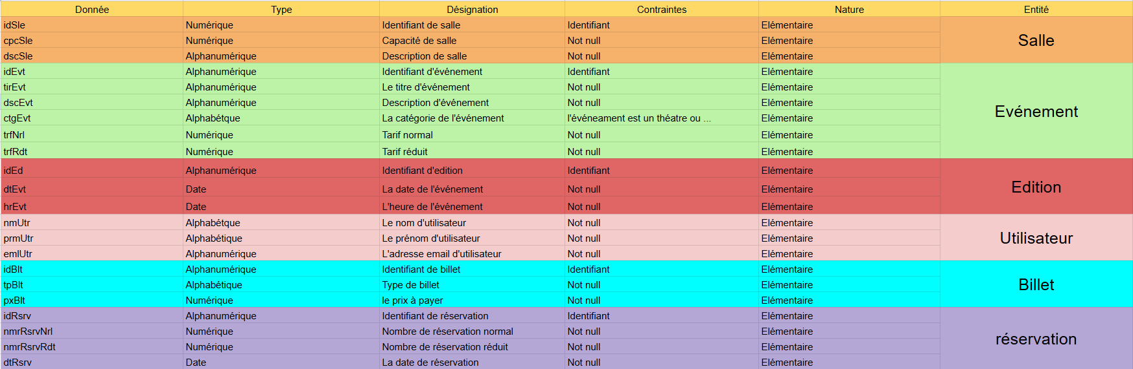

MCD

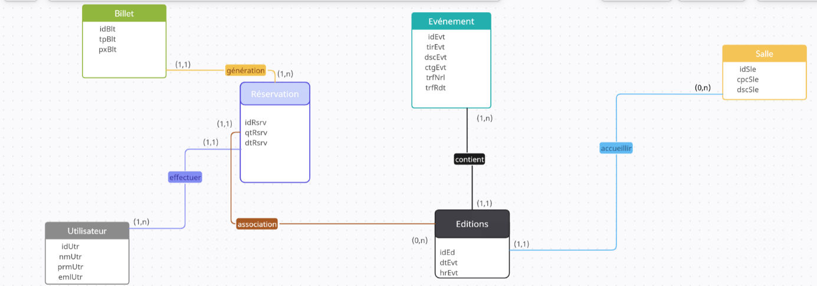

MLD

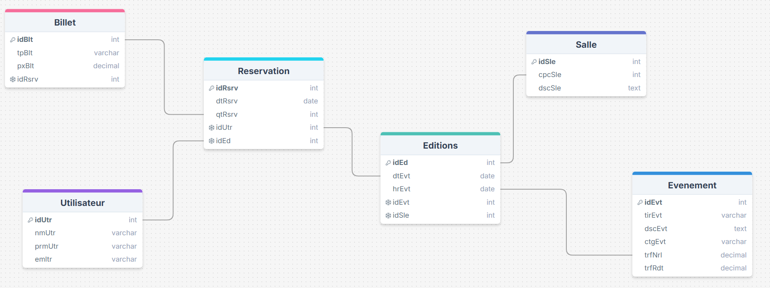

Code SQL

CREATE DATABASE alfarha;

USE alfarha;

CREATE TABLE Utilisateur (

idUtr INT PRIMARY KEY,

nmUtr VARCHAR(100) NOT NULL,

prmUtr VARCHAR(50) NOT NULL,

emlUtr VARCHAR(150) UNIQUE NOT NULL

);

/////////////////////////////////////////////////

CREATE TABLE Billet (

idBlt INT PRIMARY KEY,

tpBlt VARCHAR(50) NOT NULL,

pxBlt DECIMAL(10, 2) NOT NULL

FOREIGN KEY (idRsrv) REFERENCES Reservation(idRsrv) ON DELETE CASCADE ON UPDATE CASCADE,

);

//////////////////////////////////////////////

CREATE TABLE Evenement (

idEvt INT PRIMARY KEY,

tirEvt VARCHAR(100) NOT NULL,

dscEvt TEXT NOT NULL,

ctgEvt VARCHAR(50) NOT NULL,

trfNrl DECIMAL(10, 2) NOT NULL,

trfRdt DECIMAL(10, 2) NOT NULL

);

////////////////////////////////////////

CREATE TABLE Salle (

idSle INT PRIMARY KEY,

cpcSle INT NOT NULL,

dscSle TEXT NOT NULL

);

///////////////////////////////////////

CREATE TABLE Editions (

idEd INT PRIMARY KEY,

dtEvt DATE NOT NULL,

hrEvt TIME NOT NULL,

idEvt INT NOT NULL,

idSle INT NOT NULL,

PRIMARY KEY (dtEvt, hrEvt),

FOREIGN KEY (idEvt) REFERENCES Evenement(idEvt) ON DELETE CASCADE ON UPDATE CASCADE,

FOREIGN KEY (idSle) REFERENCES Salle(idSle) ON DELETE CASCADE ON UPDATE CASCADE

);

//////////////////////////////////////////

CREATE TABLE Reservation (

idRsrv INT PRIMARY KEY,

qtRsrv INT NOT NULL,

dtRsrv DATE NOT NULL,

idUtr INT NOT NULL,

idBlt INT NOT NULL,

idEd INT PRIMARY KEY,

FOREIGN KEY (idUtr) REFERENCES Utilisateur(idUtr) ON DELETE CASCADE ON UPDATE CASCADE,

FOREIGN KEY (idEd) REFERENCES Editions(idEd) ON DELETE CASCADE ON UPDATE CASCADE

);