Images for Classroom Presenter
Functional Specification
Julia Schwarz
July 28, 2006

Overview
Allowing students and instructors to insert images into their presentation will give Presenter more versatility and allow teachers to present and examine other activities in action. This will require the implementation of the ImageSheet class, as well as coding the UI which goes with it.

Scenarios
There are two main uses for student submissions:
- Student submissions
- Instructor presentation

Additionally, there are several ways to insert images:
- From a file
- By copying and pasting.
Initially, users will only be able to insert images from a file, but eventually they will also be able to paste images they have copied.

The User Experience
To insert an image, the user will click the “image stylus” button on the upper toolbar, then click a location he/she wants the image to be. The student then pastes/loads an image (loading would require a file dialogue). An image editing panel much like the textitbox will then appear with the image inside it.

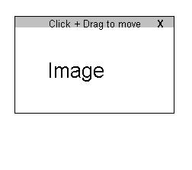
Editing
A user can move an image by clicking and dragging the top panel of the image box. Additionally, the user can delete the image by clicking the “x” button on the image box.
Additional options to consider are:
1. Cropping images
2. resizing images

How To Implement
Several classes will need to be created or modified:
ImageSheetModel
ImageSheetRenderer
StylusModel (adding a new ImageStylus)
Creation of a new class called PresentIt, which describes both the textit and imageit controls.
ImageIt (the image box)
Toolbar
MainSlideViewer
ImageSheetMessage
StudentSubmissionNetworkService
ImageSheetNetworkService

