Research Summary: Vector Databases

  - Claude White
  - CÉGEP Heritage College
  - 420-G40: Advanced Topics I
  - Katrina Butler
  - Friday, November 29, 2024

Introduction
Retrieving data by similarity is a handy feature that is very hard to accomplish with a traditional relational database. It is also a key feature of many applications today. Spotify recommends songs based on your liked ones. This is precisely what Vector databases are excellent at.
This paper will examine the difficulties of gathering data by resemblance, the power of vector databases, the algorithms used to query these databases, and the future of vector databases.

Limitations of Relational Databases
Relational databases store information in tables and rows.
This is very good at retrieving lots of data with clear and predefined relationships, like a person and their team. If the relationship is predefined in the schema, it is easy to get all the players in a team.
Relational databases are also very good at handling structured data. Data with a fixed number of attributes, and a single type. So, comparing numbers together is very efficient.
The difficulty comes when we need to obtain data based on similarity. Large language models and recommendation systems require more than a small quantity of structured data to achieve this.

What are Vector Databases
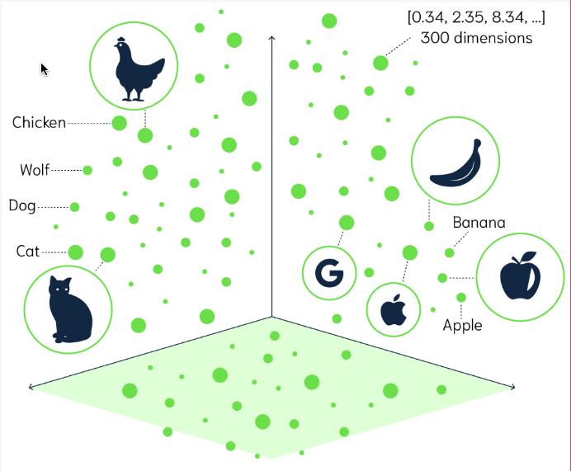
Vector databases are an efficient way to store, index and search information stored as vectors. Each piece of data entered in the database gets stored as a vector in multidimensional space. Each dimension is a characteristic of the object stored. Data stored as a vector in these databases is called an embedding. Generally, embeddings are generated by large language models. For example, an audio file of a song can be represented by the tempo, genre, instruments used and more. Because all data is stored as a vector based on characteristics, data of all types can be compared together. An image of a dog and the word cat can be found similar when querying for house pets.

Querying Algorithms
Many querying algorithms can be used to find similarities between embeddings. Here are 4 of them:
- Euclidean Distance (L2) measures the straight-line distance between the terminal points of the vectors. The equation is the following:
$d\left(p, q\right) = \sqrt{\sum_{i=1}^{n}{}}{\left(q_{i} - p_{i}\right)}^{2}$S
The output will be between 0 and ∞. The closer to 0 the higher the similarity.

- Cosine Similarity measures the angle between 2 vectors. From this, we can determine if they point in a similar direction. The equation is the following:
$$\cos\left(θ\right) = \frac{u⋅v}{\left|\left|u\right|\right|\left|\left|v\right|\right|}$$
The output will be between –1 and 1. 1 means they point in the exact same direction and –1 means they are complete opposites.

- Inner Product (dot product) measures how much one vector goes in the direction of another. This indicates the degree of similarity. The equation is the following:
$$a⋅b = \sum_{i=1}^{n}{a_{i}} b_{i}$$
The output will be between -∞ and +∞. The higher the number the higher the similarity.

- Hamming Distance measures the difference in the entries of 2 vectors. This is the simplest algorithm. It is computed using the XOR operation. Because of this, it is only used on binary and text. Therefore, it cannot be used on most vector embeddings.

The Future of Vector Databases
Vector databases are only getting started. As artificial intelligence grows and expands to new products, vector databases will need to become flexible. Like relational databases adapted with options like SQLite for optimization on weaker hardware, vector databases will probably do the same. Also, new methods of querying are on the horizon and capabilities such as exact matching are coming. Lastly, vector databases can be leveraged to help with fraud detection. It could improve current systems with its ability to see complex patterns in the data it absorbs.

References
Belagatti, P. (2023, September 8). WTF is a vector database: A beginner’s guide! DEV Community. https://dev.to/pavanbelagatti/wtf-is-a-vector-database-a-beginners-guide-16p
Crettaz, V. (2024, October 9). Vector similarity techniques and scoring. Search Labs. https://www.elastic.co/search-labs/blog/vector-similarity-techniques-and-scoring
Gu, H. (2023). What is a vector database?: A comprehensive vector database guide. Elastic. https://www.elastic.co/what-is/vector-database
Labelbox. (2023). How vector similarity search works. https://labelbox.com/blog/how-vector-similarity-search-works/
Manager, E. C. P. (2023, August 15). Distance metrics in vector search: Weaviate. Weaviate RSS. https://weaviate.io/blog/distance-metrics-in-vector-search
Namala, P. K. (2024, March 11). Vector databases: From embeddings to Intelligence. Medium. https://phaneendrakn.medium.com/vector-databases-from-embeddings-to-intelligence-cd182e2f9f16
Sun, P. (2020). Announcing Scann: Efficient Vector Similarity Search. Google Research. https://research.google/blog/announcing-scann-efficient-vector-similarity-search/
Tang, Y. (2023). Similarity metrics for vector search. Zilliz blog. https://zilliz.com/blog/similarity-metrics-for-vector-search

