
Figure 1: Heritage Logo

Office Hours Management System
  - A formal report document on the development of the Office Hours Management Application System.
Claude White
Jacob Morency
Pax Bertin Izabayo
Matteo Falasconi

Introduction 3
Office Hours Context Diagram 4
Software Architectural Diagram 5
Database Schema 7
Class Diagram 8
Coding Standards 9
Frameworks and Tools 13
Document Organization Standards 14
Test Standards 15
Black Box 15
White Box 15
Sanity Testing 15
Concurrency and Load Testing 15
Logs for Uptime Monitoring 16
Interaction Testing 16
Test Driven Development, XUnit Framework, and Unit Test Cases 16
Process 18

Introduction
The purpose of this document is to provide an overview of the software architecture and design decisions our development team has established for the Office Hours Management System (OHMS). It will serve as a reference for both the current and future development teams working on the OHMS application. The primary goals of this document are as follows:

- Establish a shared understanding of the system's high-level architecture and design choices.
- Document the different architectural layers, their responsibilities, and how they interact with one another.
- Outline the frameworks, tools, and coding standards that will be used throughout the project.
- Describe the document organization standards and both black-box and white-box testing approaches for this system.
This document helps ensure consistency and traceability throughout the system's lifecycle. It serves as a valuable reference for the project team and lays the foundation for a maintainable software solution.

Office Hours Context Diagram
The Office Hours Management System (OHMS) context diagram demonstrates how the OHMS interacts with different components.
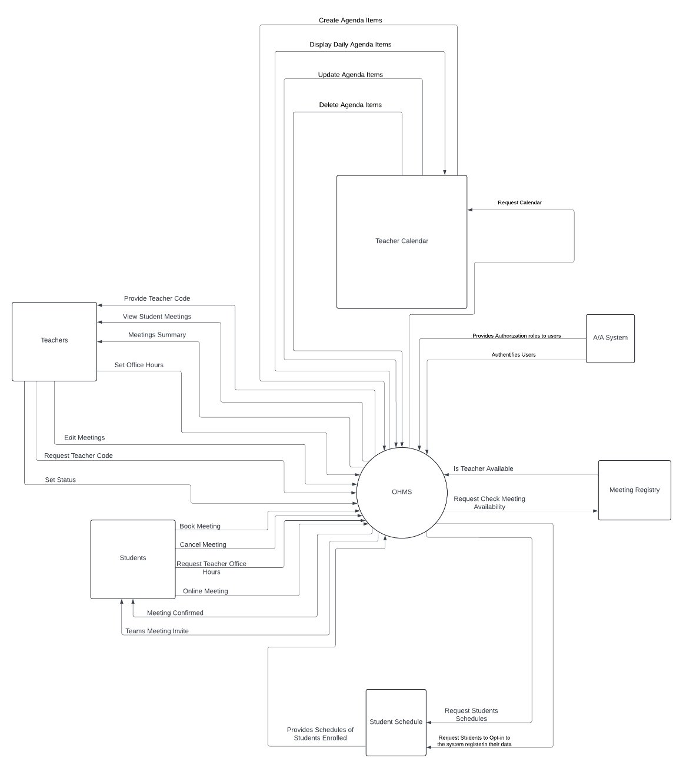
The main purpose of OHMS is to let student's book office hours appointments with their teachers and let the teachers know if they have students coming to their office hours. It also lets the teacher be informed on the topic of the students’ appointment before they present themselves. Lastly, it helps teachers manage their office hours, choose better times to display their availabilities in cases of sudden changes, and notify their students of any changes regarding their office hours schedule (out of office notice, cancelled office hours, office hours room relocation, etc.)

Software Architectural Diagram
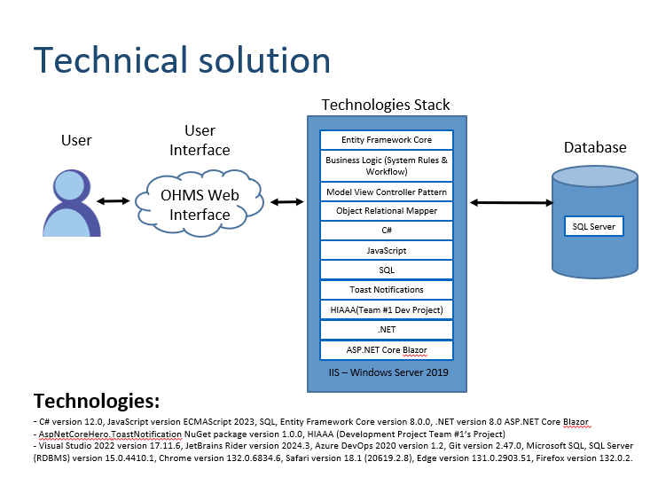
Above is an overview of the Office Hours Management System’s architecture and how the components interact is detailed below.
Architectural Tiers:
Presentation Layer:
- This layer is for presenting content to the users visually and handles their interactions such as collecting their inputs. Known as the user interface.
- Actions in this layer are client side and do not require any server-side interaction.
Business Layer:
- This layer is for handling user actions to manipulate the data in the application. It also contains the business logic for the application.
- This layer also is for handling operations such as CRUD on user appointments and emphasizes the core functionality
Data Access Layer:
- This layer is for interacting with the database directly to store and manage the applications data or interacting with external sources such as APIs.
- This layer separates the data access logic from the rest of the application.

Database Schema

Class Diagram
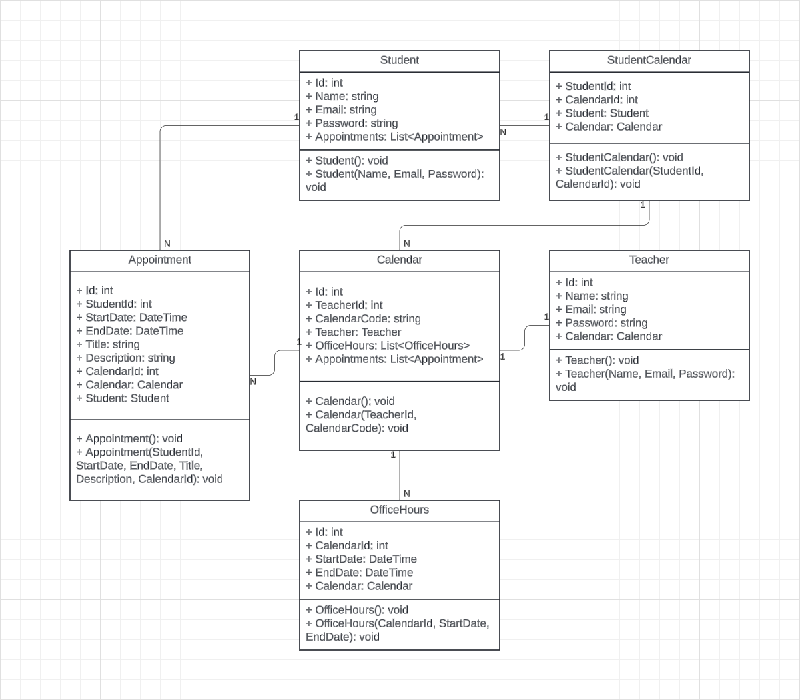

Coding Standards
Naming Standards
- C# Naming Standards
  - Classes, Constructors, Attributes, Enumerator Names, & Method Headers: Pascal Case
C# Code Sample
// Example
public class ExampleClass
{
public ExampleClass() { }
public int ExampleProperty { get; set; }
}

  - Method Parameters and Variable Names: Camel Case
C# Code Sample
// Example
public void ProcessData(int exampleParameter)
{
var exampleVariable = exampleParameter * 2;
}

  - Constants: Uppercase
C# Code Sample
// Example
public const string EXAMPLECONSTANT = "This is a constant";

  - LINQ EF Core Queries: Method Syntax
LINQ Code Sample
// Example
var example = _context.Example
.Include(x => x.Other)
.ToListAsync();

- Blazor file (.razor) Standards
  - Html Tags and Attributes: Kebab Case
Blazor Code Sample
<!-- Example -->
<button type="submit" class="btn-primary" id="btn-submit-form">
Submit
</button>

- Styling Standards (CSS/Tailwind)
  - Classes, Ids, and CSS Variables: Kebab Case
CSS Code Sample
/* Example */
.example-class {
--primary-color: #3498db;
}

#example-id {
margin: 10px;
}

<button class=”px-4 py-2 text-white”>Click</button>

- Files Names
  - Should match the primary class, interface, or Razor page in the file. Use Pascal Case for filenames.
Example:
Class: ExampleClass → File: ExampleClass.cs
Razor Page: ExamplePage → File: ExamplePage.razor
- Interface Names
  - Prefix interfaces with “I” and Use Pascal Case
C# Code Sample
public interface IExampleService
{
void DoSomething();
}

Layout/Formatting Standards
- Brace Style: K&R (Brace at the End of the Line)
C# Code Sample
// Example
public class ExampleClass
{
public void ExampleMethod()
{
// Method logic
}
}

- Spacing: Maintain a minimum of one blank line in between methods.
C# Code Sample
public class ExampleClass
{
public void MethodOne()
{
// Logic for MethodOne
}

public void MethodTwo()
{
// Logic for MethodTwo
}
}

Code Structure
- Directory Organization
  - Group files logically by feature or layer (i.e., Controllers, Models, Views, Services, DAL – Data Access Layer)

- Dependency Injection
  - Register dependencies in Startup.cs or Program.cs.
C# Code Sample
builder.Services.AddScoped<IExampleService, ExampleService>();

- Code Review Standard
  - Ensure that all pull requests are peer-reviewed with a checklist for:
    - Adherence to coding standards
    - Readability & maintainability
    - Proper test coverage
    - Comments with explanation of the code logic

- Unit Testing Standards
  - Test methods names should properly describe the scenario that is being tested additionally comment shall be presented.

  - Test methods should use the [MethodName_StateUnderTest_ExpectedBehavior] pattern.
xUnit C# Code Sample
[Fact]
public void AddUser_ValidUser_ReturnsTrue()
{
// Arrange, Act, Assert
}

Frameworks and Tools
- Entity Framework Core (Version 8.0.10)
- .NET (Version 8.0)
- ASP.NET Core Blazor
- AspNetCoreHero.ToastNotification (NuGet package version 1.0.0)
- Visual Studio 2022 (Version 17.11.6)
- JetBrains Rider (Version 2024.3)
- Azure DevOps 2020 (Version 1.2)
- Git (Version 2.47.0)
- Microsoft SQL Server (RDBMS Version 15.0.4410.1)
- Browsers: Chrome (Version 132.0.6834.6), Safari (Version 18.1 [20619.2.8]), Edge (Version 131.0.2903.51), Firefox (Version 132.0.2)
- C# (Version 12.0)
- JavaScript (ECMAScript 2023)
- SQL
- HIAAA (Development Project Team #1’s Project

Document Organization Standards
Office Hours App \ Documentation
- Design – Folder that contains all the documents for the designs in the project.
- Emails – Folder that contains all emails sent and received from the client.
- Presentation and Reports – Folder contains all the documents that were presented to the client.
- Scrum Summaries – Folder contains all the notes for scrums.
- Meeting Minutes – Folder that contains all Meeting Minute documents.
- Memos – Folder that contains all the Memos documents.
- Standards – Folder that contains all team standard documents.
- System Tests – Folder that contains all systems test results for every version of the system.

Test Standards

Black Box
Black box testing revolves is focused on the functionality of a system without regards for its internal code structure, specifications, or business logic. Acceptance Test-Driven Development (ATTD) showcases this approach. It involves the collaboration of both the Product Owners and Developers to define criteria that shall be met to declare a feature complete and successfully implemented. Black box testing usually includes business cycle test and scalability testing to guarantee that the application can handle semesterly changes, adapt to and variable user base, and perform the management of inactive users, graduates, etc.

White Box
White box testing involves testing the internal structure and logic of the application. This type of testing requires knowledge of the business logic of the system and is carried out by developers. Developers must ensure they are familiar with the documentation and are responsible for updating it if new logic or modifications to the business logic are made. This is a critical step in the development of an application, as it will ease the maintenance of the system for future business cycles. This test includes testing how modules such as authentication, database and services integration, and the user interface work properly together to deliver the intended functionality to the client.

Sanity Testing
This method of testing ensures that the core functionality of the application is operational after new changes have been made. For instance, in a login module, the sanity test would verify that users can successfully log in and access the system. If this basic functionality test were to fail, further testing would not be performed, as it would indicate that the system is not in a working state. It is a simple and easy way to ensure an application’s readiness prior to extensive testing. This is a crucial step that often saves a lot of time and resources.

Concurrency and Load Testing
This method of testing determines the application performance and stability under load (concurrent usage of the system by multiple users). For example, simulating that 250 concurrent users are using your system at once, attempting to log in, browse the application, create appointments, etc. This study is performed to ensure that an application remains scalable and can maintain adequate performance levels as its usage grows.

Logs for Uptime Monitoring
Keeping track of the logs is important to identify issues and diagnose the potential source of issues that may arise. This involves capturing system events, errors message, critical failures, warnings, performance metrics, etc. This allows developers to promptly address and localize problems within a system that is up and running and published and accessible from the World Wide Web.

Interaction Testing
This method of testing focuses on verifying how different components of the application interact with one another. This includes testing modules like authentication, authorization, user interface, database integration all works together to deliver its intended purpose. The failure of a singular module should also be tested to ensure that the system handles the loss off an integral portion of the system and properly handle the situation without crashing and exposing system errors message to the users.

Test Driven Development, XUnit Framework, and Unit Test Cases
Test Driven Development (TDD) emphasizes writing test case prior to the implementation of code. This ensures that every new piece of code integrated within the system is tested, it validates that it is functional, is linked to test case, which in turn puts a watch on each component of the system. Meaning that the test case will flag when a piece of code doesn’t return the expected output when it used to do in the past. This approach promotes an error-free robust coding environment. The XUnit framework will be used as it is a staple standard structure for .NET applications. The following types of test cases should be performed: Primary test cases, Edge test cases, and Corner test cases.
Primary Test Case: Expected use case (also known as “Happy Path”), such as entering a valid information inside of a registration form.
Edge Test Case: Input interactions at the boundary (also known as “Limits”), such as testing the maximum number of characters your password field can hold.
Corner Test Case: Complex conditions and rare scenarios, such as logging into a system on a different browser while still having an active session in another browser or attempting to access pages after clearing cookies and local storage data in an active session.
Addressing the following, will ensure a comprehensive understanding of the overall application behavior amidst normal and abnormal conditions.

Process
We would like to change from the scrum process to the agile process, because we are more familiar with it. User stories and Issues are the main difference, and we think that our process efficiency can be improved by changing to the type of board we are more comfortable with.
