[ZANG] - [Chuanjie] - C# Finial Project

Student ID: 699382953

[chuanjiezang@gmail.com](mailto:chuanjiezang@gmail.com)

Since I've already completed the entire content of the code that contains the requirements for the bonuses, I'll explain next, in steps, what each part of my code accomplishes individually.

1. Basic Functions

Insert a new item in inventory (Insert a new item in inventory) and Code to automatically generate IDs and add items (InventoryManager.cs):  
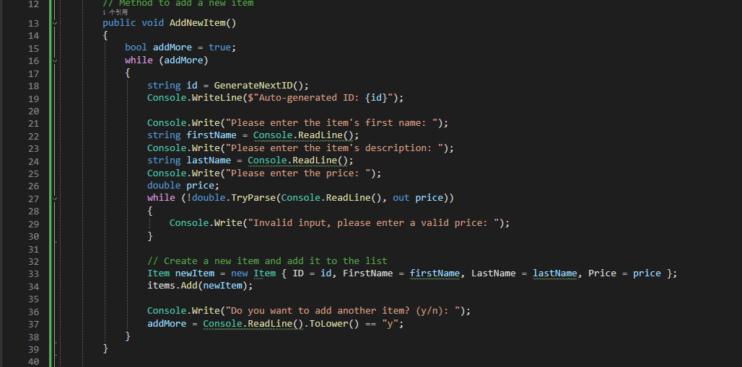

Display a specific item (Display a specific item) and Code for displaying a specific item (InventoryManager.cs):  
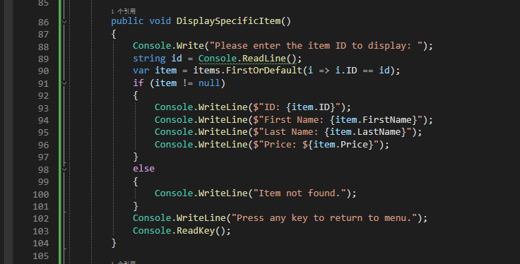

Display all items (Display all items) and Code for displaying all items (InventoryManager.cs):  
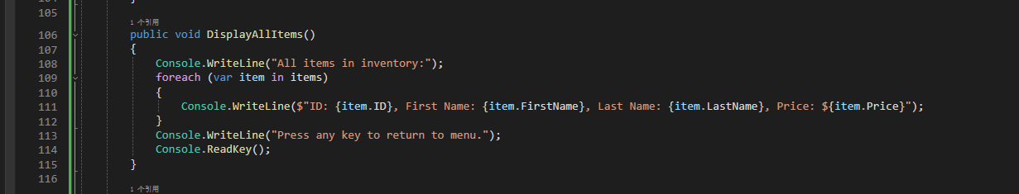

Exit the application and Code to exit the application (Program.cs):

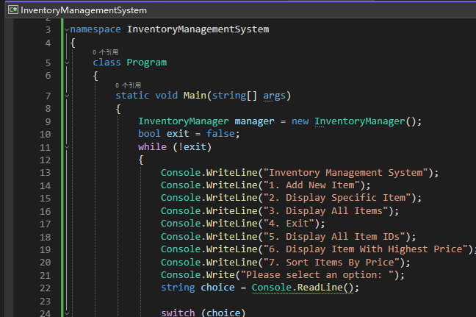

Additional Functions (Bonus)

Automatic sequential ID generation

Code for automatic ID generation (InventoryManager.cs)

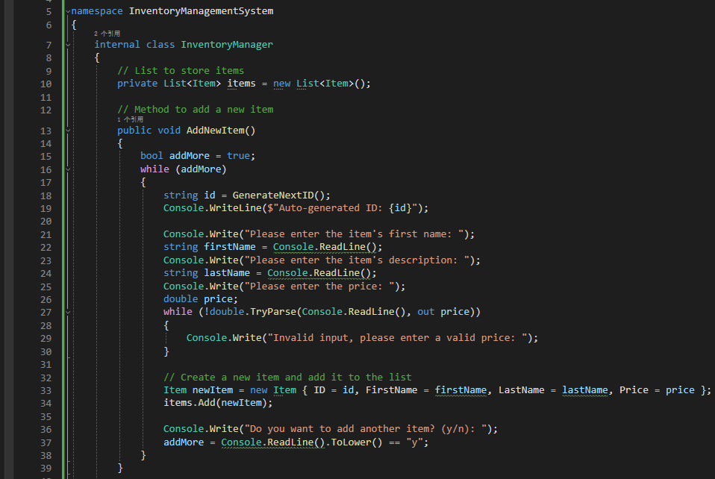

Show all available item IDs and Code to display all IDs (InventoryManager.cs)  
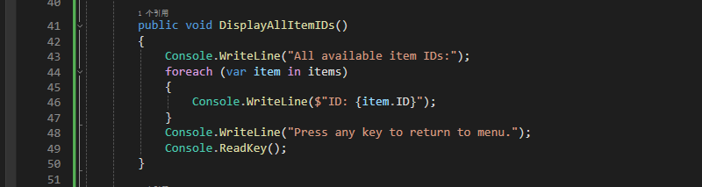

Show highest priced items and Code to display the highest priced item (InventoryManager.cs):

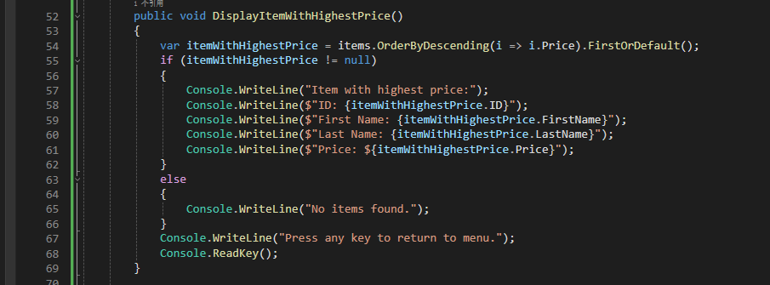

Sorting items based on price and Code for sorting by price (InventoryManager.cs)

