Software Requirements Specification
for
Information Distributed System for Students’ Projects Administration
Version 2.0

Prepared by Badea Elena Delia
Bînă Claudia Mihaela
Spînu Alexandru

Table of Contents

1. Introduction 1
1.1 Purpose 1
1.2 Product Scope 1
1.3 Intended Audience and Reading Suggestions 1
1.4 Glossary 1
2. Overall Description 2
2.1 Product Perspective 2
2.2 Product Functions 3
2.3 User Classes and Characteristics 3
2.4 Operating Environment 3
2.5 User Documentation 3
3. External Interface Requirements 3
3.1 User Interfaces 3
3.2 Hardware Interfaces 4
3.3 Software Interfaces 4
3.4 Communications Interfaces 4
4. System Features 5
4.1 View Account Information Feature 5
4.2 Change Password Feature 6
4.3 Upload Projects Feature 6
4.4 View Courses Feature 6
4.5 View Uploaded Projects Feature 7
4.6 Review Uploaded Project Feature 7
5. Other Nonfunctional Requirements 8
5.1 Performance Requirements 8
5.2 Safety Requirements 8
5.3 Security Requirements 8
5.4 Software Quality Attributes 8
5.5 Business Rules 8
6. Other Requirements 8

Revision History
Name | Date | Reason For Changes | Version
Badea Delia  Bînă Claudia  Spînu Alexandru | 13.03.2017 | Document Setup – initial revision | 1.0
Badea Delia  Bînă Claudia  Spînu Alexandru | 29.03.2017 | Proofread and complete RS | 2.0
Badea Delia  Bînă Claudia  Spînu Alexandru | 05.04.2017 | Update Table of Contents | 2.1

Introduction

Purpose
The purpose of this document is to present a detailed description of the Information Distributed System for Students’ Projects Administration. It will explain the purpose and features of the system, the interfaces of the system, what the system will do, the constraints under which it must operate and how the system will react to external stimuli.

Product Scope
The software system will be an Information Distributed System for administration of students’ projects in any institution that requires such a service. This system will be designed to maximize the teachers’ and students’ productivity by providing tools to assist in automating the projects upload and evaluation.

More specifically, this system is designed to allow the students to send their projects online to be evaluated by the teachers. The information system contains an interface with the user (Web navigator), a database server which will store information about students, teachers, grades etc, an applications server which administrate students, projects and grades and a web server. The user can acces the service only form the user interface.

Intended Audience and Reading Suggestions
This Software Requirements specifications document is intended for the students and the teachers of any school/university, for the administrator of the application and also for the developers of the system.

Glossary
Term | Definition
Project | The document that is uploaded by the student and reviewed by the teacher; it can be a single file or an archive.
Student | Person submitting a project to be reviewed.
Database | Collection of all the information monitored by this system.
Teacher | Person who receives projects, reviews and grades them.
Field | A cell within a form.
Admin | Person controlling who can do what.
Software Requirements Specification | A document that completely describes all of the functions of a proposed system and the constraints under which it must operate. For example, this document.
Review | The act of the Teacher of commenting and grading students’ projects.
User | Student or Teacher

Overall Description

Product Perspective

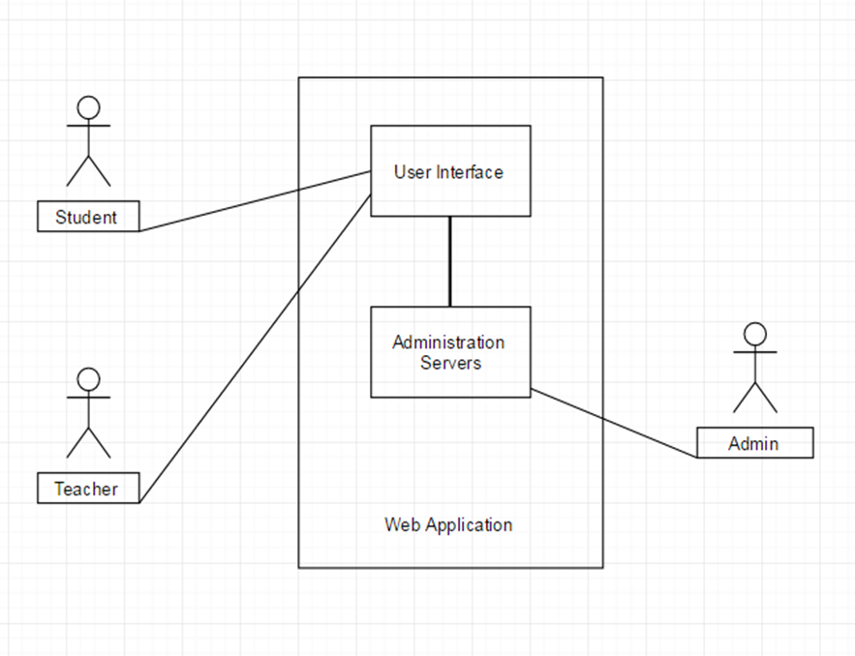

This is a self-contained product meant to administrate the activity in terms of projects of teachers and students in a public institution. The above diagram displays the relation between the different kind of users and the subsystems of the application.

Product Functions

The major functions of this product are:
- Serve as online platform for students’ projects administration in an education institution;
- There are three types of users: administrator, teacher, student and it doesn`t exist a guest user type.
- The student type user can log on the platform, view the account information and upload projects for the desired courses.
- The teacher type user is able to log on the platform, view the account information and review (comment and/or grade) the projects uploaded by the students.
- The administrator can add new users, delete existent users and update an user information, including password change request.

User Classes and Characteristics
There are three types of users: student, teacher and administrator. It is expected that the student type will the most frequent user of the application, followed by the teacher class. The administrator will be the user with full permission over all functionalities.

Operating Environment
The application will support Windows Operating Systems (starting with XP version) and web browsers, Google Chrome being the main browser used when developing.

User Documentation
The application will be released together with the Software Requirements Specifications documents and the testing documents.

External Interface Requirements

User Interfaces
3.1.1 Log in Interface
Log in interface is the interface that appears when opening the application. It contains two fields: one for user name and one for password and a Log in button. If any of the inserted information is wrongly introduced, an error window will pop up.

3.1.2 User Interface
User Interface contains three main areas: a header area with the name of the user and the name of the university or institution he is enrolled in, the area under the header is split in two parts, the left side has a menu containing options such as: Account Information, Courses etc. and the right side will display detailed information about the chosen menu option.

3.1.3 Courses Option Interface
The Courses Option Interface contains information about the selected course and in the bottom part of the page is an Upload button whose functionality differs for students and teachers. For the student user, it allows to choose which document to upload and for the teacher user, it displays the already uploaded projects for that course.

3.1.4 Account Information Interface
The Account Information Interface contains personal details about the logged user and the option for password changing.

Hardware Interfaces
Not Applicable

Software Interfaces
This product’s development requires support of the following products: mySql, JDK and HTML editors, Windows Operating System (starting with XP version).

Communications Interfaces
Client (system user) on Internet will be using HTTP/HTTPS protocol.

System Features

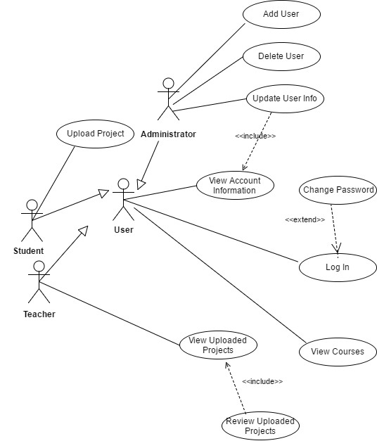

Fig.1: Use Case Diagram

View Account Information Feature
This feature allows the user to view the information about the account and personal data.

- The system allows the user to see personal data.
- The data is displayed in different fields like name, surname, university.
- The system doesn’t allow all the users to change the data directly.
- The system shall allow only the administrator to change the data in this section.
- The system shall allow access to Change Password feature.

Change Password Feature
This feature allows the user to change the password of his account and this function can be found accessing the Account Information interface. In order to be performed, this action will need the user to complete three fields: old password, new password, repeat new password.

- After accessing the Change Password option, the system shall display the three fields and the confirm button.
- To change the password, the system will display three communication fields: one for the old password, one for the new password and a third one for repeating the new password.
- The system shall verify that the old password entered is correct.
- If the old password entered is not correct, the system shall display an error message and should ask the user to type the password again.
- If the old password entered is correct, the system shall allow the user to type the new password.
- The password should be made entirely out of UNICODE characters
- The password is changed immediately
- The system shall display a successfully changed password message.
- All the information is stored in the database
- After the password is changed and the user successfully logged in, he can continue doing his desired actions

Upload Projects Feature
This feature is available for the student user type. It allows the student to upload a file to a desired project, in order to be evaluated by the teacher.

- The system shall allow only the student type user to have access to the Upload Projects option.
- When the user click the Upload Projects button, the system shall open a standard dialog box for selecting file.
- The system shall allow the user to select multiple files from his computer. After the user confirm his selection, the system shall display the name of the selected file/files below the Upload Projects button.
- The system shall allow the user to click Upload Projects after the files have been selected.
- The system shall upload the files successfully.
- The system shall display a message after the files have been uploaded.
- Any student can upload multiple documents for multiple projects

View Courses Feature
Depending on the type of the user (teacher of student) it can be shown either the courses that the user is coordinating, either the courses the user is enrolled in.

- The system shall allow any user type to access the View Courses option.
- If the user logs in as a student, the system shall allow him to see the courses that he is enrolled in.
- If the user logs in as a teacher, the system shall allow him to see the courses that he is coordinating.
- The system shall display a list of courses.
- The system shall allow the user to click on the name of a course and see its details and the options available at the course level.
- The system shall display an error message if a course is not available.

View Course Details
At the course level the user is able to see some details related to the current course.
- The system shall display the name of the course followed by a list of details.
- The system shall display details such as a short description, the coordinator teacher.
- The system shall display the Upload Project button for the current course.
- The system shall allow the user to go back to View Courses screen.

View Uploaded Projects Feature
This is a specific feature for the teacher user type. It will provide ways for the user to access and visualize the projects uploaded by the students for a specific course.

- This feature is available only for the users that log in as a teacher
- The system shall display all the projects uploaded by the students at the course level.
- The system shall display a list of projects.
- The list of projects shall contain the following information: name of the files, name or username of the student.
- The system shall allow the user to see the uploaded projects for each course he is coordinating.
- Teachers can see only the projects uploaded for their specific course(s).
- The system shall allow the user to go back to the Course Details screen.
- For each displayed file, the system shall display the Review button.

Review Uploaded Project Feature
The Review Uploaded Projects is a feature available only for the teacher user type. The review term represents two actions: grading a project and leaving a comment for a project.

- This feature is available only for the users that log in as a teacher
- The teachers can grade only the projects from their specific course(s)
- The teachers can leave comments only to their courses(s)
- The teachers can give the projects a grade between 1 and 10
- The system shall allow the user to click on the name of a file and to visualize it.
- After the user clicks the Review button, the system displays a screen with two fields: Grade and Comment.
- The Grade field should accept only digits (between 1 and 10).
- The system should display an error message if the user type anything else but a digit in the Grade field.
- The Comment field shall have a limit of characters.
- If the user exceeds the character limit, he can not type anything more.

Other Nonfunctional Requirements

Performance Requirements
- Respone time: the maximum response time for the submission of a job will be 1 minute.
- The response should be fast enough to avoid users’ response collisions

Safety Requirements
Not Applicable

Security Requirements
- The system should provide databases’ modification only for students, teachers and system administrator after authorization procedures.
- Access to the system is permitted only for the members of the instituition that is using th system and only after authorization procedures.

Software Quality Attributes
User friendly interface with self explanatory content.
Multiple compilers and/or languages shall only be used if there is a common defined interface standard for object code to which the languages/compilers/assemblers conform.
Source code shall only use /*...*/ style comments.
All usage of implementation-defined behaviour shall be documented.
All uses of the #pragma directive shall be documented and explained.
Preprocessing directives shall be syntactically meaningful even when excluded by the preprocessor
The validity of values passed to library functions shall be checked.
Minimisation of run-time failures shall be ensured by the use of at least one of static analysis tools/techniques;
(a) dynamic analysis tools/techniques;
(b) explicit coding of checks to handle run-time faults.
(c) explicit coding of checks to handle run-time faults

Business Rules
Not Applicable

Other Requirements
Not Applicable.
Appendix A: Analysis Models
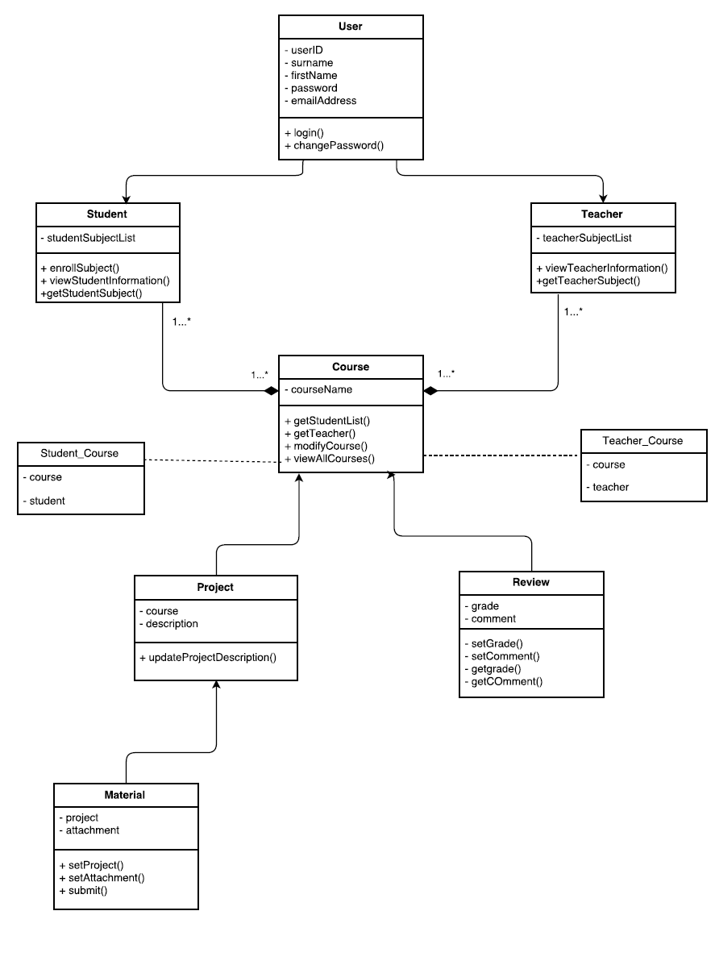
Fig 2. Class Diagram

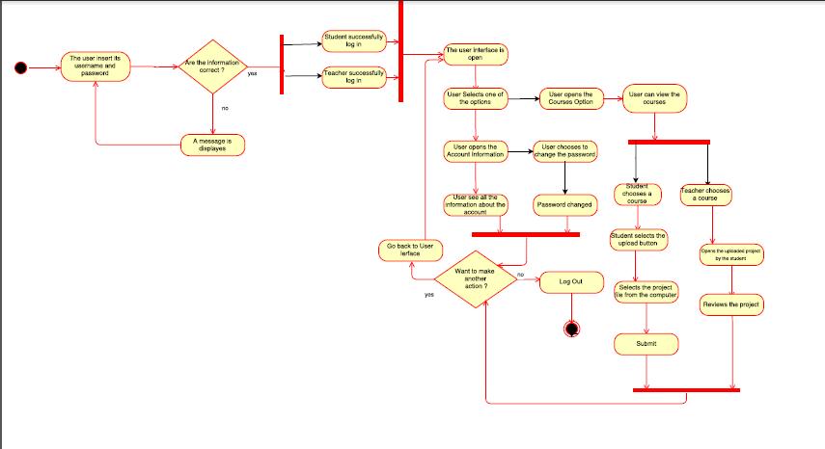
Fig.3 : Activity Diagram

Appendix B: To Be Determined List
Not Applicable.

