MoodSlider
- http://skymoodslider.eu-west-1.elasticbeanstalk.com/

I've created a trello board:
https://trello.com/b/MWlVxqc9/test-sky

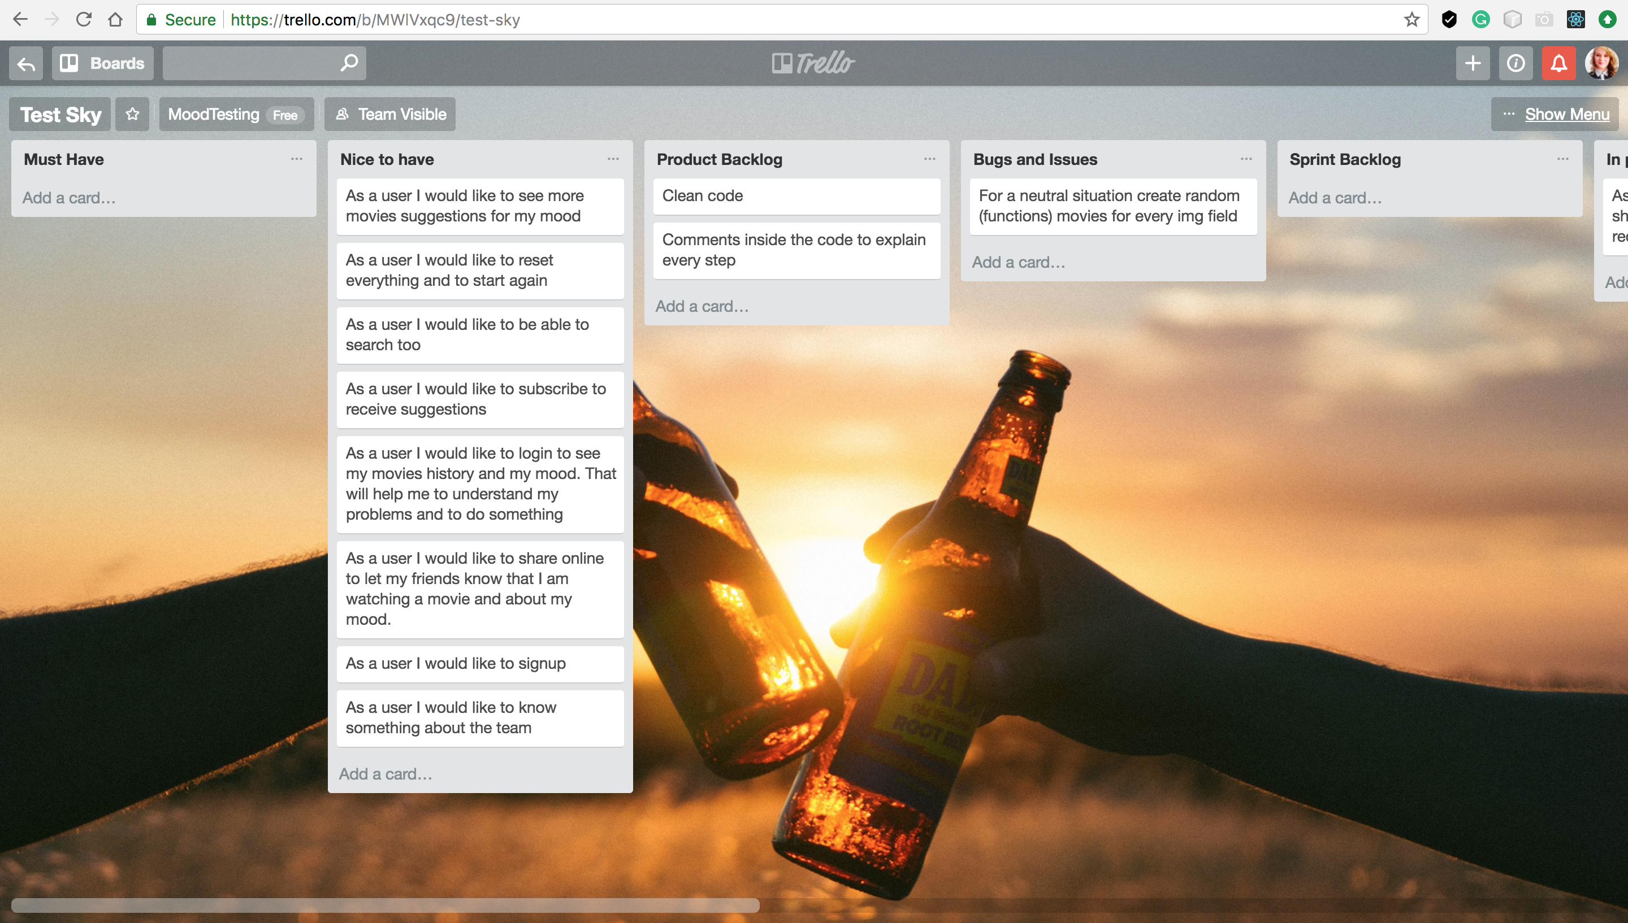
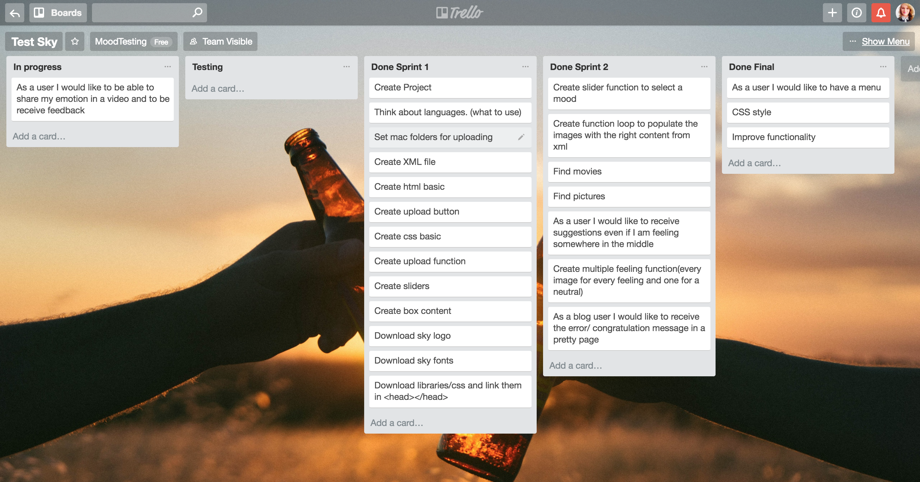

- I created an HTML basic structure, the upload button, the upload function and a basic CSS.
- The Upload functions are checking all posibilities for our upload functionality and otput an answer into a new page(for every case) and then is returning to the home page after 2 seconds.
- I created a new xml file.
- In the main.js . I set 4 sliders with a middle value of 5. If you chose left side with a value from 0->5 the value will be the one from left. If you chose from 6->10 the value is from right. If you chose 5 it will be a random one.
- slider one will take the moods 0,1 from the string (agitated and calm) and so on, and will select the movie for your mood; value 5 set the slider to be in the middle from the beginning,
- I created an ajax function that will return the xml data from the file uploaded
- then I created a loop function that will check the mood values and then will replace the img and the title

Future work:

- I tried to display random pictures(to populate all the pictures) after we select something; The issue is that if I will click somewhere on 5 will reset all the movies (We can have some picture to replace the no content ones - but I thought that might be important to have no content fields there)
- Refactoring code and optimising for speed and better looking interface.

