# chipAnalyseR

An useful R package for ChIP-seq data analysis and visualisation.

**!STILL IN DEVELOPMENT!**

## Installation

devtools::install_github(repo = 'ClaudiaRHD/chipAnalyser')

## Usage

### What you can do with chipAnalyseR

#### Visualisation

* Profile plot
* Heat map
  + ordered by row mean average
  + ordered by row mean of one selected matrix
  + clustered by kmeans of one selected matrix
* Peak annotation plot
* MA plot
* RNA Polymerase 2 pausing index

#### Example plots

p

plot_profile()

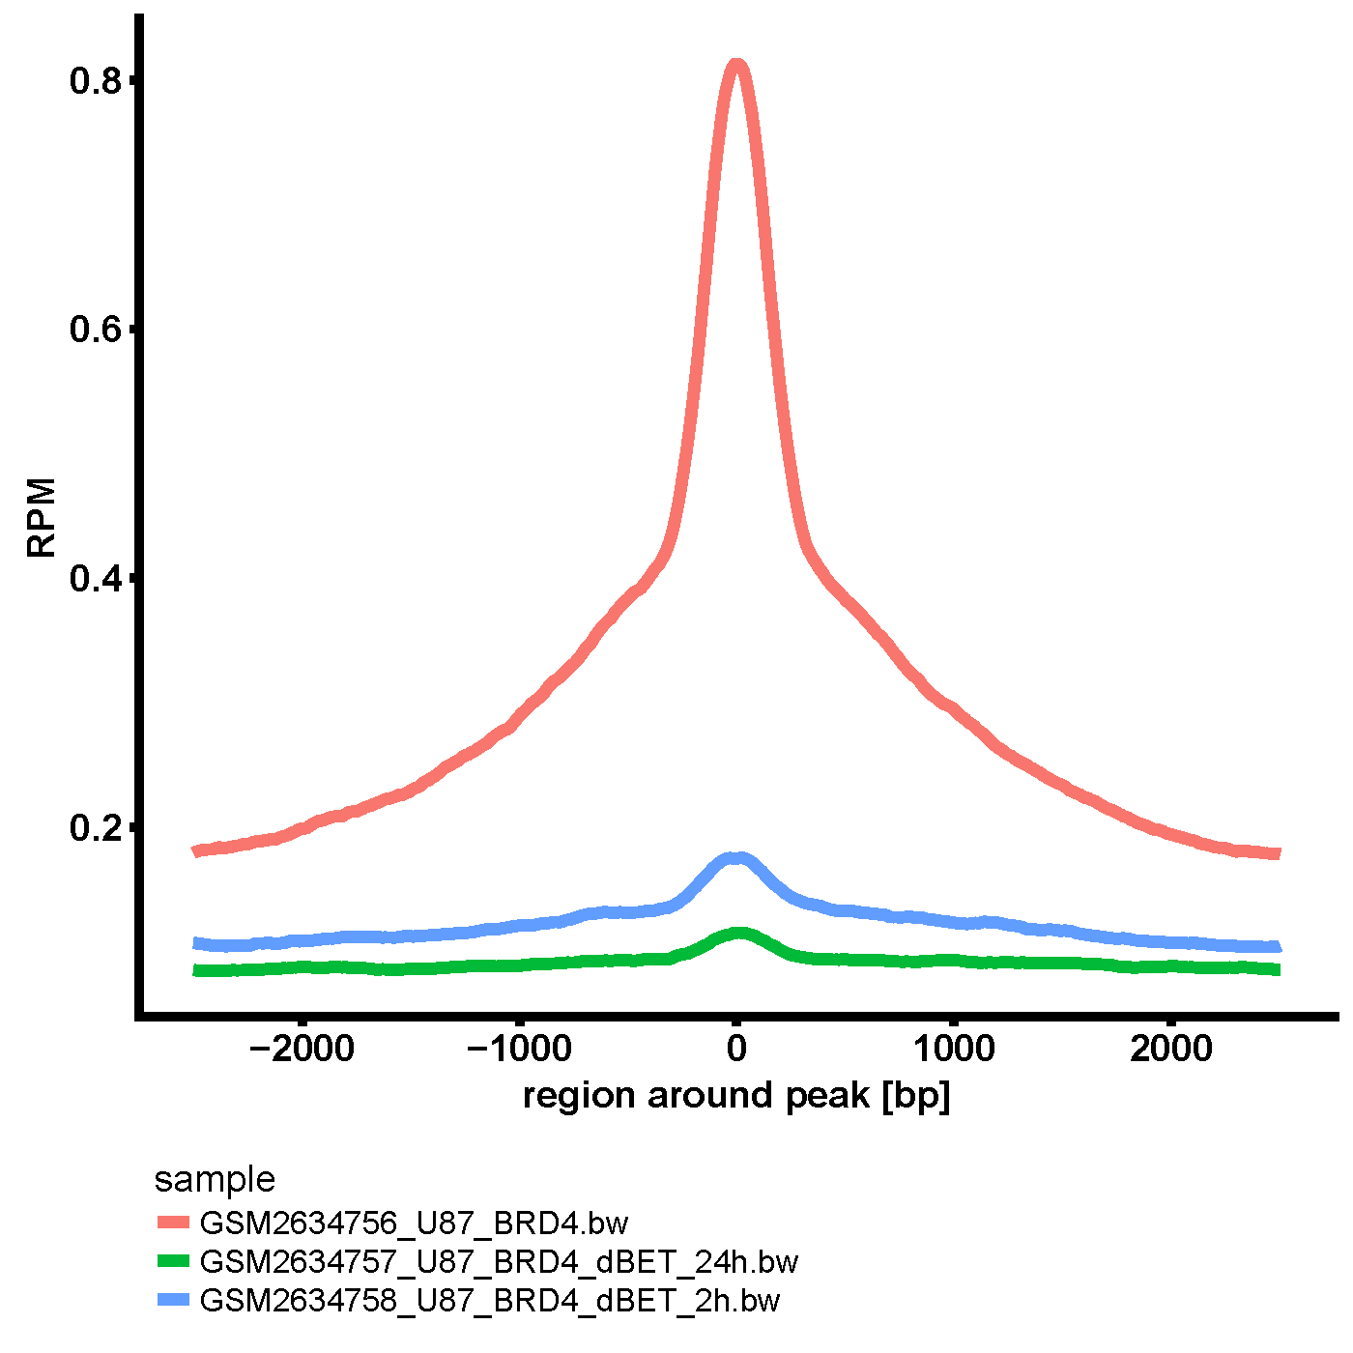

plot_profile example

**plot_MA()** 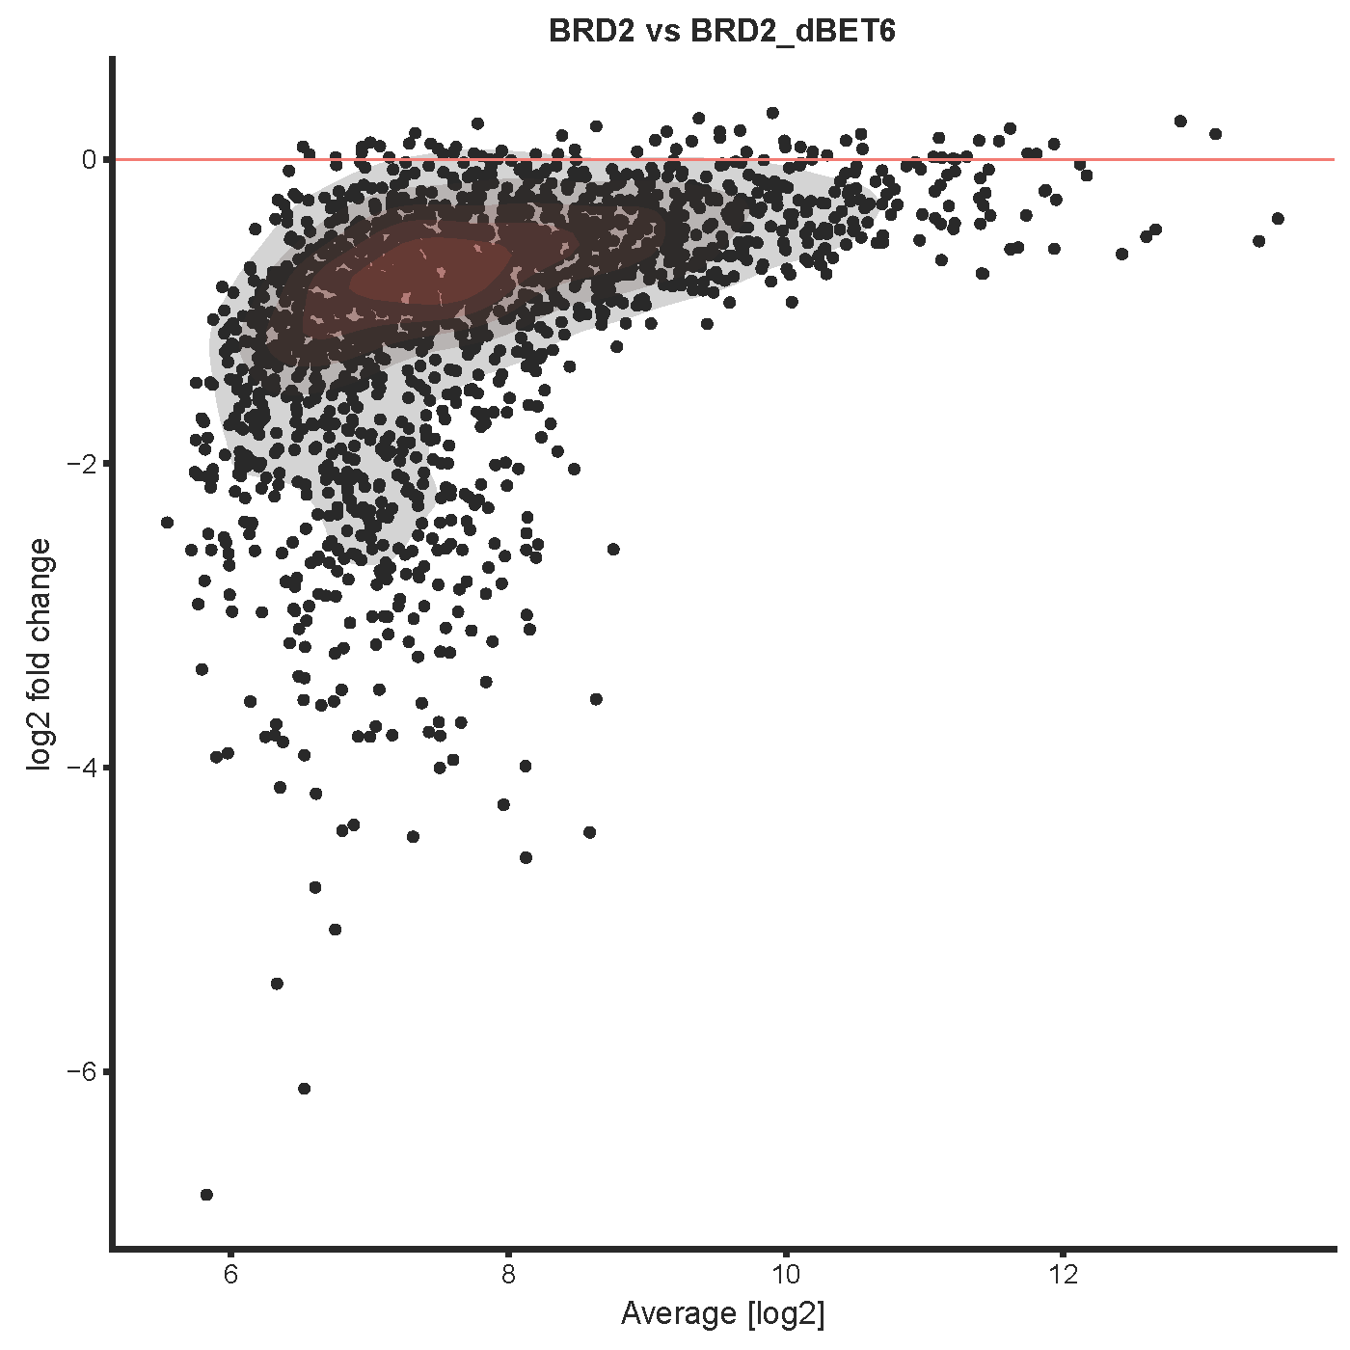 —

**peak_annos()** 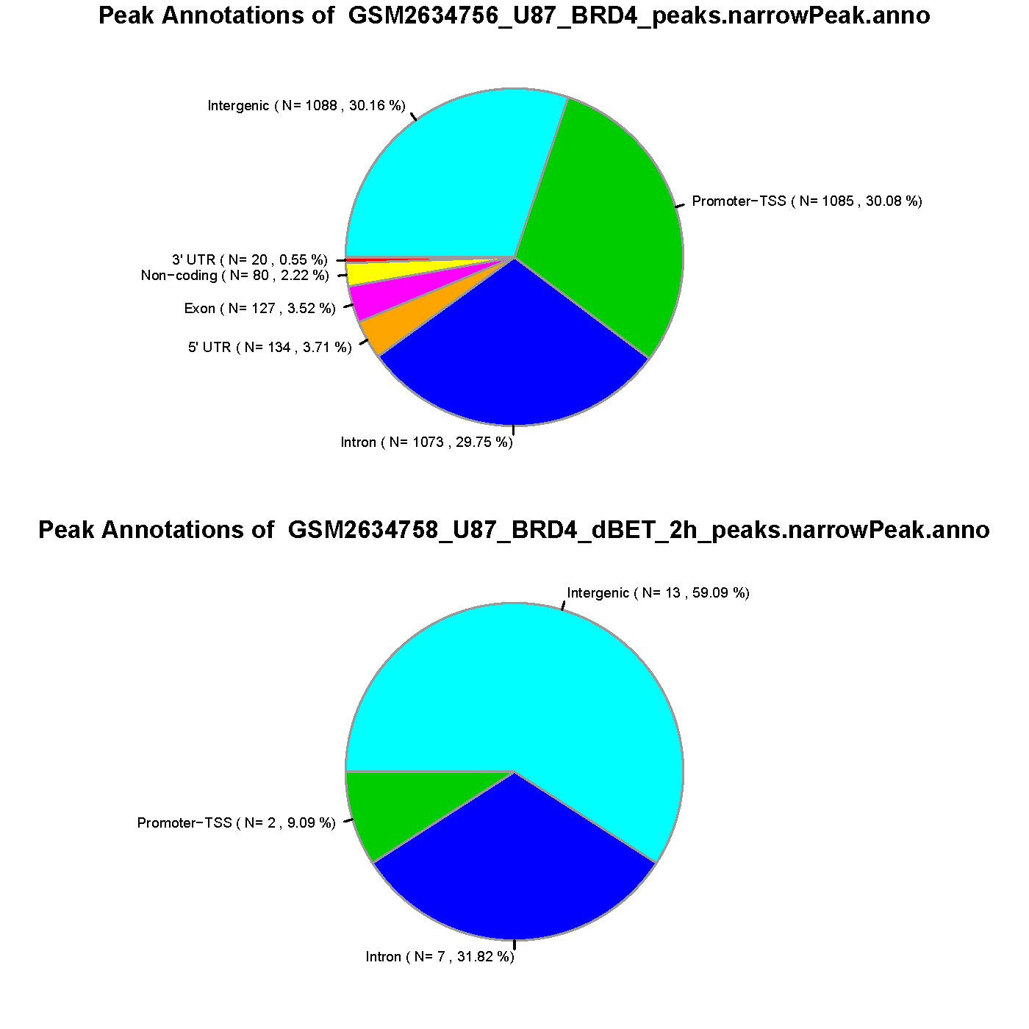 —

**plot_pol2i()** 