

Trabalho de Engenharia de Software I

Sistema de revistas de uma livraria

**Alunos:**

Paulo Henrique T. Borges

Claudio dos Santos

Leonardo Ramos

João Lucas Rulff

**Professora:** Teresa Cristina de Aguiar

**Índice**

Padrões de projeto e ferramentas........................................ 3

Imagens das telas de projeto.................................................. 4

Classes de Modelo....................................................................... 5

Classes DAO................................................................................ 12

Classes de Serviço...................................................................... 25

Classes de Controle................................................................... 27

Classes de utilitários.................................................................. 38

JSPs do projeto........................................................................... 41

Scripts e plugins utilizados no front-end............................. 51

Javascripts escritos por nós usando jQuery......................... 54

Arquivo XML com as declarações dos Servlets e Filter... 58

Arquivo de conexão com o Banco de Dados.................... 60

Interface Homem-Máquina – Telas..................................... 61

Projeto de Banco de Dados.................................................... 67

Diagrama ER.............................................................................. 69

Scripts SQL do banco................................................................ 70

Diagrama de Classes................................................................. 73

Diagrama de Sequência.......................................................... 75

Mais informações sobre o código........................................... 76

Descrição do caso de uso real................................................. 77

*Código fonte da implementação:*

*Design Patterns usadas na implementação do projeto:*

* MVC
* Singleton
* DAO, Generic DAO (DAO abstrato e genérico)
* Factory Method (Alternative Constructor)
* Builder

*Ferramentas utilizadas:*

* Eclipse Spring Tool Suite (STS) para Java EE
* Astah Professional
* Github para versionamento
* Servidor Jetty – plugin pro STS

**Exibição do projeto distribuído em camadas de pacotes no Eclipse Spring Tool Suite (STS – IDE de Java EE):**

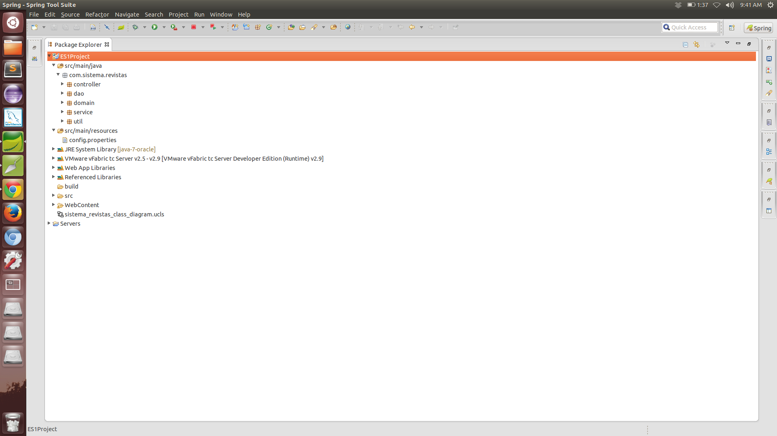

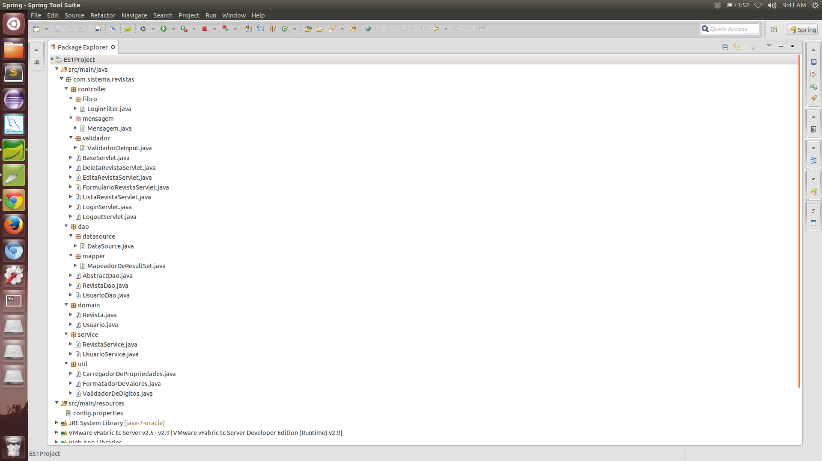

**Pasta de WebContent com as views e arquivos referentes às telas :**

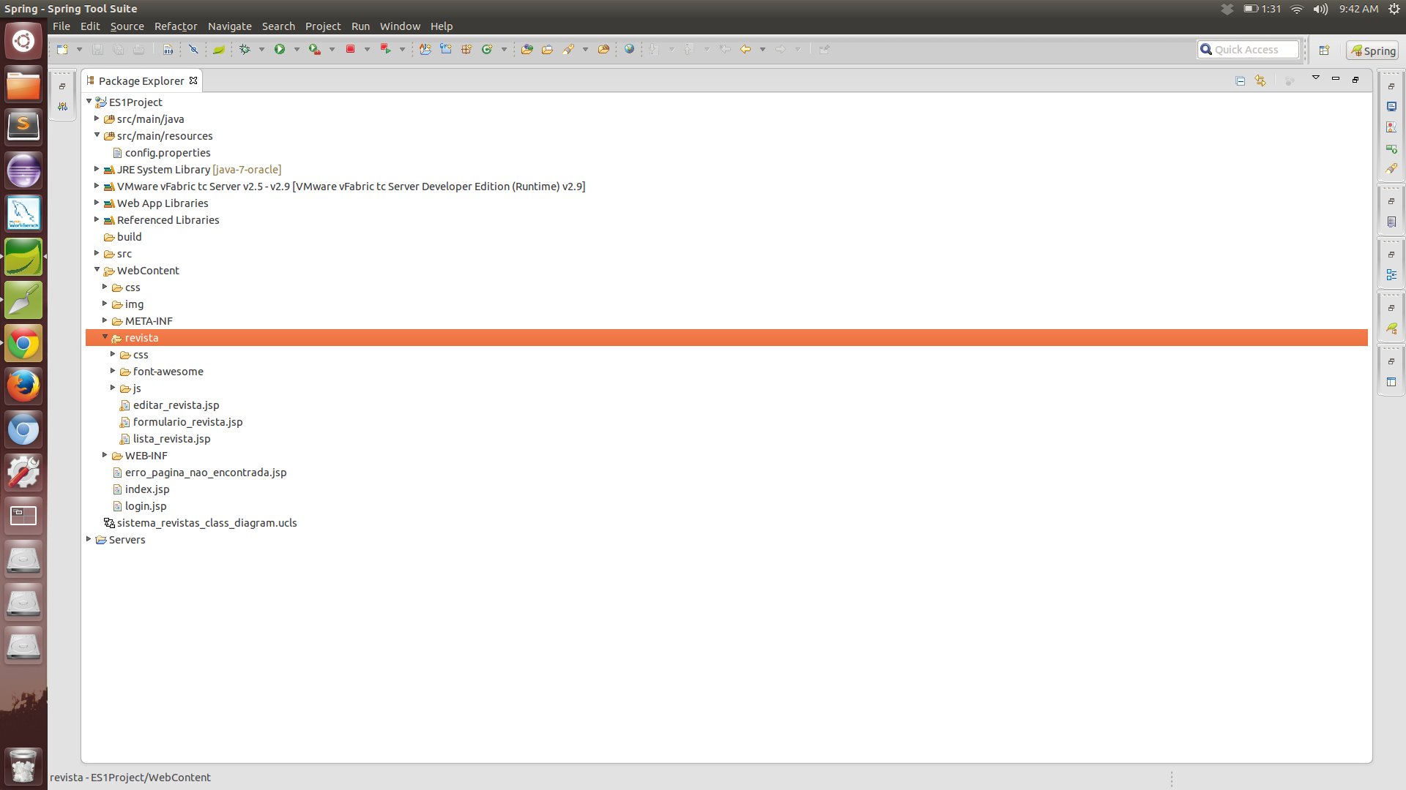

*Classes de Modelo (pacote ‘domain’):*

**Revista.java :**

**package** com**.**sistema**.**revistas**.**domain**;**

**import** java.math.BigDecimal**;**

**import** com.sistema.revistas.util.FormatadorDeValores**;**

**public** **class** **Revista** **{**

**private** Long id**;**

**private** String nome**;**

**private** Boolean temDigital**;**

**private** String tema**;**

**private** String descricao**;**

**private** BigDecimal precoDe**;**

**private** BigDecimal precoPor**;**

**private** Boolean estaDeletado**;**

**public** **static** **class** **RevistaBuilder** **{**

**private** Long id**;**

**private** String nome**;**

**private** Boolean temDigital**;**

**private** String tema**;**

**private** String descricao**;**

**private** BigDecimal precoDe**;**

**private** BigDecimal precoPor**;**

**private** Boolean estaDeletado **=** **false;**

**public** RevistaBuilder **id(**Long val**)** **{**

id **=** val**;**

**return** **this;**

**}**

**public** RevistaBuilder **nome(**String val**)** **{**

nome **=** val**;**

**return** **this;**

**}**

**public** RevistaBuilder **temDigital(**Boolean val**)** **{**

temDigital **=** val**;**

**return** **this;**

**}**

**public** RevistaBuilder **tema(**String val**)** **{**

tipo **=** val**;**

**return** **this;**

**}**

**public** RevistaBuilder **descricao(**String val**)** **{**

descricao **=** val**;**

**return** **this;**

**}**

**public** RevistaBuilder **precoDe(**BigDecimal val**)** **{**

precoDe **=** val**;**

**return** **this;**

**}**

**public** RevistaBuilder **precoPor(**BigDecimal val**)** **{**

precoPor **=** val**;**

**return** **this;**

**}**

**public** RevistaBuilder **estaDeletado(**Boolean val**)** **{**

estaDeletado **=** val**;**

**return** **this;**

**}**

**public** Revista **build()** **{**

**return** **new** **Revista(this);**

**}**

**}**

**public** **Revista(**RevistaBuilder revistaBuilder**)** **{**

**this.**nome **=** revistaBuilder**.**nome**;**

**this.**id **=** revistaBuilder**.**id**;**

**this.**temDigital **=** revistaBuilder**.**temDigital**;**

**this.**tema **=** revistaBuilder**.**tema**;**

**this.**descricao **=** revistaBuilder**.**descricao**;**

**this.**precoDe **=** revistaBuilder**.**precoDe**;**

**this.**precoPor **=** revistaBuilder**.**precoPor**;**

**this.**estaDeletado **=** revistaBuilder**.**estaDeletado**;**

**}**

**public** Long **getId()** **{**

**return** id**;**

**}**

**public** String **getNome()** **{**

**return** nome**;**

**}**

**public** String **getTema()** **{**

**return** tema**;**

**}**

**public** String **getDescricao()** **{**

**return** descricao**;**

**}**

**public** Boolean **getTemDigital()** **{**

**return** temDigital**;**

**}**

**public** BigDecimal **getPrecoDe()** **{**

**return** precoDe**;**

**}**

**public** BigDecimal **getPrecoPor()** **{**

**return** precoPor**;**

**}**

**public** Boolean **getEstaDeletado()** **{**

**return** estaDeletado**;**

**}**

**public** String **getPrecoDeFormatado()** **{**

**return** FormatadorDeValores**.**formataNumero**(**precoDe**);**

**}**

**public** String **getPrecoPorFormatado()** **{**

**return** FormatadorDeValores**.**formataNumero**(**precoPor**);**

**}**

**}**

**Usuario.java :**

**package** com**.**sistema**.**revistas**.**domain**;**

**import** java.security.MessageDigest**;**

**import** java.security.NoSuchAlgorithmException**;**

**public** **class** **Usuario** **{**

**private** Long id**;**

**private** String nome**;**

**private** String sobrenome**;**

**private** String senha**;**

**private** Boolean usuarioGerente**;**

**private** Boolean estaDeletado**;**

**public** **static** **class** **UsuarioBuilder** **{**

**private** Long id**;**

**private** String nome**;**

**private** String sobrenome**;**

**private** String senha**;**

**private** Boolean usuarioGerente**;**

**private** Boolean estaDeletado **=** **false;**

**public** UsuarioBuilder **id(**Long val**)** **{**

id **=** val**;**

**return** **this;**

**}**

**public** UsuarioBuilder **nome(**String val**)** **{**

nome **=** val**;**

**return** **this;**

**}**

**public** UsuarioBuilder **estaDeletado(**Boolean val**)** **{**

estaDeletado **=** val**;**

**return** **this;**

**}**

**public** UsuarioBuilder **sobrenome(**String val**)** **{**

sobrenome **=** val**;**

**return** **this;**

**}**

**public** UsuarioBuilder **senha(**String val**)** **{**

senha **=** val**;**

**return** **this;**

**}**

**public** UsuarioBuilder **usuarioGerente(**Boolean val**)** **{**

usuarioGerente **=** val**;**

**return** **this;**

**}**

**public** Usuario **build()** **{**

**return** **new** **Usuario(this);**

**}**

**}**

**public** **Usuario(**UsuarioBuilder usuarioBuilder**)** **{**

**this.**id **=** usuarioBuilder**.**id**;**

**this.**nome **=** usuarioBuilder**.**nome**;**

**this.**sobrenome **=** usuarioBuilder**.**sobrenome**;**

**this.**senha **=** tornaSenhaSegura**(**usuarioBuilder**.**senha**);**

**this.**usuarioGerente **=** usuarioBuilder**.**usuarioGerente**;**

**this.**estaDeletado **=** usuarioBuilder**.**estaDeletado**;**

**}**

**private** String **tornaSenhaSegura(**String senhaParaHash**) {**

String salt **=** "sistemarevista"**;**

         String senhaGerada **=** **null;**

**try** **{**

             MessageDigest md **=** MessageDigest**.**getInstance**(**"SHA-512"**);**

             md**.**update**(**salt**.**getBytes**());**

**byte[]** bytes **=** md**.**digest**(**senhaParaHash**.**getBytes**());**

             StringBuilder sb **=** **new** StringBuilder**();**

**for(int** i **=** 0**;** i **<** bytes**.**length**;** i**++)** **{**

                 sb**.**append**(**Integer**.**toString**((**bytes**[**i**]** **&** 0xff**)** **+** 0x100**,** 16**).**substring**(**1**));**

**}**

             senhaGerada **=** sb**.**toString**();**

**}** **catch** **(**NoSuchAlgorithmException e**)** **{**

         e**.**printStackTrace**();**

**}**

**return** senhaGerada**;**

**}**

**public** Long **getId()** **{**

**return** id**;**

**}**

**public** String **getNome()** **{**

**return** nome**;**

**}**

**public** String **getSobrenome()** **{**

**return** sobrenome**;**

**}**

**public** String **getSenha()** **{**

**return** senha**;**

**}**

**public** Boolean **getUsuarioGerente()** **{**

**return** usuarioGerente**;**

**}**

**public** Boolean **getEstaDeletado()** **{**

**return** estaDeletado**;**

**}**

**}**

*Classes DAO (pacote ‘DAO’):*

**GenericDao.java :**

**package** com**.**sistema**.**revistas**.**dao**;**

**import** java.util.List**;**

**import** com.sistema.revistas.dao.datasource.DataSource**;**

**public** **abstract** **class** **GenericDao<**T**>** **{**

**protected** DataSource dataSource**;**

**protected** **static** **final** String CAMINHO_DO_ARQUIVO **=** "src/main/resources/config.properties"**;**

**public** **abstract** Boolean **insereObjeto(**T objeto**);**

**public** **abstract** Boolean **atualizaObjeto(**T objeto**);**

**public** **abstract** Boolean **deletaElemento(**T objeto**);**

**public** **abstract** List**<**T**>** **encontraTodosOsObjetos();**

**public** **abstract** T **encontraObejetoPorId(**Long id**);**

**}**

**DataSource.java :**

**package** com**.**sistema**.**revistas**.**dao**.**datasource**;**

**public** **class** **DataSource** **{**

**private** String url**;**

**private** String username**;**

**private** String password**;**

**private** String driverClass**;**

**public** **DataSource(**String url**,** String username**,** String password**,** String driverClass**)** **{**

**this.**url **=** url**;**

**this.**username **=** username**;**

**this.**password **=** password**;**

**this.**driverClass **=** driverClass**;**

**}**

**public** String **getUrl()** **{**

**return** url**;**

**}**

**public** String **getUsername()** **{**

**return** username**;**

**}**

**public** String **getPassword()** **{**

**return** password**;**

**}**

**public** String **getDriverClass()** **{**

**return** driverClass**;**

**}**

**}**

**RevistaDao.java :**

**package** com**.**sistema**.**revistas**.**dao**;**

**import** java.sql.Connection**;**

**import** java.sql.DriverManager**;**

**import** java.sql.PreparedStatement**;**

**import** java.sql.ResultSet**;**

**import** java.sql.SQLException**;**

**import** java.sql.Statement**;**

**import** java.util.ArrayList**;**

**import** java.util.List**;**

**import** java.util.Properties**;**

**import** com.sistema.revistas.domain.Revista**;**

**import** com.sistema.revistas.dao.datasource.DataSource**;**

**import** com.sistema.revistas.dao.mapper.MapeadorDeResultSet**;**

**import** com.sistema.revistas.util.CarregadorDePropriedades**;**

**public** **class** **RevistaDao** **extends** GenericDao**<**Revista**>** **{**

**private** **static** **class** **Loader** **{**

**private** **static** RevistaDao revistaDaoInstancia **=** **new** RevistaDao**();**

**}**

**private** **RevistaDao()** **{**

Properties propriedades **=** CarregadorDePropriedades**.**carregaPropriedades**(**CAMINHO_DO_ARQUIVO**);**

dataSource **=** **new** DataSource**(**propriedades**.**getProperty**(**"dataSource.url"**),**

propriedades**.**getProperty**(**"dataSource.username"**),**

propriedades**.**getProperty**(**"dataSource.password"**),**

propriedades**.**getProperty**(**"dataSource.driver"**));**

**}**

**public** **static** RevistaDao **getInstanciaDeRevistaDao()** **{**

**return** Loader**.**revistaDaoInstancia**;**

**}**

@Override

**public** Boolean **insereObjeto(**Revista revista**)** **{**

**try** **{**

Class**.**forName**(**dataSource**.**getDriverClass**());**

Connection connection **=** DriverManager**.**getConnection**(**dataSource**.**getUrl**(),** dataSource**.**getUsername**(),** dataSource**.**getPassword**());**

String sql **=** "INSERT INTO REVISTA (NM_NOME, BO_TEM_DIGITAL, NR_PRECO_DE, NR_PRECO_POR, " **+**

"BO_ESTA_DELETADO, NM_DESCRICAO, NM_TEMA) VALUES (?, ?, ?, ?, ?, ?, ?)"**;**

PreparedStatement statement **=** connection**.**prepareStatement**(**sql**);**

statement**.**setString**(**1**,** revista**.**getNome**());**

statement**.**setBoolean**(**2**,** revista**.**getTemDigital**());**

statement**.**setBigDecimal**(**3**,** revista**.**getPrecoDe**());**

statement**.**setBigDecimal**(**4**,** revista**.**getPrecoPor**());**

statement**.**setBoolean**(**5**,** revista**.**getEstaDeletado**());**

statement**.**setString**(**6**,** revista**.**getDescricao**());**

statement**.**setString**(**7**,** revista**.**getTema**());**

statement**.**execute**();**

fechaRecursos**(**connection**,** statement**);**

**return** **true;**

**}** **catch** **(**ClassNotFoundException e**)** **{**

e**.**printStackTrace**();**

**return** **false;**

**}** **catch** **(**SQLException e**)** **{**

e**.**printStackTrace**();**

**return** **false;**

**}**

**}**

@Override

**public** Boolean **atualizaObjeto(**Revista revista**)** **{**

**try** **{**

Class**.**forName**(**dataSource**.**getDriverClass**());**

Connection connection **=** DriverManager**.**getConnection**(**dataSource**.**getUrl**(),** dataSource**.**getUsername**(),** dataSource**.**getPassword**());**

String sql **=** "UPDATE REVISTA SET NM_NOME = ?, BO_TEM_DIGITAL = ?, NR_PRECO_DE = ?, NR_PRECO_POR = ?, BO_ESTA_DELETADO = ?,"

**+** "NM_DESCRICAO = ?, NM_TEMA = ? WHERE CD_REVISTA = ?"**;**

PreparedStatement statement **=** connection**.**prepareStatement**(**sql**);**

statement**.**setString**(**1**,** revista**.**getNome**());**

statement**.**setBoolean**(**2**,** revista**.**getTemDigital**());**

statement**.**setBigDecimal**(**3**,** revista**.**getPrecoDe**());**

statement**.**setBigDecimal**(**4**,** revista**.**getPrecoPor**());**

statement**.**setBoolean**(**5**,** revista**.**getEstaDeletado**());**

statement**.**setString**(**6**,** revista**.**getDescricao**());**

statement**.**setString**(**7**,** revista**.**getTema**());**

statement**.**setLong**(**8**,** revista**.**getId**());**

statement**.**execute**();**

fechaRecursos**(**connection**,** statement**);**

**return** **true;**

**}** **catch** **(**ClassNotFoundException e**)** **{**

e**.**printStackTrace**();**

**return** **false;**

**}** **catch** **(**SQLException e**)** **{**

e**.**printStackTrace**();**

**return** **false;**

**}**

**}**

@Override

**public** Boolean **deletaElemento(**Revista revista**)** **{**

**try** **{**

Class**.**forName**(**dataSource**.**getDriverClass**());**

Connection connection **=** DriverManager**.**getConnection**(**dataSource**.**getUrl**(),** dataSource**.**getUsername**(),** dataSource**.**getPassword**());**

String sql **=** "UPDATE REVISTA SET BO_ESTA_DELETADO = ? WHERE CD_REVISTA = ?"**;**

PreparedStatement statement **=** connection**.**prepareStatement**(**sql**);**

statement**.**setBoolean**(**1**,** **true);**

statement**.**setLong**(**2**,** revista**.**getId**());**

statement**.**execute**();**

fechaRecursos**(**connection**,** statement**);**

**return** **true;**

**}** **catch** **(**ClassNotFoundException e**)** **{**

e**.**printStackTrace**();**

**return** **false;**

**}** **catch** **(**SQLException e**)** **{**

e**.**printStackTrace**();**

**return** **false;**

**}**

**}**

@Override

**public** List**<**Revista**>** **encontraTodosOsObjetos()** **{**

**try** **{**

Class**.**forName**(**dataSource**.**getDriverClass**());**

Connection connection **=** DriverManager**.**getConnection**(**dataSource**.**getUrl**(),** dataSource**.**getUsername**(),** dataSource**.**getPassword**());**

String sql **=** "SELECT * FROM REVISTA WHERE BO_ESTA_DELETADO = 0"**;**

Statement statement **=** connection**.**createStatement**();**

ResultSet rs **=** statement**.**executeQuery**(**sql**);**

ArrayList**<**Revista**>** ListaDeRevistas **=** **new** ArrayList**<**Revista**>();**

**while** **(**rs**.**next**())** **{**

ListaDeRevistas**.**add**(**MapeadorDeResultSet**.**mapeiaRevista**(**rs**));**

**}**

fechaRecursos**(**connection**,** statement**,** rs**);**

**return** ListaDeRevistas**;**

**}** **catch** **(**ClassNotFoundException e**)** **{**

e**.**printStackTrace**();**

**return** **new** ArrayList**<**Revista**>();**

**}** **catch** **(**SQLException e**)** **{**

e**.**printStackTrace**();**

**return** **new** ArrayList**<**Revista**>();**

**}**

**}**

@Override

**public** Revista **encontraObejetoPorId(**Long id**)** **{**

**try** **{**

Class**.**forName**(**dataSource**.**getDriverClass**());**

Connection connection **=** DriverManager**.**getConnection**(**dataSource**.**getUrl**(),** dataSource**.**getUsername**(),** dataSource**.**getPassword**());**

String sql **=** "SELECT * FROM REVISTA WHERE CD_REVISTA = ? AND BO_ESTA_DELETADO = 0"**;**

PreparedStatement statement **=** connection**.**prepareStatement**(**sql**);**

statement**.**setLong**(**1**,** id**);**

ResultSet rs **=** statement**.**executeQuery**();**

**if** **(**rs**.**next**())** **{**

Revista revista **=** MapeadorDeResultSet**.**mapeiaRevista**(**rs**);**

fechaRecursos**(**connection**,** statement**,** rs**);**

**return** revista**;**

**}**

fechaRecursos**(**connection**,** statement**,** rs**);**

**return** **null;**

**}** **catch** **(**ClassNotFoundException e**)** **{**

e**.**printStackTrace**();**

**return** **null;**

**}** **catch** **(**SQLException e**)** **{**

e**.**printStackTrace**();**

**return** **null;**

**}**

**}**

**private** **void** **fechaRecursos(**Connection connection**,** Statement statement**)** **throws** SQLException **{**

fechaRecursos**(**connection**,** statement**,** **null);**

**}**

**private** **void** **fechaRecursos(**Connection connection**,** Statement statement**,** ResultSet resultSet**)** **throws** SQLException **{**

**if(**resultSet **!=** **null)** **{**

resultSet**.**close**();**

**}**

**if(**statement **!=** **null)** **{**

statement**.**close**();**

**}**

**if(**connection **!=** **null)** **{**

connection**.**close**();**

**}**

**}**

**}**

**UsuarioDao.java :**

**package** com**.**sistema**.**revistas**.**dao**;**

**import** java.sql.Connection**;**

**import** java.sql.DriverManager**;**

**import** java.sql.PreparedStatement**;**

**import** java.sql.ResultSet**;**

**import** java.sql.SQLException**;**

**import** java.sql.Statement**;**

**import** java.util.ArrayList**;**

**import** java.util.List**;**

**import** java.util.Properties**;**

**import** com.sistema.revistas.domain.Usuario**;**

**import** com.sistema.revistas.dao.datasource.DataSource**;**

**import** com.sistema.revistas.dao.mapper.MapeadorDeResultSet**;**

**import** com.sistema.revistas.util.CarregadorDePropriedades**;**

**public** **class** **UsuarioDao** **extends** GenericDao**<**Usuario**>** **{**

**private** **static** **class** **Loader** **{**

**private** **static** UsuarioDao usuarioDaoInstancia **=** **new** UsuarioDao**();**

**}**

**private** **UsuarioDao()** **{**

Properties propriedades **=** CarregadorDePropriedades**.**carregaPropriedades**(**CAMINHO_DO_ARQUIVO**);**

dataSource **=** **new** DataSource**(**propriedades**.**getProperty**(**"dataSource.url"**),**

propriedades**.**getProperty**(**"dataSource.username"**),**

propriedades**.**getProperty**(**"dataSource.password"**),**

propriedades**.**getProperty**(**"dataSource.driver"**));**

**}**

**public** **static** UsuarioDao **getInstanciaDeUsuarioDao()** **{**

**return** Loader**.**usuarioDaoInstancia**;**

**}**

**public** Usuario **autenticaUsuario(**Usuario usuario**)** **{**

**try** **{**

Class**.**forName**(**dataSource**.**getDriverClass**());**

Connection connection **=** DriverManager**.**getConnection**(**dataSource**.**getUrl**(),** dataSource**.**getUsername**(),** dataSource**.**getPassword**());**

String sql **=** "SELECT * FROM USUARIO WHERE NM_NOME = ? AND NM_SENHA = ? AND BO_E_GERENTE = 1 AND BO_ESTA_DELETADO = 0"**;**

PreparedStatement statement **=** connection**.**prepareStatement**(**sql**);**

statement**.**setString**(**1**,** usuario**.**getNome**());**

statement**.**setString**(**2**,** usuario**.**getSenha**());**

ResultSet rs **=** statement**.**executeQuery**();**

**if** **(**rs**.**next**())** **{**

Usuario usuarioDoBanco **=** MapeadorDeResultSet**.**mapeiaUsuario**(**rs**);**

fechaRecursos**(**connection**,** statement**,** rs**);**

**return** usuarioDoBanco**;**

**}**

fechaRecursos**(**connection**,** statement**,** rs**);**

**return** **null;**

**}** **catch** **(**ClassNotFoundException e**)** **{**

e**.**printStackTrace**();**

**return** **null;**

**}** **catch** **(**SQLException e**)** **{**

e**.**printStackTrace**();**

**return** **null;**

**}**

**}**

@Override

**public** Boolean **insereObjeto(**Usuario usuario**)** **{**

**try** **{**

Class**.**forName**(**dataSource**.**getDriverClass**());**

Connection connection **=** DriverManager**.**getConnection**(**dataSource**.**getUrl**(),** dataSource**.**getUsername**(),** dataSource**.**getPassword**());**

String sql **=** "INSERT INTO USUARIO (NM_NOME, NM_SOBRENOME, NM_SENHA, " **+**

"BO_ESTA_DELETADO, BO_E_GERENTE) VALUES (?, ?, ?, ?, ?)"**;**

PreparedStatement statement **=** connection**.**prepareStatement**(**sql**);**

statement**.**setString**(**1**,** usuario**.**getNome**());**

statement**.**setString**(**2**,** usuario**.**getSobrenome**());**

statement**.**setString**(**3**,** usuario**.**getSenha**());**

statement**.**setBoolean**(**4**,** usuario**.**getEstaDeletado**());**

statement**.**setBoolean**(**5**,** usuario**.**getUsuarioGerente**());**

statement**.**execute**();**

fechaRecursos**(**connection**,** statement**);**

**return** **true;**

**}** **catch** **(**ClassNotFoundException e**)** **{**

e**.**printStackTrace**();**

**return** **false;**

**}** **catch** **(**SQLException e**)** **{**

e**.**printStackTrace**();**

**return** **false;**

**}**

**}**

@Override

**public** Boolean **atualizaObjeto(**Usuario usuario**)** **{**

**try** **{**

Class**.**forName**(**dataSource**.**getDriverClass**());**

Connection connection **=** DriverManager**.**getConnection**(**dataSource**.**getUrl**(),** dataSource**.**getUsername**(),** dataSource**.**getPassword**());**

String sql **=** "UPDATE USUARIO SET NM_NOME = ?, NM_SOBRENOME = ?, NM_SENHA = ?, BO_ESTA_DELETADO = ?, BO_E_GERENTE = ?"

**+** " WHERE CD_USUARIO = ?"**;**

PreparedStatement statement **=** connection**.**prepareStatement**(**sql**);**

statement**.**setString**(**1**,** usuario**.**getNome**());**

statement**.**setString**(**2**,** usuario**.**getSobrenome**());**

statement**.**setString**(**3**,** usuario**.**getSenha**());**

statement**.**setBoolean**(**4**,** usuario**.**getEstaDeletado**());**

statement**.**setBoolean**(**5**,** usuario**.**getUsuarioGerente**());**

statement**.**setLong**(**6**,** usuario**.**getId**());**

statement**.**execute**();**

fechaRecursos**(**connection**,** statement**);**

**return** **true;**

**}** **catch** **(**ClassNotFoundException e**)** **{**

e**.**printStackTrace**();**

**return** **false;**

**}** **catch** **(**SQLException e**)** **{**

e**.**printStackTrace**();**

**return** **false;**

**}**

**}**

@Override

**public** Boolean **deletaElemento(**Usuario usuario**)** **{**

**try** **{**

Class**.**forName**(**dataSource**.**getDriverClass**());**

Connection connection **=** DriverManager**.**getConnection**(**dataSource**.**getUrl**(),** dataSource**.**getUsername**(),** dataSource**.**getPassword**());**

String sql **=** "UPDATE USUARIO SET BO_ESTA_DELETADO = ? WHERE CD_USUARIO = ?"**;**

PreparedStatement statement **=** connection**.**prepareStatement**(**sql**);**

statement**.**setBoolean**(**1**,** **true);**

statement**.**setLong**(**2**,** usuario**.**getId**());**

statement**.**execute**();**

fechaRecursos**(**connection**,** statement**);**

**return** **true;**

**}** **catch** **(**ClassNotFoundException e**)** **{**

e**.**printStackTrace**();**

**return** **false;**

**}** **catch** **(**SQLException e**)** **{**

e**.**printStackTrace**();**

**return** **false;**

**}**

**}**

@Override

**public** List**<**Usuario**>** **encontraTodosOsObjetos()** **{**

**try** **{**

Class**.**forName**(**dataSource**.**getDriverClass**());**

Connection connection **=** DriverManager**.**getConnection**(**dataSource**.**getUrl**(),** dataSource**.**getUsername**(),** dataSource**.**getPassword**());**

String sql **=** "SELECT * FROM USUARIO WHERE BO_ESTA_DELETADO = 0"**;**

Statement statement **=** connection**.**createStatement**();**

ResultSet rs **=** statement**.**executeQuery**(**sql**);**

ArrayList**<**Usuario**>** ListaDeUsuarios **=** **new** ArrayList**<**Usuario**>();**

**while** **(**rs**.**next**())** **{**

ListaDeUsuarios**.**add**(**MapeadorDeResultSet**.**mapeiaUsuario**(**rs**));**

**}**

fechaRecursos**(**connection**,** statement**,** rs**);**

**return** ListaDeUsuarios**;**

**}** **catch** **(**ClassNotFoundException e**)** **{**

e**.**printStackTrace**();**

**return** **new** ArrayList**<**Usuario**>();**

**}** **catch** **(**SQLException e**)** **{**

e**.**printStackTrace**();**

**return** **new** ArrayList**<**Usuario**>();**

**}**

**}**

@Override

**public** Usuario **encontraObejetoPorId(**Long id**)** **{**

**try** **{**

Class**.**forName**(**dataSource**.**getDriverClass**());**

Connection connection **=** DriverManager**.**getConnection**(**dataSource**.**getUrl**(),** dataSource**.**getUsername**(),** dataSource**.**getPassword**());**

String sql **=** "SELECT * FROM USUARIO WHERE CD_USUARIO = ? AND BO_ESTA_DELETADO = 0"**;**

PreparedStatement statement **=** connection**.**prepareStatement**(**sql**);**

statement**.**setLong**(**1**,** id**);**

ResultSet rs **=** statement**.**executeQuery**();**

**if** **(**rs**.**next**())** **{**

Usuario usuario **=** MapeadorDeResultSet**.**mapeiaUsuario**(**rs**);**

fechaRecursos**(**connection**,** statement**,** rs**);**

**return** usuario**;**

**}**

fechaRecursos**(**connection**,** statement**,** rs**);**

**return** **null;**

**}** **catch** **(**ClassNotFoundException e**)** **{**

e**.**printStackTrace**();**

**return** **null;**

**}** **catch** **(**SQLException e**)** **{**

e**.**printStackTrace**();**

**return** **null;**

**}**

**}**

**private** **void** **fechaRecursos(**Connection connection**,** Statement statement**)** **throws** SQLException **{**

fechaRecursos**(**connection**,** statement**,** **null);**

**}**

**private** **void** **fechaRecursos(**Connection connection**,** Statement statement**,** ResultSet resultSet**)** **throws** SQLException **{**

**if(**resultSet **!=** **null)** **{**

resultSet**.**close**();**

**}**

**if(**statement **!=** **null)** **{**

statement**.**close**();**

**}**

**if(**connection **!=** **null)** **{**

connection**.**close**();**

**}**

**}**

**}**

**MapeadorDeResultSet.java :**

**package** com**.**sistema**.**revistas**.**dao**.**mapper**;**

**import** java.sql.ResultSet**;**

**import** java.sql.SQLException**;**

**import** com.sistema.revistas.domain.Revista**;**

**import** com.sistema.revistas.domain.Usuario**;**

**public** **class** **MapeadorDeResultSet** **{**

**public** **static** Usuario **mapeiaUsuario(**ResultSet rs**)** **throws** SQLException **{**

Usuario usuario **=** **new** Usuario**.**UsuarioBuilder**().**nome**(**rs**.**getString**(**"NM_NOME"**)).**sobrenome**(**rs**.**getString**(**"NM_SOBRENOME"**)).**

senha**(**rs**.**getString**(**"NM_SENHA"**)).**usuarioGerente**(**rs**.**getBoolean**(**"BO_E_GERENTE"**)).**id**(**rs**.**getLong**(**"CD_USUARIO"**)).**

estaDeletado**(**rs**.**getBoolean**(**"BO_ESTA_DELETADO"**)).**build**();**

**return** usuario**;**

**}**

**public** **static** Revista **mapeiaRevista(**ResultSet rs**)** **throws** SQLException **{**

Revista revista **=** **new** Revista**.**RevistaBuilder**().**id**(**rs**.**getLong**(**"CD_REVISTA"**)).**nome**(**rs**.**getString**(**"NM_NOME"**)).**

temDigital**(**rs**.**getBoolean**(**"BO_TEM_DIGITAL"**)).**precoDe**(**rs**.**getBigDecimal**(**"NR_PRECO_DE"**)).**

precoPor**(**rs**.**getBigDecimal**(**"NR_PRECO_POR"**)).**estaDeletado**(**rs**.**getBoolean**(**"BO_ESTA_DELETADO"**)).**descricao**(**rs**.**getString**(**"NM_DESCRICAO"**)).**

tema**(**rs**.**getString**(**"NM_TEMA"**)).**build**();**

**return** revista**;**

**}**

**}**

*Classes de Serviço (pacote ‘service’):*

**RevistaService.java :**

**package** com**.**sistema**.**revistas**.**service**;**

**import** java.util.List**;**

**import** com.sistema.revistas.dao.RevistaDao**;**

**import** com.sistema.revistas.domain.Revista**;**

**public** **class** **RevistaService** **{**

**private** RevistaDao revistaDao**;**

**private** **static** **class** **Loader** **{**

**private** **static** RevistaService revistaServiceInstancia **=** **new** RevistaService**();**

**}**

**private** **RevistaService()** **{**

revistaDao **=** RevistaDao**.**getInstanciaDeRevistaDao**();**

**}**

**public** **static** RevistaService **getInstanciaDeRevistaService()** **{**

**return** Loader**.**revistaServiceInstancia**;**

**}**

**public** List**<**Revista**>** **consultaTodasAsRevistas()** **{**

**return** revistaDao**.**encontraTodosOsObjetos**();**

**}**

**public** Boolean **excluiRevista(**Revista revista**)** **{**

**return** revistaDao**.**deletaElemento**(**revista**);**

**}**

**public** Revista **consultaRevistaPorId(**Long id**)** **{**

**return** revistaDao**.**encontraObejetoPorId**(**id**);**

**}**

**public** Boolean **criaRevista(**Revista revista**)** **{**

**return** revistaDao**.**insereObjeto**(**revista**);**

**}**

**public** Boolean **atualizaRevista(**Revista revista**)** **{**

**return** revistaDao**.**atualizaObjeto**(**revista**);**

**}**

**}**

**UsuarioService.java :**

**package** com**.**sistema**.**revistas**.**service**;**

**import** java.util.List**;**

**import** com.sistema.revistas.dao.UsuarioDao**;**

**import** com.sistema.revistas.domain.Usuario**;**

**public** **class** **UsuarioService** **{**

**private** UsuarioDao usuarioDao**;**

**private** **static** **class** **Loader** **{**

**private** **static** UsuarioService usuarioServiceInstancia **=** **new** UsuarioService**();**

**}**

**private** **UsuarioService()** **{**

usuarioDao **=** UsuarioDao**.**getInstanciaDeUsuarioDao**();**

**}**

**public** **static** UsuarioService **getInstanciaDeUsuarioService()** **{**

**return** Loader**.**usuarioServiceInstancia**;**

**}**

**public** Usuario **autenticaLoginDeUsuario(**Usuario usuario**)** **{**

**return** usuarioDao**.**autenticaUsuario**(**usuario**);**

**}**

**public** Boolean **removeUsuario(**Usuario usuario**)** **{**

**return** usuarioDao**.**deletaElemento**(**usuario**);**

**}**

**public** Boolean **insereUsuario(**Usuario usuario**)** **{**

**return** usuarioDao**.**insereObjeto**(**usuario**);**

**}**

**public** Boolean **atualizaUsuario(**Usuario usuario**)** **{**

**return** usuarioDao**.**atualizaObjeto**(**usuario**);**

**}**

**public** Usuario **consultaUsuarioPorId(**Long id**)** **{**

**return** usuarioDao**.**encontraObejetoPorId**(**id**);**

**}**

**public** List**<**Usuario**>** **consultaTodosOsUsuarios()** **{**

**return** usuarioDao**.**encontraTodosOsObjetos**();**

**}**

**}**

*Classes de Controle (pacote ‘controller’):*

**BaseServlet.java :**

**package** com**.**sistema**.**revistas**.**controller**;**

**import** java.io.IOException**;**

**import** javax.servlet.http.HttpServlet**;**

**import** javax.servlet.http.HttpServletRequest**;**

**import** javax.servlet.http.HttpServletResponse**;**

**import** com.sistema.revistas.controller.mensagem.Mensagem**;**

**public** **abstract** **class** **BaseServlet** **extends** HttpServlet **{**

**private** **static** **final** **long** serialVersionUID **=** 1L**;**

**public** **void** **renderizaJSP(**HttpServletRequest request**,** HttpServletResponse response**,** String urlPagina**)** **throws** IOException **{**

**if** **(**request**.**getParameter**(**"mensagem"**)** **==** **null)** **{**

request**.**getSession**().**setAttribute**(**"mensagem"**,** Mensagem**.**mensagemNulaFactory**());**

**}**

response**.**sendRedirect**(**urlPagina**);**

**}**

**}**

**DeletaRevistaServlet.java :**

**package** com**.**sistema**.**revistas**.**controller**;**

**import** java.io.IOException**;**

**import** javax.servlet.ServletException**;**

**import** javax.servlet.http.HttpServletRequest**;**

**import** javax.servlet.http.HttpServletResponse**;**

**import** com.sistema.revistas.controller.mensagem.Mensagem**;**

**import** com.sistema.revistas.controller.validador.ValidadorDeInput**;**

**import** com.sistema.revistas.domain.Revista**;**

**import** com.sistema.revistas.service.RevistaService**;**

**public** **class** **DeletaRevistaServlet** **extends** BaseServlet **{**

**private** **static** **final** **long** serialVersionUID **=** 1L**;**

**private** RevistaService revistaService**;**

**public** **DeletaRevistaServlet()** **{**

**super();**

     revistaService **=** RevistaService**.**getInstanciaDeRevistaService**();**

**}**

**protected** **void** **doGet(**HttpServletRequest request**,** HttpServletResponse response**)** **throws** ServletException**,** IOException **{**

**if** **(!**ValidadorDeInput**.**validaId**(**request**))** **{**

request**.**setAttribute**(**"mensagem"**,** Mensagem**.**erroIdInvalidoFactory**());**

**}** **else** **{**

Long id **=** **new** Long**(**request**.**getParameter**(**"id"**));**

Revista revista **=** revistaService**.**consultaRevistaPorId**(**id**);**

excluiRevista**(**request**,** revista**);**

**}**

response**.**sendRedirect**(**"listaRevista?mensagem=true"**);**

**}**

**private** **void** **excluiRevista(**HttpServletRequest request**,** Revista revista**)** **{**

**if** **(**revista **!=** **null** **&&** revistaService**.**excluiRevista**(**revista**))** **{**

request**.**getSession**().**setAttribute**(**"mensagem"**,** Mensagem**.**deletarComSucessoFactory**());**

**}** **else** **{**

request**.**getSession**().**setAttribute**(**"mensagem"**,** Mensagem**.**deletarComErroFactory**());**

**}**

**}**

**}**

**EditaRevistaServlet.java :**

**package** com**.**sistema**.**revistas**.**controller**;**

**import** java.io.IOException**;**

**import** java.math.BigDecimal**;**

**import** javax.servlet.ServletException**;**

**import** javax.servlet.http.HttpServletRequest**;**

**import** javax.servlet.http.HttpServletResponse**;**

**import** com.sistema.revistas.controller.mensagem.Mensagem**;**

**import** com.sistema.revistas.controller.validador.ValidadorDeInput**;**

**import** com.sistema.revistas.domain.Revista**;**

**import** com.sistema.revistas.service.RevistaService**;**

**public** **class** **EditaRevistaServlet** **extends** BaseServlet **{**

**private** **static** **final** **long** serialVersionUID **=** 1L**;**

**private** RevistaService revistaService**;**

**public** **EditaRevistaServlet()** **{**

**super();**

     revistaService **=** RevistaService**.**getInstanciaDeRevistaService**();**

**}**

**protected** **void** **doGet(**HttpServletRequest request**,** HttpServletResponse response**)** **throws** ServletException**,** IOException **{**

**if** **(!**ValidadorDeInput**.**validaId**(**request**))** **{**

request**.**getSession**().**setAttribute**(**"revista"**,** **null);**

**}** **else** **{**

Long id **=** **new** Long**(**request**.**getParameter**(**"id"**));**

Revista revista **=** revistaService**.**consultaRevistaPorId**(**id**);**

request**.**getSession**().**setAttribute**(**"revista"**,** revista**);**

**}**

renderizaJSP**(**request**,** response**,** "editar_revista.jsp"**);**

**}**

**protected** **void** **doPost(**HttpServletRequest request**,** HttpServletResponse response**)** **throws** ServletException**,** IOException **{**

**if** **(**ValidadorDeInput**.**validaEdicaoDeRevista**(**request**))** **{**

Revista revista **=** **new** Revista**.**RevistaBuilder**().**id**(new** Long**(**request**.**getParameter**(**"id"**))).**nome**(**request**.**getParameter**(**"nome"**)).**

temDigital**(new** Boolean**(**request**.**getParameter**(**"temDigital"**))).**precoDe**(new** BigDecimal**(**request**.**getParameter**(**"precoDe"**))).**

precoPor**(new** BigDecimal**(**request**.**getParameter**(**"precoPor"**))).**estaDeletado**(new** Boolean**(**request**.**getParameter**(**"estaDeletado"**))).**

descricao**(**request**.**getParameter**(**"descricao"**)).**tema**(**request**.**getParameter**(**"tema"**)).**build**();**

editaRevista**(**request**,** revista**);**

**}**

response**.**sendRedirect**(**"editaRevista?id=" **+** request**.**getParameter**(**"id"**)+** "&mensagem=true"**);**

**}**

**private** **void** **editaRevista(**HttpServletRequest request**,** Revista revista**)** **{**

**if** **(**revistaService**.**atualizaRevista**(**revista**))** **{**

request**.**getSession**().**setAttribute**(**"mensagem"**,** Mensagem**.**editarComSucessoFactory**());**

**}** **else** **{**

request**.**getSession**().**setAttribute**(**"mensagem"**,** Mensagem**.**editarComErroFactory**());**

**}**

**}**

**}**

**FormularioRevistaServlet.java :**

**package** com**.**sistema**.**revistas**.**controller**;**

**import** java.io.IOException**;**

**import** java.math.BigDecimal**;**

**import** javax.servlet.ServletException**;**

**import** javax.servlet.http.HttpServletRequest**;**

**import** javax.servlet.http.HttpServletResponse**;**

**import** com.sistema.revistas.controller.mensagem.Mensagem**;**

**import** com.sistema.revistas.controller.validador.ValidadorDeInput**;**

**import** com.sistema.revistas.domain.Revista**;**

**import** com.sistema.revistas.service.RevistaService**;**

**public** **class** **FormularioRevistaServlet** **extends** BaseServlet**{**

**private** **static** **final** **long** serialVersionUID **=** 1L**;**

**private** RevistaService revistaService**;**

**public** **FormularioRevistaServlet()** **{**

**super();**

     revistaService **=** RevistaService**.**getInstanciaDeRevistaService**();**

**}**

**protected** **void** **doGet(**HttpServletRequest request**,** HttpServletResponse response**)** **throws** ServletException**,** IOException **{**

renderizaJSP**(**request**,** response**,** "formulario_revista.jsp"**);**

**}**

**protected** **void** **doPost(**HttpServletRequest request**,** HttpServletResponse response**)** **throws** ServletException**,** IOException **{**

**if** **(**ValidadorDeInput**.**validaCriacaoDeRevista**(**request**))** **{**

Revista revista **=** **new** Revista**.**RevistaBuilder**().**nome**(**request**.**getParameter**(**"nome"**)).**

temDigital**(new** Boolean**(**request**.**getParameter**(**"temDigital"**))).**precoPor**(new** BigDecimal**(**request**.**getParameter**(**"precoPor"**))).**

precoDe**(new** BigDecimal**(**request**.**getParameter**(**"precoDe"**))).**descricao**(**request**.**getParameter**(**"descricao"**)).**

tema**(**request**.**getParameter**(**"tema"**)).**build**();**

cadastraRevista**(**request**,** revista**);**

**}**

response**.**sendRedirect**(**"formularioRevista?mensagem=true"**);**

**}**

**private** **void** **cadastraRevista(**HttpServletRequest request**,** Revista revista**)** **{**

**if** **(**revistaService**.**criaRevista**(**revista**))** **{**

request**.**getSession**().**setAttribute**(**"mensagem"**,** Mensagem**.**cadastrarComSucessoFactory**());**

**}** **else** **{**

request**.**getSession**().**setAttribute**(**"mensagem"**,** Mensagem**.**cadastrarComErroFactory**());**

**}**

**}**

**}**

**ListaRevistaServlet.java :**

**package** com**.**sistema**.**revistas**.**controller**;**

**import** java.io.IOException**;**

**import** java.util.List**;**

**import** javax.servlet.ServletException**;**

**import** javax.servlet.http.HttpServletRequest**;**

**import** javax.servlet.http.HttpServletResponse**;**

**import** com.sistema.revistas.domain.Revista**;**

**import** com.sistema.revistas.service.RevistaService**;**

**public** **class** **ListaRevistaServlet** **extends** BaseServlet **{**

**private** **static** **final** **long** serialVersionUID **=** 1L**;**

**private** RevistaService revistaService**;**

**public** **ListaRevistaServlet()** **{**

**super();**

     revistaService **=** RevistaService**.**getInstanciaDeRevistaService**();**

**}**

**protected** **void** **doGet(**HttpServletRequest request**,** HttpServletResponse response**)** **throws** ServletException**,** IOException **{**

List**<**Revista**>** revistas **=** revistaService**.**consultaTodasAsRevistas**();**

request**.**getSession**().**setAttribute**(**"revistas"**,** revistas**);**

renderizaJSP**(**request**,** response**,** "lista_revista.jsp"**);**

**}**

**}**

**LoginServlet.java :**

**package** com**.**sistema**.**revistas**.**controller**;**

**import** java.io.IOException**;**

**import** javax.servlet.ServletException**;**

**import** javax.servlet.http.HttpServletRequest**;**

**import** javax.servlet.http.HttpServletResponse**;**

**import** com.sistema.revistas.controller.mensagem.Mensagem**;**

**import** com.sistema.revistas.domain.Usuario**;**

**import** com.sistema.revistas.service.UsuarioService**;**

**public** **class** **LoginServlet** **extends** BaseServlet **{**

**private** **static** **final** **long** serialVersionUID **=** 1L**;**

**private** UsuarioService usuarioService**;**

**public** **LoginServlet()** **{**

**super();**

usuarioService **=** UsuarioService**.**getInstanciaDeUsuarioService**();**

**}**

**protected** **void** **doGet(**HttpServletRequest request**,** HttpServletResponse response**)** **throws** ServletException**,** IOException **{**

renderizaJSP**(**request**,** response**,** "login.jsp"**);**

**}**

**protected** **void** **doPost(**HttpServletRequest request**,** HttpServletResponse response**)** **throws** ServletException**,** IOException **{**

Usuario usuario **=** **new** Usuario**.**UsuarioBuilder**().**nome**(**request**.**getParameter**(**"nome"**)).**senha**(**request**.**getParameter**(**"senha"**)).**build**();**

Usuario usuarioDoBanco **=** usuarioService**.**autenticaLoginDeUsuario**(**usuario**);**

**if** **(**usuarioDoBanco **==** **null)** **{**

request**.**getSession**().**setAttribute**(**"mensagem"**,** Mensagem**.**loginComErroFactory**());**

response**.**sendRedirect**(**"login?mensagem=true"**);**

**}** **else** **{**

*//Sessão setada para uma hora*

request**.**getSession**().**setAttribute**(**"usuario"**,** usuario**);**

request**.**getSession**().**setMaxInactiveInterval**(**30 **\*** 2 **\*** 60**);**

response**.**sendRedirect**(**"revista/listaRevista"**);**

**}**

**}**

**}**

**LogoutServlet.java :**

**package** com**.**sistema**.**revistas**.**controller**;**

**import** java.io.IOException**;**

**import** javax.servlet.ServletException**;**

**import** javax.servlet.http.HttpServletRequest**;**

**import** javax.servlet.http.HttpServletResponse**;**

**public** **class** **LogoutServlet** **extends** BaseServlet **{**

**private** **static** **final** **long** serialVersionUID **=** 1L**;**

**public** **LogoutServlet()** **{**

**super();**

**}**

**protected** **void** **doGet(**HttpServletRequest request**,** HttpServletResponse response**)** **throws** ServletException**,** IOException **{**

request**.**getSession**().**invalidate**();**

response**.**sendRedirect**(**"http://localhost:8080/ES1Project/"**);**

**}**

**}**

**LoginFilter.java :**

**package** com**.**sistema**.**revistas**.**controller**.**filtro**;**

**import** java.io.IOException**;**

**import** javax.servlet.Filter**;**

**import** javax.servlet.FilterChain**;**

**import** javax.servlet.FilterConfig**;**

**import** javax.servlet.ServletException**;**

**import** javax.servlet.ServletRequest**;**

**import** javax.servlet.ServletResponse**;**

**import** javax.servlet.http.HttpServletRequest**;**

**import** javax.servlet.http.HttpServletResponse**;**

**import** com.sistema.revistas.domain.Usuario**;**

**public** **class** **LoginFilter** **implements** Filter **{**

**public** **LoginFilter()** **{**

**super();**

**}**

**public** **void** **doFilter(**ServletRequest request**,** ServletResponse response**,** FilterChain chain**)** **throws** IOException**,** ServletException **{**

HttpServletRequest httpRequest **=** **(**HttpServletRequest**)** request**;**

HttpServletResponse httpResponse **=** **(**HttpServletResponse**)** response**;**

Usuario usuario **=** **(**Usuario**)** httpRequest**.**getSession**().**getAttribute**(**"usuario"**);**

**if** **(**usuario **==** **null)** **{**

httpResponse**.**sendRedirect**(**"http://localhost:8080/ES1Project/login"**);**

**}** **else** **{**

chain**.**doFilter**(**request**,** response**);**

**}**

**}**

@Override

**public** **void** **destroy()** **{}**

@Override

**public** **void** **init(**FilterConfig arg0**)** **throws** ServletException **{}**

**}**

**Mensagem :**

**package** com**.**sistema**.**revistas**.**controller**.**mensagem**;**

**public** **class** **Mensagem** **{**

**private** String tipo**;**

**private** String texto**;**

**private** **Mensagem(**String tipo**,** String texto**)** **{**

**this.**tipo **=** tipo**;**

**this.**texto **=** texto**;**

**}**

**public** String **getTipo()** **{**

**return** tipo**;**

**}**

**public** String **getTexto()** **{**

**return** texto**;**

**}**

**public** **static** Mensagem **cadastrarComSucessoFactory()** **{**

**return** **new** **Mensagem(**"mensagemSucesso"**,** "Revista cadastrada com sucesso."**);**

**}**

**public** **static** Mensagem **cadastrarComErroFactory()** **{**

**return** **new** **Mensagem(**"mensagemErro"**,** "Erro ao cadastrar revista."**);**

**}**

**public** **static** Mensagem **editarComSucessoFactory()** **{**

**return** **new** **Mensagem(**"mensagemSucesso"**,** "Revista editada com sucesso."**);**

**}**

**public** **static** Mensagem **deletarComErroFactory()** **{**

**return** **new** **Mensagem(**"mensagemErro"**,** "Erro ao excluir revista."**);**

**}**

**public** **static** Mensagem **deletarComSucessoFactory()** **{**

**return** **new** **Mensagem(**"mensagemSucesso"**,** "Revista excluída com sucesso."**);**

**}**

**public** **static** Mensagem **editarComErroFactory()** **{**

**return** **new** **Mensagem(**"mensagemErro"**,** "Erro ao editar revista."**);**

**}**

**public** **static** Mensagem **loginComErroFactory()** **{**

**return** **new** **Mensagem(**"mensagemErro"**,** "Senha ou nome de usuário inválidos."**);**

**}**

**public** **static** Mensagem **erroIdInvalidoFactory()** **{**

**return** **new** **Mensagem(**"mensagemErro"**,** "Id de revista inválido."**);**

**}**

**public** **static** Mensagem **mensagemNulaFactory()** **{**

**return** **null;**

**}**

**}**

**ValidadorDeInput.java :**

**package** com**.**sistema**.**revistas**.**controller**.**validador**;**

**import** java.math.BigDecimal**;**

**import** javax.servlet.http.HttpServletRequest**;**

**import** com.sistema.revistas.util.ValidadorDeDigitos**;**

**public** **class** **ValidadorDeInput** **{**

**public** **static** Boolean **validaId(**HttpServletRequest request**)** **{**

**if** **(!**ValidadorDeDigitos**.**validaNumero**(**request**.**getParameter**(**"id"**)))** **{**

**return** **false;**

**}**

**return** **true;**

**}**

**public** **static** Boolean **validaEdicaoDeRevista(**HttpServletRequest request**)** **{**

**if** **(**validaCamposObrigatoriosDeRevista**(**request**)** **&&** validaCamposBooleano**(**request**.**getParameter**(**"temDigital"**))**

**&&** validaPrecos**(**request**.**getParameter**(**"precoDe"**),** request**.**getParameter**(**"precoPor"**))** **&&**

validaCamposBooleano**(**request**.**getParameter**(**"estaDeletado"**))** **&&** ValidadorDeDigitos**.**validaNumero**(**request**.**getParameter**(**"id"**)))** **{**

**return** **true;**

**}**

**return** **false;**

**}**

**public** **static** Boolean **validaCriacaoDeRevista(**HttpServletRequest request**)** **{**

**if** **(**validaCamposObrigatoriosDeRevista**(**request**)** **&&** validaCamposBooleano**(**request**.**getParameter**(**"temDigital"**))**

**&&** validaPrecos**(**request**.**getParameter**(**"precoDe"**),** request**.**getParameter**(**"precoPor"**)))** **{**

**return** **true;**

**}**

**return** **false;**

**}**

**private** **static** Boolean **validaPrecos(**String precoDe**,** String precoPor**)** **{**

**try** **{**

BigDecimal precoDeBigDecimal **=** **new** BigDecimal**(**precoDe**);**

BigDecimal precoPorBigDecimal **=** **new** BigDecimal**(**precoPor**);**

**if** **(**precoDeBigDecimal**.**compareTo**(**precoPorBigDecimal**)** **<** 0**)** **{**

**return** **false;**

**}**

**return** **true;**

**}** **catch** **(**Exception e**)** **{**

**return** **false;**

**}**

**}**

**private** **static** Boolean **validaCamposBooleano(**String temDigital**)** **{**

**if** **(!**Boolean**.**TRUE**.**toString**().**equals**(**temDigital**)** **&&** **!**Boolean**.**FALSE**.**toString**().**equals**(**temDigital**))** **{**

**return** **false;**

**}**

**return** **true;**

**}**

**private** **static** Boolean **validaCamposObrigatoriosDeRevista(**HttpServletRequest request**)** **{**

**return** request**.**getParameter**(**"nome"**)** **!=** **null** **&&** request**.**getParameter**(**"tema"**)** **!=** **null** **&&** request**.**getParameter**(**"precoDe"**)** **!=** **null** **&&**

request**.**getParameter**(**"precoPor"**)** **!=** **null** **&&** request**.**getParameter**(**"temDigital"**)** **!=** **null;**

**}**

**}**

*Classes de utilitários (pacote ‘util’):*

**CarregadorDePropriedades.java :**

**package** com**.**sistema**.**revistas**.**util**;**

**import** java.io.FileInputStream**;**

**import** java.io.IOException**;**

**import** java.io.InputStream**;**

**import** java.util.Properties**;**

**public** **class** **CarregadorDePropriedades** **{**

**public** **static** Properties **carregaPropriedades(**String caminhoDoArquivo**)** **{**

Properties propriedades **=** **null;**

InputStream input **=** **null;**

**try** **{**

propriedades **=** **new** Properties**();**

input **=** **new** FileInputStream**(**caminhoDoArquivo**);**

propriedades**.**load**(**input**);**

**return** propriedades**;**

**}** **catch** **(**IOException ex**)** **{**

ex**.**printStackTrace**();**

**}** **finally** **{**

**if** **(**input **!=** **null)** **{**

**try** **{**

input**.**close**();**

**}** **catch** **(**IOException e**)** **{**

e**.**printStackTrace**();**

**}**

**}**

**}**

**return** propriedades**;**

**}**

**}**

**FormatadorDeValores.java :**

**package** com**.**sistema**.**revistas**.**util**;**

**import** java.math.BigDecimal**;**

**import** java.text.DecimalFormat**;**

**import** java.text.DecimalFormatSymbols**;**

**import** java.util.Locale**;**

**public** **class** **FormatadorDeValores** **{**

**public** **static** String **formataNumero(**BigDecimal value**)** **{**

Locale local **=** **new** Locale**(**"pt"**,** "BR"**);**

DecimalFormat df **=** **new** DecimalFormat**(**"#,##0.00"**,** **new** DecimalFormatSymbols**(**local**));**

**return** "R$ " **+** df**.**format**(**value**);**

**}**

**}**

**ValidadorDeDigitos.java :**

**package** com**.**sistema**.**revistas**.**util**;**

**public** **class** **ValidadorDeDigitos** **{**

**private** **static** **final** String QUANTITY_REGEX **=** "^(0|[1-9][0-9]*)$"**;**

**public** **static** **boolean** **validaNumero(**String input**)** **{**

**return** input **!=** **null** **&&** input**.**matches**(**QUANTITY_REGEX**);**

**}**

**}**

*JSPs do projeto:*

**erro_pagina_nao_encontrada.jsp :**

**<%@** page language**=**"java" contentType**=**"text/html; charset=UTF-8"

pageEncoding**=**"UTF-8"**%>**

**<!DOCTYPE html PUBLIC "-//W3C//DTD HTML 4.01 Transitional//EN" "http://www.w3.org/TR/html4/loose.dtd">**

<html>

<head>

<meta http-equiv="Content-Type" content="text/html; charset=UTF-8">

<title>Página não encontrada</title>

<link rel="stylesheet" href="http://localhost:8080/ES1Project/css/erro.css">

</head>

<body>

<div class="image-container"></div>

</body>

</html>

**index.jsp :**

**<%@** page language**=**"java" contentType**=**"text/html; charset=UTF-8"

pageEncoding**=**"UTF-8"**%>**

**<!DOCTYPE html PUBLIC "-//W3C//DTD HTML 4.01 Transitional//EN" "http://www.w3.org/TR/html4/loose.dtd">**

<html>

<head>

<meta http-equiv="Content-Type" content="text/html; charset=UTF-8">

<title>Home</title>

</head>

<body>

**<%**

    String redirectURL **=** "http://localhost:8080/ES1Project/revista/listaRevista"**;**

    response**.**sendRedirect**(**redirectURL**);**

**%>**

</body>

</html>

**login.jsp :**

**<%@** page language**=**"java" contentType**=**"text/html; charset=UTF-8" pageEncoding**=**"UTF-8"**%>**

**<%@** taglib uri**=**"http://java.sun.com/jsp/jstl/core" prefix**=**"c" **%>**

**<!DOCTYPE html>**

*<!--[if lt IE 7]> <html class="lt-ie9 lt-ie8 lt-ie7" lang="en"> <![endif]-->*

*<!--[if IE 7]> <html class="lt-ie9 lt-ie8" lang="en"> <![endif]-->*

*<!--[if IE 8]> <html class="lt-ie9" lang="en"> <![endif]-->*

*<!--[if gt IE 8]><!-->* <html lang="en"> *<!--<![endif]-->*

<head>

  <meta charset="utf-8">

  <meta http-equiv="X-UA-Compatible" content="IE=edge,chrome=1">

  <title>Sistema revistas - login</title>

  <link rel="stylesheet" href="css/style.css">

*<!--[if lt IE 9]><script src="//html5shim.googlecode.com/svn/trunk/html5.js"></script><![endif]-->*

</head>

<body>

  <div class="title-container">

   <h1 class="title">Sistema Revistas</h1>

  </div>

  <div class="login-form">

<c:if test="${mensagem != null && mensagem.tipo eq 'mensagemErro'}">

<div class="errormsgbox">${mensagem.texto}</div>

</c:if>

<form method="post" action="login" class="login">

<p>

<label for="login">Usuário:</label>

<input type="text" name="nome" id="login">

</p>

<p>

<label for="password">Senha:</label>

<input type="password" name="senha" id="password">

</p>

<p class="login-submit">

<button type="submit" class="login-button">Login</button>

</p>

</form>

</div>

</body>

</html>

**editar_revista.jsp :**

**<%@** page language**=**"java" contentType**=**"text/html; charset=UTF-8" pageEncoding**=**"UTF-8"**%>**

**<%@** taglib uri**=**"http://java.sun.com/jsp/jstl/core" prefix**=**"c" **%>**

**<!DOCTYPE html>**

<html lang="en">

  <head>

    <meta charset="utf-8">

    <meta name="viewport" content="width=device-width, initial-scale=1.0">

    <meta name="description" content="">

    <meta name="author" content="">

    <title>Sistema Revistas - editar revista</title>

*<!-- Bootstrap core CSS -->*

    <link href="css/bootstrap.css" rel="stylesheet">

*<!-- Add custom CSS here -->*

    <link href="css/sb-admin.css" rel="stylesheet">

    <link rel="stylesheet" href="font-awesome/css/font-awesome.min.css">

    <link rel="stylesheet" href="css/validationEngine.jquery.css">

    <link rel="stylesheet" href="css/jquery-ui.css">

  </head>

  <body>

    <div id="wrapper">

*<!-- Sidebar -->*

      <nav class="navbar navbar-inverse navbar-fixed-top" role="navigation">

*<!-- Brand and toggle get grouped for better mobile display -->*

        <div class="navbar-header">

          <button type="button" class="navbar-toggle" data-toggle="collapse" data-target=".navbar-ex1-collapse">

            <span class="sr-only">Toggle navigation</span>

            <span class="icon-bar"></span>

            <span class="icon-bar"></span>

            <span class="icon-bar"></span>

          </button>

          <a class="navbar-brand" href="">Sistema Revistas</a>

        </div>

*<!-- Collect the nav links, forms, and other content for toggling -->*

        <div class="collapse navbar-collapse navbar-ex1-collapse">

          <ul class="nav navbar-nav side-nav">

            <li class="dropdown">

              <a href="#" class="dropdown-toggle" id="menu-top" data-toggle="dropdown"><i class="fa fa-caret-square-o-down"></i> Gerenciar revistas <b class="caret"></b></a>

              <ul id="dropdown-menu-items" class="dropdown-menu">

                <li><a href="http://localhost:8080/ES1Project/revista/listaRevista"><i class="fa fa-table"></i> Exibir revistas cadastradas</a></li>

                <li><a href="http://localhost:8080/ES1Project/revista/formularioRevista"><i class="fa fa-edit"></i> Cadastrar nova revista</a></li>

              </ul>

            </li>

          </ul>

          <ul class="nav navbar-nav navbar-right navbar-user">

            <li class="dropdown user-dropdown">

              <a href="#" class="dropdown-toggle" data-toggle="dropdown"><i class="fa fa-user"></i> ${usuario.nome} <b class="caret"></b></a>

              <ul class="dropdown-menu">

                <li><a href="http://localhost:8080/ES1Project/logout"><i class="fa fa-power-off"></i> Log Out</a></li>

              </ul>

            </li>

          </ul>

        </div>*<!-- /.navbar-collapse -->*

      </nav>

      <div id="page-wrapper">

        <div class="row">

          <div class="col-lg-12">

            <h1>Editar Revista <small> Entre com os dados</small></h1>

          </div>

        </div>*<!-- /.row -->*

<div class="form-magazine">

<c:if test="${mensagem != null && mensagem.tipo eq 'mensagemErro'}">

<div class="errormsgbox">${mensagem.texto}</div>

</c:if>

<c:if test="${mensagem != null && mensagem.tipo eq 'mensagemSucesso'}">

<div class="successbox">${mensagem.texto}</div>

</c:if>

<div class="row">

<div class="col-lg-6">

<form class="form" method="post" action="editaRevista" role="form">

<input type="hidden" name="id" value="${revista.id}" class="form-control" maxlength="100">

<input type="hidden" name="estaDeletado" value="${revista.estaDeletado}" class="form-control" maxlength="100">

<div class="form-group">

<label class="non-radio-label">Nome da revista: <span class="required-field">* </span></label>

<input name="nome" value="${revista.nome}" autocomplete="off" class="form-control nome" maxlength="100">

</div>

<div class="form-group">

<label class="non-radio-label">Tema: <span class="required-field">* </span></label>

<input name="tema" value="${revista.tema}" autocomplete="off" class="form-control tema" maxlength="100">

</div>

<div class="form-group">

<label class="non-radio-label">Descrição da revista: </label>

<input name="descricao" value="${revista.descricao}" autocomplete="off" class="form-control descricao" maxlength="100">

</div>

<div class="form-group">

<label class="non-radio-label">Preço Por: <span class="required-field">* </span></label>

<input name="precoPor" value="${revista.precoPor}" class="form-control precoPor" maxlength="10">

</div>

<div class="form-group">

<label class="non-radio-label">Preço De: <span class="required-field">* </span></label>

<input name="precoDe" value="${revista.precoDe}" autocomplete="off" class="form-control precoDe" maxlength="10">

</div>

<c:if test="${revista.temDigital == true}">

<div class="form-group">

<label class="radio-label">Tem formato digital: <span class="required-field">* </span></label>

<label class="radio-inline">

<input type="radio" name="temDigital" id="optionsRadiosInline1" value="true" checked> Sim

</label>

<label class="radio-inline">

<input type="radio" name="temDigital" id="optionsRadiosInline2" value="false">Não

</label>

</div>

</c:if>

<c:if test="${revista.temDigital != true}">

<div class="form-group">

<label class="radio-label">Tem formato digital: <span class="required-field">* </span></label>

<label class="radio-inline">

<input type="radio" name="temDigital" id="optionsRadiosInline1" value="true"> Sim

</label>

<label class="radio-inline">

<input type="radio" name="temDigital" id="optionsRadiosInline2" value="false" checked> Não

</label>

</div>

</c:if>

          <c:if test="${revista != null}">

<button type="submit" class="btn btn-default">Editar revista</button>

</c:if>

</form>

<br />

<br />

<br />

<a class="back_button" href="http://localhost:8080/ES1Project/revista/listaRevista">voltar para lista de revistas</a>

</div>

</div>*<!-- /.row -->*

</div>

      </div>*<!-- /#page-wrapper -->*

    </div>*<!-- /#wrapper -->*

*<!-- JavaScript -->*

    <script src="js/jquery-1.10.2.js"></script>

    <script src="js/bootstrap.js"></script>

    <script src="js/showhidemenu.js"></script>

    <script src="js/jquery.mask.min.js"></script>

  <script src="js/jquery.validate.min.js"></script>

  <script src="js/jquery.validationEngine-pt_BR.js"></script>

  <script src="js/jquery.validationEngine.js"></script>

    <script src="js/validate.revista.js"></script>

  </body>

</html>

**formulario_revista.jsp :**

**<%@** page language**=**"java" contentType**=**"text/html; charset=UTF-8" pageEncoding**=**"UTF-8"**%>**

**<%@** taglib uri**=**"http://java.sun.com/jsp/jstl/core" prefix**=**"c" **%>**

**<!DOCTYPE html>**

<html lang="en">

  <head>

    <meta charset="utf-8">

    <meta name="viewport" content="width=device-width, initial-scale=1.0">

    <meta name="description" content="">

    <meta name="author" content="">

    <title>Sistema Revistas - cadastrar revista</title>

*<!-- Bootstrap core CSS -->*

    <link href="css/bootstrap.css" rel="stylesheet">

*<!-- Add custom CSS here -->*

    <link href="css/sb-admin.css" rel="stylesheet">

    <link rel="stylesheet" href="font-awesome/css/font-awesome.min.css">

    <link rel="stylesheet" href="css/validationEngine.jquery.css">

    <link rel="stylesheet" href="css/jquery-ui.css">

  </head>

  <body>

    <div id="wrapper">

*<!-- Sidebar -->*

      <nav class="navbar navbar-inverse navbar-fixed-top" role="navigation">

*<!-- Brand and toggle get grouped for better mobile display -->*

        <div class="navbar-header">

          <button type="button" class="navbar-toggle" data-toggle="collapse" data-target=".navbar-ex1-collapse">

            <span class="sr-only">Toggle navigation</span>

            <span class="icon-bar"></span>

            <span class="icon-bar"></span>

            <span class="icon-bar"></span>

          </button>

          <a class="navbar-brand" href="">Sistema Revistas</a>

        </div>

*<!-- Collect the nav links, forms, and other content for toggling -->*

        <div class="collapse navbar-collapse navbar-ex1-collapse">

          <ul class="nav navbar-nav side-nav">

            <li class="dropdown">

              <a href="#" class="dropdown-toggle" id="menu-top" data-toggle="dropdown"><i class="fa fa-caret-square-o-down"></i> Gerenciar revistas <b class="caret"></b></a>

              <ul id="dropdown-menu-items" class="dropdown-menu">

                <li><a href="http://localhost:8080/ES1Project/revista/listaRevista"><i class="fa fa-table"></i> Exibir revistas cadastradas</a></li>

                <li><a href="http://localhost:8080/ES1Project/revista/formularioRevista"><i class="fa fa-edit"></i> Cadastrar nova revista</a></li>

              </ul>

            </li>

          </ul>

          <ul class="nav navbar-nav navbar-right navbar-user">

            <li class="dropdown user-dropdown">

              <a href="#" class="dropdown-toggle" data-toggle="dropdown"><i class="fa fa-user"></i> ${usuario.nome} <b class="caret"></b></a>

              <ul class="dropdown-menu">

                <li><a href="http://localhost:8080/ES1Project/logout"><i class="fa fa-power-off"></i> Log Out</a></li>

              </ul>

            </li>

          </ul>

        </div>*<!-- /.navbar-collapse -->*

      </nav>

      <div id="page-wrapper">

        <div class="row">

          <div class="col-lg-12">

            <h1>Cadastrar Revista <small> Entre com os dados</small></h1>

          </div>

        </div>*<!-- /.row -->*

<div class="form-magazine">

<c:if test="${mensagem != null && mensagem.tipo eq 'mensagemErro'}">

<div class="errormsgbox">${mensagem.texto}</div>

</c:if>

<c:if test="${mensagem != null && mensagem.tipo eq 'mensagemSucesso'}">

<div class="successbox">${mensagem.texto}</div>

</c:if>

<div class="row">

<div class="col-lg-6">

<form class="form" method="post" action="formularioRevista" role="form">

<div class="form-group">

<label class="non-radio-label">Nome da revista: <span class="required-field">* </span></label>

<input name="nome" autocomplete="off" class="form-control nome" maxlength="100">

</div>

<div class="form-group">

<label class="non-radio-label">Tema: <span class="required-field">* </span></label>

<input name="tema" autocomplete="off" class="form-control tema" maxlength="100">

</div>

<div class="form-group">

<label class="non-radio-label">Descrição da revista: </label>

<input name="descricao" autocomplete="off" class="form-control descricao" maxlength="100">

</div>

<div class="form-group">

<label class="non-radio-label">Preço Por: <span class="required-field">* </span></label>

<input name="precoPor" autocomplete="off" class="form-control precoPor" maxlength="10">

</div>

<div class="form-group">

<label class="non-radio-label">Preço De: <span class="required-field">* </span></label>

<input name="precoDe" autocomplete="off" class="form-control precoDe" maxlength="10">

</div>

<div class="form-group">

<label class="radio-label">Tem formato digital: <span class="required-field">* </span></label>

<label class="radio-inline">

<input type="radio" name="temDigital" id="optionsRadiosInline1" value="true" checked> Sim

</label>

<label class="radio-inline">

<input type="radio" name="temDigital" id="optionsRadiosInline2" value="false">Não

</label>

</div>

<button type="submit" class="btn btn-default">Cadastrar revista</button>

<button type="reset" class="btn btn-default">Resetar formulário</button>

</form>

</div>

</div>*<!-- /.row -->*

</div>

      </div>*<!-- /#page-wrapper -->*

    </div>*<!-- /#wrapper -->*

*<!-- JavaScript -->*

    <script src="js/jquery-1.10.2.js"></script>

    <script src="js/bootstrap.js"></script>

    <script src="js/showhidemenu.js"></script>

    <script src="js/jquery.mask.min.js"></script>

  <script src="js/jquery.validate.min.js"></script>

  <script src="js/jquery.validationEngine-pt_BR.js"></script>

  <script src="js/jquery.validationEngine.js"></script>

    <script src="js/validate.revista.js"></script>

  </body>

</html>

**lista_revista.jsp :**

**<%@** page language**=**"java" contentType**=**"text/html; charset=UTF-8" pageEncoding**=**"UTF-8"**%>**

**<%@** taglib uri**=**"http://java.sun.com/jsp/jstl/core" prefix**=**"c" **%>**

**<%@** taglib prefix**=**"fn" uri**=**"http://java.sun.com/jsp/jstl/functions" **%>**

**<!DOCTYPE html>**

<html lang="en">

  <head>

    <meta charset="utf-8">

    <meta name="viewport" content="width=device-width, initial-scale=1.0">

    <meta name="description" content="">

    <meta name="author" content="">

    <title>Sistema Revistas - lista de revista</title>

*<!-- Bootstrap core CSS -->*

    <link href="css/bootstrap.css" rel="stylesheet">

*<!-- Custom CSS -->*

    <link href="css/sb-admin.css" rel="stylesheet">

    <link rel="stylesheet" href="font-awesome/css/font-awesome.min.css">

<link href="css/lightbox.css" rel="stylesheet">

  </head>

  <body>

    <div id="wrapper">

*<!-- Sidebar -->*

      <nav class="navbar navbar-inverse navbar-fixed-top" role="navigation">

*<!-- Brand and toggle get grouped for better mobile display -->*

        <div class="navbar-header">

          <button type="button" class="navbar-toggle" data-toggle="collapse" data-target=".navbar-ex1-collapse">

            <span class="sr-only">Toggle navigation</span>

            <span class="icon-bar"></span>

            <span class="icon-bar"></span>

            <span class="icon-bar"></span>

          </button>

          <a class="navbar-brand" href="">Sistema Revistas</a>

        </div>

*<!-- Collect the nav links, forms, and other content for toggling -->*

        <div class="collapse navbar-collapse navbar-ex1-collapse">

          <ul class="nav navbar-nav side-nav">

            <li class="dropdown">

              <a href="#" class="dropdown-toggle" id="menu-top" data-toggle="dropdown"><i class="fa fa-caret-square-o-down"></i> Gerenciar revistas <b class="caret"></b></a>

              <ul id="dropdown-menu-items" class="dropdown-menu">

                <li><a href="http://localhost:8080/ES1Project/revista/listaRevista"><i class="fa fa-table"></i> Exibir revistas cadastradas</a></li>

                <li><a href="http://localhost:8080/ES1Project/revista/formularioRevista"><i class="fa fa-edit"></i> Cadastrar nova revista</a></li>

              </ul>

            </li>

          </ul>

          <ul class="nav navbar-nav navbar-right navbar-user">

            <li class="dropdown user-dropdown">

              <a href="#" class="dropdown-toggle" data-toggle="dropdown"><i class="fa fa-user"></i> ${usuario.nome} <b class="caret"></b></a>

              <ul class="dropdown-menu">

                <li><a href="http://localhost:8080/ES1Project/logout"><i class="fa fa-power-off"></i> Log Out</a></li>

              </ul>

            </li>

          </ul>

        </div>*<!-- /.navbar-collapse -->*

      </nav>

      <div id="page-wrapper">

        <div class="row">

          <div class="col-lg-12">

            <h1>Lista de Revistas</h1>

          </div>

        </div>*<!-- /.row -->*

<c:if test="${mensagem != null && mensagem.tipo eq 'mensagemErro'}">

<div class="errormsgbox">${mensagem.texto}</div>

</c:if>

<c:if test="${mensagem != null && mensagem.tipo eq 'mensagemSucesso'}">

<div class="successbox">${mensagem.texto}</div>

</c:if>

          <div class="col-lg-6">

            <div class="table-responsive">

             <c:if test="${revistas == null || fn:length(revistas) eq 0}">

               <h4 class="no_magazines">Não há revistas cadastradas.</h4>

             </c:if>

             <c:if test="${revistas != null && fn:length(revistas) gt 0}">

<table class="table table-hover table-striped tablesorter">

<thead>

<tr>

<th>id <i class="fa fa-sort"></i></th>

<th>Nome <i class="fa fa-sort"></i></th>

<th>Tema <i class="fa fa-sort"></i></th>

<th>Descrição <i class="fa fa-sort"></i></th>

<th>Formato Digital <i class="fa fa-sort"></i></th>

<th>Preço De <i class="fa fa-sort"></i></th>

<th>Preço Por <i class="fa fa-sort"></i></th>

<th>Gerenciar</th>

</tr>

</thead>

<tbody>

<c:forEach items="${revistas}" var="revista" varStatus="status">

<tr>

<td>${revista.id}</td>

<td>${revista.nome}</td>

<td>${revista.tema}</td>

<td>${revista.descricao}</td>

<c:if test="${revista.temDigital == true}">

<td>Sim</td>

</c:if>

<c:if test="${revista.temDigital != true}">

<td>Não</td>

</c:if>

<td>${revista.precoDeFormatado}</td>

<td>${revista.precoPorFormatado}</td>

<td><a class="manage-magazine" href="http://localhost:8080/ES1Project/revista/editaRevista?id=${revista.id}">editar</a>

<a href="javascript:void(0)" class="manage-magazine" onclick = "summonLightBox('http://localhost:8080/ES1Project/revista/deletaRevista?id=${revista.id}')">excluir</a></td>

</tr>

</c:forEach>

</tbody>

</table>

</c:if>

            </div>

          </div>

      </div>*<!-- /#page-wrapper -->*

    </div>*<!-- /#wrapper -->*

*<!-- JavaScript -->*

    <script src="js/jquery-1.10.2.js"></script>

    <script src="js/bootstrap.js"></script>

    <script src="js/showhidemenu.js"></script>

*<!-- Page Specific Plugins -->*

    <script src="js/tablesorter/jquery.tablesorter.js"></script>

    <script src="js/tablesorter/tables.js"></script>

    <script src="js/lightbox.js"></script>

  <div id="light" class="white_content hidden"></div>

<div id="fade" class="black_overlay hidden"></div>

  </body>

</html>

*Javascripts e plugins utilizados no front-end:*

*Plugins utilizados:*

* jquery-1.10.2.js
* bootstrap.js
* jquery.tablesorter.js
* tables.js
* validate.min.js
* validationEngine-pt_BR.js
* jquery.validationEngine.js
* jquery.mask.min.js

*Javascripts escritos por nós usando jQuery:*

**lightbox.js :**

$(**function**() {

$(document).on('click', "#fade", **function**() {

killLightBoxWithFire();

});

});

**function** summonLightBox(url) {

**var** content **=** '<p class="delete_message">Você tem certeza que deseja excluir a revista?</p><br/><a class="select_lightbox_option" id="optionInLightBox" href="'**+**url**+**'" >Sim</a>&nbsp;&nbsp;<a id="optionInLightBox" href="javascript:void(0)" onclick = "killLightBoxWithFire()" class="select_lightbox_option" >Não</a>';

$('#light').removeClass("hidden").html(content);

$('#fade').removeClass("hidden");

}

**function** killLightBoxWithFire() {

$('#light').addClass("hidden");

$('#fade').addClass("hidden");

}

**showhidemenu.js :**

$(document).ready(**function**() {

$("#menu-top").click(**function**() {

**if**($("#dropdown-menu-items").is(':hidden')) {

$("#dropdown-menu-items").show(130);

} **else** {

$("#dropdown-menu-items").hide(130);

}

});

})

**validate.revista.js :**

$(**function**() {

**var** doubleTypeInputs **=** **new** Array();

**var** form **=** $(".form");

**var** priceFrom **=** $(".precoDe");

**var** priceFor **=** $(".precoPor");

doubleTypeInputs.push(priceFor);

doubleTypeInputs.push(priceFrom);

*// Apply Double Type masks*

$.each(doubleTypeInputs, **function**(index, data) {

data.mask('09999.00');

});

$.validator.addMethod("greaterThan",

**function** (value, element, param) {

**var** $min **=** $(param);

**if** (**this**.settings.onfocusout) {

$min.off(".validate-greaterThan").on("blur.validate-greaterThan", **function** () {

$(element).valid();

});

}

**return** parseInt(value) **>** parseInt($min.val());

}, "Preço de deve ser maior que preço por.");

form.validate({

submitHandler **:** **function**(form) {

form.submit();

},

rules **:** {

"nome" **:** {

required **:** **true**

},

"tema" **:** {

required **:** **true**

},

"precoDe" **:** {

required **:** **true**,

number**:** **true**,

greaterThan**:** '.precoPor'

},

"precoPor" **:** {

required **:** **true**,

number**:** **true**

}

},

messages **:** {

"nome" **:** {

required **:** "Este campo é obrigatório.",

},

"tema" **:** {

required **:** "Este campo é obrigatório.",

},

"precoDe" **:** {

required **:** "Este campo é obrigatório.",

number**:** "Este campo deve ser um número."

},

"precoPor" **:** {

required **:** "Este campo é obrigatório.",

number**:** "Este campo deve ser um número."

}

}

});

});

*Arquivo web.xml com as declarações dos Servlets e Filter:*

**Web.xml :**

**<?xml version="1.0" encoding="ISO-8859-1"?>**

<web-app xmlns:xsi="http://www.w3.org/2001/XMLSchema-instance" xmlns="http://java.sun.com/xml/ns/javaee" xsi:schemaLocation="http://java.sun.com/xml/ns/javaee http://java.sun.com/xml/ns/javaee/web-app_3_0.xsd" metadata-complete="true" version="3.0">

  <display-name>ES1 Sistema Revistas</display-name>

  <servlet>

    <servlet-name>FormularioRevistaServlet</servlet-name>

    <servlet-class>com.sistema.revistas.controller.FormularioRevistaServlet</servlet-class>

  </servlet>

  <servlet-mapping>

    <servlet-name>FormularioRevistaServlet</servlet-name>

    <url-pattern>/revista/formularioRevista</url-pattern>

  </servlet-mapping>

  <servlet>

    <servlet-name>ListaRevistaServlet</servlet-name>

    <servlet-class>com.sistema.revistas.controller.ListaRevistaServlet</servlet-class>

  </servlet>

  <servlet-mapping>

    <servlet-name>ListaRevistaServlet</servlet-name>

    <url-pattern>/revista/listaRevista</url-pattern>

  </servlet-mapping>

  <servlet>

    <servlet-name>EditaRevistaServlet</servlet-name>

    <servlet-class>com.sistema.revistas.controller.EditaRevistaServlet</servlet-class>

  </servlet>

  <servlet-mapping>

    <servlet-name>EditaRevistaServlet</servlet-name>

    <url-pattern>/revista/editaRevista</url-pattern>

  </servlet-mapping>

  <servlet>

    <servlet-name>DeletaRevistaServlet</servlet-name>

    <servlet-class>com.sistema.revistas.controller.DeletaRevistaServlet</servlet-class>

  </servlet>

  <servlet-mapping>

    <servlet-name>DeletaRevistaServlet</servlet-name>

    <url-pattern>/revista/deletaRevista</url-pattern>

  </servlet-mapping>

  <servlet>

    <servlet-name>LoginServlet</servlet-name>

    <servlet-class>com.sistema.revistas.controller.LoginServlet</servlet-class>

  </servlet>

  <servlet-mapping>

    <servlet-name>LoginServlet</servlet-name>

    <url-pattern>/login</url-pattern>

  </servlet-mapping>

  <servlet>

    <servlet-name>LogoutServlet</servlet-name>

    <servlet-class>com.sistema.revistas.controller.LogoutServlet</servlet-class>

  </servlet>

  <servlet-mapping>

    <servlet-name>LogoutServlet</servlet-name>

    <url-pattern>/logout</url-pattern>

  </servlet-mapping>

  <filter>

    <filter-name>LoginFilter</filter-name>

    <filter-class>com.sistema.revistas.controller.filtro.LoginFilter</filter-class>

  </filter>

  <filter-mapping>

    <filter-name>LoginFilter</filter-name>

    <url-pattern>/revista/*</url-pattern>

  </filter-mapping>

  <error-page>

   <error-code>404</error-code>

    <location>/erro_pagina_nao_encontrada.jsp</location>

  </error-page>

</web-app>

*Arquivo de configuração de conexão com o banco de dados:*

**Config.properties :**

dataSource.driver**=**com.mysql.jdbc.Driver

dataSource.url**=**jdbc:mysql://localhost/sistemarevistas

dataSource.username**=**root

dataSource.password**=**root

dataSource.dialect**=**org.hibernate.dialect.MySQLDialect

dataSource.strategy**=**update

dataSource.hibernate.temp.use_jdbc_metadata_defaults**=**false

*Interface homem-máquina – telas:*

**erro_pagina_nao_encontrada.jsp:**

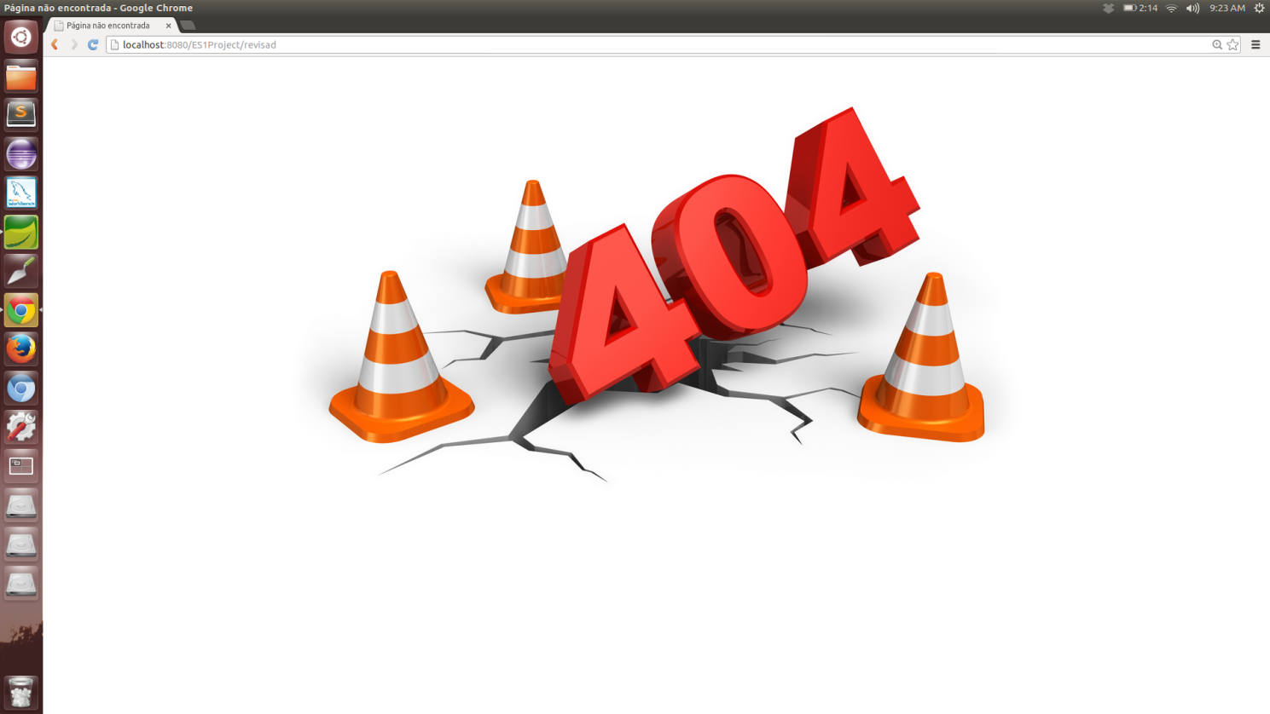

**formulario_revista.jsp :**

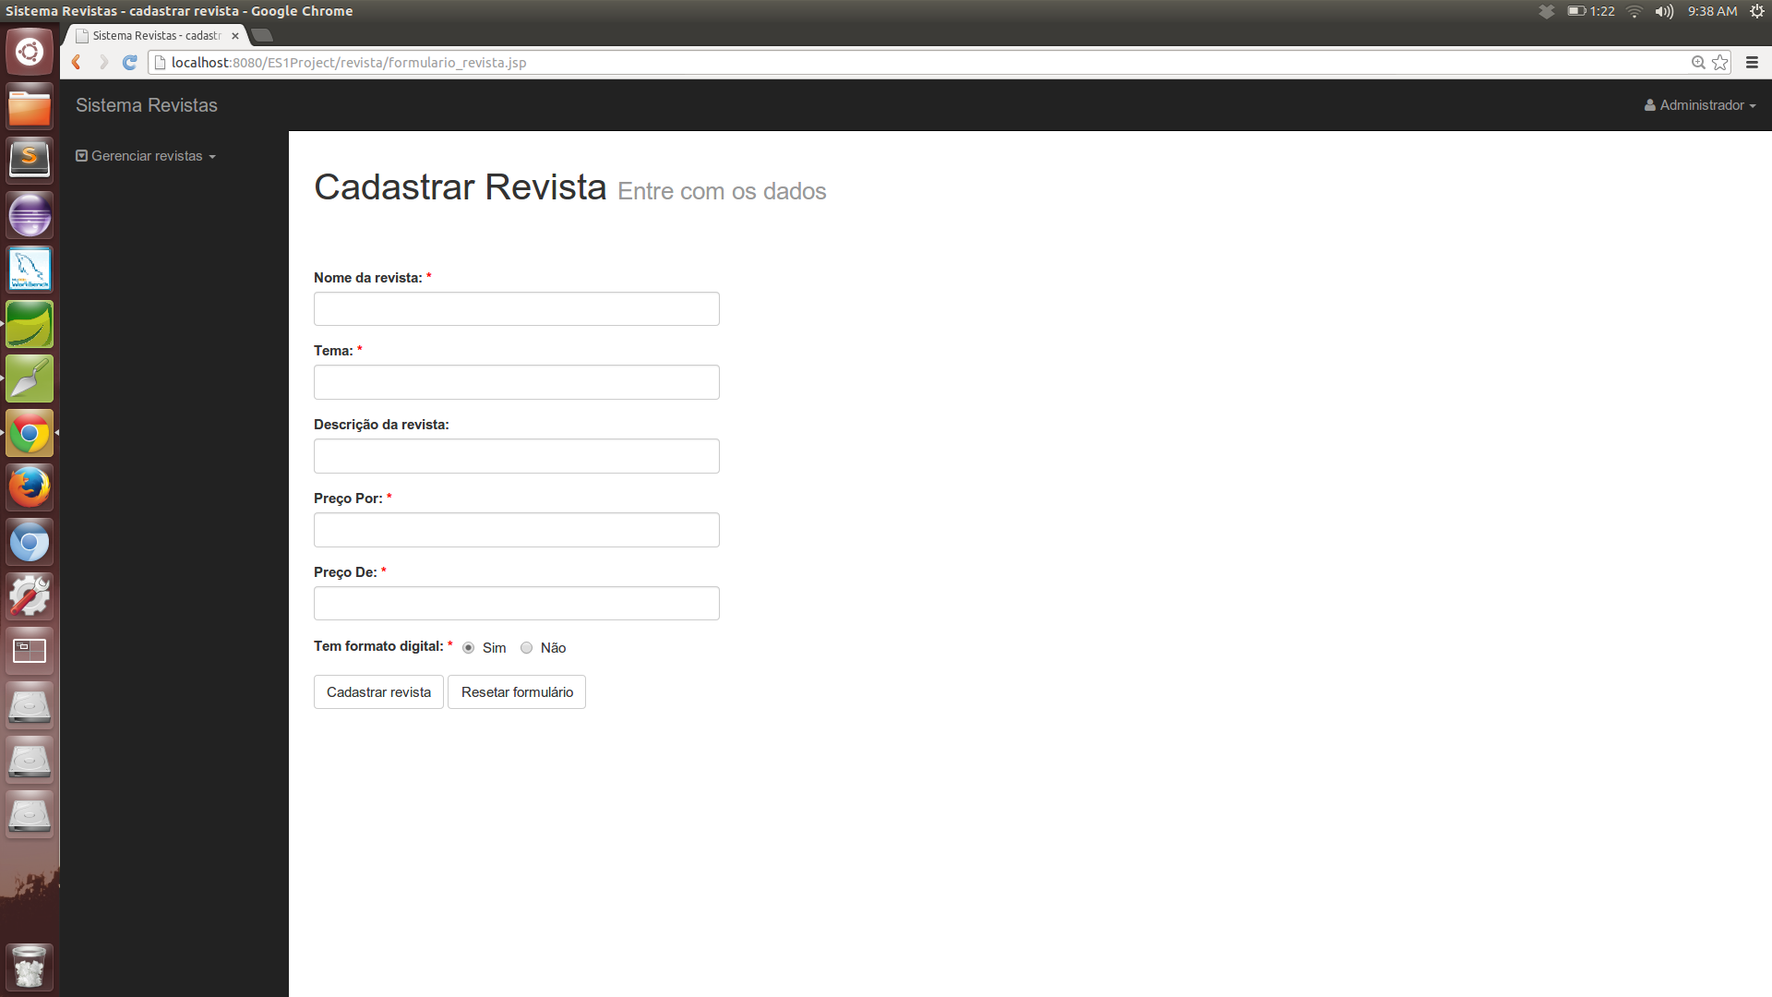

**formulario_revista.jsp – dados inválidos no cadastro:**

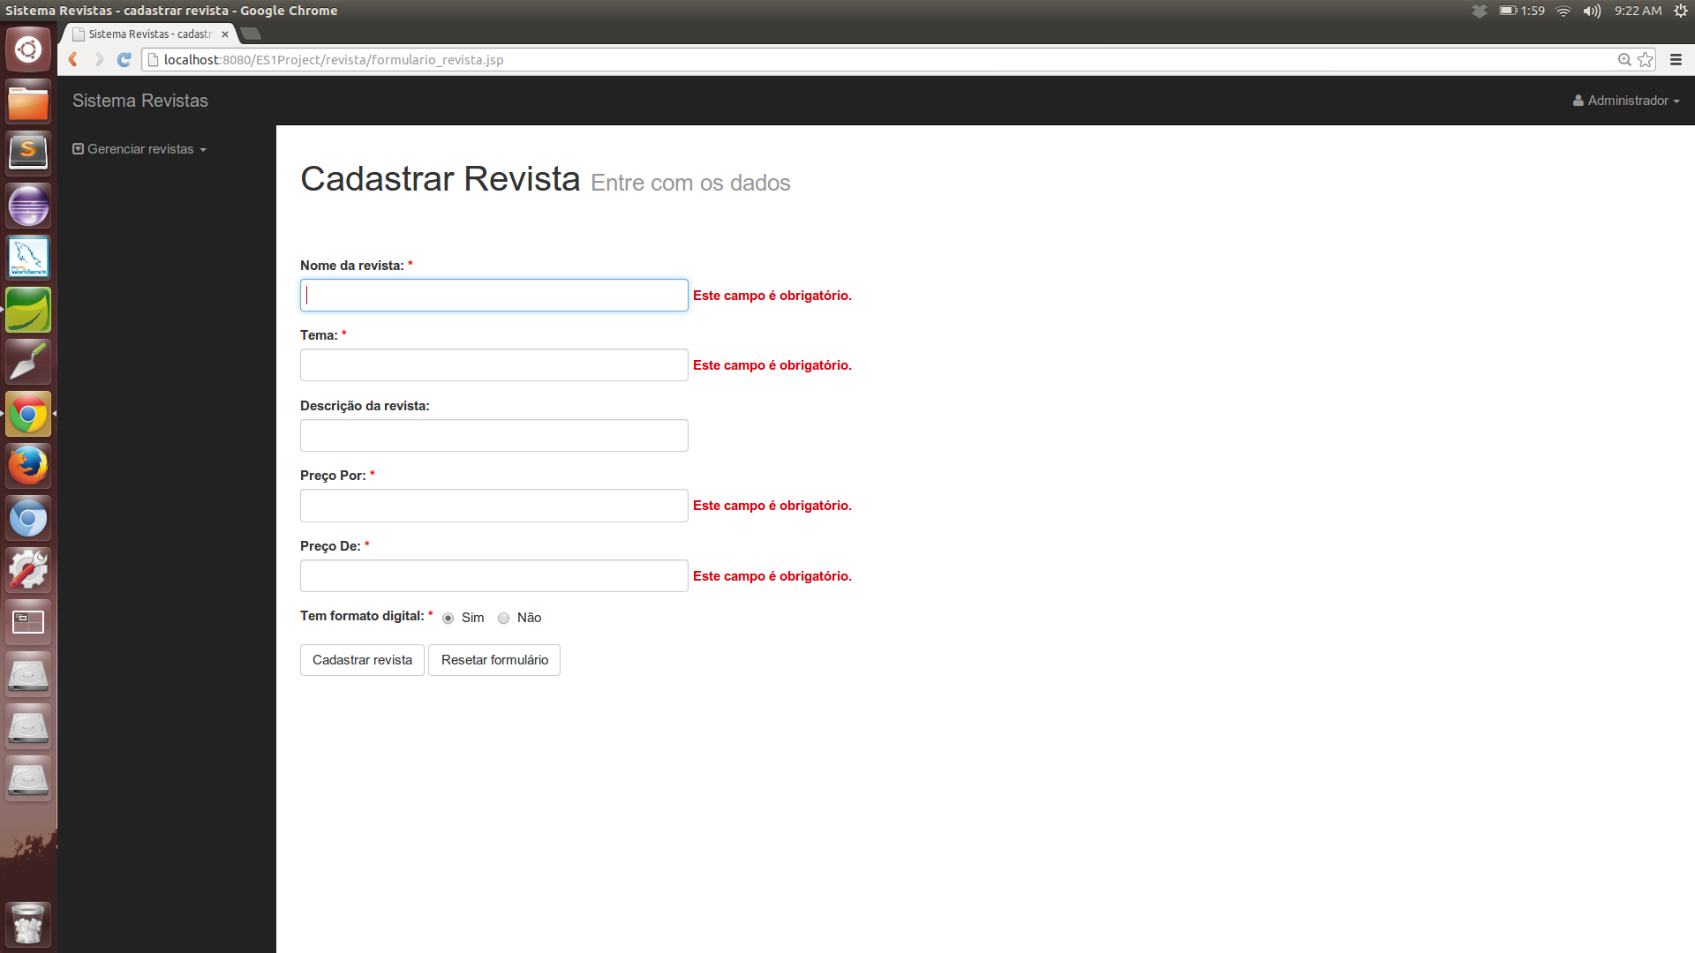

**formulario_revista.jsp – dados cadastro com sucesso:**

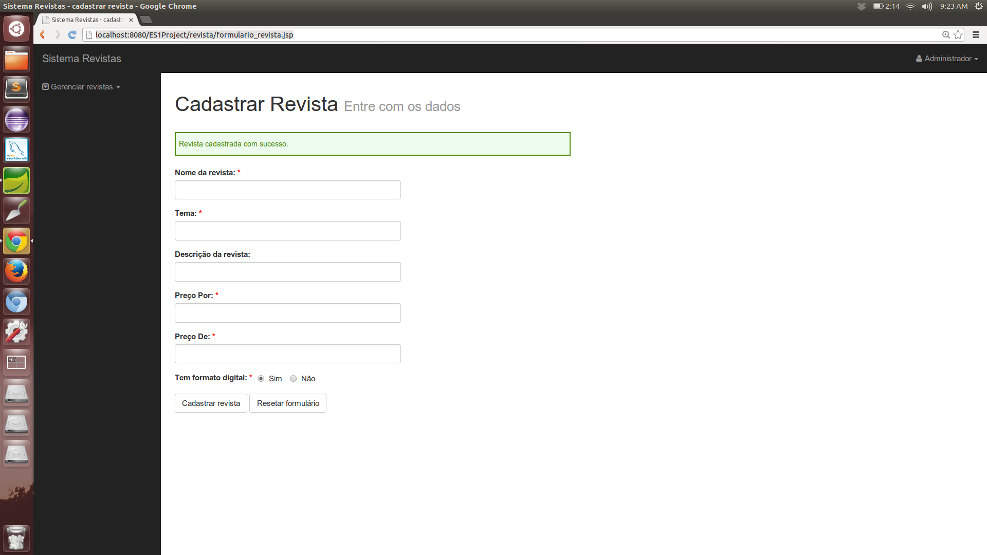

**editar_revista.jsp:**

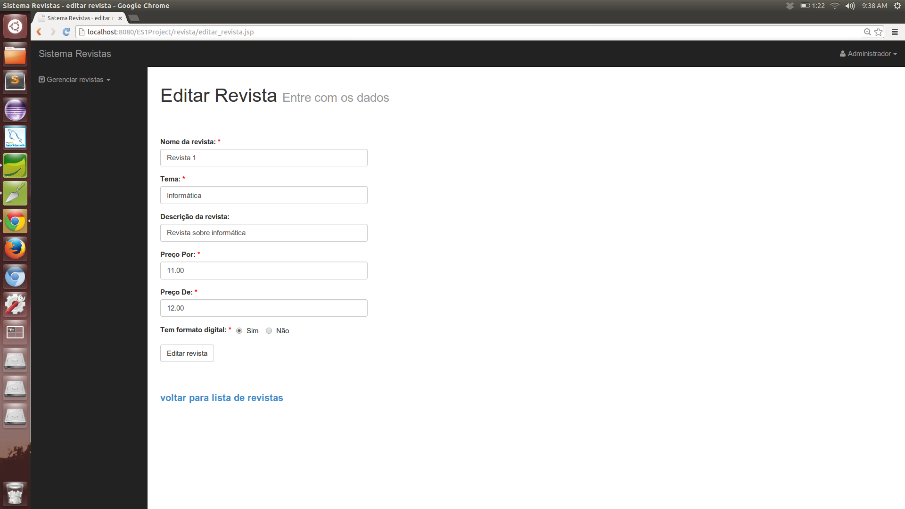

**editar_revista.jsp – dados inválidos a edição:**

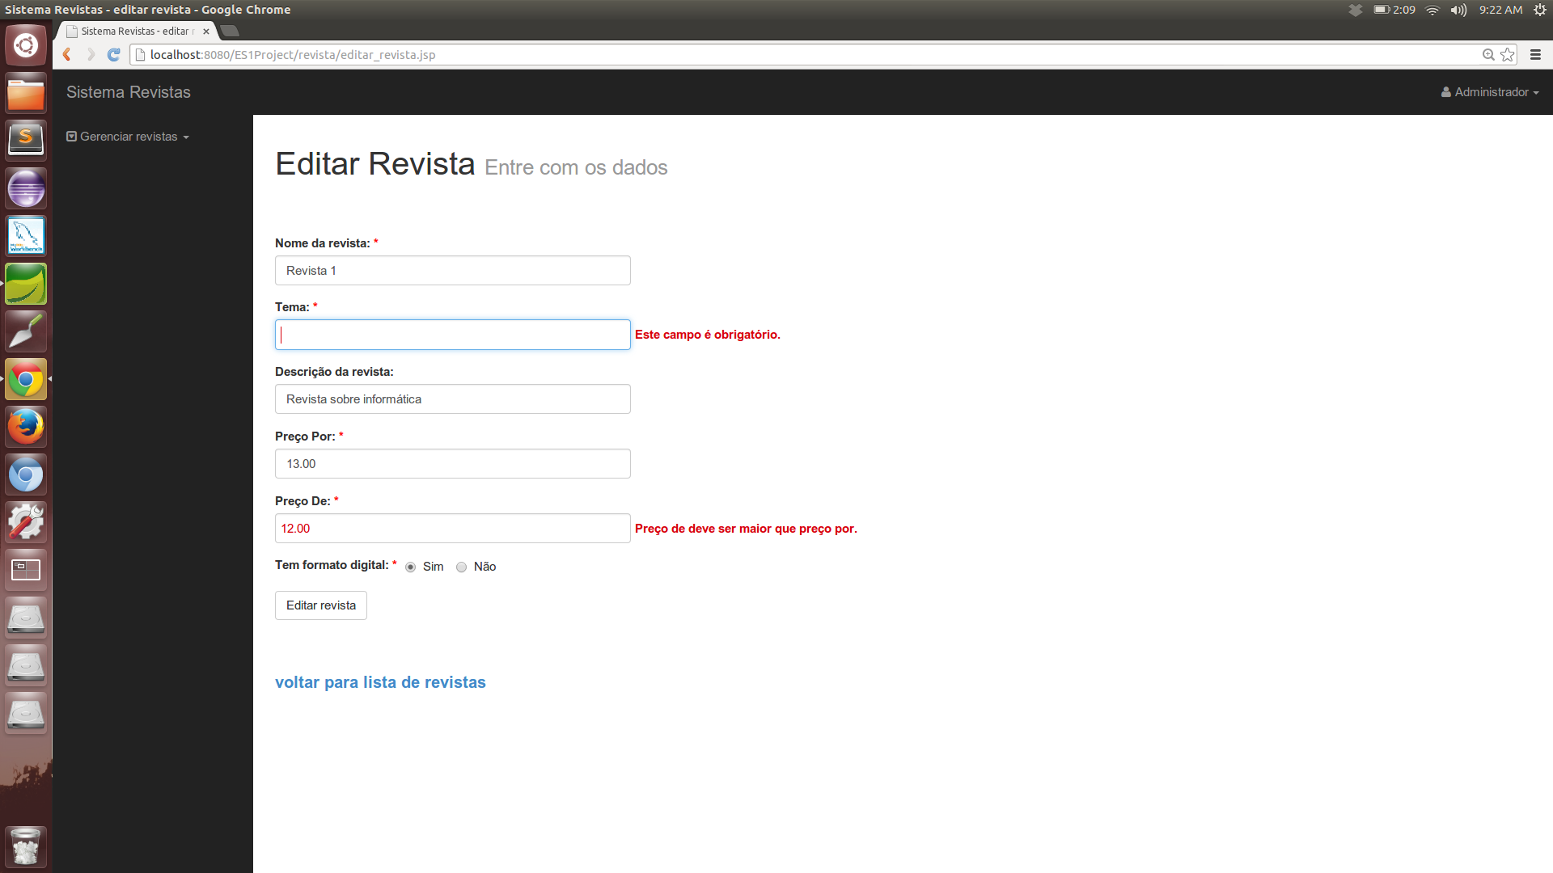

**editar_revista.jsp – edição realizada com sucesso:**

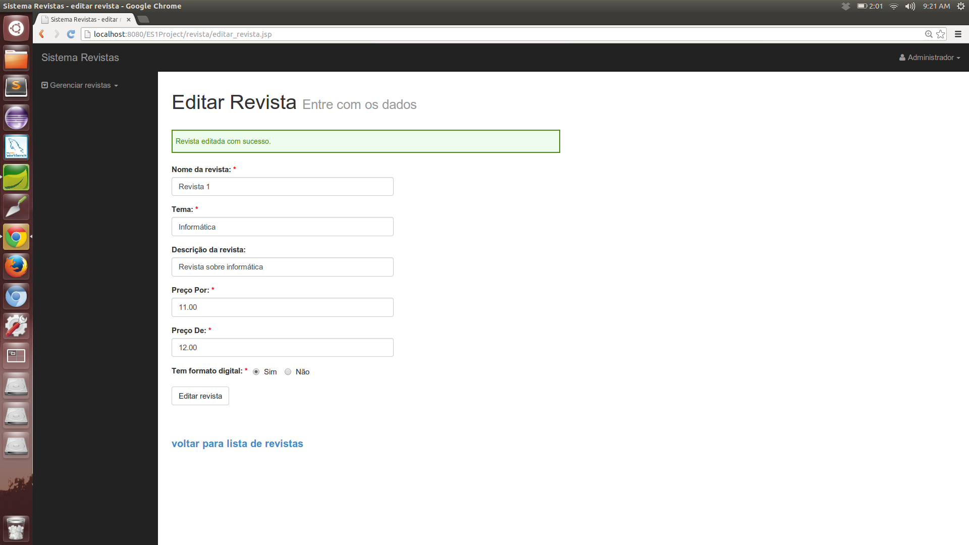

**lista_revista.jsp – lightbox com confirmação de exclusão de uma revista:**

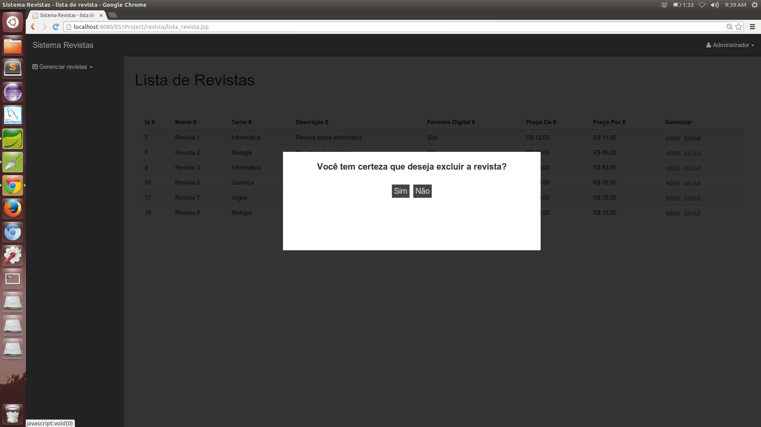

**lista_revista.jsp revista excluída com sucesso:**

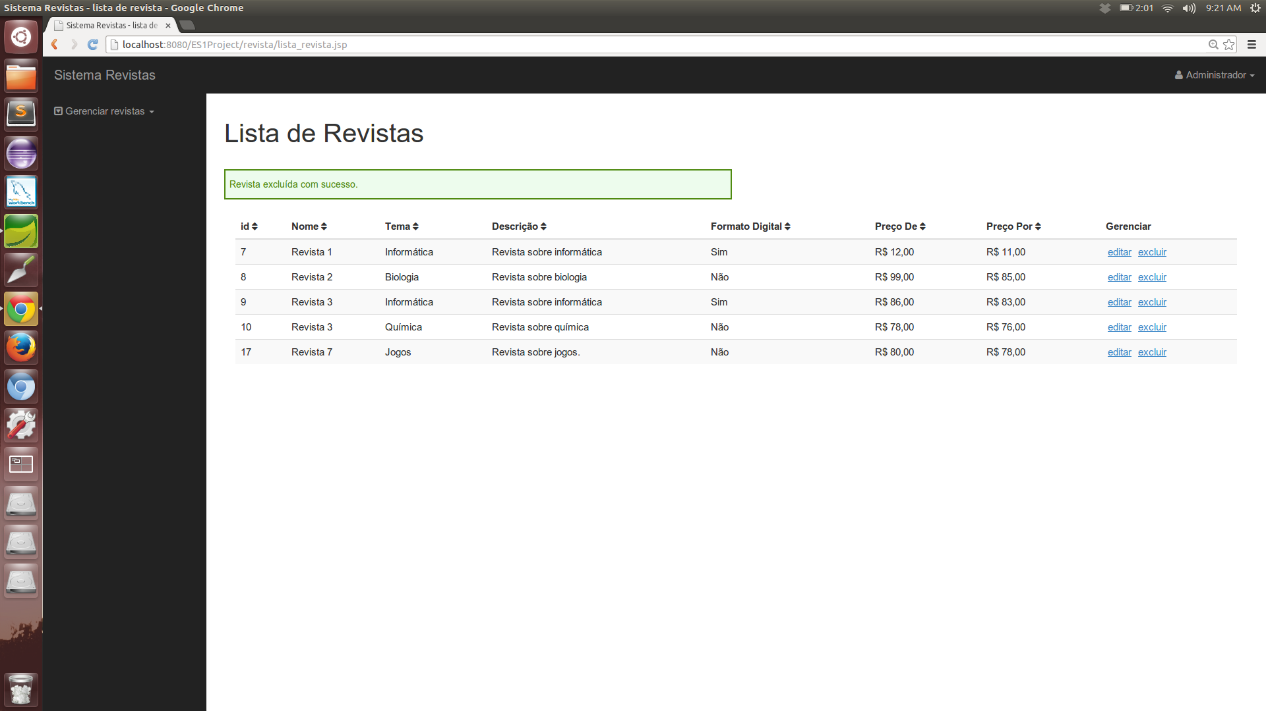

**lista_revista.jsp:**

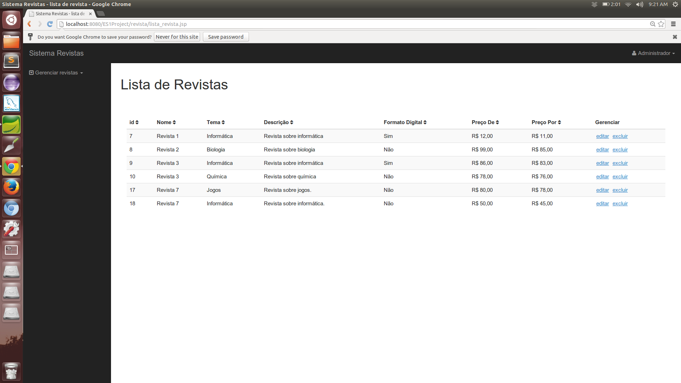

**login.jsp:**

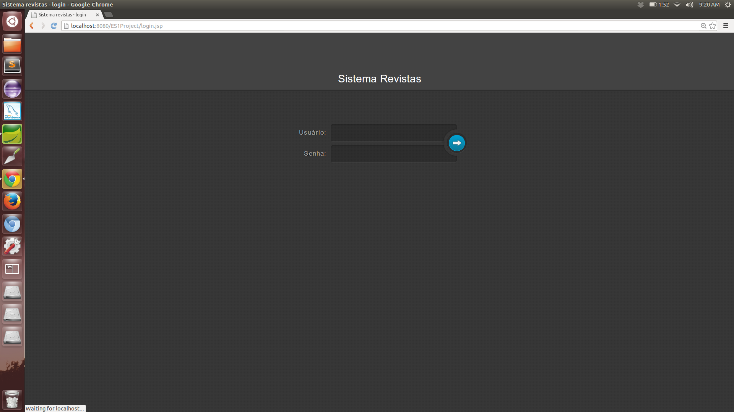

**login.jsp – nome de usuário ou senha inválidos:**

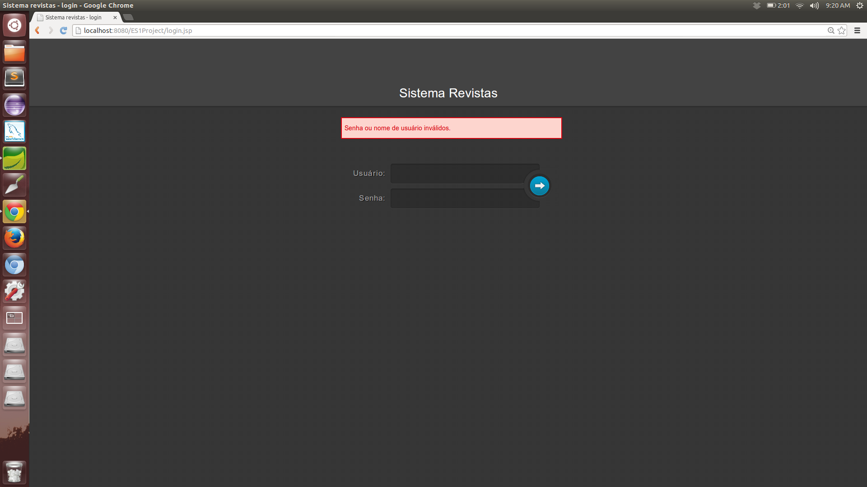

*Projeto de banco de dados:*

**Diagrama Lógico Relacional:**

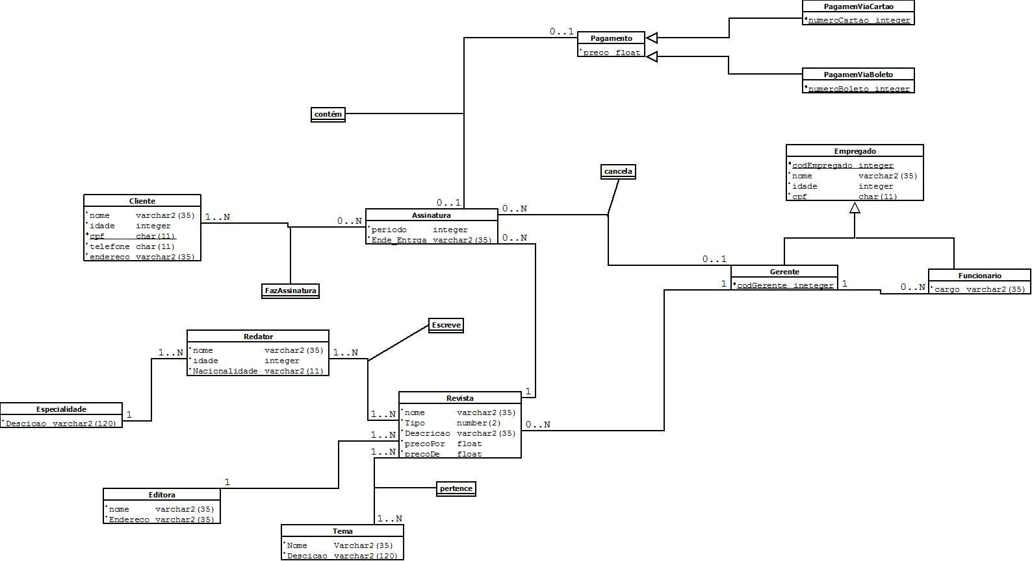

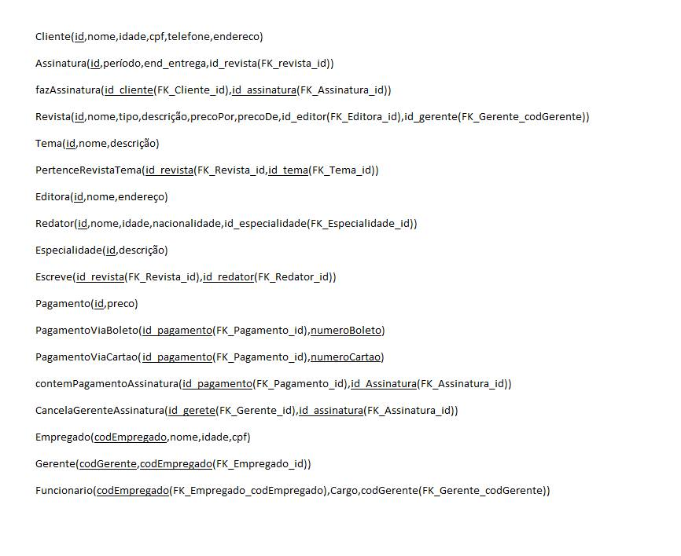

**Diagrama ER:**

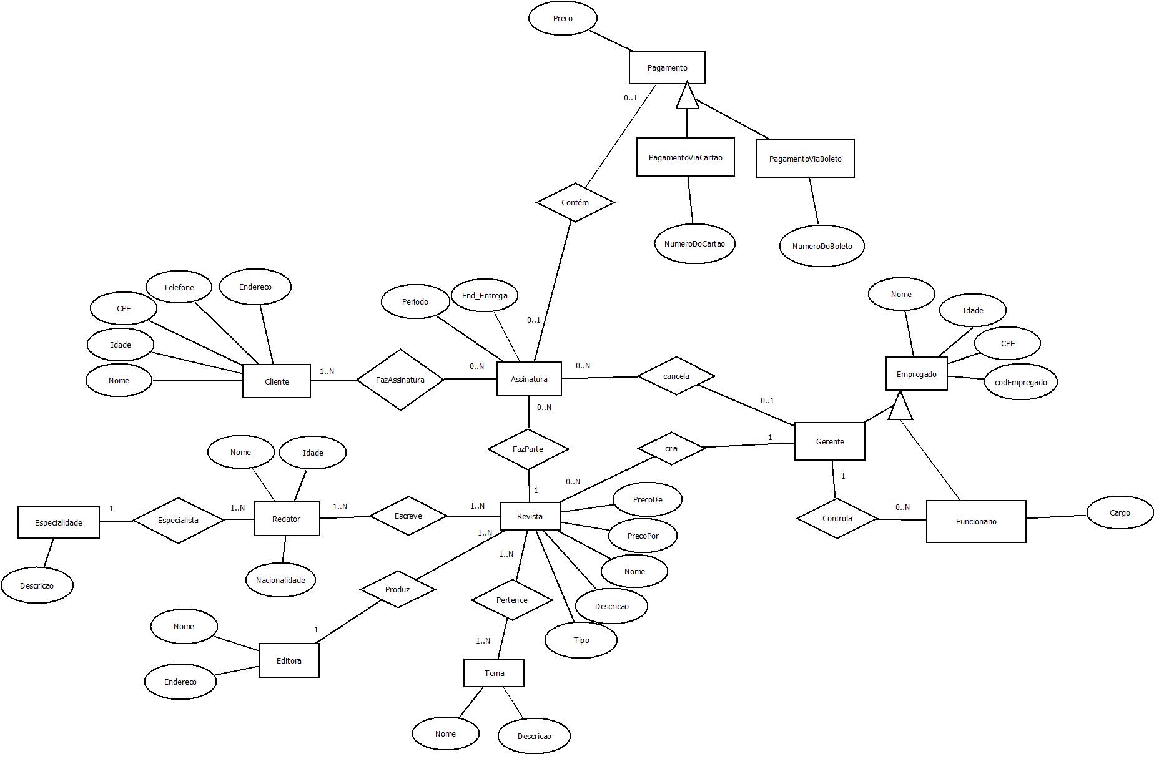

*Scripts SQL do banco:*

**Create or replace table cliente(**

**id:integer,**

**nome:varchar2(35) not null,**

**cpf: char(11) not null,**

**telefone: char(11) not null,**

**endereço: varchar2(35) not null,**

**constraint PK_cliente primary key (id)**

**);**

**create or replace table assinatura(**

**id: integer,**

**periodo: integer not null,**

**ende_entrega: varchar2(35) not null,**

**id_revista:integer not null,**

**constraint PK_assinatura primary key (id),**

**constraint FK_revista_id FOREIGN KEY (id_revista) REFERENCES revista(id)**

**);**

**create or replace table fazAssinatura(**

**id_revista: integer not null,**

**id_assinatura: integer not null,**

**constraint PK_fazAssinatura primary key (id_revista,id_assinatura),**

**constraint FK_revista_id FOREIGN KEY (id_revista) REFERENCES revista(id),**

**constraint FK_assinatura_id FOREIGN KEY (id_assinatura) REFERENCES assinatura(id)**

**);**

**create or replace table revista(**

**id:integer,**

**nome:varchar2(35) not null,**

**dercricao:varchar2(120) not null,**

**precoPor:float,**

**precoDe:float not null,**

**id_editor:integer not null,**

**id_gerente:integer not null,**

**constraint PK_revista primary key (id),**

**constraint FK_editora_id FOREIGN KEY (id_editor) REFERENCES editora(id),**

**constraint FK_gerente_id FOREIGN KEY (id_gerente) REFERENCES gerente(codGerente)**

**);**

**create or replace table tema(**

**id: integer,**

**nome:varchar2(35) not null,**

**descricao:varchar2(35) not null,**

**constraint PK_tema primary key (id)**

**);**

**create or replace table PertenceRevistaTema(**

**id_revista:integer,**

**id_tema:integer,**

**constraint PK_pertenceRevistaTema primary key (id_tema,id_revista),**

**constraint FK_revista_id FOREIGN KEY (id_revista) REFERENCES revista(id),**

**constraint FK_tema_id FOREIGN KEY (id_tema) REFERENCES tema(id)**

**);**

**create or replace table editora(**

**id:integer,**

**nome:varchar2(35) not null,**

**endereco:varchar2(35) not null,**

**constraint PK_editora primary key (id)**

**);**

**create or replace table redator(**

**id:integer,**

**nome: varchar2(35) not null,**

**nacionalidade: varchar2(35) not null,**

**id_especialidade: integer not null,**

**constraint PK_redator primary key (id),**

**constraint FK_especialidade_id FOREIGN KEY (id_especialidade) REFERENCES especialidade(id)**

**);**

**create or replace table especialidade(**

**id:integer,**

**descricao:varchar2(35),**

**constraint PK_especialidade primary key (id)**

**);**

**create or replace table escreve(**

**id_revista:integer,**

**id_redator:integer,**

**constraint PK_escreve primary key (id_redator,id_revista),**

**constraint FK_revista_id FOREIGN KEY (id_revista) REFERENCES revista(id),**

**constraint FK_redator_id FOREIGN KEY (id_redator) REFERENCES redator(id)**

**);**

**create or replace table pagamento(**

**id: integer,**

**preco: float,**

**constraint PK_pagamento primary key (id)**

**);**

**create or replace table pagamentoViaBoleto(**

**id_pagamento:integer,**

**numeroBoleto:integer,**

**constraint PK_pagamentoViaBoleto primary key (id_pagamento,numeroBoleto),**

**constraint FK_pagamento_id foreign key (id_pagamento) references pagamento(id)**

**);**

**create or replace table pagamentoViaCartao(**

**id_pagamento:integer,**

**numeroCartao:integer,**

**constraint PK_pagamentoViaCartao primary key (id_pagamento,numeroCartao),**

**constraint FK_pagamento_id foreign key (id_pagamento) references pagamento(id)**

**);**

**create or replace table contemPagamentoAssinatura(**

**id_pagamento:integer,**

**id_assinatura:integer,**

**constraint PK_contemPagamentoAssinatura primary key (id_pagamento,id_assinatura),**

**constraint FK_pagamento_id foreign key (id_pagamento) references pagamento(id),**

**constraint FK_assinatura_id foreign key (id_assinatura) references assinatura(id)**

**);**

**create or replace table cancelaGerenteAssinatura(**

**id_gerente:integer,**

**id_assinatura:integer,**

**constraint PK_cancelaGerenteAssinatura primary key (id_gerente,id_assinatura),**

**constraint FK_gerente_id foreign key (id_gerente) references gerente(codGerente),**

**constraint FK_assinatura_id foreign key (id_assinatura) references assinatura(id)**

**);**

**create or replace table empregado(**

**codEmpregado:integer,**

**nome:varchar2(35) not null,**

**idade:integer not null,**

**cpf:char(11) not null,**

**constraint PK_empregado primary key (codEmpregado)**

**);**

**create or replace table gerente(**

**codEmpregado:integer,**

**codGerente:integer,**

**constraint PK_gerente primary key (codEmpregado,codGerente),**

**constraint FK_Empregado_id foreign key (codEmpregado) references empregado(codEmpregado)**

**);**

**create or replace table funcionario(**

**codEmpregado:integer,**

**codFuncionario:integer,**

**cargo:varchar2(35) not null,**

**id_gerente:integer not null,**

**constraint PK_funcionario primary key (codEmpregado,codFuncionario),**

**constraint FK_Empregado_id foreign key (codEmpregado) references empregado(codEmpregado),**

**constraint FK_gerente_id foreign key (id_gerente) references gerente(codGerente)**

**);**

*Diagrama de Classes:*

**Gerado pelo Eclipse (STS):**

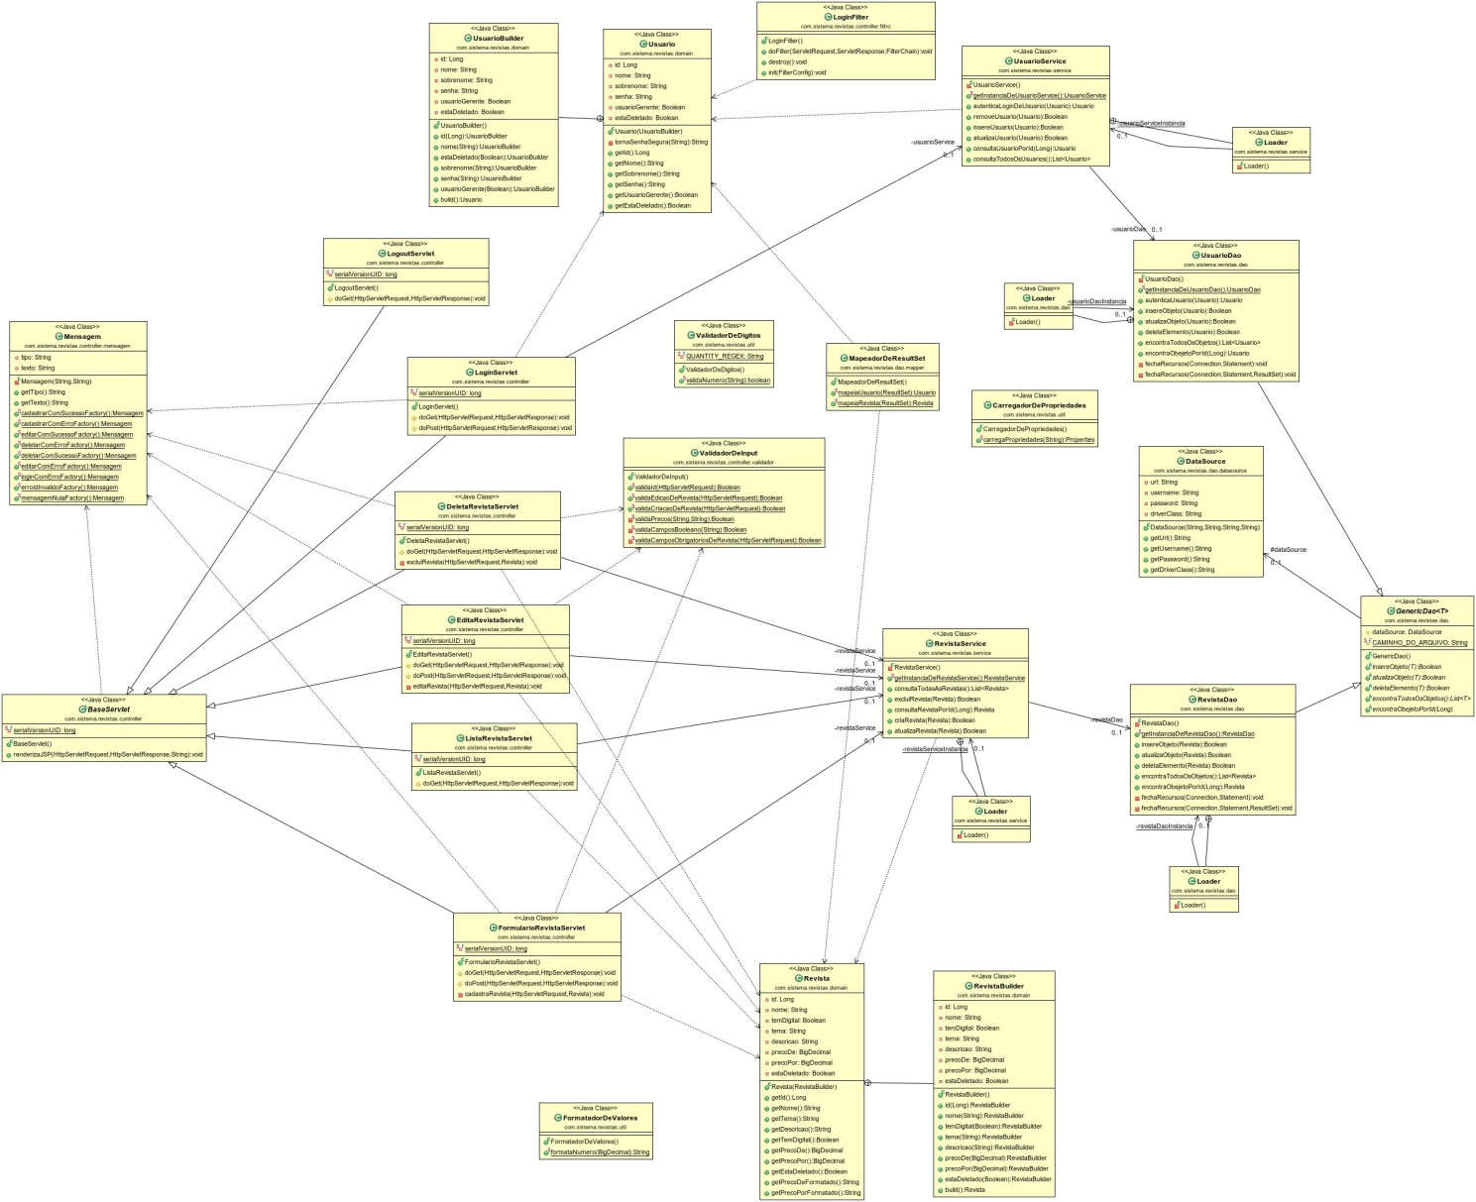

**Feito no Astah Professional:**

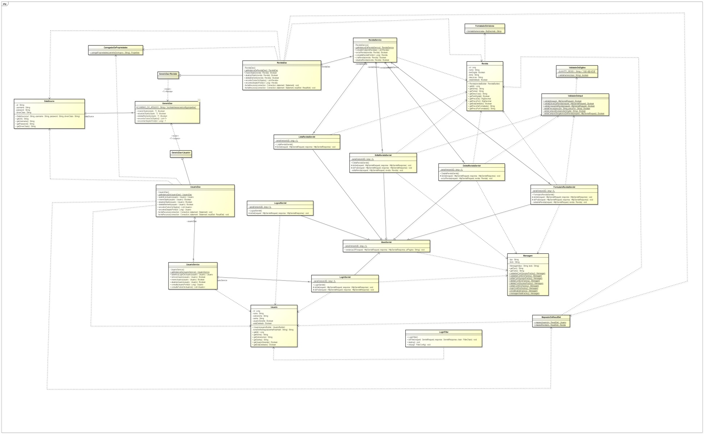

*Diagrama de Sequência – Criação de Revista*

*Cenário de Sucesso*

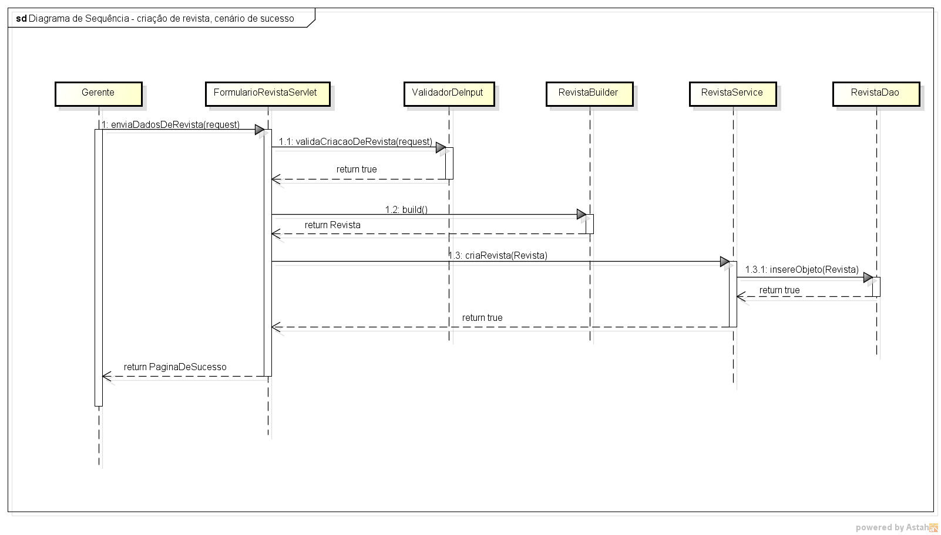

*Mais informações sobre o código fonte em:*

<https://github.com/LeonardoRamos/Trabalho-ES1>

*Descrição do caso de uso real:*

**- Cenário principal:**

1 - Gerente faz o login no sistema inserindo usuário e senha nos campos apresentados na primeira página do sistema.

2 - Sistema apresenta página lista de revistas mostrando uma lista com dados de cada revista e as opções de editar e excluir revista. Na página há o botão gerenciar revistas. Gerente clica em gerenciar revistas e seleciona a opção cadastrar revista.

3 – Sistema apresenta tela cadastrar revista.

4 - Gerente insere os dados da revista nos campos de cadastro da revista. Nome da Revista(String), Tema(String), Descrição da Revista(String), Preço por(Big Decimal), Preço de(Big Decimal), Tem formato digital (seleção).

5 – Gerente clica em cadastrar revista e o sistema gera uma mensagem de revista cadastrada com sucesso.

**- Cenário alternativo 1: Gerente insere dados de usuário e senha errados**

1 - Gerente faz o login no sistema inserindo usuário e senha nos campos apresentados na primeira página do sistema.

2- Ao validar dados de login, o sistema comunica um erro e apresenta uma mensagem de senha ou nome de usuário inválidos.

3 – Sistema se mantém na página de login.

**- Cenário alternativo 2: Gerente deixa campos em branco ao cadastrar revista**

1 - Gerente faz o login no sistema inserindo usuário e senha nos campos apresentados na primeira página do sistema.

2 - Sistema apresenta página lista de revistas mostrando uma lista com dados de cada revista e as opções de editar e excluir revista. Na página há o botão gerenciar revistas. Gerente clica em gerenciar revistas e seleciona a opção cadastrar revista.

3 – Sistema apresenta tela cadastrar revista.

4 - Gerente insere os dados da revista nos campos de cadastro da revista. Nome da Revista (String), Tema(String), Descrição da Revista(String), Preço por(Big Decimal), Preço de(Big Decimal), Tem formato digital (seleção).

5 – Ao validar os dados inseridos, o sistema comunica que todos os campos não foram preenchidos por meio da mensagem de campo obrigatório ao lado de cada campo não preenchido.

6 – Sistema se mantém na página de cadastro de revista.