The following script is used to extract metrics: main_live_script_ODSS.m, it has the following sub-scripts:

%interacts with engine to create circuit data structure

run_case1_MLX;

%creates the preliminary summary tables (one for lines and one for loads)

summarytable_ODSS_MLX;

%create the adjacency matrix

make_aMatrix_ODSS_MLX;

%calcs some metrics for transformers (downstream)

xformer_loads_ODSS_MLX;

%plots the feeder

plot_aMatrix_MLX;

%pulls the additional metrics/stats calculated into the summary tables

final_summarytable_ODSS_MLX;

%calcs the aggregate metrics

agg_metrics_shared_ODSS_MLX;

%saves summary statistics into an excel sheet

table_contents_ODSS_MLX;

%segregates and calculates feeder level metrics

Feeder_Level_Metrics;

%creates feederwise aggregate metrics

Format_Aggregate;

%creates system level aggregate metrics

System_Level;

* Before running the script we have to setup paths in the set_up1_MLX;
* Before running the scripts, check if any meter is placed at the starting of the system or else place a meter at the starting line/transformer of the feeder. This will helps in getting the distance of nodes/lines etc., from source.

**Extracting Feeder Level Metrics:**

**Method 1:** If nodes ID/names are provided per feeder, then these IDs are used to extract the feeder-wise metrics.

**Method 2:** Generally in most of the cases the node IDs/names corresponding to each feeder are not provided particularly in case of utility data sets, in this case with unknown node names per feeder this method can be used to extract metrics per feeder. This method is based on graph theory using tarjan’s algorithm and implemented as follows:

**Step-1**: Create an array of all node names (bus_names)

**Step-2:** Create node adjacency matrix (a_matrix) (1 if connected else 0)

**Step-3:** Check for any open switches and ensure that element of a_matrix for that open switch is 0

**Step-4:** Identify Substations (Transformers) based on:

1. Voltage range 2.4 to 38 kV (Lower and upper bound)
2. 3-Phase
3. Rating > 499 kVA

…any other condition can be included

**Step-5:** Identify secondary node name of substation (e.g SS2)

**Step-6:** Identify starting node names of all feeders leaving the substation i.e all 3-ph trunks leaving the substation (generally switches in between). (Feeder Starting node names: F1,F2,F3….etc)

**Step-6:** Make elements in adjacency matrix corresponding to SS2-F1, SS2-F2, SS2-F3 etc…. from 1 to 0 (basically disconnecting feeder from substation)

**Step-**7: Crosscheck for any loops and open switches by making the corresponding element in a_matrix as 0. (In RNM generated models the normally open switches are connected but their resistance is very high 1e11, this is to assume the switch is open but in the connectivity matrix it will be shown as connected so have to make this elements 0)

**Step-8:** Find strongly or weakly connected components in graph using tarjan algorithm or “*graphconncomp”* MATLAB inbuilt function. Which will group nodes based on connectivity, since all nodes downstream of Feeder starting node F1 is disconnected from substation they are grouped together like wise for other feeders also. Using this nodes in each feeder can be identified. If there are 10 feeders we will get 11 groups of nodes i.e 1 node group per feeder and 1 node group for nodes upstream of substation mostly HV/MV nodes.

Example: https://www.mathworks.com/help/bioinfo/ref/graphconncomp.html

**Step-8:** Based on identified feeder wise nodes any other required feeder wise data can be extracted.

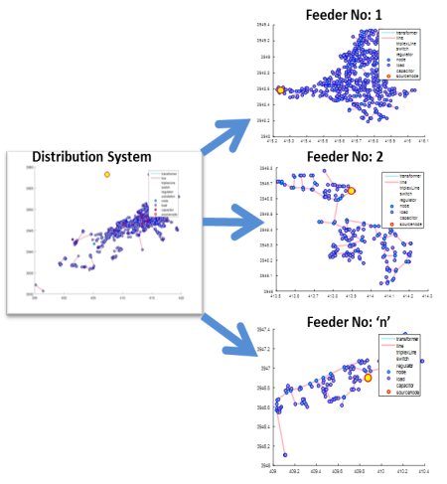

**Explanation of Feeder Wise Metrics:**

|  |
| --- |
| Feeder_Number |
| Substation_Name |
| Substation_Capacity_MVA |
| Substation_Type |
| Distribution_Tranformer_Total_Capacity_MVA |
| No_of_Distribution_Transformer |
| No_of_Customers |
| Ratio_1phto3ph_Xfrm |
| lv_length_miles |
| mv_length_miles |
| furtherest_node_miles |
| Length_mv3ph_miles |
| Length_OH_mv3ph_miles |
| Length_mv2ph_miles |
| Length_OH_mv2ph_miles |
| Length_mv1ph_miles |
| Length_OH_mv1ph_miles |
| Length_lv3ph_miles |
| Length_OH_lv3ph_miles |
| Length_lv1ph_miles |
| Length_OH_lv1ph_miles |
| lv_ph_A_load_kw_percentage |
| lv_ph_B_load_kw_percentage |
| lv_ph_C_load_kw_percentage |
| Total_Demand_kW |
| Total_Reactive_Power_kVAr |
| No_Loads_LV_1ph |
| No_Loads_LV_3ph |
| No_Loads_MV_3ph |
| No_Loads_per_Xfrm |
| No_of_Regulators |
| No_of_CapacitorBanks |
| No_of_Boosters |
| NominalVoltage_HV_kV |
| NominalVoltage_MV_kV |
| NominalVoltage_LV_kV |
| No_of_Fuses |
| No_of_Reclosers |
| No_of_Sectionalizers |
| No_of_Switches |
| No_of_Breakers |
| No_of_Interruptors |
| Avg_Degree |
| Char_Path_Length |
| Graph_Diameter |