Computing attributes of networks in Open DSS format.

Claudio Vergara, June 23, 2017.

1. Set the current directory in Matlab to *...\SMART-DS\Network_Characterization\ODSS\scripts*
2. Open the file set_up1_MLX.mlx in the folder *SMART-DS\Network_Characterization\ODSS\scripts*
3. Enter the path to the code and the data. Matlab bgl is a free package of functions to analyze graphs <https://www.mathworks.com/matlabcentral/fileexchange/10922-matlabbgl>

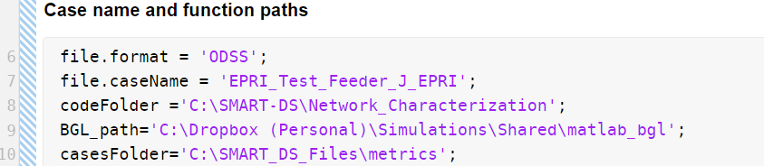

The scripts assume a certain structure for the folders that contain input files, and the existence of the RunDSS.dss main file.

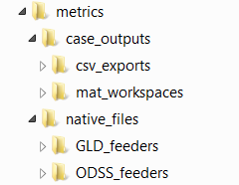 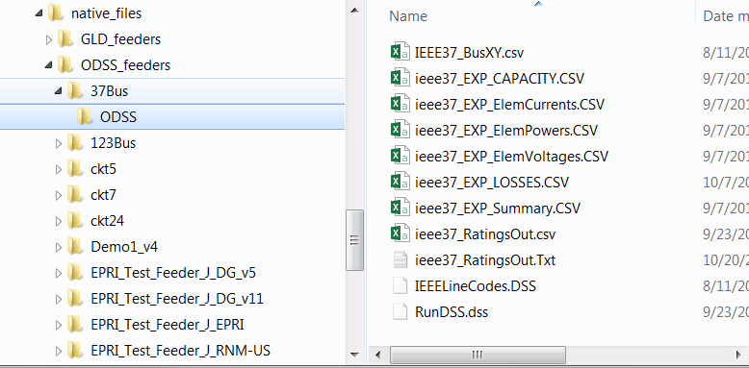

1. Execute the file *main_live_script_ODSS.m.* This will save a number of csv files and matlab workspaces in the corresponding output directory

