Modeling tools to guide Asli’s experiments

# TetR module

## Goal

## Model formulation

Write most complex model including all modules measured



## Parameter values and bounds

|  |  |  |  |  |  |
| --- | --- | --- | --- | --- | --- |
| Fixed parameters | | | | | |
| name | description | unit | value | Reference or calculation details | |
| d | Dilution by growth | 1/min | 0.0077 | ln(2)/90 | |
|  |  |  |  |  | |
|  |  |  |  |  | |
|  |  |  |  |  | |
| Estimated parameters | | | | | |
| name | description | unit | Best fit value | Min bound used for opt | Max bound |
|  | TetR repression threshold | nM | 35 | 0.1 | 1000 |
|  |  |  |  |  |  |

## Data/experiment description

## Optimization results

### Best fit

Figure with legend

Generated by function/script …

### Parameter space

Figure with legend

Generated by function/script …

## Conclusions

# LacI module (LacI WT)

## Goal

## Model formulation

Write most complex model including all modules measured

$$\frac{dLacI}{dt}=PAct1_{LacI}-\left(dLacI+mu\right)*LacI$$

$$\frac{dCitrimmature}{dt}=P4Lacn_{cit}*\frac{(PAct1_{LacI_{L}}+\left(1-PAct1_{LacI_{L}}\right)}{(1+(LacIfree/{\left(LacI_{rep_{Cit}}\right)}^{nLaci}}-\left(dCit+ mu\right)* Citimmature$$

$$\frac{dCitrine}{dt}=kmaturation*Citimmature-\left(dCit+mu\right)*Citrine$$

$$LacIfree= \frac{LacI}{2}- \frac{KdLacI_{InUnit}}{2}- \frac{IPTG_{InUnit}}{2}+ \sqrt{\frac{KdLacI_{InUnit}^{2}+2*KdLacI_{InUnit}*IPTG_{InUnit}+LacI^{2}-2*LacI*IPTG_{InUnit}+IPTG_{InUnit}^{2}}{2}}$$

## Parameter values and bounds

|  |  |  |  |  |  |
| --- | --- | --- | --- | --- | --- |
| Fixed parameters | | | | | |
| name | description | unit | value | Reference or calculation details | |
| IPTG | Inducer added | nmolar | 0 - 200000000 |  | |
| indTime | Induction time | Min | 0 – 5000 |  | |
| Mu | Basal degredation rate | 1/min | 0.0077 |  | |
|  |  |  |  |  | |
| Estimated parameters | | | | | |
| name | description | unit | Best fit value | Min bound used for opt | Max bound |
| Pact1_LacI | LacI production rate | (molarity)/minute |  | 0.01 | 100 |
| P4Lacn_cit | Citrine production rate | (molarity)/minute |  | 0.01 | 100 |
| dLacI | LacI concentration change | 1/minute |  | 0.0001 | 1 |
| dCit | Citrine concentration change | 1/minute |  | 0.0001 | 1 |
| KdLacI | K LacI | Mole/liter |  | 0.005 | 1000 |
| nLacI | Hill constant | Dimensionless |  | 1 | 5 |
| Pact1_LacI_L | Leakage term | Dimensionless |  | 0.00001 | 0.01 |
| LacI_rep_cit | Repression coefficient | Molarity |  | 0.001 | 100 |
| nMperUnit | Scaling factor | Dimensionless |  | 0.01 | 10 |

## Data/experiment description

## Optimization results

### Best fit

Figure with legend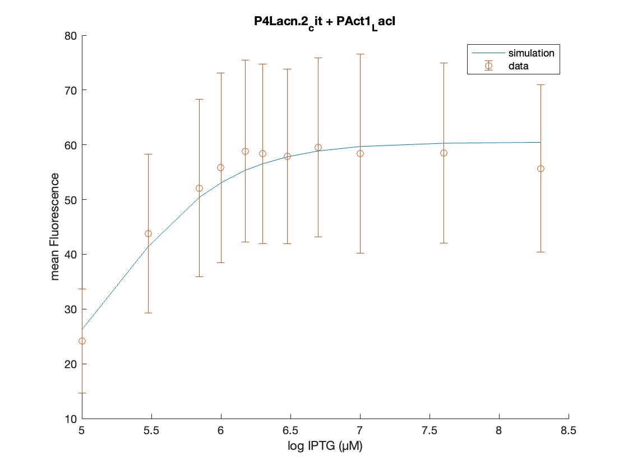

Generated by function/script main_LacI

### Parameter space

Figure with legend

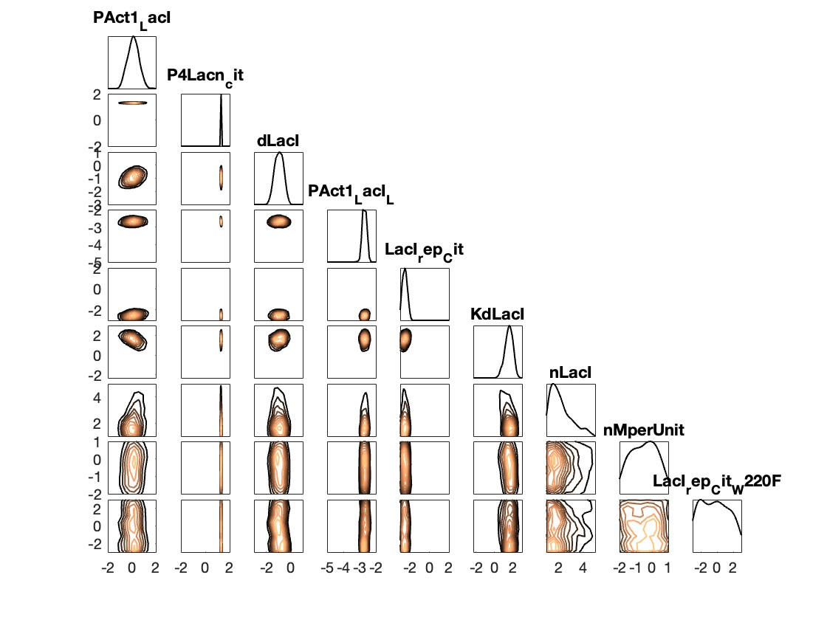

Generated by function/script …

## Conclusions

# LacI module (LacI WT + LacI(W220F))

## Goal

## Model formulation

Write most complex model including all modules measured

$$\frac{dLacI}{dt}=PAct1_{LacI}-\left(dLacI+mu\right)*LacI$$

$$\frac{dCitrimmature}{dt}=P4Lacn_{cit}*\frac{(PAct1_{LacI_{L}}+\left(1-PAct1_{LacI_{L}}\right)}{(1+(LacIfree/{\left(LacI_{rep_{Cit}}+LacI_rep_Cit_{W220F}\right)}^{nLaci}}-\left(dCit+ mu\right)* Citimmature$$

$$\frac{dCitrine}{dt}=kmaturation*Citimmature-\left(dCit+mu\right)*Citrine$$

$$LacIfree= \frac{LacI}{2}- \frac{KdLacI_{InUnit}}{2}- \frac{IPTG_{InUnit}}{2}+ \sqrt{\frac{KdLacI_{InUnit}^{2}+2*KdLacI_{InUnit}*IPTG_{InUnit}+LacI^{2}-2*LacI*IPTG_{InUnit}+IPTG_{InUnit}^{2}}{2}}$$

## Parameter values and bounds

|  |  |  |  |  |  |
| --- | --- | --- | --- | --- | --- |
| Fixed parameters | | | | | |
| name | description | unit | value | Reference or calculation details | |
| IPTG | Inducer added | nmolar | 0 - 200000000 |  | |
| indTime | Induction time | Min | 0 – 5000 |  | |
| Mu | Basal degredation rate | 1/min | 0.0077 |  | |
|  |  |  |  |  | |
| Estimated parameters | | | | | |
| name | description | unit | Best fit value | Min bound used for opt | Max bound |
| Pact1_LacI | LacI production rate | (molarity)/minute |  | 0.01 | 100 |
| P4Lacn_cit | Citrine production rate | (molarity)/minute |  | 0.01 | 100 |
| dLacI | LacI concentration change | 1/minute |  | 0.0001 | 1 |
| dCit | Citrine concentration change | 1/minute |  | 0.0001 | 1 |
| KdLacI | K LacI | Mole/liter |  | 0.005 | 1000 |
| nLacI | Hill constant | Dimensionless |  | 1 | 5 |
| Pact1_LacI_L | Leakage term | Dimensionless |  | 0.00001 | 0.01 |
| LacI_rep_cit_W220F) | Repression coefficient (mutation W220F) | Molarity |  | 0.001 | 100 |
| nMperUnit | Scaling factor | Dimensionless |  | 0.01 | 10 |
| LacI_rep_cit | Repression coefficient WT | Molarity |  | 0.001 | 100 |

## Data/experiment description

## Optimization results

### Best fit

Figure with legend

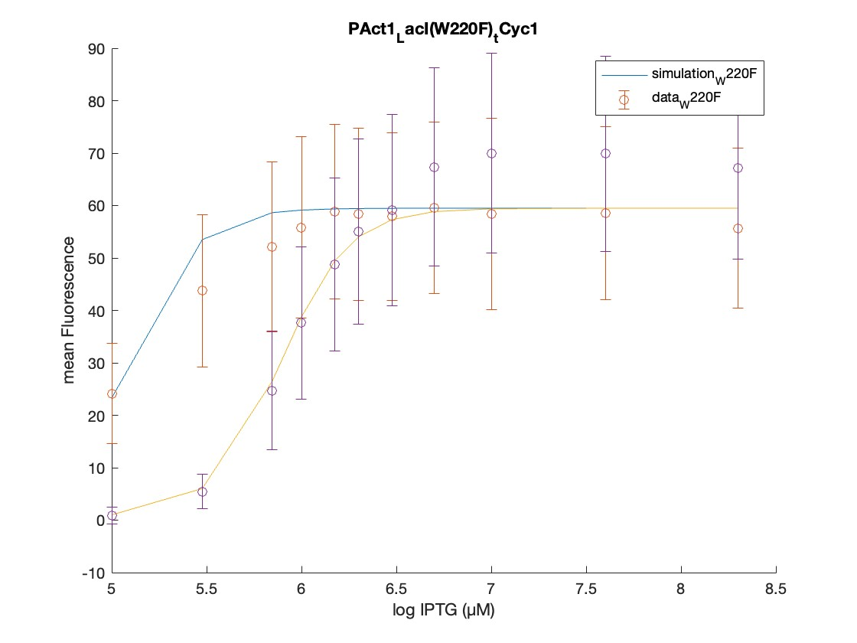

Generated by function/script main_LacI_1

### Parameter space

Figure with legend

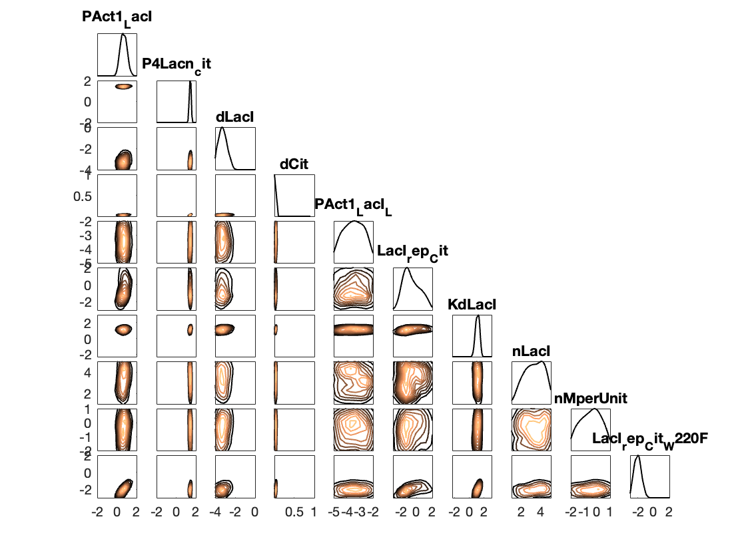

Generated by function/script …

## Conclusions

* Fit ok for low IPTG concentrations
* Less well for hight IPTG concentrations