 | Wooby  daffra.claudio@gmail.com
Wisual Object Oriented Beginner Yet !

EDITOR

Ctrl-F / Cmd-F | Start searching
Ctrl-G / Cmd-G | Find next
Shift-Ctrl-G / Shift-Cmd-G | Find previous
Shift-Ctrl-F / Cmd-Option-F | Replace
Shift-Ctrl-R / Shift-Cmd-Option-F | Replace all
Alt-F | Persistent search (dialog doesn't autoclose, enter to find next, Shift-Enter to find previous)
Alt-G | Jump to line

SELECT

TAG | Match Tag | </...>
{ | Match curly braces | }
[ | Match square bracket | ]
( | Match round bracket | )

Commands

Commands are parameter-less actions that can be performed on an editor. Their main use is for key bindings. Commands are defined by adding properties to the CodeMirror.commands object. A number of common commands are defined by the library itself, most of them used by the default key bindings. The value of a command property must be a function of one argument (an editor instance). Some of the commands below are referenced in the default key map, but not defined by the core library. These are intended to be defined by user code or addons.
Commands can also be run with the execCommand method.

SelectAll  Ctrl-A (PC), Cmd-A (Mac) | Select the whole content of the editor.
SingleSelection  Esc | When multiple selections are present, this deselects all but the primary selection.
KillLine  Ctrl-K (Mac) | Emacs-style line killing. Deletes the part of the line after the cursor. If that consists only of whitespace, the newline at the end of the line is also deleted.
DeleteLine  Ctrl-D (PC), Cmd-D (Mac) | Deletes the whole line under the cursor, including newline at the end.
DelLine  LeftCmd-Backspace (Mac) | Delete the part of the line before the cursor.
Undo  Ctrl-Z (PC), Cmd-Z (Mac) | Undo the last change.
Redo  Ctrl-Y (PC), Shift-Cmd-Z (Mac), Cmd-Y (Mac) | Redo the last undone change.
UndoSelection  Ctrl-U (PC), Cmd-U (Mac) | Undo the last change to the selection, or if there are no selection-only changes at the top of the history, undo the last change.
RedoSelection  Alt-U (PC), Shift-Cmd-U (Mac) | Redo the last change to the selection, or the last text change if no selection changes remain.
GoDocStart  Ctrl-Up (PC), Cmd-Up (Mac) | Move the cursor to the start of the document.
GoDocEnd  Ctrl-Down (PC), Cmd-End (Mac), Cmd-Down (Mac) | Move the cursor to the end of the document.
GoLineStart  Alt-Left (PC), Cmd-Left (Mac), Ctrl-A (Mac) | Move the cursor to the start of the line.

GoLineStartSmart  Home | Move to the start of the text on the line, or if we are already there, to the actual start of the line (including whitespace).
GoLineEnd  Alt-Right (PC), Cmd-Right (Mac), Ctrl-E (Mac) | Move the cursor to the end of the line.
goLineLeft | Move the cursor to the left side of the visual line it is on. If this line is wrapped, that may not be the start of the line.
goLineRight | Move the cursor to the right side of the visual line it is on.
GoLineUp  Up, Ctrl-P (Mac) | Move the cursor up one line.
GoLineDown  Down, Ctrl-N (Mac) | Move down one line.
GoPageUp  PageUp, Shift-Ctrl-V (Mac) | Move the cursor up one screen, and scroll up by the same distance.
GoPageDown  PageDown, Ctrl-V (Mac) | Move the cursor down one screen, and scroll down by the same distance.
GoCharLeft  Left, Ctrl-B (Mac) | Move the cursor one character left, going to the previous line when hitting the start of line.
GoCharRight  Right, Ctrl-F (Mac) | Move the cursor one character right, going to the next line when hitting the end of line.
goColumnLeft | Move the cursor one character left, but don't cross line boundaries.
goColumnRight | Move the cursor one character right, don't cross line boundaries.
GoWordLeft  Alt-B (Mac) | Move the cursor to the start of the previous word.
GoWordRight  Alt-F (Mac) | Move the cursor to the end of the next word.
GoGroupLeft  Ctrl-Left (PC), Alt-Left (Mac) | Move to the left of the group before the cursor. A group is a stretch of word characters, a stretch of punctuation characters, a newline, or a stretch of more than one whitespace character.
GoGroupRight  Ctrl-Right (PC), Alt-Right (Mac) | Move to the right of the group after the cursor (see above).
DelCharBefore  Shift-Backspace, Ctrl-H (Mac) | Delete the character before the cursor.
DelCharAfter  Delete, Ctrl-D (Mac) | Delete the character after the cursor

DelWordBefore  Alt-Backspace (Mac) | Delete up to the start of the word before the cursor.
DelWordAfter  Alt-D (Mac) | Delete up to the end of the word after the cursor.
DelGroupBefore  Ctrl-Backspace (PC), Alt-Backspace (Mac) | Delete to the left of the group before the cursor.
DelGroupAfter  Ctrl-Delete (PC), Ctrl-Alt-Backspace (Mac), Alt-Delete (Mac) | Delete to the start of the group after the cursor.
IndentAuto  Shift-Tab | Auto-indent the current line or selection.
IndentMore  Ctrl-] (PC), Cmd-] (Mac) | Indent the current line or selection by one indent unit.
IndentLess  Ctrl-[ (PC), Cmd-[ (Mac) | Dedent the current line or selection by one indent unit.
insertTab | Insert a tab character at the cursor
insertSoftTab | Insert the amount of spaces that match the width a tab at the cursor position would have.
DefaultTab  Tab | If something is selected, indent it by one indent unit. If nothing is selected, insert a tab
character.transpose Chars  Ctrl-T (Mac) | Swap the characters before and after the cursor.
Newline  AndIndentEnter | Insert a newline and auto-indent the new line.
Toggle  OverwriteInsert | Flip the overwrite flag.
Save  Ctrl-S (PC), Cmd-S (Mac) | Not defined by the core library, only referred to in key maps. Intended to provide an easy way for user code to define a save command.
Find  Ctrl-F (PC), Cmd-F (Mac) | Find
FindNext  Ctrl-G (PC), Cmd-G (Mac) | Find Next
FindPrev  Shift-Ctrl-G (PC), Shift-Cmd-G (Mac) | Find Prev
Replace  Shift-Ctrl-F (PC), Cmd-Alt-F (Mac) | Replace
ReplaceAll Shift-Ctrl-R (PC), Shift-Cmd-Alt-F (Mac) | Replace All

Wb Mini Editor

Html Selection, works with <p> inside only.
You can use these keys on selected text.
Key on Selected Text : activate key editor property
Key again on selected Text : deactivate key editor property.

Key | Function
b | Bold
u | Underline
i | Italic
S | Stroke
+ | Sup / Apice
- | Sub / Pedice
q | Quote

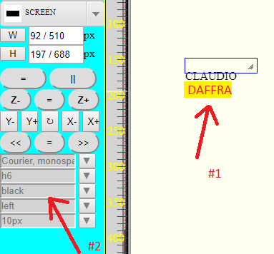

#1 : Html Selection

#2 : Nav editor Menu

This command works with nav menu on left only.

Key | Function
a | A lign
c | Color
k | Background – Color
f | Font Family
h | Header
t | Padding 10%
z | Font Size

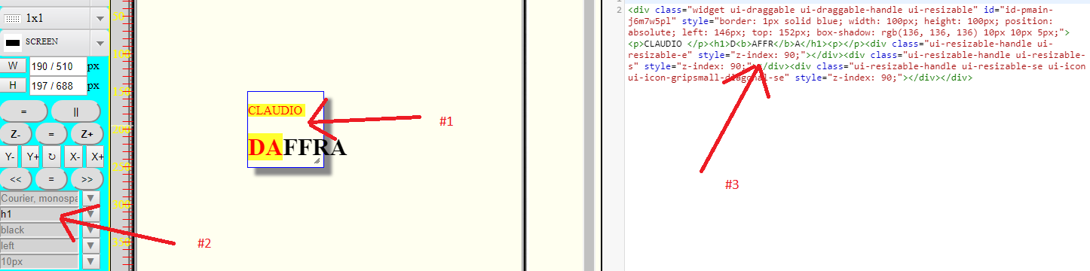
#1 Html Selection

#2 Header ( h1 )

#3 Html Real Time Result

Context Menu on mini Editor

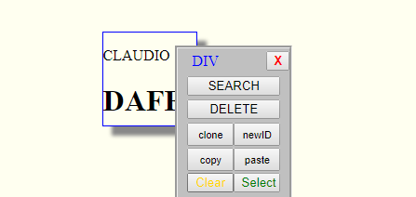

Context Menu Active serveral function, about mini editor we ca see :

1) clear : clear formatting text inside element ;

2) select : insert <p> … </p> Making the text selectable

