**Gekko**

Claudio Sciotto & John Torres

**Steam Game Finder**

**Problem:** Our program will be used to search for video games on the Steam store. It will give recommendations based on the users preferred categories, providing a list of the most compatible games by the categories specified

**Motivation:** We believe that this is a problem for the gaming community since from personal experience we can say that every now and then when people are looking for new a video game to play it becomes a tedious process where one can spend hours searching online getting plenty of recommendations without any good answer. Sometimes those recommendations are biased or very broad, making the process more complicated than it should be. We want to simplify that process and give a concise list of the most compatible games based on the criteria provided by the user.

**Features:** We will know that we have accomplished our solution when we are able to provide accurate video game suggestions to the user.

**Data:** We are planning on using the main steam website (https://store.steampowered.com/) in order to get the data. In order to do that we will be using the Steam Website API

**Tools:** We plan to do the main project on C++ and try to stick to it if possible. However, we are open to using a different language if when researching for the production of the project it makes it easier to work with the API. We are also planning on using the previously mentioned Steam Website API in order to gather all the data to create our structures.

**Visuals:** Reference Image 1

**Strategy:** We plan to use a B+ tree to organize the gathered data since we believe it will make it easier to provide weights to each branch, allowing for faster search of possible games. We would also like to implement that idea with graphs but we still need a little bit more understanding to know which one would fit better for the project. Regardless of the data structure we use, we plan on giving weights to different categories and when filtering through these categories, in reality we will be filtering through different values in order to find the games that have the highest similarities (or closest value) to the one provided by the user.

**Distribution of Responsibility and Roles:** We both will be working on almost every aspect of the project simultaneously however, Claudio will focus primarily on the interactions with the API and the coordination with the created structure while John will be mainly working on implementing such structures along the functions within it. Both of these tasks are not exclusive and we do plan on helping each other on these tasks if one seems to be harder than the other one.

**References:**

* 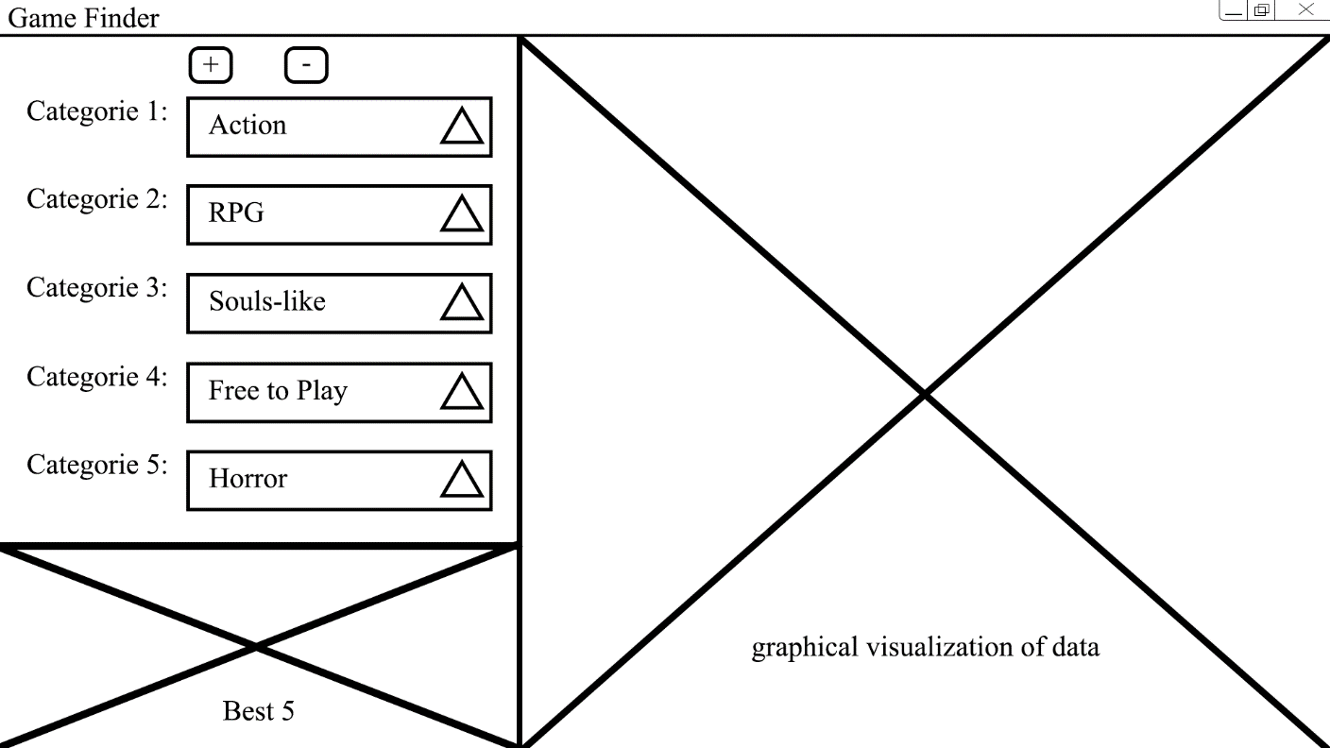Link to Steam Website API <https://partner.steamgames.com/doc/webapi_overview>

Image 1