Supplementary Material for:
A LUCAS-based fine soil bulk density assessment in Europe
This supplementary material includes additional information for the paper.
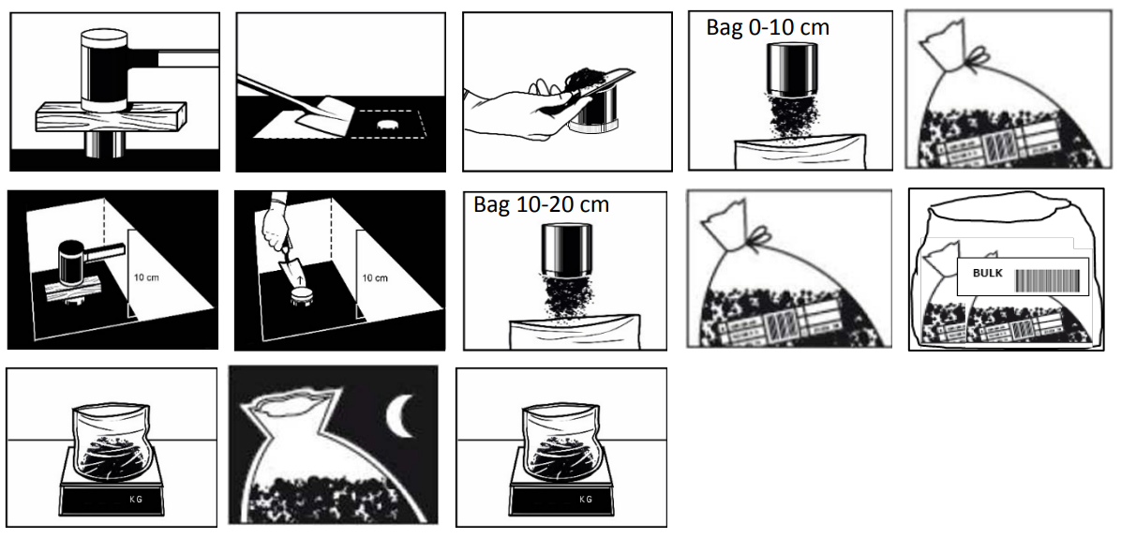
Fig. S1: Summary of the bulk density sampling during LUCAS Soil Survey. Before taking the soil cores, stones (>6 cm), vegetation residues, grass and litter were removed from soil surface by raking with the spade as in the common sampling procedure. After the cleaning of the soil surface, five soil cores were taken from 0 to 10 cm depth with a metallic ring of 100 cm³ at each LUCAS point. As shown in Figure S1, a metallic ring was gently driven into soil using a wooden block to push the ring with a mallet. This avoided the compaction of soil. The ring was removed from soil with the help of a spade placed underneath the ring. The excess soil around the ring was removed with a knife and the soil core was pushed into a labelled plastic bag. The procedure was repeated in the four cardinal directions and the soil cores collected were placed in the same labelled plastic bag. In the end, five soil cores of known volume were taken at the 0 to 10-cm depth (Fig. S1 - first row). After sampling the 0-10 cm depth was completed, the sampling of soil cores in the 10-20 cm depth was carried out following the same procedure (Fig. s1 – second row). Labels have been added to both samples. The soil cores were then allowed to air-dry and their weight was again recoded. The plastic bags were then sealed for their transportation to the laboratory following the analysis.

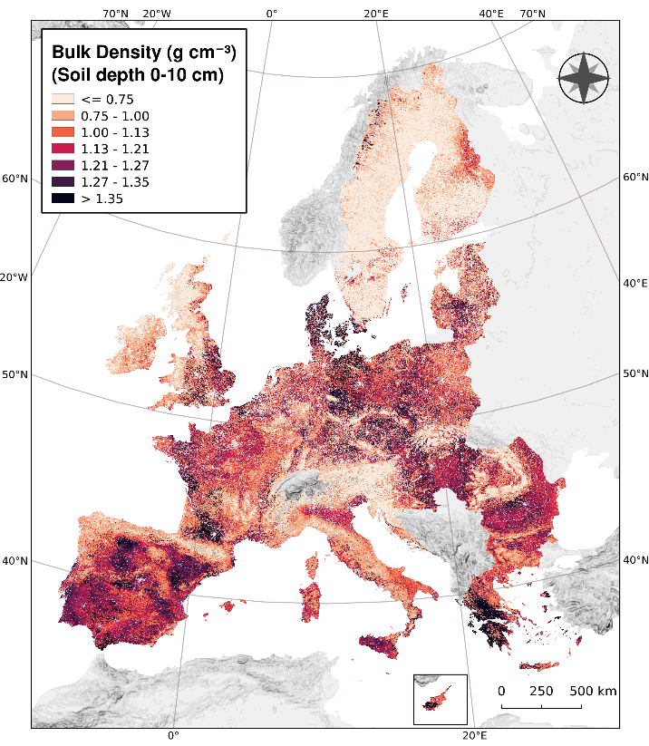 | 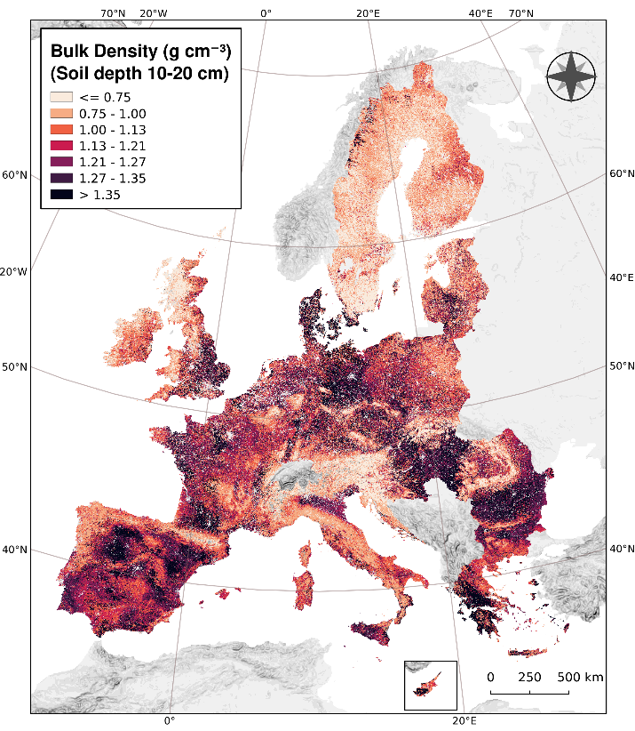

Fig. S2: Bulk density for the depth 0-10cm and bulk density for the depth 10-20cm.

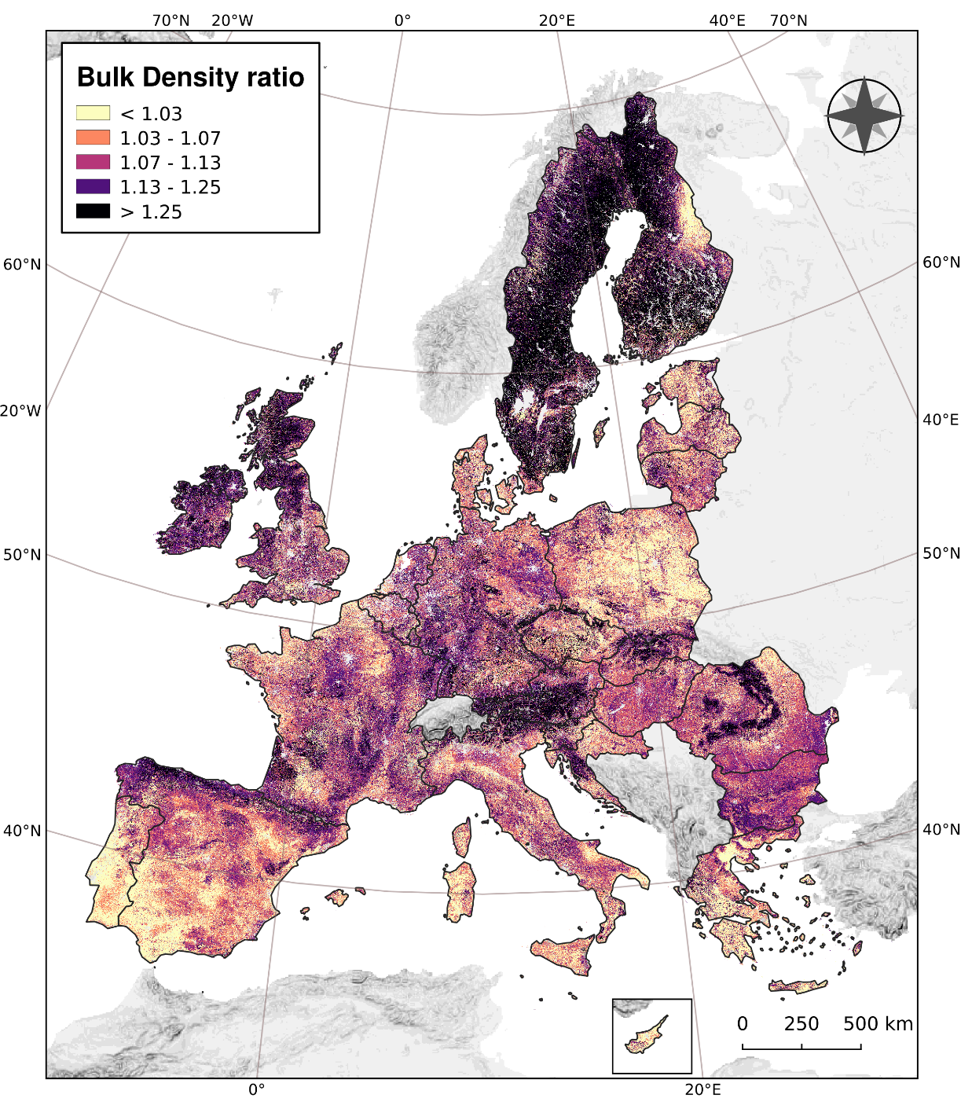
Fig. S3: Ratio of Bulk Density (BD) depth 10-20cm to BD 0-10cm.

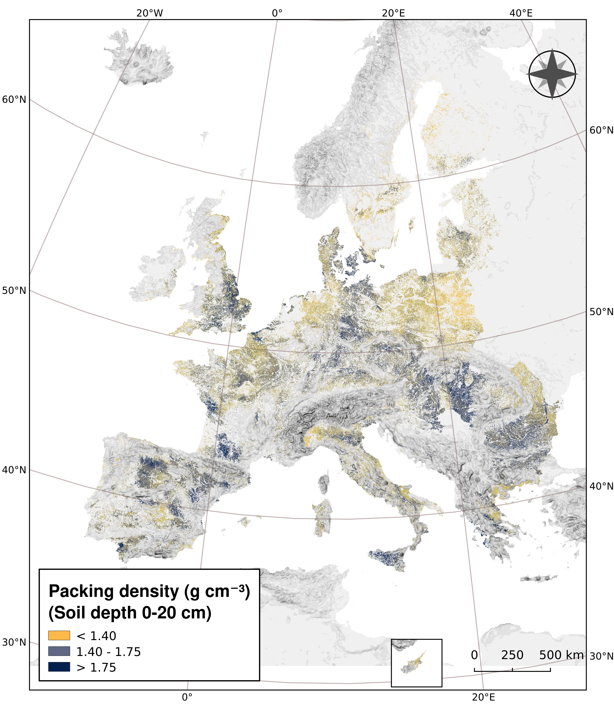
Fig. S4. Packing density in arable lands based on equation of Jones et al. (2003).
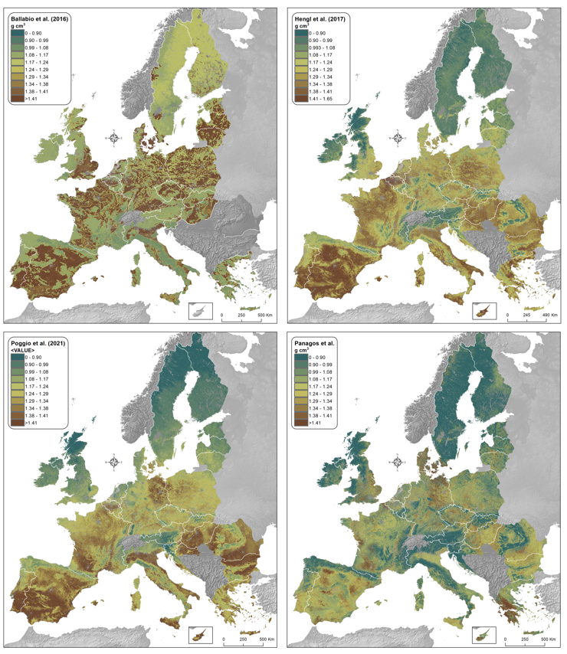
Fig. S5: Bulk density assessments 0-20cm a) upper left Ballabio et al., 2016; b) upper right Hengl et al., 2017; c) bottom left Poggio et al., 2021; d) current study

