**Assignments and Activities - 1**

**Task 1: Neurogaming**

1. Visit <http://eyewire.org/> and create an account. Visit the “About” page.

Watch the TED talks:

- “Play a game, map the mind” by Amy Robinson Sterling <https://youtu.be/R6WEElXC8wI>

- “I am my connectome” by Sebastian Seung <https://youtu.be/HA7GwKXfJB0>

|  |
| --- |
| By joining [Eyewire](https://eyewire.org/), you can help map the [connectome](https://blog.eyewire.org/i-am-my-connectome/" \t "_blank" \o "I am my connectome: Sebastian Seung’s TEDTalk), starting with connections between retinal neurons. Eyewire gameplay advances neuroscience by helping researchers discover how neurons connect and network to process information. You also help develop advanced artificial intelligence and computational technologies for mapping the connectome.  In Eyewire, gamers transform into the [Heroes of Neuroscience](https://story.eyewire.org/heroes.html).  People like you solve 3D puzzles to map vast neuron branches, completing reconstructions of cells and ultimately, entire circuits.  neuron, reconstruction, connectome, connectomics, eyewire, citizen science, AI, machine learning, EM, sectioning, neuroscience, brains |

2. Make an account and map some neurons in Eyewire.

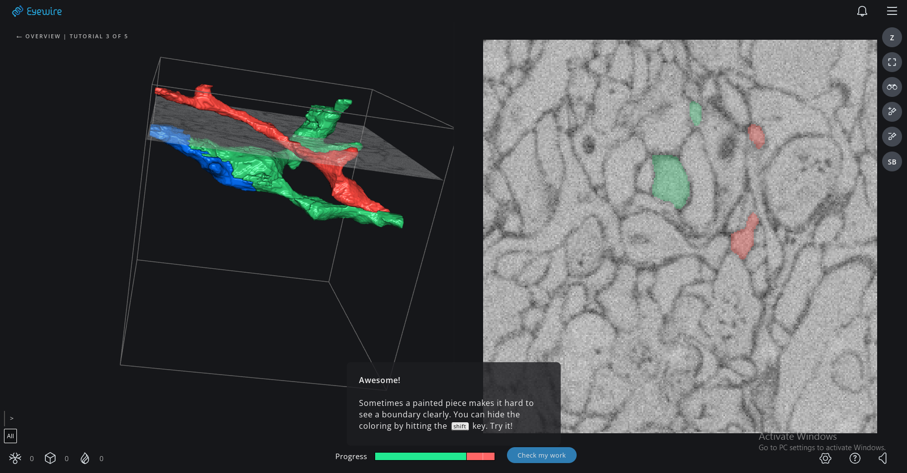

|  |  |
| --- | --- |
| E:\FACULTATE - CURSURI\NeuroScience\000 Main\MyCourse\Ch2  Neurons and Glia\tangle.png | **Fig. A**  The cellular tangle in the cerebral cortex: dendrites are shown in red or orange, axons in blue and green and glial branches in yellow.    Source: Lichtman Lab,  Harvard University  “The brain is astonishingly crowded. [...] Pictures of the brain are always a trade-off – leaving out enough detail so we can see the important things, but not taking out so much that vital features of the real brain are missing.”  Turney (2018) |

Answer the following:

a. How would you describe the communality between depiction in Fig. A and your experience in mapping neurons in Eyewire?

\_\_\_\_\_\_\_\_\_\_\_\_\_\_\_\_\_\_\_\_

b. What is a connectome?

\_\_\_\_\_\_\_\_\_\_\_\_\_\_\_\_\_\_\_\_

c. What personal meaning do you ascribe to the statement “I am my connectome” (it helps to repeat the statement in your head a few times – also repeating this last statement “in your head” may help as well). Do you agree with the statement or disagree? Why?

\_\_\_\_\_\_\_\_\_\_\_\_\_\_\_\_\_\_\_\_

d. After mapping some neurons in Eyewire, how did this experience contribute to your understanding of neuron morphology?

\_\_\_\_\_\_\_\_\_\_\_\_\_\_\_\_\_\_\_\_

**Task 2: Draw me a Brain Ep. 1**

Draw this ([link to editable drawing here](https://github.com/ClaudiuPapasteri/DrawMeABrain/tree/main/DMAB-1)):

|  |
| --- |
| E:\FACULTATE - CURSURI\NeuroScience\000 Main\MyCourse\Ch2  Neurons and Glia\Draw me a brain\Drawmod_Neurontypes_fin_1.png |

Your turn:

|  |
| --- |
|  |