**Assignments and Activities - 4**

**Task 1: Test your understanding**

**Question 1:** A drug called *strychnine*, isolated from the seeds of a tree native to India and commonly used as rat poison, blocks the effects of glycine. Is strychnine an agonist or an antagonist of the glycine receptor?

\_\_\_\_\_\_\_\_\_\_\_\_\_\_

\_\_\_\_\_\_\_\_\_\_\_\_\_\_

**Question 2:** Why is an excitatory synapse on the soma more effective in evoking action potentials in the postsynaptic neuron than an excitatory synapse on the tip of a dendrite?

\_\_\_\_\_\_\_\_\_\_\_\_\_\_

\_\_\_\_\_\_\_\_\_\_\_\_\_\_

**Task 2: Build the Puzzle**

**Task 2a:** Access [this link](https://im-a-puzzle.com/share/eac27b1edb8edef) and build the puzzle of the synaptic transmission.

**Task 2b:** Once the puzzle is done, arrange the following steps of the synaptic transmission in the right order and assign them by drawing arrows to their corresponding representation in the image of the synaptic transmission.

* Ca2+ allows vesicle docking and neurotransmitter release.
* Vesicular membrane is retrieved from the plasma membrane.
* Neurotransmitters are synthesized and stored in vesicles.
* Excitatory (or inhibitory) postsynaptic potential is generated.
* Neurotransmitter is removed by glial uptake (or enzymatic degradation).
* Voltage-gated Ca2+ channels open, allowing influx of Ca2+.
* Action potential arrives at the presynaptic terminal.
* Neurotransmitter binds to the receptors, causing channels to open (or close).

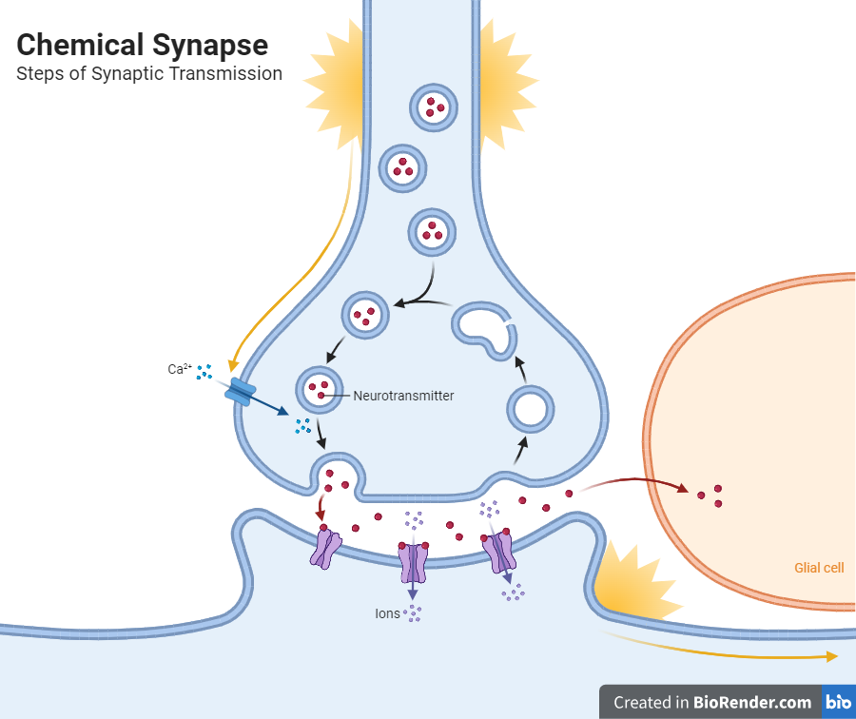

**Task 3: Draw me a Brain Ep. 4**

Draw this ([link to editable drawing here](https://github.com/ClaudiuPapasteri/DrawMeABrain/tree/main/DMAB-4)):

|  |
| --- |
| E:\FACULTATE - CURSURI\NeuroScience\000 Main\MyCourse\04_Ch5 Synaptic Transmission\DMAB-4\DMAB-4_fin_2.png |

Your turn:

|  |
| --- |
|  |