**Assignments and Activities - 5**

**Task 1: Test your understanding**

**Question 1:** In the study of neural coding, what are the main differences between rate coding and temporal coding, and in what contexts might one coding scheme be more advantageous than the other?

\_\_\_\_\_\_\_\_\_\_\_\_\_\_

\_\_\_\_\_\_\_\_\_\_\_\_\_\_

**Question 2:** Event-Related Potentials (ERPs) are used to study the brain's response to specific events or stimuli. How can the timing and amplitude of ERP components provide insights into cognitive processes, and how might individual differences affect ERP findings?

\_\_\_\_\_\_\_\_\_\_\_\_\_\_

\_\_\_\_\_\_\_\_\_\_\_\_\_\_

**Task 2: Simulating an EEG ERP experiment (*in silico* experiment)**

* P300 evoked potential is an involuntary positive potential that arises around 300 ms after the user has perceived a relevant and rare stimulus.
* Read the following seminal paper: Donchin, E. (1981). Surprise!...Surprise? Psychophysiology, *18*, 493-513. <https://doi.org/10.1111/j.1469-8986.1981.tb01815.x>
* Download Virtual EEG from: <https://pcl.sitehost.iu.edu/CogsciSoftware/EEG/index.html> or the course repository.
* Try to obtain obtain a discernable P300 in Virtual EEG. Describe what stimulus / stimuli / stimulus category vs. what contrasts you used. Why did you chose these stimuli?

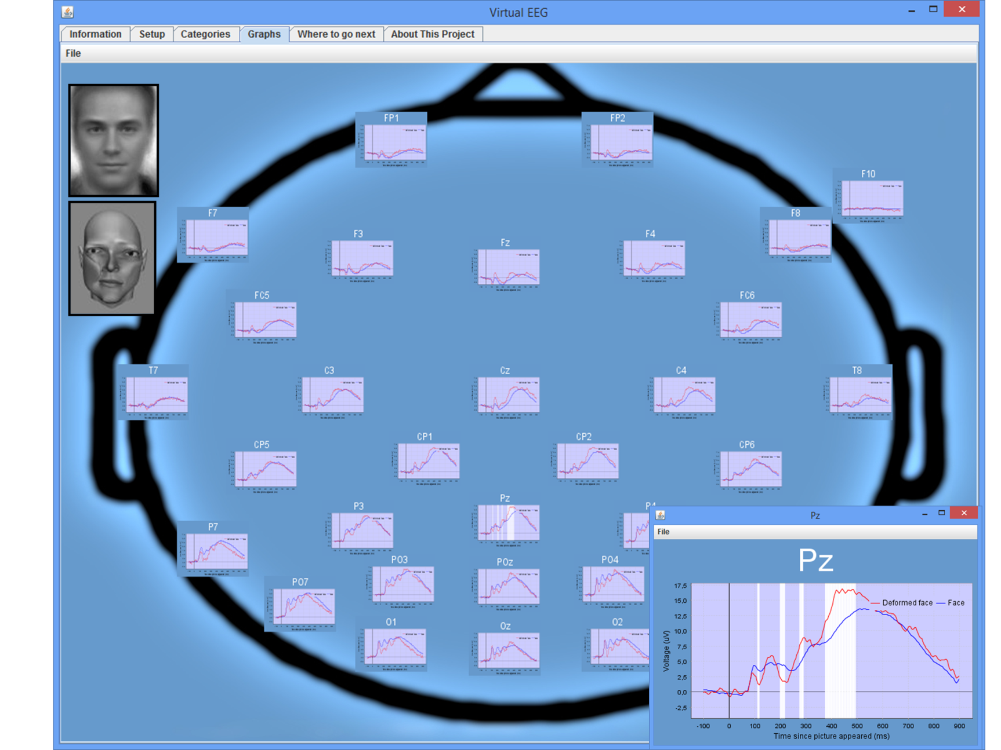

\_\_\_\_\_\_\_\_\_\_\_\_\_\_

\_\_\_\_\_\_\_\_\_\_\_\_\_\_

\_\_\_\_\_\_\_\_\_\_\_\_\_\_

\_\_\_\_\_\_\_\_\_\_\_\_\_\_

**Task 3: Draw me a Brain Ep. 5**

Draw this ([link to editable drawing here](https://github.com/ClaudiuPapasteri/DrawMeABrain/tree/main/DMAB-5)):

|  |
| --- |
| E:\FACULTATE - CURSURI\NeuroScience\000 Main\MyCourse\05_Peripheral Electrophysiology and the Electroencephalogram\DMAB-5\DMAB-5_fin_1.png |

Your turn:

|  |
| --- |
|  |