**Assignments and Activities - 8**

**Task 1: Test your understanding**

**Question 1:** What lobe of the cortex contains the main somatosensory areas? What lobe contains the motor cortex? Contrast their locations with that of primary visual cortex involved in seeing and frontal eye field involved in eye movement.

______________

______________

**Question 2:** If someone tossed you a hot potato and you caught it, which information would reach your CNS first — news that the potato was hot or that it was relatively smooth? Why?

______________

______________

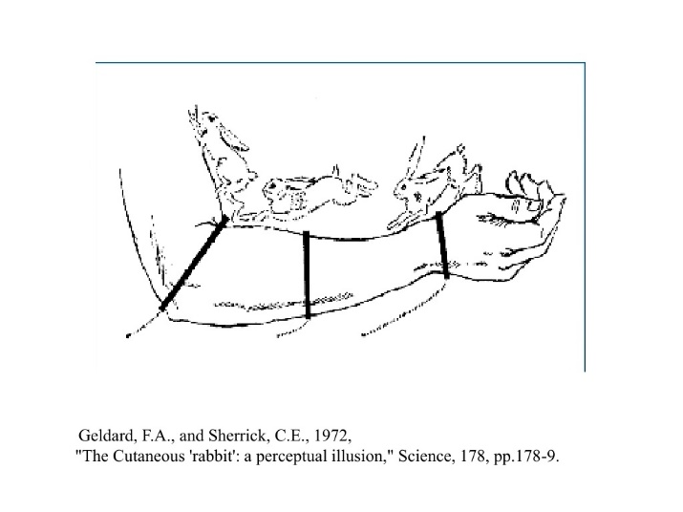**Task 2: Psychophysics experiment**

Research the “cutaneous rabbit” illusion or another somatosensory illusion online.

* Original article: Geldard, F. A., & Sherrick, C. E. (1972). The cutaneous" rabbit": a perceptual illusion. *Science*, *178*(4057), 178-179. doi: [10.1126/science.178.4057.178](https://doi.org/10.1126/science.178.4057.178)
* Additional reading: Flach, R., & Haggard, P. (2006). The cutaneous rabbit revisited. *Journal of Experimental Psychology: Human Perception and Performance*, *32*(3), 717-732. doi: [10.1037/0096-1523.32.3.717](https://doi.org/10.1037/0096-1523.32.3.717)

Experience the illusion yourself and perform it on others. What does the illusion tell us about how the somatosensory system functions?

______________

______________

______________

**Optional Task: Map your own homunculus**

|  |  |  |
| --- | --- | --- |
| Materials | Take measurements | Inspect results |

Access: <https://brainmapper.org/>

Follow the instructions to (1) prepare the materials, (2) take measurements, and (3) input the data and inspect results.

**Task 3: Draw me a Brain Ep. 8**

Draw this ([link to editable drawing here](https://github.com/ClaudiuPapasteri/DrawMeABrain/tree/main/DMAB-08)):

|  |
| --- |
|  |

Your turn:

|  |
| --- |
|  |