Your computer's IP address is:[*](http://www.myipaddress.com/about/)

87.59.103.16

Ved at skrive "whois 87.59.103.16" i googles søgefelt, kom følgende frem:

[87.59.103.0 IP Address - Denmark - Frederikssund | Tools whois IP ...](http://my-address-ip.com/whois-ip-address-87.59.103.0.html)

my-address-ip.com/whois-ip-address-87.59.103.0.html

87.59.103.0 - Whois IP address 87.59.103.0 - Denmark - Frederikssund - 87.59.103.0 | whois IP address. ... 87.59.103.16 · 87.59.103.17 · 87.59.103.18 · 87.59.

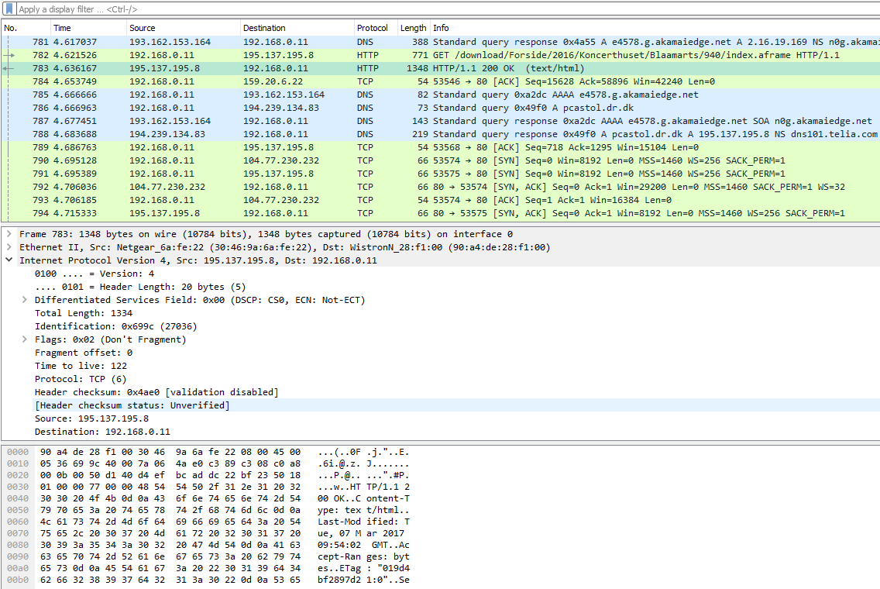

http://freevpnaccess.com/

|  |  |  |  |  |
| --- | --- | --- | --- | --- |
| Location | VPN Server | Protocol | Username | Password |
| US - Chicago | 67.212.175.123 | PPTP | freevpnaccess.com | 4850 |
| UK - London | 83.170.84.216 | PPTP | freevpnaccess.com | 5550 |
| Canada - Montreal | 184.107.164.107 | PPTP | freevpnaccess.com | 3080 |
| NL - Haarlem | 95.211.214.169 | PPTP | freevpnaccess.com | 5930 |
| US - Miami | 69.60.121.29 | PPTP | freevpnaccess.com | 2691 |
| UK - Maidenhead | 94.76.233.203 | PPTP | freevpnaccess.com | 2487 |
| UK - London | 83.170.106.154 | L2TP | freevpnaccess.com | 9970 |
| Canada - Montreal | 184.107.171.51 | L2TP | freevpnaccess.com | 2055 |
| Germany - Frankfurt | 46.165.220.239 | L2TP | freevpnaccess.com | 3091 |
| US - Miami | 69.60.121.28 | L2TP | freevpnaccess.com | 1080 |
| HK - Hong Kong | 209.95.60.88 | L2TP | freevpnaccess.com | 2507 |

http://www.myipaddress.com/show-my-ip-address/

Your computer's IP address is:*

83.170.84.216

Ved at skrive "whois 83.170.84.216" i googles søgefelt, kom følgende information frem:

Search Results

[83.170.84.216 Whois lookup - Whois - CQ Counter](http://cqcounter.com/whois/ip/83.170.84.216.html)

cqcounter.com/whois/ip/83.170.84.216.html

83.170.84.216 - Geo Information. IP Address, 83.170.84.216. Host, 83.170.84.216. Location, GB, United Kingdom. City, -,. Organization, UK2 Customer.

dr.dk

I denne session var der et par ARP requets, men eller var al trafikken mellem pc'en (192.168.0.11) og VPN-severen (83.170.84.216)

