

DE LA SALLE UNIVERSITY-DASMARIÑAS
COLLEGE OF ENGINEERING, ARCHITECTURE, AND TECHNOLOGY
ENGINEERING DEPARTMENT
COMPUTER ENGINEERING PROGRAM

COMPUTER ORGANIZATION AND ARCHITECTURE
(T-CPET326LA)

Enabling Assessment 3:
Design of 4-bit Carry Ripple Adder

Grade

Submitted By:

Submitted To:

Engr. Michael C. Olivo
Professor

Prayer:

Thank you God for all the things you've made our world to be.
For every single living plant, insect, bird and tree.
Thank you God for all the people you have placed around us.
For every single parent, friend and teacher that we trust.
Thank you Lord for all the gifts you send to us each day.
For every single meal and snack, for cuddles, toys and play.
Thank you God for caring for us, we know you always see,
Our every need, our worries, cares, our laughter, joys and tears.
Thank you Lord that you're our friend, you delight in all we do,
Especially when you hear our prayers, and we give thanks to you.
Amen.
Learning Outcome

TLO1. Demonstrates 4-bit Carry Ripple Adder circuit.
TLO2. Design 4-bit Carry Ripple Adder circuit using simulation software.

Discussion:
Ripple Carry Adder
A structure of multiple full adders is cascaded in a manner to give the results of the addition of an n bit binary sequence. This adder includes cascaded full adders in its structure so, the carry will be generated at every full adder stage in a ripple-carry adder circuit. These carry output at each full adder stage is forwarded to its next full adder and applied as a carry input to it. This process continues up to its last full adder stage. So, each carry output bit is rippled to the next stage of a full adder. By this reason, it is named as “RIPPLE CARRY ADDER”. The most important feature of it is to add the input bit sequences whether the sequence is 4 bit or 5 bit or any.
“One of the most important points to be considered in this carry adder is the final output is known only after the carry outputs are generated by each full adder stage and forwarded to its next stage. So, there will be a delay to get the result with using of this carry adder”.

4-bit Ripple Carry Adder
The diagram below represents the 4-bit ripple-carry adder. In this adder, four full adders are connected in cascade. Co is the carry input bit and it is zero always. When this input carry ‘Co’ is applied to the two input sequences A1 A2 A3 A4 and B1 B2 B3 B4 then output represented with S1 S2 S3 S4 and output carry C4.
Assume you want to add two operands A and B were
A= A3 A2 A1 A0
B=B3 B2 B1 B0
For example: A= 1 0 1 1
+
B= 1 1 0 1
---------------
A+B= 11 0 0 0 = C _{out} S₃ S₂ S₁ S₀

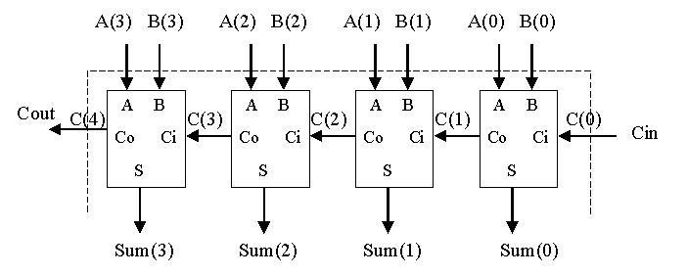
Fig. 1 4_bit ripple carry adder

Working on 4-bit Ripple Carry Adder

Example of two input sequences 0101 and 1010. These are representing the A4 A3 A2 A1 and B4 B3 B2 B1.
As per this adder concept, input carry is 0.
When Ao & Bo are applied at 1st full adder along with input carry 0.
Here A1 =1 ; B1=0 ; Cin=0
Sum (S1) and carry (C1) will be generated as per the Sum and Carry equations of this adder. As per its theory, the output equation for the Sum = A1⊕B1⊕Cin and Carry = A1B1⊕B1Cin⊕CinA1

As per this equation, for 1st full adder S1 =1 and Carry output i.e., C1=0.
Same as for next input bits A2 and B2, output S2 = 1 and C2 = 0. Here the important point is the second stage full adder gets input carry i.e., C1 which is the output carry of initial stage full adder.
Like this will get the final output sequence (S4 S3 S2 S1) = (1 1 1 1) and Output carry C4 = 0
This is the addition process for 4-bit input sequences when it’s applied to this carry adder.

Questions:
- Give the truth table and simulation screen shot for 4-bit Ripple-Carry Adder
- Give the circuit diagram of and truth table of 8-bit Ripple Carry Adder. Simulate using simulation tool
- Give the circuit diagram of and truth table of 16-bit Ripple Carry Adder. Simulate using simulation tool

OBSERVATIONS/RESULTS:
__________________________________________________________________________________________________________________________________________________________
__________________________________________________________________________________________________________________________________________________________
__________________________________________________________________________________________________________________________________________________________

CONCLUSION:
__________________________________________________________________________________________________________________________________________________________
__________________________________________________________________________________________________________________________________________________________
__________________________________________________________________________________________________________________________________________________________

Rubrics:

All circuit diagrams are running using simulation software | 75%
Questions | 15%
Observation and Conclusion | 15%
Total

--------------------------------------------------------END-----------------------------------------------

