Title: Subject and Content

Learning Outcomes:

* Differentiate representational art and non-representational art;
* Discuss the difference between an artwork’s subject and its content;
* Identify the subject matter and specific examples of art; and
* Enumerate the sources of the subjects of some of the most recognizable works of art in Philippine art history.

In viewing art, there are clues that mediate between the artwork and the viewer, allowing the viewer to more easily comprehend what he is seeing.

These clues are the three basic components of a work of art:

* Subject – the visual focus or the image that may be extracted from examining the artwork; the “what”
* Content – the meaning that is communicated by the artist or the artwork; the “why”
* Form – the development and configuration of the art work – how elements and the medium or material are put together; the “how”

THINK-PAIR-SHARE

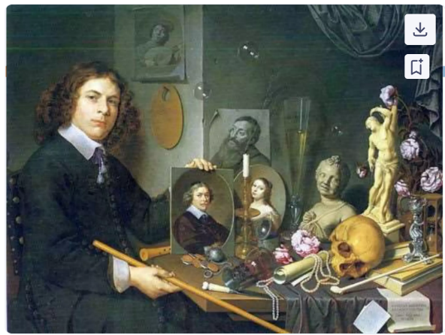Look at the painting below by artist David Bailly entitled Selbstbildnis mit Vanitassymbolen (Self-Portrait with Vanitas Symbols).

(Engage sa mga classmate of unsa ilang thoughts about sa painting)

TYPES OF SUBJECT

REPRESENTATIONAL ART

* These types of art have subjects that refer to objects or events occurring in the real world.
* Also termed ***figurative art*** because the figures depicted are easy to make out and decipher.

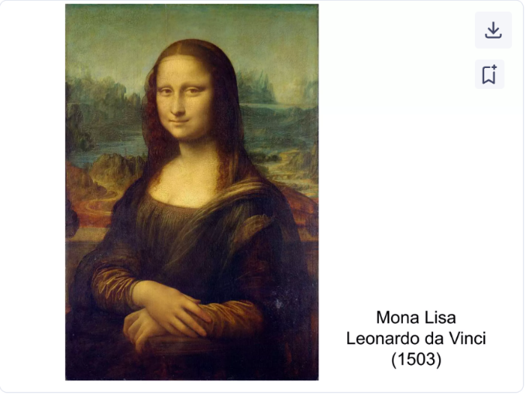

[Painting ni Mona Lisa]

Leonardo da Vinci (1503)

* Despite not knowing who Mona Lisa is, it is clear that the painting is of a woman that is realistically-proportioned;
* Only the upper torso is shown;
* A beguiling and mysterious smile is flashed;
* The background is a landscape

NON-REPRESENTATIONAL ART

* Art forms that do not make a reference to the real world, whether it is a person, place, thing, or even a particular event.
* It is stripped down to visual elements, such as shapes, lines, and colors that are employed to translate a particular feeling, emotion, and even concept.

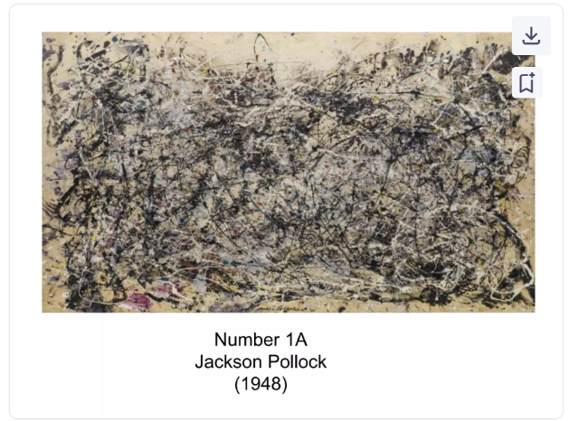

[painting]

Number 1A

Jackson Pollock (1948)

NON-REPRESENTATIONAL ART AND ABSTRACT ART

* Is non-representational art the same with abstract art?
* There is no clear-cut divide, rather they exist in a spectrum.

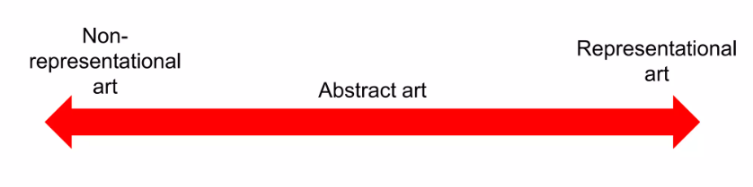

* 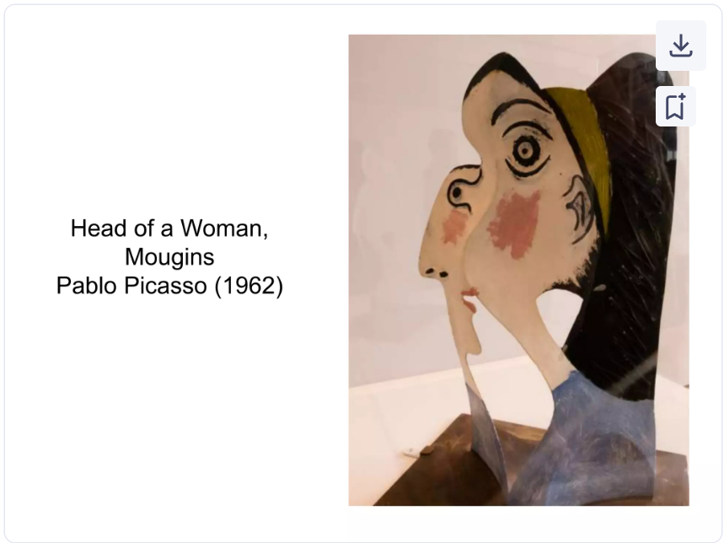Looking at the combination of lines, shapes, and colors of the sculpture will point to a head of a woman
* Even with the abstraction of the image, this work is arguably representational art.

SOURCES AND KINDS OF SUBJECT

* For non-representational art, a higher, level of perceptiveness and insight might be required to fully grasped the feeling, emotion, or concept behind the work.
* For representational art, it is easier to infer the subject matter because from the figures depicted in the artwork, there is already a suggestion as to its implication.

SOURCES OF SUBJECT

* Nature

[painting]

* History

[painting]

* Greek and Roman mythology

[painting]

* Religious

[painting]

KINDS OF SUBJECT

* History
* Still life
* Animals
* Figures
* Nature
* Landscape
* Seascape
* Cityscape
* Mythology
* Myth
* Dreams
* Fantasies

CONTENT IN ART

* The meaning or message that is expressed or communicated by the artwork.
* In understanding the content of art, it is important to note that there are various **levels of meaning:**

FACTUAL MEANING

* The most rudimentary level of meaning for it may be extracted from the identifiable or recognizable forms in the artwork and understanding how there elements relate to one another.

CONVENTIONAL MEANING

* Pertains to he acknowledged interpretation of the artwork using motifs, signs, and symbols and other cyphers as bases of its meaning.
* These conventions are established through time, strengthened by recurrent use and wide acceptance by its viewers or audience and scholars who study them.

SUBJECTIVE MEANING

* When subjectivities are consulted, a variety of meanings may arise when a particular work of art is read.
* These meanings stem from the viewer’s or audience’s circumstances that come into play when engaging with art (what we know, what we learned, what we experienced; what values we stand for)
* Meaning may not be singular, rather, multiple and varied

[painting Creation of Adam]

ANALYSIS

* Subject: biblical art
* Factual meaning: Creating Story (creation of man)
* Conventional meaning: man was created in the image and likeness of God
* Subjective meaning: endowment of intellect to man from God