L07 — Neural Networks Playground
Technical Report · TensorFlow Playground Exploration
Team | Team Members | Course | Due
TuringCollective | Joseph Clay (all tasks performed) | ITAI-1370 · Prof. Anna Devarakonda · HCC | Jul 11, 2026
Team member participation: Joseph Clay performed all five exploration tasks, captured all experimental screenshots, and authored this report. All listed members vouch for the participation stated above.

1. Purpose — What We Address and Why
The objective of this assignment is to become familiar with the fundamentals of neural networks and their behavior by experimenting with TensorFlow Playground, an interactive browser-based neural network visualizer [1]. A neural network is a machine learning model made of layers of connected “neurons”: an input layer receives data features, one or more hidden layers transform that data using weighted connections and activation functions, and an output layer produces a prediction [2]. During training, the network repeatedly adjusts its connection weights to reduce a loss value — a number measuring how wrong its predictions are (lower is better).
In this report we investigate how five specific parameters affect a network's ability to classify data: (1) the activation function, (2) the number of neurons in the hidden layer, (3) the learning rate, (4) noise in the training data, and (5) the complexity of the dataset itself. For each task we state the activity performed, the results obtained, and what was learned.

2. Activities Performed and Results Obtained

Task 1 — Activation Functions
Activity performed: We built a network with one hidden layer of 4 neurons on the circle dataset (learning rate 0.03, noise 0) and trained it twice — once with the ReLU activation function and once with sigmoid — for roughly 1,050 epochs each. The activation function decides how each neuron converts its weighted input into an output signal [2].
Configuration | Epoch | Test Loss | Training Loss | Decision Boundary
ReLU | 1,050 | 0.012 | 0.000 | Sharp, polygonal edges
Sigmoid | 1,052 | 0.016 | 0.007 | Smooth, rounded curve
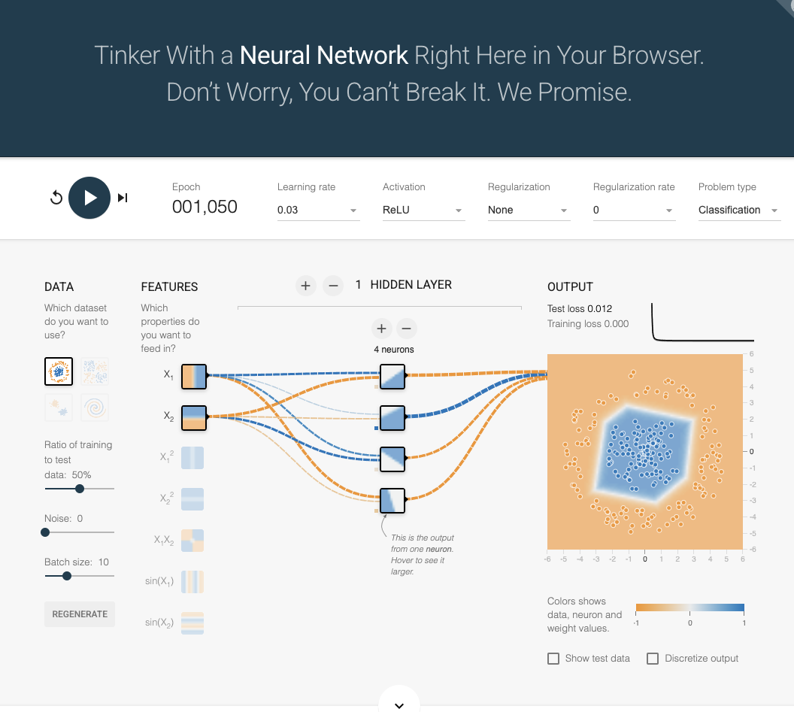
Figure 1 — ReLU activation: test loss 0.012 with an angular, piecewise-linear decision boundary.
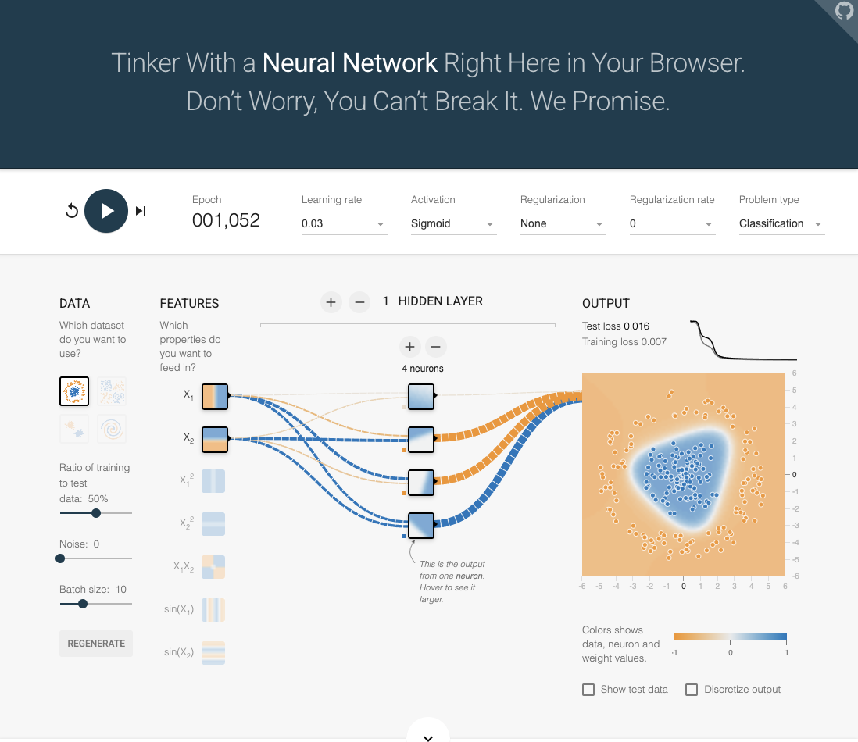
Figure 2 — Sigmoid activation: test loss 0.016 with a smoother, rounded decision boundary.
What was learned: Both functions solved the problem, but they shaped the boundary differently. ReLU outputs max(0, x), a piecewise-linear function, so the network assembles its boundary from straight segments — visible as the sharp edges in Figure 1 — and it drove training loss all the way to 0.000. Sigmoid squashes values into a smooth 0-to-1 curve, producing the rounded boundary in Figure 2, but it converged slightly less tightly (0.016 vs. 0.012). ReLU is the modern default in deep networks largely because sigmoid's flat tails can cause the “vanishing gradient” problem, where learning slows to a crawl in deeper networks [3]. With only one hidden layer that weakness barely appears, which is why both performed well here.

Task 2 — Hidden Layer Neurons
Activity performed: Keeping one hidden layer and sigmoid activation on the circle dataset, we varied the number of hidden neurons — first 2, then 8 — and compared performance at roughly the same epoch count.
Configuration | Epoch | Test Loss | Training Loss | Decision Boundary
2 neurons | 1,061 | 0.308 | 0.206 | Almost a straight diagonal — underfit
8 neurons | 1,081 | 0.009 | 0.005 | Tight fit around the circular cluster
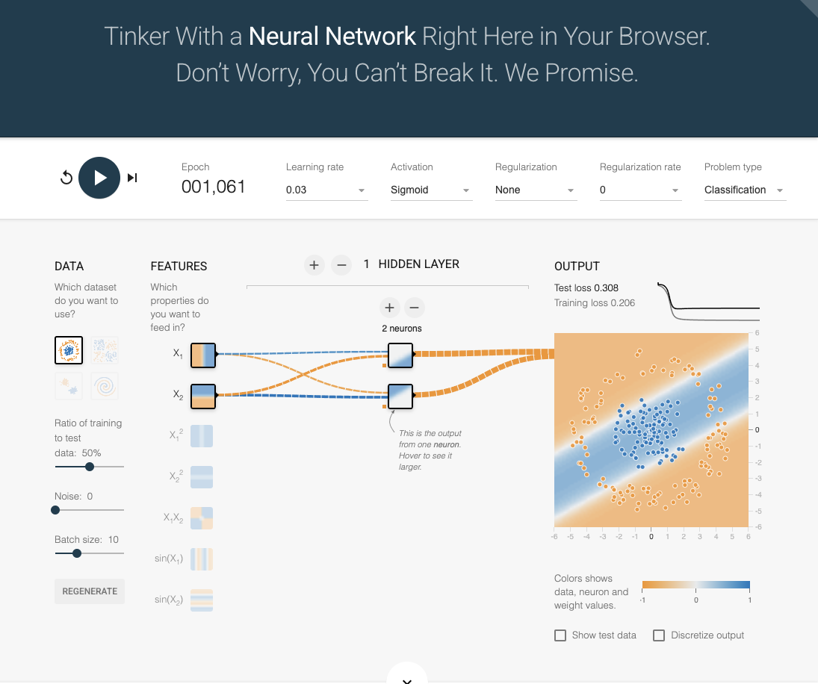
Figure 3 — 2 hidden neurons: the network collapses to a nearly linear split and misclassifies much of the data (test loss 0.308).
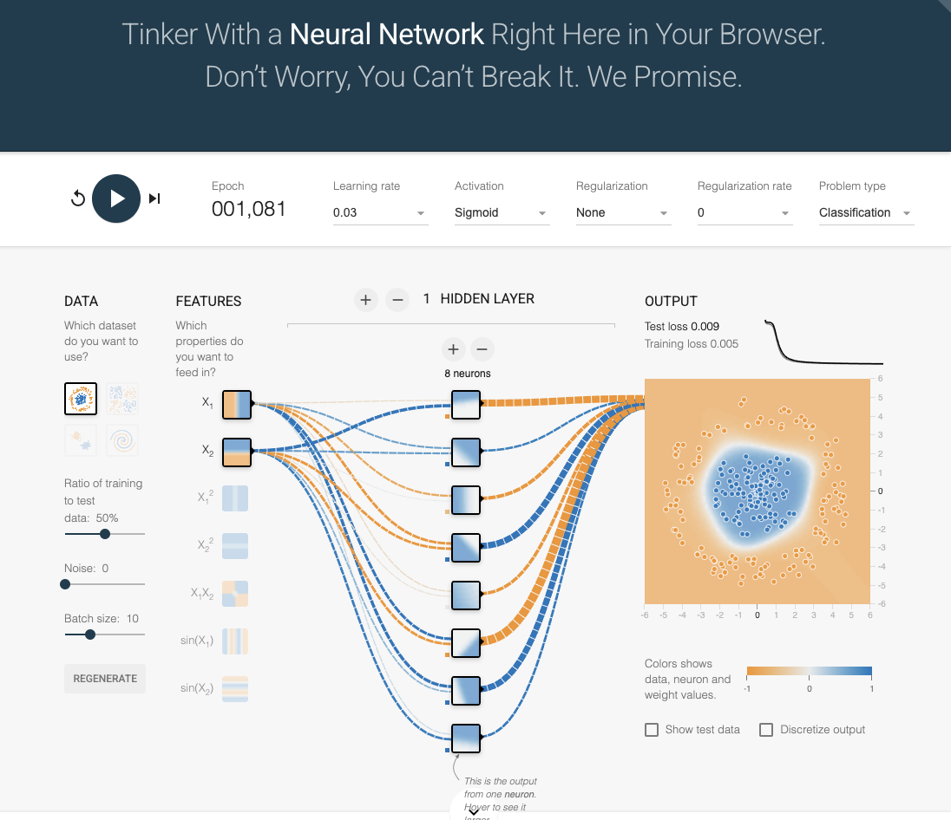
Figure 4 — 8 hidden neurons: the network traces the circular boundary tightly (test loss 0.009).
What was learned: Neuron count controls the network's capacity — how complex a pattern it can represent. Two neurons were simply too few to bend a boundary around a circle, so the model underfit, settling for a nearly straight line and a poor 0.308 test loss (Figure 3). Eight neurons gave the network enough building blocks to wrap the boundary around the blue cluster, cutting test loss by more than 30× to 0.009 (Figure 4). The lesson: a model must be at least as complex as the pattern it is asked to learn [2].

Task 3 — Learning Rate
Activity performed: Using one hidden layer of 4 neurons (sigmoid, circle dataset), we compared a moderate learning rate of 0.03 against an aggressive rate of 3 — a 100× increase. The learning rate controls the size of each weight adjustment during training [2].
Configuration | Epoch | Test Loss | Training Loss | Observation
Learning rate 0.03 | 1,061 | 0.020 | 0.006 | Gradual, smooth loss curve
Learning rate 3 | 1,062 | 0.006 | 0.000 | Near-instant convergence; boxier boundary
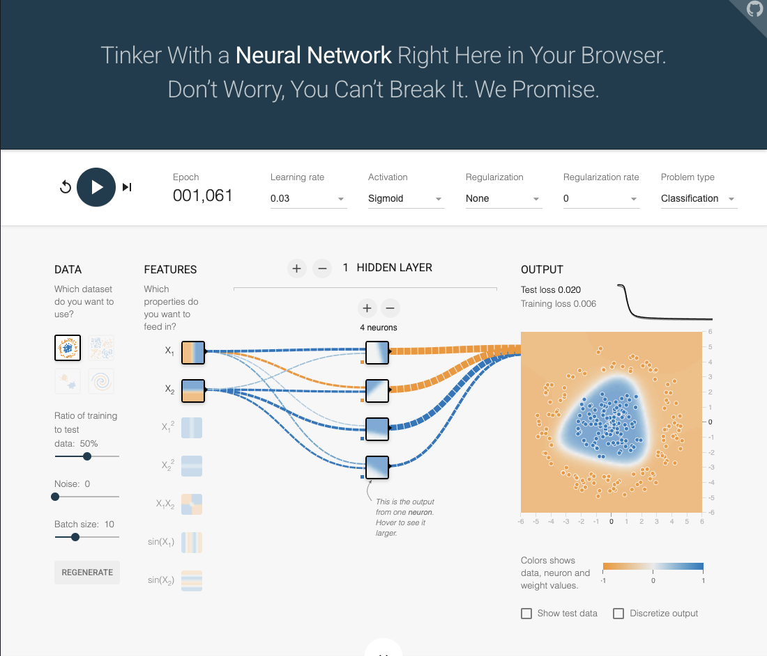
Figure 5 — Learning rate 0.03: steady convergence to test loss 0.020.
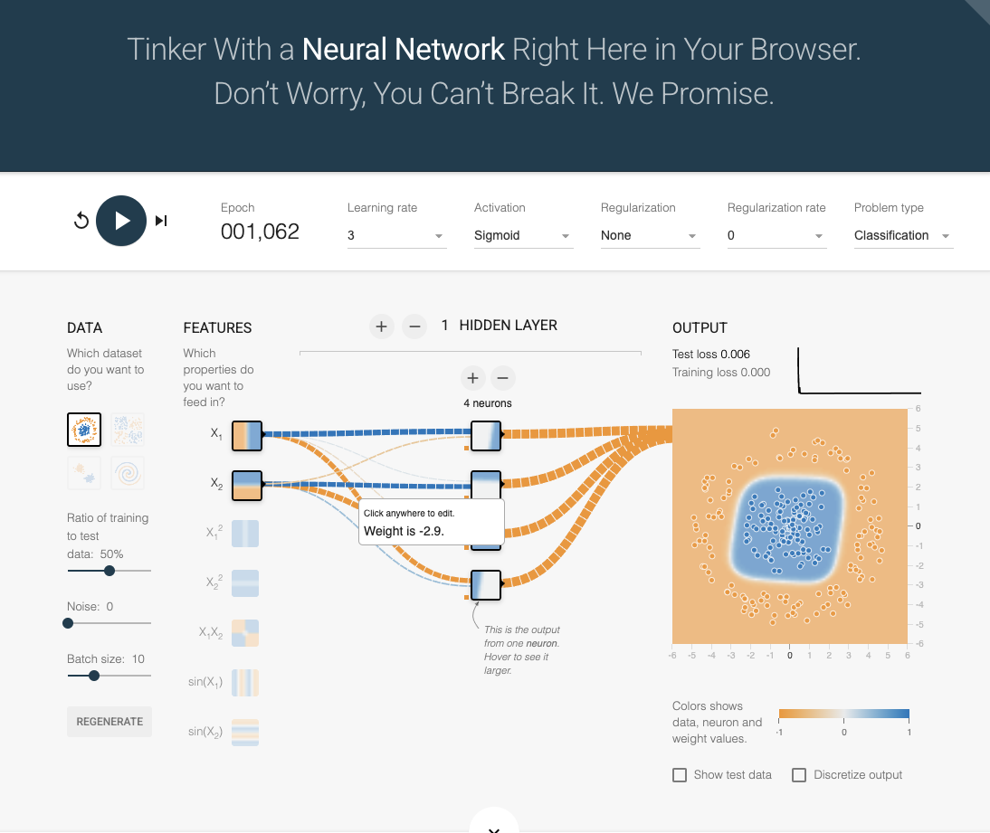
Figure 6 — Learning rate 3: extremely fast convergence to test loss 0.006, with large individual weights (e.g., −2.9).
What was learned: The learning rate is a speed-versus-stability trade-off. A small rate takes cautious steps: reliable, but slower to converge. Our high rate of 3 took huge steps — the loss curve in Figure 6 drops almost vertically and individual weights grew large — and on this simple, clean dataset it actually landed on a better solution (0.006 vs. 0.020). We researched why this is considered risky rather than a free win: in general, an overly large learning rate can overshoot the loss minimum and cause the loss to oscillate or diverge entirely, especially on complex data or deeper networks [2][4]. Our result is best read as “this easy problem tolerated an aggressive rate,” not as evidence that bigger is always better.

Task 4 — Data Noise
Activity performed: With settings held constant (1 hidden layer, 4 neurons, sigmoid, learning rate 0.3, circle dataset), we trained once with the Noise slider at 0 and once at 30. Noise randomly perturbs the data points so the two classes begin to overlap.
Configuration | Epoch | Test Loss | Training Loss | Decision Boundary
Noise 0 | 1,060 | 0.007 | 0.001 | Clean, confident circular fit
Noise 30 | 1,065 | 0.170 | 0.150 | Blurred, irregular; classes intermixed
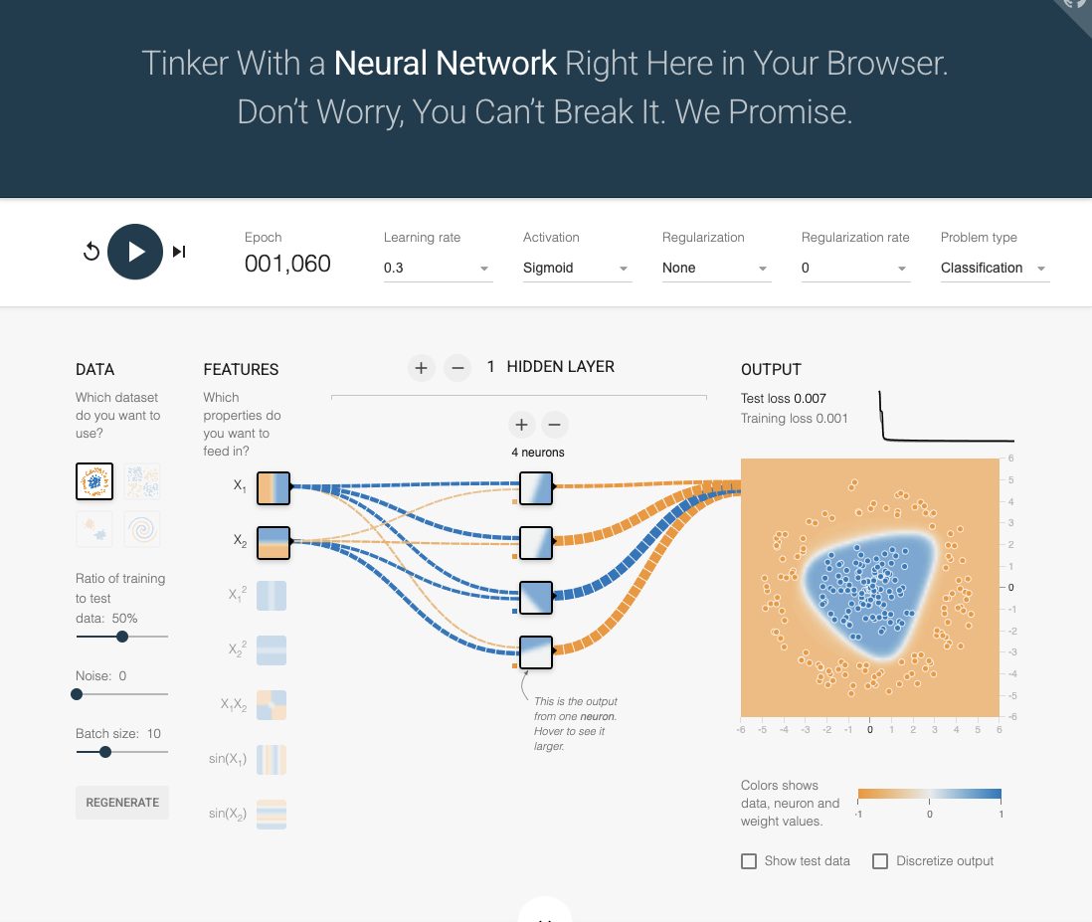
Figure 7 — Noise 0: cleanly separated classes and a near-perfect boundary (test loss 0.007).
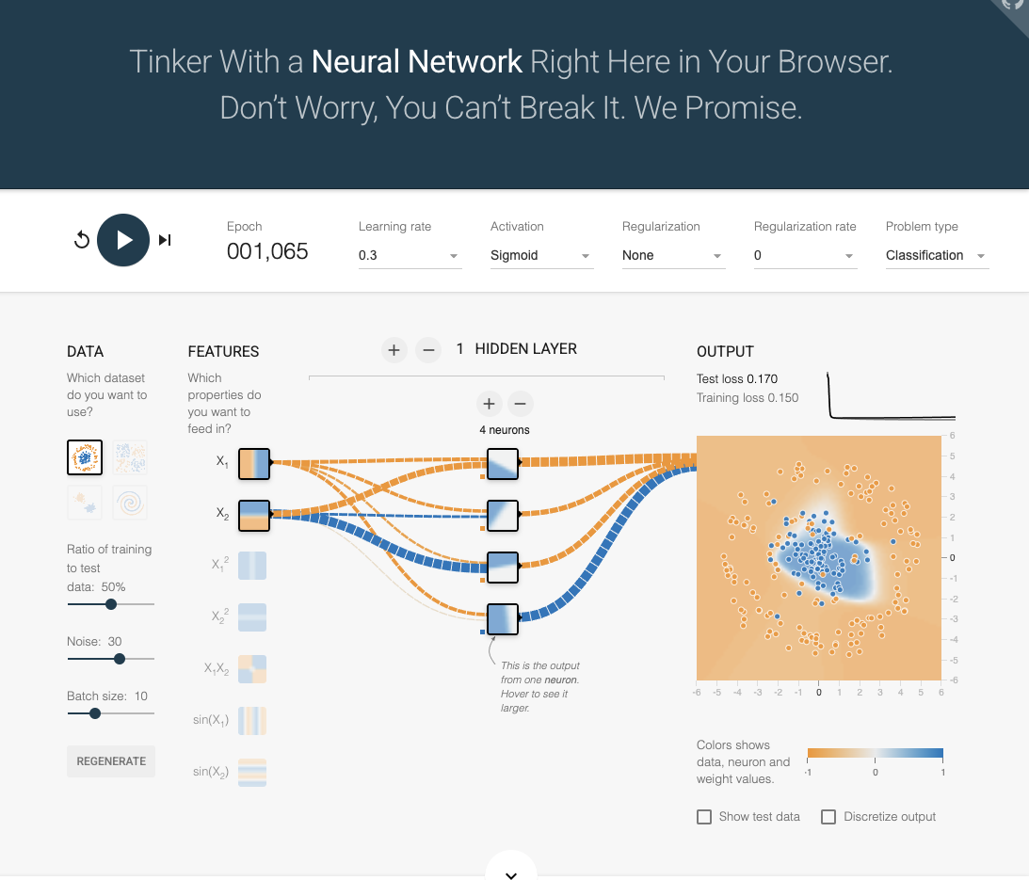
Figure 8 — Noise 30: orange and blue points intermix; test loss climbs 24× to 0.170.
What was learned: Data quality caps model quality. At noise 30, points from each class land inside the other class's territory, so no boundary — however clever — can separate them perfectly. Test loss jumped from 0.007 to 0.170 and the boundary in Figure 8 visibly warps as the network chases mislabeled outliers. This demonstrates why generalization suffers on noisy data: the network risks memorizing noise (overfitting) instead of learning the true underlying pattern [2]. In practice, this is an argument for cleaning data before reaching for a bigger model.

Task 5 — Dataset Exploration
Activity performed: Holding the network constant (1 hidden layer, 4 neurons, sigmoid, learning rate 0.3, noise 0), we trained on three additional TensorFlow Playground datasets — Gaussian, Exclusive-OR (XOR), and Spiral — to see how the same model handles increasingly complex data shapes.
Dataset | Epoch | Test Loss | Training Loss | Result
Gaussian (two blobs) | 1,059 | 0.000 | 0.000 | Perfect — linearly separable
XOR (checkerboard) | 1,052 | 0.178 | 0.048 | Struggles — non-linear pattern
Spiral | 1,110 | 0.485 | 0.389 | Fails — far beyond network capacity
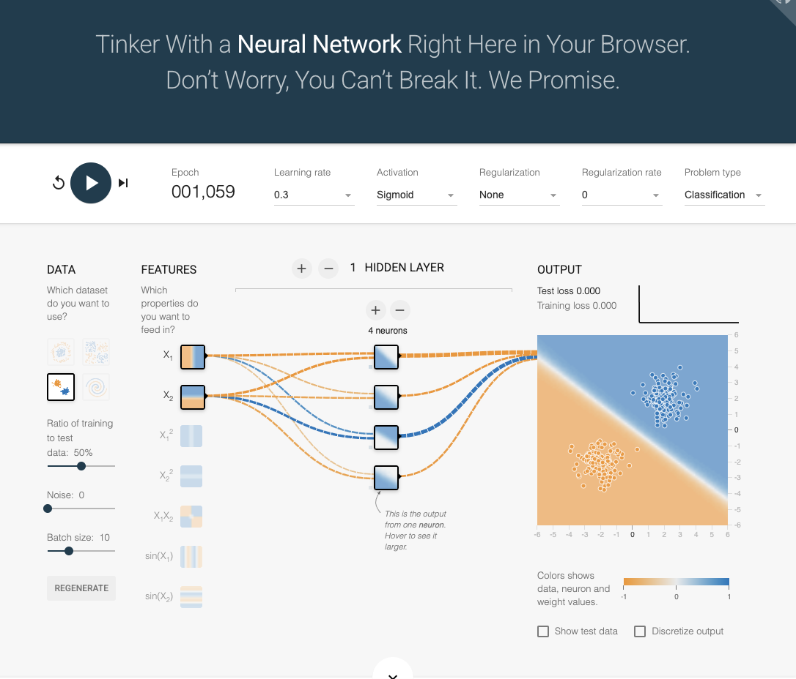
Figure 9 — Gaussian dataset: a single straight-ish boundary separates the blobs perfectly (test loss 0.000).
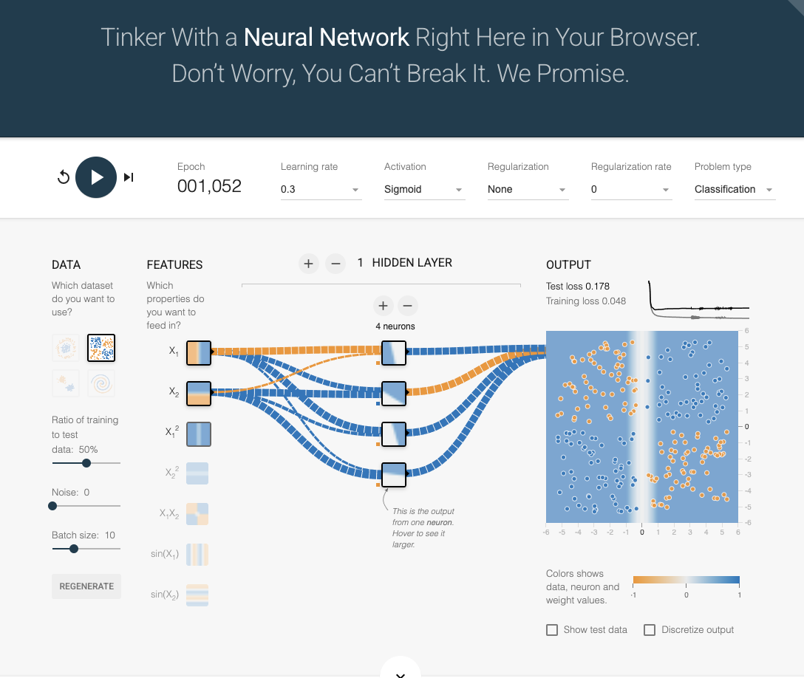
Figure 10 — XOR dataset: the network cannot cleanly carve the four alternating quadrants (test loss 0.178).
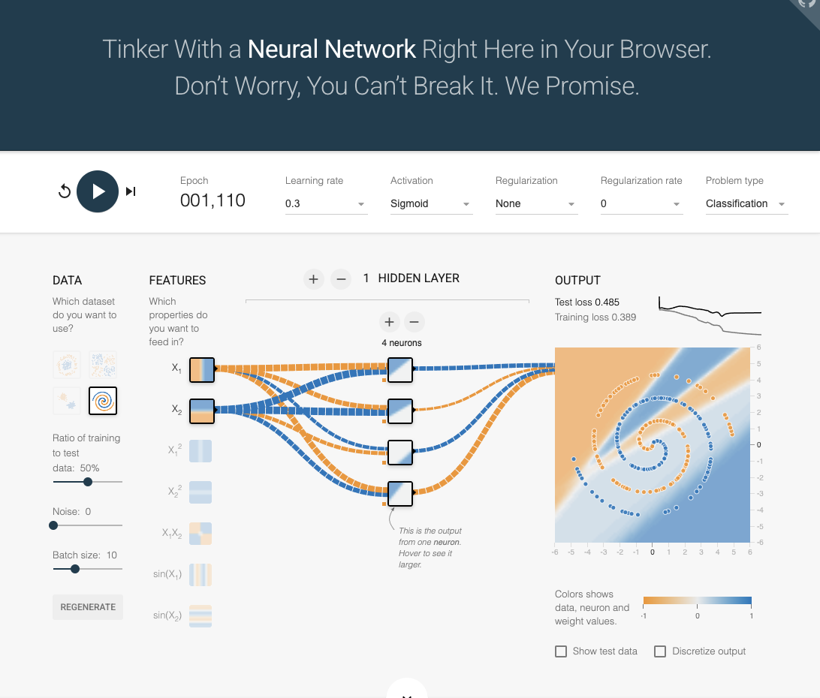
Figure 11 — Spiral dataset: the boundary degenerates to a diagonal band; the model is far too simple (test loss 0.485).
What was learned: Dataset complexity determines how much network you need. The Gaussian blobs are linearly separable, so our small network solved them perfectly. XOR is the textbook non-linear problem — famously unsolvable by a single-layer perceptron [5] — and our shallow network only partially separated its checkerboard pattern (0.178). The spiral demands either far more neurons, additional hidden layers, or engineered input features such as sin(x₁) and sin(x₂); with none of those, the model gave up on the spiral shape entirely (0.485, Figure 11). This connects directly to Task 2: capacity that is optional for easy data becomes mandatory for hard data.

3. Discussion — Practical Implications
Taken together, the five experiments map directly onto decisions real machine-learning practitioners face:
- Choose activation functions deliberately. ReLU's sharp, efficient behavior explains its dominance in modern deep networks, while sigmoid survives in output layers where a smooth 0–1 probability is wanted [3].
- Size the model to the problem. Too little capacity underfits (Task 2's straight line); real projects tune neuron and layer counts the same way we did, just at larger scale.
- Tune the learning rate carefully. It is often called the single most important hyperparameter [2] — our 100× sweep showed how dramatically it changes training dynamics.
- Invest in data quality. Task 4 showed a 24× loss increase from noise alone. In industry, cleaning data frequently beats adding model complexity.
- Match architecture to data complexity. Task 5's spiral failure is a miniature version of why image and speech problems require deep, specialized architectures rather than small generic ones.

4. Conclusion — What the Team Learned
Through hands-on experimentation rather than lecture alone, our team learned that a neural network's success is not a property of the network by itself — it is the fit between architecture, hyperparameters, and data. The same 4-neuron network went from perfect (Gaussian, 0.000) to nearly useless (Spiral, 0.485) with no change except the data. We also learned to read loss values and decision boundaries as diagnostic evidence: a straight-line boundary on curved data signals underfitting; a warped boundary on noisy data signals memorization. Finally, we gained an intuition for why terms like activation function, capacity, learning rate, and generalization matter — each one was a slider we physically moved and whose consequences we watched unfold. TensorFlow Playground made abstract theory tangible, and these intuitions transfer directly to the full-scale frameworks we will use later in the program.

References
[1] Smilkov, D., & Carter, S. (n.d.). TensorFlow Playground — Tinker with a neural network in your browser. https://playground.tensorflow.org
[2] Goodfellow, I., Bengio, Y., & Courville, A. (2016). Deep Learning. MIT Press. https://www.deeplearningbook.org
[3] Nair, V., & Hinton, G. E. (2010). Rectified linear units improve restricted Boltzmann machines. Proceedings of the 27th International Conference on Machine Learning (ICML-10), 807–814.
[4] Nielsen, M. (2015). Neural Networks and Deep Learning. Determination Press. http://neuralnetworksanddeeplearning.com
[5] Minsky, M., & Papert, S. (1969). Perceptrons: An Introduction to Computational Geometry. MIT Press.
[6] Devarakonda, A. (2026). ITAI-1370 Module 07 — L07: Neural Networks Playground. Houston Community College.
L07_TuringCollective_JosephClay_ITAI1370 · ITAI-1370 · Prof. Anna Devarakonda · HCC · Summer 2026

