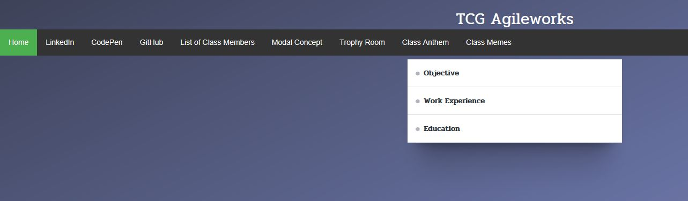

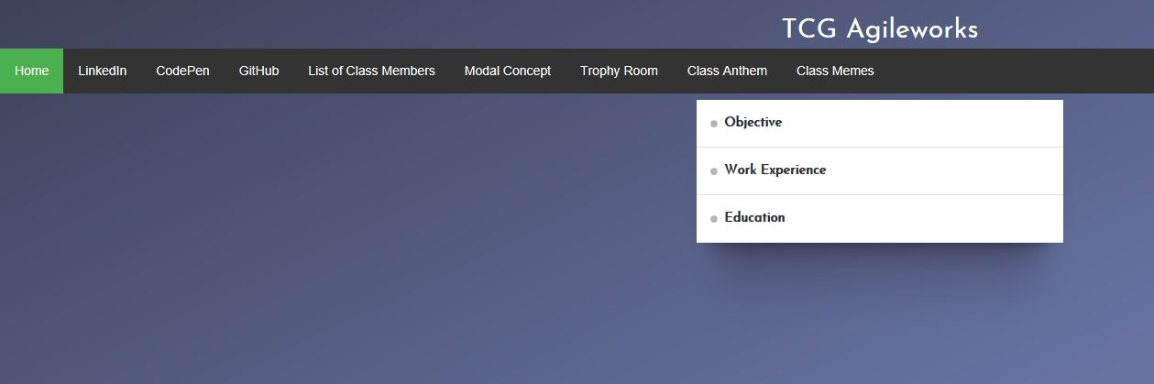

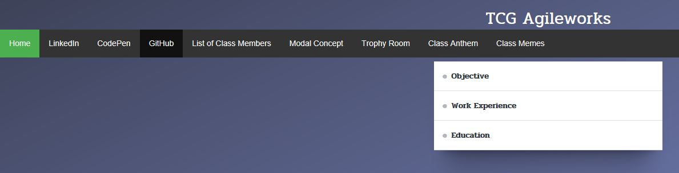

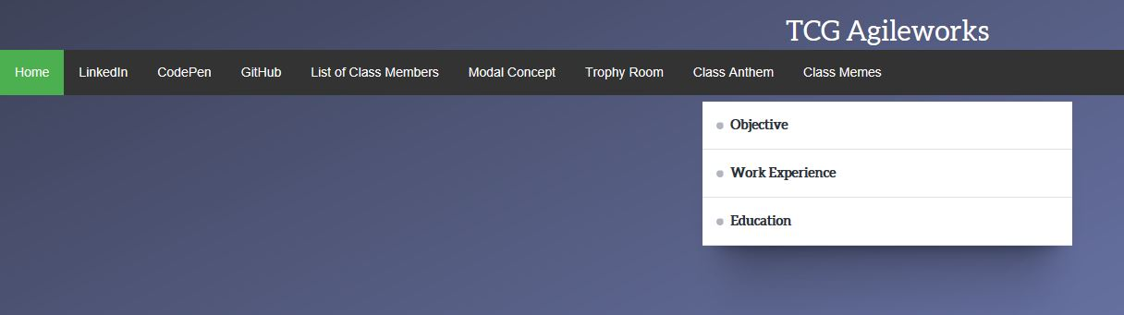

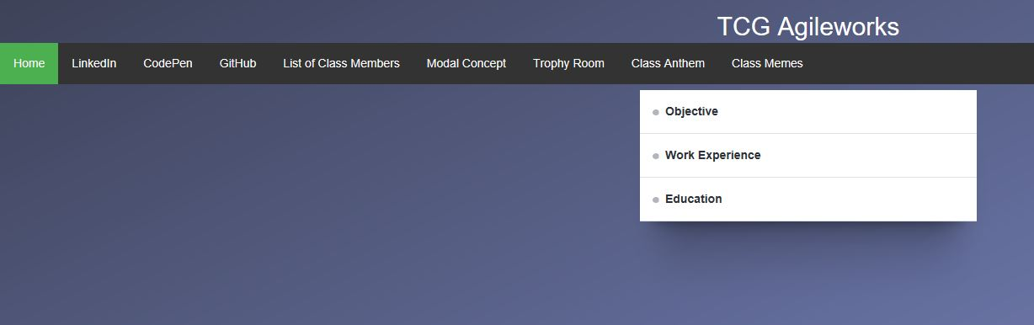

Font1:

font-family: 'Poppins', sans-serif;

<link href="https://fonts.googleapis.com/css?family=Poppins" rel="stylesheet">



Font2:

font-family: 'Josefin Sans', sans-serif;

<link href="https://fonts.googleapis.com/css?family=Josefin+Sans" rel="stylesheet">



Font3:

font-family: 'Pridi', serif;

<link href="https://fonts.googleapis.com/css?family=Pridi" rel="stylesheet">

Font4:

font-family: 'Aleo', serif;

<link href="https://fonts.googleapis.com/css?family=Aleo" rel="stylesheet">



Font5: default