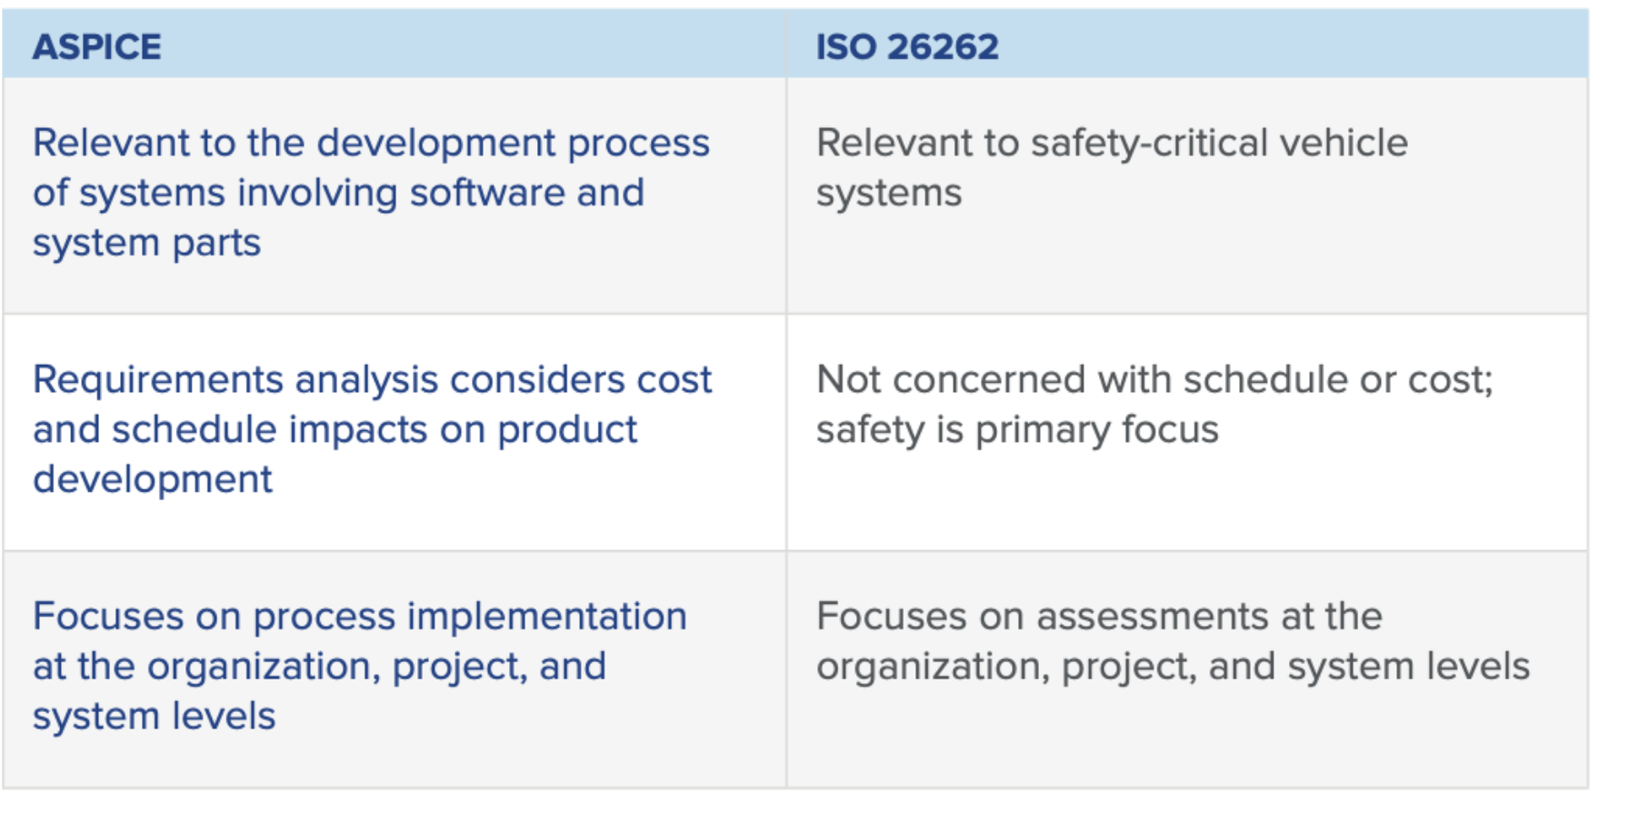

https://www.jamasoftware.com/blog/aspice-101-iso-26262-vs-aspice/

