https://github.com/github/c2c-actions-compute

High Level Architecture
https://github.com/github/c2c-actions-compute/blob/main/docs/development/high-level-architecture.md

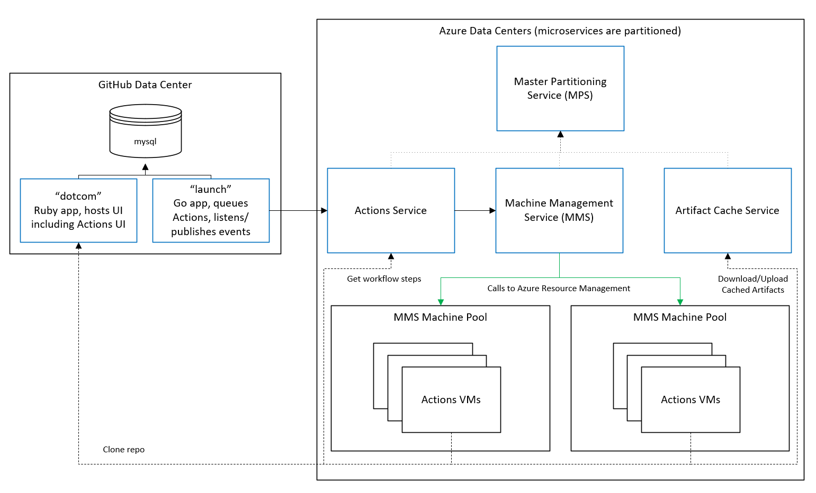

<$Scr_H::1>MMS Overview
<!$Scr_H::1>
<$Scr_H::2>Introduction
<!$Scr_H::2>The Machine Management Service (MMS) is the VSTS Service that provides the capabilities that Hosted Build and Release use to securely and efficiently share a Pool of Virtual Machines between all accounts on VSTS. It allows us to provide a push-button experience for Build and Release users that don't want to manage their own build infrastructure.
All accounts get one Hosted Agent and up to 240 Free Minutes of usage per Month. Users can purchase additional Hosted Agents to increase their concurrency. Purchasing Premium Agents also increases the max time allowed per build for the account and allows unlimited usage of those Hosted Agents.

<$Scr_H::2>Core MMS Types
- <!$Scr_H::2> • Machine Pool
  - Represents a set of Machine Instances (VM's) that are co-located and have the same performance configuration.
- Machine Instance
  - An individual Machine in the Pool.
  - Can be assigned Machine Requests
- Machine Request
  - The request made by the consuming service to perform some work on a VM.
  - Put into a Queue in MMS and assigned when a Machine Instance becomes available.
- Machine Provisioner
  - This is what we call our MMS Agent that resides on each VM in our Machine Pools. It handles connecting to the MMS Message Queue and executing Machine Requests on the local VM. It uses extensions provided by the Consuming Services to perform the actual work that system needed the machine for.
- Machine Image
  - Represents a particular VM Image and its associated metadata (OS, Name / Version, Friendly Name, etc.)
  - Machine Pool's and Machine Instance's both reference the Machine Image they are currently using
- Machine Request Type
  - Determines which extensions will be used to handle a Machine Request. Today we have DistributedTask and XamlBuild.
  - Settings / Metadata about how Machine Requests of this type should be handled. Example, "AllowMultiple" determines the behavior when a Machine Request is queued by a Service Host (Project Collection) when there is already an unassigned Machine Request in the Queue.
All Types in the MMS API implement a property named Properties that uses the VSSF Extended Properties Service which provides a property bag on the Type that can be used to extend the behavior without requiring a full schema update.

<$Scr_H::2>Resource Provider Extensibility
<!$Scr_H::2>MMS supports the following Resource Providers
- Azure
- ServiceBus (Mac)
- Virtual Pool
The service is extensible for other Resource Providers but we track our resources in a very Azure focused way right now. These parts of the schema might be pulled into the Azure Resource Provider implementation instead of being in MMS Core at some point.
Keep in mind while reading the bullets below that these types aren't technically tied to Azure in the MMS core services despite the descriptions of their usage using the Azure specific examples. Other Resource Provider implementations could probably be shoe-horned into the models below but it seems more likely that they will be better off defining and tracking their Resources in a schema that more closely matches their specific provider.
- Resource Groups
  - Used to group a set of Resources (Storage Accounts, Disks)
  - Specifies the Resource Provider extension that manages its resources.
  - Region and Performance Level are first class properties.
  - Generic Data property is provided to store whatever is most relevant to the Resource Provider it belongs to. Azure Resource Provider uses it to store the Azure Subscription Id.
- Storage Accounts
  - Represents a storage location with one of three purposes (see Types below).
  - Machine Instances in a Pool are balanced across MachineDisk Storage Accounts.
  - Virtual Machine Disks reference the Storage Account they are in.
  - Types
    - ImageRepository
      - Where base VM Images are stored
      - The "outside-in" copy of the Image from where it's prodced to this region comes into this storage account.
    - Diagnostic
      - Diagnostic logs will be pushed here
    - MachineDisk
      - VM Disks will be stored here.
      - Typically 6-12 of these for a Machine Pool depending on its size.
- Virtual Machine Disks
  - Represents an individual VM Disk.
  - Machine Instances reference a FactoryDisk and an OSDisk.
  - The State of each disk is tracked (Creating, Created, Deleting, DeletedByPlatform, DeletedByJob, DeleteVerified)
  - Types
    - Image
      - The actual blob or physical disk / vhd data for the Machine Image in the ImageRepository Storage Account
    - ReplicatedImage
      - Has a Parent disk that is of type Image
      - A copy of the Image disk, there will be one in each Storage Account of type MachineDisk
    - FactoryDisk
      - Has a Parent disk that is of type ReplicatedImage
      - A copy of the Replicated Image in each Storage Account that has been provisioned (specialized in the case of Windows sysprep) and prepared to authenticate and connect back to the owning MMS Scale Unit.
      - Each Machine Instance will make a copy of this FactoryDisk (which will be its OSDisk) and run its assigned Machine Request on that.
    - OSDisk
      - Has a Parent disk that is of type FactoryDisk
      - A copy of the FactoryDisk that will be "dirtied" by executing a Machine Request and will then be deleted as a part of the Reimage process for that machine. After which a fresh copy of the clean FactoryDisk will be created as a new OSDisk for the next request.

<$Scr_H::2>Machine Request Routing
<!$Scr_H::2>When a Machine Request is Queued it is not explicitly targeting any particular Machine Pool. The metadata on the Machine Request is used by the Routing Service in MMS to determine which Machine Pools can handle the request and prioritize those Machine Pools in order of desirability.
The Routing Service assigns a Machine Request Route to the Machine Request which is a list of Pool Id's in order of preference.
The Routing Service is extensible, routers implement a very simple interface. An example of a built-in router is the Location Router. It prioritizes Machine Pools that are co-located in the same Region as the collection that Queued the Machine Request. It's configured with fallback lists that identify the next closest Regions in order.
The assignment logic for a Machine Request iterates over it's Route in priority order and assigns the Request to the first Machine Pool that is available. If none are available it'll remain in the queue until one becomes available.
The Routing Service provides a significant advantage over the previous TFS.MMS implementation (the little-s mms service that's built into TFS and was split out to become MMS). Instead of a Request being assigned to a specific Machine Pool by the consuming service at queue time it can be serviced by a dynamically updating list of Machine Pools. These Machine Pools can be located in different data centers which improves our resilience to Azure Platform issues in any one region, that was a huge weakness in TFS.MMS.
The Routing Service is the foundation for several other upcoming features including Multi-Image support and supporting Safe Deployment practices for rolling out new Image updates and updating to new Orchestration Versions (explained later).

<$Scr_H::2>How Consuming Services Use MMS
<!$Scr_H::2>Consuming Services that want to use MMS can use our SDK to Queue Machine Requests against MMS.
The Consuming Services (i.e. DistributedTask in TFS, XamlBuild) also implement a simple callback interface that has 3 methods; RequestAssigned, RequestStarted, and RequestFinished. MMS will call these extensibility points as each of those transitions occurs, giving the Consuming Service an opportunity to take appropriate action.
There is also an extension model for the Machine Provisioner, the MMS "agent" that runs on the VM and manages communication with MMS and common VM lifecycle tasks. If the work that service needs to do on the VM once it has it reserved requires software, tools, or other actions to be taken then that is implemented in the Provisioner plugin.

<$Scr_H::3>DistributedTask's Usage of MMS
<!$Scr_H::3>DistributedTask is the platform component that VSTS Build and Release are both built on. It manages the Agent Pools, Queue's, and the Agents themselves. Build and Release both create TaskAgentJobRequest's in DistributedTask. DistributedTask then handles assignment to an appropriate agent and the execution of the Plan and Job(s) that compose that Build.
DistributedTask interfaces with MMS by providing a "virtual" Agent Pool and Queue that users can queue requests against (the "Hosted" Queue and "Hosted Agents" in any VSTS Account). The Hosted Agents in Distributed Task are treated a bit differently than OnPremise Agents. One example is that a TaskAgentJobRequest can be assigned to a Hosted Agent that isn't technically "online" in the DistributedTask service. Online means that the Agent is connected to its Message Queue and polling for messages. Another example is that Hosted Agents are always shown as Online in the Admin UI. This is to prevent confusion with users more than anything.
When a TaskAgentJobRequest is assigned to a Hosted Agent in DistributedTask an extension point is used that includes Queueing a Machine Request to MMS. MMS will then send that Machine Request, which contains all of the information needed for the Machine Provisioner plugins to start up the VSTS Task Agent and connect it to the originating users Account / Collection.
Once the Machine Provisioner starts the Agent and it connects, it acts like any other VSTS Agent for the duration of that build or release. It connects as that virtual / Hosted Agent and executes the build. Xaml Builds usage of MMS is very similar in nature to how DistributedTask uses it, all of the same concepts apply.

<$Scr_H::2>Machine Pool and Machine Instance Orchestrations
<!$Scr_H::2>We use the VSSF SDK Orchestration Service / Runtime to manage the workflows for our Machine Pools and individual Machine Instances. The Orchestration Service provides a durable task / workflow runtime that persists the state of the Orchestration to the database between every activity.

<$Scr_H::3>RunMachine Orchestration
- <!$Scr_H::3> • The RunMachine Orchestration handles the Reimage process for its Machine Instance.
- Every Machine Instance has its own instance of the RunMachine Orchestration.

<$Scr_H::3>RunPool Orchestration
<!$Scr_H::3>Handles the workflows required to manage a Machine Pool, including:
- Performing Resize operations on the pool
  - Analyzes current state against desired state and orchestrates all of the activities needed to move the Pool to the desired state.
- Updating the Machine Image / Factory Disks for all Machines in the Pool

<$Scr_H::3>Resource Provider Extensibility
<!$Scr_H::3>The actions that require direct manipulation of the Pool Resources invoke sub-orchestrations to do that work. The top-level RunPool and RunMachine Orchestrations use the Resource Provider extension for the Pool to determine which sub-orchestrations to load and use.

<$Scr_H::2>Dependencies
- <!$Scr_H::2> • VSSF SDK
  - Core Services
  - Message Queue Service
    - This is how messages / assignments are passed down from MMS to the Machine Provisioner.
  - Orchestration Service / Runtime
    - Durable Task system that drives all of our core Pool and Machine Management workflows, referred to as orchestrations.
  - Job Agents / Job Service
- Azure
  - ARM VM Compute, Networking, etc.
  - KeyVault
  - Storage Accounts
  - AAD

