<$ScrKeepWithNext><$Scr_H::1><$Scr_Ps::0>Automotive Ecosystems
<!$Scr_H::1><!$Scr_Ps::0>
Companies don’t compete against each other—their ecosystems do.

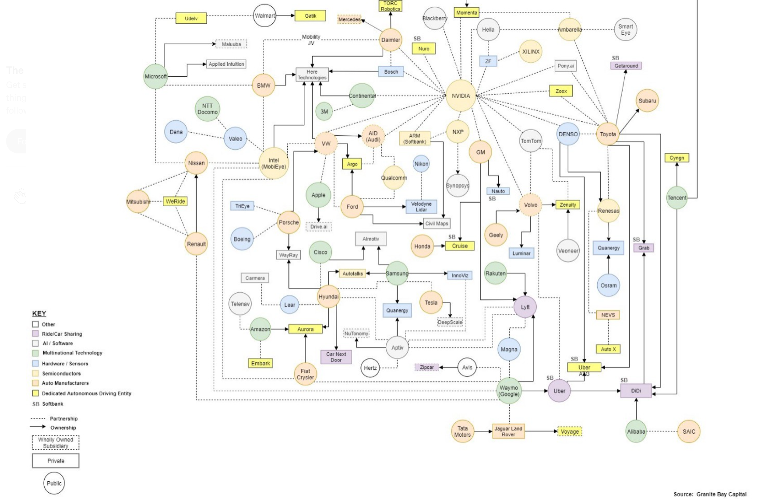

Go it alone- Toyota is building it’s own automotive OS

Heritage Providers- Continental + AWS

Technology Partner- Ford + Google

<$ScrKeepWithNext><$Scr_H::2><$Scr_Ps::1>Silicon providers
<!$Scr_H::2><!$Scr_Ps::1>NXP
Texas Instruments
Qualcomm

<$ScrKeepWithNext><$Scr_H::2><$Scr_Ps::1>Microcontroller/Microprocessor designers
<!$Scr_H::2><!$Scr_Ps::1>ARM

<$ScrKeepWithNext><$Scr_H::2><$Scr_Ps::1>Operating Systems
<!$Scr_H::2><!$Scr_Ps::1>
QNX
Linux for Automotive

