Qualcomm
Ian
Raya
Rob Reeves
Craig- OSS, Release management, compliance

Over 10000 requirements from Ferrari
Industry standard data format. They are also talking to CodeBeamer.
Meta Model that defines repo structure.

I introduce them to Team Topologies... they seemed to like the discussion and the terminology that they had been calling their Meta Model.

They often release one monolithic repo.

1. Patterns for Requirements to GitHub

Point of View
We believe Qualcomm is witnessing an emerging pattern in the automotive market that GitHub sees in numerous industries - the need to collaborate across ecosystems outside traditional organizational boundaries. The intersection of software and hardware engineering practices and the accelerating rate of change across the automotive ecosystem demands a new cloud-based platform for collaboration and innovation.

GitHub is taking our experience as the home of open source software and using it to build collaboration patterns that break traditional barriers. GitHub is also working with numerous ISV’s building communities around their code. These communities leverage the GitHub platform to facilitate distribution of SDKs, testing assets, and facilitate open communication between clients, partners, and SI’s working to integrate solutions into the end user consumer experience.

What’s the objective of the call for Ian? For Qualcomm?

What we’re working on for automotive
1. Virtualized chips in CI workflow for Actions custom runners. Enable faster development cycles for embedded developers, remove the fixed constraint of chip testing farms.
2. Compliance and coding standards in the developer workflow. We’re bring to compliance adherence what we’re doing for Security testing. Scanning the code earlier in the dev cycle, reporting compliance issues alongside vulnerabilities in the Pull Request.
3. Software defined Vehicle with Eclipse Foundation

1 . How does Qualcomm collaborate with industry ecosystems now?
a. What is the biggest blocker to tighter collaboration?
2. What would an ideal collaboration platform look like?

Trends
1. OEMs that were very hesitant to move to the cloud a couple years ago are now either in the process of moving or investigating. Driven by the need for faster innovation loops.
2. More interest in cross OEM collaboration within Europe

Concerns and Risks
1. How to share without IP leakage
2.

Another good book you might be interested in is a called “New Power” - How power works in our hyper-connected world and how to make it work for you.

Scenarios
1. Ford adds 3rd party developers directly to their on prem instance
2.

Rick- technical partner director

Jeremiah- Rob’s boss

Rob Reeves- wants to do as much as possible in the cloud.
The mobile group is the 900 lbs gorilla at Qualcomm

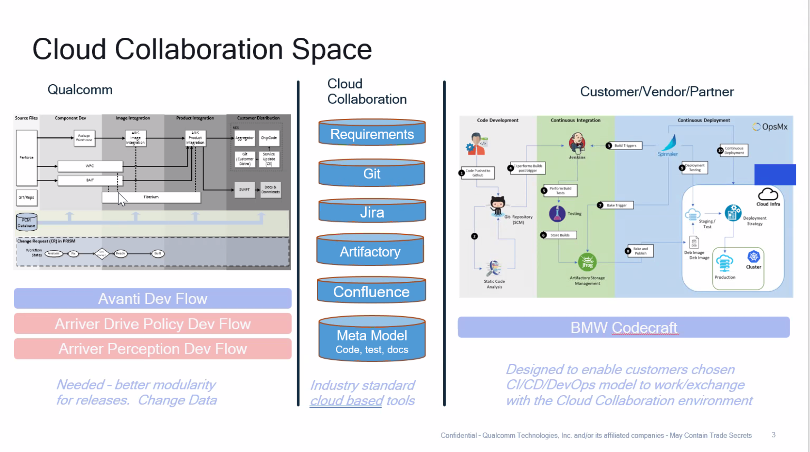
Improving Code to Cloud on a more regular cadence that’s easier for them to consume.
The space in between tools is where they get stuck.

Questions
1.

