<$ScrKeepWithNext><$Scr_H::1><$Scr_Ps::0>The Future of Automotive Development is in the Cloud
<!$Scr_H::1><!$Scr_Ps::0>
Automotive software development will be driven to the cloud. The race to deliver safe, sustainable, connected driving experiences for consumers is moving at a relentless pace with no sign of abating. Consumers want transportation that is connected and intelligent. Whether they are purchasing vehicles or using connected mobility services, the accelerated demands for software and data intensive capabilites is impacting the automotive ecosystem at every level.
Connected and Autonomous vehicles (CV and AV respectively) require new hardware and software architectures within the vehicle that are connected to the Cloud to deliver everything from realtime driving and safety functionality, to safety and entertainment services.
The battle to deliver the best driving experience has simulataneously driven the battle to provide the best cloud runtime to access High Performance Compute (HPC), large data storage…
The GitHub strategy of driving software development to the cloud…

This paper will lay out the path toward aligning our vision with the current realities of the automotive industry, our position within the largest players in the space, and explore ways that GitHub + MSFT and our partners can be an even bigger catalyst for driving industry wide change.

<$ScrKeepWithNext><$Scr_H::2><$Scr_Ps::1>The Automotive Software Development Legacy
<!$Scr_H::2><!$Scr_Ps::1>Traditional Automotive OEMs operate in rapidly changing, horizontal supply networks where value is created both in component subsystems and the finished vehicle.
The Cloud & digital native Electric Vehicle (EV) players have been setting the pace of innovation. Tesla and numerous Chinese startups, have much more vertically aligned supply chains, operate with a higher innovation velocity,and better unit economics .

Traditional OEMs are closing the gap in delivery of EVs, but with higher unit economics and the challenge of simultaneously operating traditional internal combustion engine operations along side electric vehicle development and production. In a recognition that this is creating complexity that hinders innovation and profitability, Ford recently announced a reorganization that would split it’s operations into ICE & EV business units. Model E, the EV unit is expected to deliver 30% of Ford’s revenue by 2030.
The methods of development that have governed automotive software engineering for decades were designed for software tightly coupled with the microcontrollers purpose built for each subsystem. Nearly every subsystem from braking systems, to power steering and seats have long had embedded software developed and delivered by Tier One Suppliers. Long standing contractual relationships have dictated who owns the source code and how that source code evolves. In Ford’s case, CEO Jim Farley has acknowledged “Our legacy organization has been holding us back”.

<$ScrKeepWithNext><$Scr_H::2><$Scr_Ps::1>Software Drives the Experience and the Value
<!$Scr_H::2><!$Scr_Ps::1>As software delivers more value to the car, the stakes for improved software competency are rising.

VW CEO Herbert Diess recently departed his role reportedly, at least partially over delays in key software projects. [Need other examples ]

<$ScrKeepWithNext><$Scr_H::2><$Scr_Ps::1>I. Strategic Opportunity: Enhance the relationship with Embedded Developers to influence future edge compute.
<!$Scr_H::2><!$Scr_Ps::1>
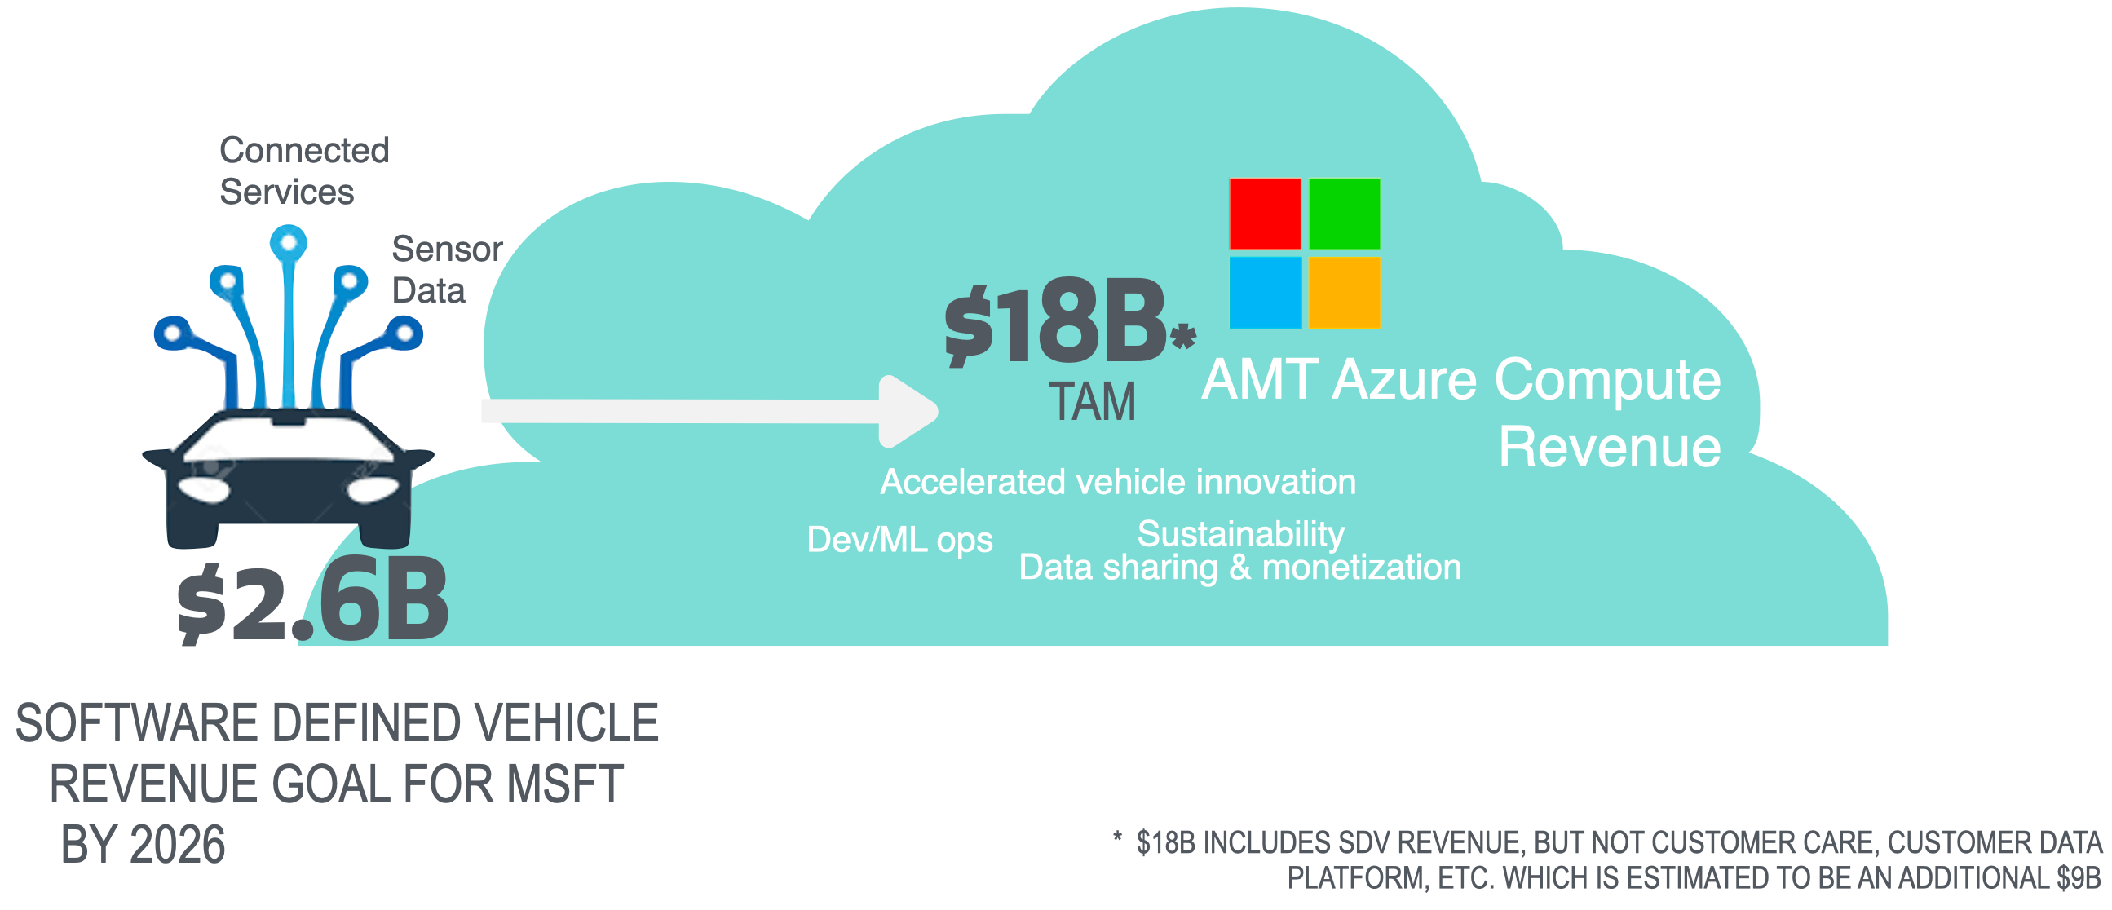

I. Strategic & Longer Term Opportunity- Provide secure, cross supplier network development and testing platform for Automotive Ecosystems.

Numerous converging forces at the intersection trends in the automotive industry and more broadly across technology will make development and collaboration in the cloud signficantly more economical and accelerate product delivery. GitHub has an opportunity to become the defacto collaboration platform across industry partners, suppliers, connected service providers and even regulatory bodies to accelerate the industry’s transformation. By extending GitHub’s developer first experience to the embedded development community, we can enable Microsoft harness the future data workloads that connected and autonomous vehicles will deliver. Workloads that Microsoft internal research suggests represent an increase from “vehicles today produce 100-400 GB of data per day while L4 (fully autonomous) test vehicles produce 15-90 TB “.
This paper will explore these converging forces and a path forward for GitHub to impact our clients, the community and the future of mobility.

OEM’s and their ecosystems are partnering with cloud providers to accelerate their ability to meet the rising expectations and capitalize on opportunties to create new business models and long term relationships with the consumer.

<$ScrKeepWithNext><$Scr_H::2><$Scr_Ps::1>How can GitHub add value?
- <!$Scr_H::2><!$Scr_Ps::1> • Bring modern cloud native development practices and tooling to embedded development teams
- Eliminate security and functional safety compliance friction for developers
- Provide patterns and cloud based collaboration space across enterprise ecosystems

How does this value map to the concerns of the industry? (UML diagram)

leverage the power of our community- enterprise and open source developers, to be a force in leading and enabling the industry to meet the challenges ahead.

The convergence of muliple industry and technology trends has been impacting the automotive industry for the past ten years.

Trend 1. Multipurpose microprocessors- Embedded development has historically consisted of tight coupling between software and hardware development teams. Software was purpose built in very close coordination with the teams building the hardware and each microcontroller had a very narrow focus. Development has been more recently moving to more multipurpose hardware and reusable software, often built on open source.

Trend 2.

GitHub provides the most robust and secure globally connected platform to facilitate highly connected digital innovation.

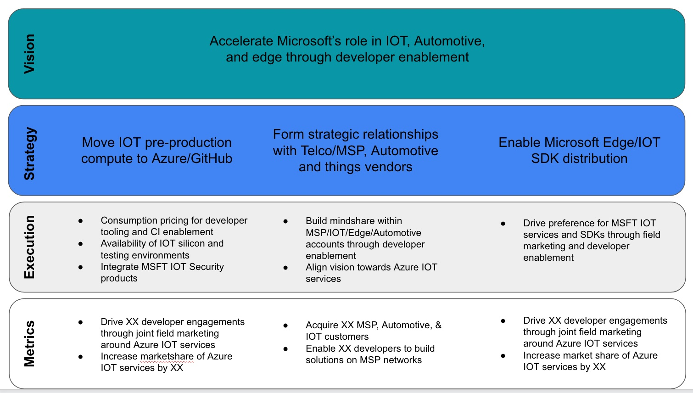

Market Opportunity

