Game Design Document

Fill up the Following document

1. **Write the title of your project.**

**Ans.** “Make your own lightsaber!” is the title of my project.

1. **What is the goal of the game?**

**Ans.** To create your own lightsaber and fight the enemy at the end with the lightsaber you made.

1. **Write a brief story of your game?**

**Ans.** You want to become a force user. In order to do so, you need to construct your own lightsaber first. After choosing your faction(Jedi or Sith) you have to build your own lightsaber. After you have completed the task, you have to fight an enemy as a test. If you win, you have passed the test. If you lose, you failed to become a force user.

1. **Which are the playing characters of this game?**

* Playing characters are the ones which respond to the user based on the input from the user
* Cars, monkeys, dinos, wizards etc, are the playing characters in the game.

|  |  |  |
| --- | --- | --- |
| **Number** | **Character Name** | **What can this character do?** |
| **1** | Yourself(No name) | Build a lightsaber and duel the enemy |
| **2** |  |  |
| **3** |  |  |
| **4** |  |  |
| **5** |  |  |
| **6** |  |  |
| **7** |  |  |
| **8** |  |  |

1. **Which are the Non Playing Characters of this game?**

* Non Playing characters are the ones which don't have an action or a behaviour when the user interacts with the game.
* Hurdles, stones, bananas, coins, etc are non-playing characters in the game.

|  |  |  |
| --- | --- | --- |
| **Number** | **Character Name** | **What can this character do?** |
| **1** | Darth Vader(If you choose to become a Jedi) | Duel with you as a final test. |
| **2** | Obi Wan Kenobi(If you choose to become a Sith) | Duel with you as a final test. |
| **3** |  |  |
| **4** |  |  |
| **5** |  |  |
| **6** |  |  |
| **7** |  |  |
| **8** |  |  |

**Draw your imagination of this game. What does this game look like?**

* Draw the game either on your computer or on paper,
* Add images of scenes of the game to show each of the playing and non-playing characters at least once.

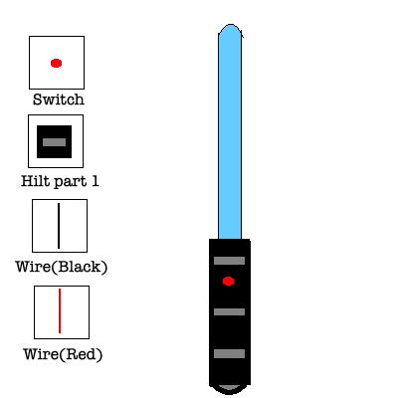

Construction of the saber(ROUGH)

**How do you plan to make your game engaging?**

**Ans.** I plan to make the game engaging by first letting the player customize their lightsaber with the various options given. After they do so they will have duel an enemy by pressing the keys mentioned in the instructions.