**Lab 3**

**A to D and PWM**

**Clayton Davidson - 000860643**

**February 16, 2022**

**P1**

**YouTube:** <https://youtu.be/t8YcDzk9mXY>

**P2**

**YouTube:** <https://youtu.be/1sCoAXcMtKQ>

**P3**

**

**200Hz / 75% Duty Cycle:**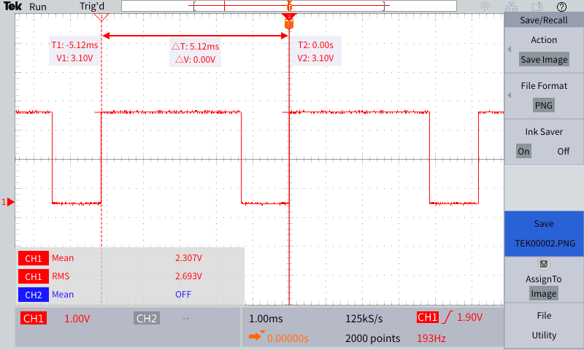

**1kHz / 10% Duty Cycle:**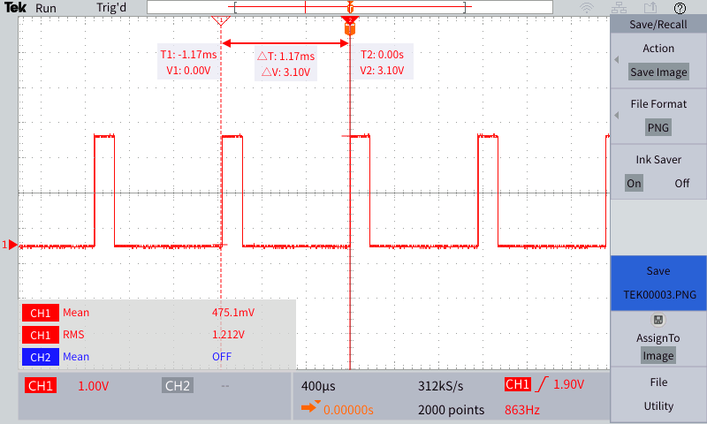

**1kHz / 90% Duty Cycle:**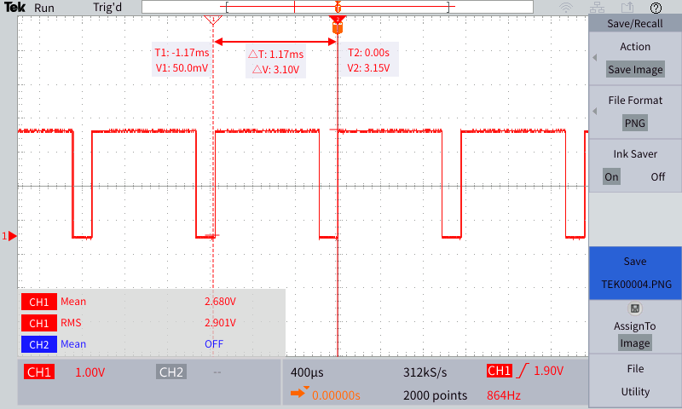

**Code:**

**P4**

**YouTube Video:** <https://youtu.be/QxOuXLfdOio>

**

**P5**

**YouTube:** <https://youtu.be/OoSk1vouQng>

**Critical Reflection**

Analog to Digital conversion and pulse-wave modulation are important parts of IoT systems. It allows us to turn physical input and/or data into digital data and manipulate it in digital space. This crossover from analog(physical, real-world) to digital is a massively important step in the process of interaction between our world and the technology we develop to better control our lives.

Lab 3 gave me some experience using PWM to control the output level of LEDs with a physical potentiometer. I also gained more hands-on experience using datasheets and small electronics such as LEDs, simple displays, potentiometers, resistors, and an A/D converter. This Lab was a great step in better understanding the workings of A/D conversion in a practical environment and being able to use the oscilloscopes to confirm our work was also very enlightening.

As usual, I had some minor, resolvable issues with Python syntax; but I feel confident saying that I had slightly fewer problems than last time! Creating an accurate bitmap for the LED display in Part 1 was somewhat more difficult that I first assumed it would be, but after being shown the proper format I was able to figure it out without too much further trouble. Using the smbus module also gave me some problems to start with but adding a sleep(0.1) function between writing and reading the smbus byte fixed my issue. Part 5 was interesting, converting from a single data input to multiple values and back to a single output provided some interesting problem-solving challenges. The ability to take raw, analog data, convert it into useful digital data and then manipulate that data to get a desired output or output effect is my most important take away from this Lab/Unit as I believe that the interaction between digital and real-world is growing more important every day. Being able to gather many points of raw data and use that to change and improve is what Industrial IoT is most useful for.