**Analyzing Tweets From @WeRateDogs**

[WeRateDogs](https://twitter.com/dog_rates) is a Twitter account create in November 2015, that rates people's dogs with a humorous comment about the dog. These ratings almost always have a denominator of 10. The numerators, though? Almost always greater than 10. 11/10, 12/10, 13/10, etc. Why? Because "they're good dogs Brent." WeRateDogs has over 8 million followers and has received international media coverage.

Through the data from the WeRateDogs account tweets we will answer some questions:

* **What is distribution the dog stage?**
* **What is the most common rating?**
* **What is the correlation between favorites and retweets?**
* **What is the most common dog names?**
* **What is the behavior of new tweets over time?**

### **What is distribution the dog stage?**

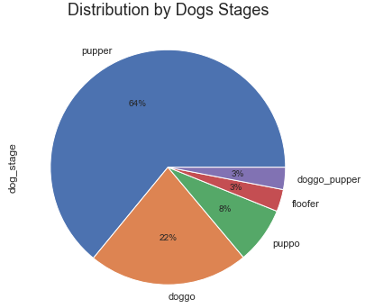

Analyzing the plot beside, we can see that dog stage majority is Pupper with 65% and the smallest is the Floofer and Doggo_Pupper with only 3%.

### **What is the most common rating?**

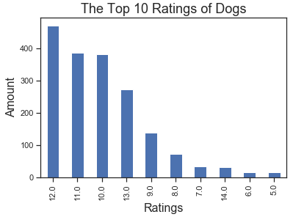

Analyzing the plot beside, we can see that most registered notes are equal to or greater than 10, with note 12 being more frequent.

### **What is the correlation between favorites and retweets?**

There is a strong and positive correlation between the amount of retweet and favorites. We can say that the more a bet is retweeted, the more favorites it receives.

### **What is the most common dog names?**

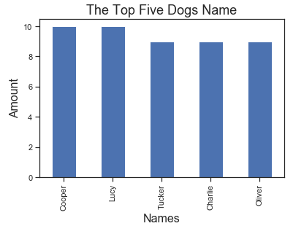

Analyzing the plot beside, we can see that most frequent names in the dataset are Lucy and Cooper.

### **What is the behavior of new tweets over time?**

We had a large amount of new tweets when the profile was created (November 2015), but still in the beginning of 2016 we have a sharp drop that slows down in the middle of the year and the downward trend continues throughout 2017.