July 2026

Zeitenwende: Showing in Numbers How the 2022 Russian Invasion of Ukraine Began an Arms Reshuffling Across Europe
Clayton Greenwell

Abstract
Following the February 2022 Russian invasion of Ukraine, European governments braced for a rebalancing of the world order. German Chancellor Olaf Scholz deemed this moment to be Europe’s Zeitenwende—a historic turning point. This report evaluates how the post-invasion period reshaped arms imports, arms exports, supplier-recipient relationships, and military expenditure across Europe. Aside from a supplier-recipient network analysis, all data used in this report is broken down across the four available years since the Russian invasion of Ukraine (2022-2025). All data is exclusive to European countries.
Import/export maps, supervised machine learning algorithms, and clustering with dimensionality reduction were used on this dataset. Germany, France, Italy, and the United Kingdom represent European arms export powerhouses, while Ukraine and Poland have become prominent importers. The top-supplier network shifted from a largely connected pre-invasion system to a fragmented, post-invasion seven-party system.
Extreme Gradient Boosting best predicted military expenditure as a share of GDP with an R-squared of 0.82 and an MAE of 0.0048; calendar year 2023 and aerial distance from Moscow dominated feature importance. Gradient Boosting classified whether the United States was a country's top supplier with 0.74 accuracy and 0.81 AUC; military expenditure per capita and import unit volume dominated feature importance. AdaBoost classified NATO membership with 0.90 accuracy and 0.95 AUC; military expenditure per capita and aerial distance from Moscow dominated feature importance. Nonlinear kernel PCA in combination with k-means clustering or agglomerative clustering produced similar silhouette scores of 0.65. The findings indicate a substantial post-invasion reorientation of European defense relationships.
Keywords: arms transfers; k-means clustering; AdaBoost; Russia-Ukraine War; dual-use technology; network analysis; agglomerative clustering; TIV; gradient boosting classifier; plurality; extreme gradient boosting

1. Introduction
This report seeks to address four questions: (1) Where have European arms exports and imports been most concentrated during the post-invasion period? (2) How did the top-supplier network change between pre-invasion and post-invasion? (3) Which variables were most predictive of military expenditure as a share of GDP, United States top-supplier status, and NATO membership? (4) What European country groupings emerged from clustering with dimensionality reduction?

2. Literature Review
According to Cepparulo and Pasimeni (2024) and Tian et al. (2023), Russia’s illegal 2014 annexation of Crimea revived the interest in a united European Union security policy and defense network. Unfortunately, the EU has a consistent issue with countries making grandiose commitments and public declarations but not following through on making meaningful advancements in military capability. Only 18% of EU defense investment is done collaboratively. The rest is country-first defense spending.
George and Sandler (2022) observed that while NATO membership grew during the late 1990s and early 2000s, (increasing risk as it neared Russia’s border,) European defense spending decreased or stagnated. Making the club bigger by expanding the alliance didn’t fix the issue of member commitment. The mathematical incentive to free ride went up, as there became a larger aggregate pool of defense spending to rely on without spending domestic capital. When frontline countries like Poland and the Baltic States increased spending, it had a negative effect, as Western European allies decreased spending in response. The analysis showed that the addition of Sweden and Finland as NATO members would increase the incentive to free ride within the alliance. Both countries have highly capable, well-funded militaries. Western European countries may use this to decrease spending.
Knezović and Tkalec (2025) posed an observation: For every 100 kilometers that a NATO member’s capital is located farther from Moscow, their average yearly military expenditure as a percentage of GDP has an associated decrease of 0.02 percentage points. Knezović and Tkalec (2025) found that Western NATO members, protected by geography, distance, and buffer states, were much less likely to see the rise of Russian aggression as an immediate threat demanding significant defense budget changes. The observed relationship between distance from Moscow and military expenditure was the inspiration behind the inclusion of aerial_distance_moscow_km in the compiled dataset.
Caldara and Iacoviello (2022) created a Geopolitical Risk Index that quantifies country-level geopolitical threat by using news text mining. This GPR Index was included in the compiled dataset.
Bachtiar et al. (2025) asserted that the most statistically significant variables correlated with high defense spending are ongoing active war, the presence of external foes, and the presence of past high budget trends. Good governance and national stability show a negative correlation with high defense spending. The variables that have no correlation with high or low defense spending are population size, GDP, democracy, type of governmental regime, trade openness, foreign direct investment, arms exports, and alliance membership.
It is a recurrent theme in the literature that Europe does not have the robust defense industry that the United States enjoys, and that the wider-European economy may suffer from lost opportunity due to this shortcoming. Knezović and Tkalec (2025) looked at the relationship between defense spending and the larger economy by comparing Keynesian and neoliberal economic theories. Keynesian economic theory suggests that increasing government defense spending in a country will result in a powerful macroeconomic stimulant in the economy. Neoliberal economic theory rejects this assertion, claiming that defense spending is a public good that crowds out private investment and is a dead-end for capital, and that having state investment in the building of weapons starves the economy of the infrastructure that builds compounding long-term wealth.
Lebacher et al. (2021) and Pamp et al. (2021) inspired the inclusion of a Gephi supplier-recipient network analysis in this report. Lebacher et al. (2021) used advanced statistical network modeling to track arms transfers as a dynamic network. They observed that though the gravity model of trade dictates that cost and nearest location (i.e. shipping cost,) play a role in all economic movement, they do not play a role in the arms trade. The decision of which country to import arms from has much more to do with long-term diplomatic and geopolitical relationships. Pamp et al. (2021) expanded on this idea by introducing the Heckman Selection Model concept—separating the decisions of “with whom to trade” from “how much to trade”. They separated the decision into (1) the matchmaking phase between countries as exporter and importer, and (2) the size of the transaction.

3. Data and Methods

3.1 Data sources and scope
An extensive amount of data cleaning was done to transform the datasets listed in Table 1 into a single, clean, usable spreadsheet.

Table 1. Data sources
Source | Contribution to the dataset
SIPRI Arms Transfers Database | Arms import TIV units, arms export TIV units, top supplier country.
SIPRI Arms Industry Database | Country representation among the SIPRI Top 100 defense companies.
SIPRI Military Expenditure Database | Military expenditure as a share of GDP, per-capita expenditure, and expenditure as a share of government spending.
Geopolitical Risk Index | Country-level geopolitical-risk indicator from Caldara and Iacoviello (2022).
Google Maps | Aerial distance in kilometers between each national capital and Moscow.
Note. SIPRI = Stockholm International Peace Research Institute; TIV = Trend Indicator Value.
The Stockholm International Peace Research Institute (SIPRI) is a globally renowned think tank known for tracking the global arms industry. Their datasets have been used in countless peer-reviewed publications.
Aside from a later experiment with Gephi, all data used is broken down across the 4 years since the Russian invasion of Ukraine (2022-2025). All data is exclusive to European countries.
This article’s definition of “Europe” includes all countries that are members of the Council of Europe. Russia is included, though it was expelled from the Council in 2022. Belarus and Kosovo were also included, despite not being Council members. Five “microstates” were excluded from all visualizations: Andorra, Liechtenstein, Monaco, San Marino, and Vatican City. Various disputed states were excluded: Northern Cyprus, Transnistria, Abkhazia, and South Ossetia.
Article 41(2) of the Treaty on European Union prohibits the regular EU budget from being used for military defense purposes. Some EU states have contributed to a workaround agency called The European Peace Facility. The EPF purchases arms as a unified body. Many of these arms are given to Ukraine or are used to bolster a collective NATO/EU defense network (Cepparulo & Pasimeni, 2024). As this is a collective agency that operates on the fringe of the EU, it’s important to understand that imports and exports from this agency would not appear in import/export visualizations unless an actual country (like Ukraine) is receiving those arms as an import.

3.2 Data preparation, feature construction, and overlapping features
The SIPRI datasets obtained contained missing values. Linear interpolation was the constant method used to fill these missing values when appropriate. Several features were constructed from calculations involving other features: import_export_ratio, import_growth_rate, export_coverage_ratio, ME_spending_%_GDP_growth_rate, and export_growth_rate.
There are many variables in this dataset that contain an element of overlap:
• import_TIV_millions
• import_export_ratio
• import_growth_rate
• export_coverage_ratio (calculation relies on import_TIV_millions)
• ME_spending_%_GDP
• ME_spending_%_GDP_lead_1_year
• ME_per_capita_in_USD
• ME_%_gov_budget
• ME_spending_%_GDP_growth_rate

As an example, it’s understandable that a country’s arms imports (import_TIV_millions) will correspond directly to that country's military expenditure as a percentage of GDP (ME_spending_%_GDP). Issues regarding overlap are dealt with appropriately in the code with some features being removed from certain machine learning experiments.
Some of the most interesting and usable features include:
• export_TIV_millions
• export_growth_rate
• aerial_distance_moscow_km
• GPR_index
• is_in_NATO?
• top_supplier_country
• is_US_top_supplier_country?
• companies_in_sipri_top_100

Many countries in companies_in_sipri_top_100 contain fractional values. This is due to joint-EU defense companies that spread operations across multiple EU countries without assigning ownership to a single state.

3.3 Measures
Arms-transfer volume is reported in SIPRI Trend Indicator Values, commonly known as TIV units. TIV units are the gold standard for arms measurements because they help normalize what would otherwise be a very difficult calculation. (Keep in mind that using euros or dollars sold wouldn’t be practical in a long-term study, as there were long periods during the Cold War that the US and USSR gave away weapons to other countries for free). As a measurement tool, TIV units standardize production costs by evaluating raw capability and resources required to build hardware (SIPRI, n.d.).

3.4 Geographic visualizations
The export and import visualizations calculate average annual country values for 2022-2025. Tableau was used to present geographic data.

3.5 Supplier-network analysis
Gephi is a powerful visualization tool for building network models. Perfect for visualizing supplier-recipient relationships, it gives us unique insight into how Russia’s 2022 invasion of Ukraine disrupted a well-connected European arms network.
With the invasion beginning in 2022, we have 4 full years of post-invasion data (2022-2025). Using these 4 years, we look at the total TIV units imported by every European country to determine its top supplier (SIPRI, n.d.). This metric relies on plurality. For example, a country could have a very diverse supplier profile with their top supplier only making up 30% of their imports. But that top supplier would still be the most important defense relationship—and it would be reflected in this metric. A separate visualization is created using supplier data from the four years leading up to the war, (2018-2021,) giving us an idea of what the supplier-recipient relationships looked like before the disruption.

3.6 Supervised learning
Three supervised learning models were evaluated. The regression model predicted military expenditure as a share of GDP (ME_spending_%_GDP). Two binary classification models predicted whether the United States was a country's top supplier and whether a country was a NATO member. Candidate models were compared, and PyCaret's tune_model() function was applied to the best performing classification models.
In relation to the NATO membership classification model, one interesting caveat in the target data was that Finland became a NATO member in 2023, and Sweden a member in 2024.
Regression performance was summarized by mean absolute error (MAE), mean squared error (MSE), root mean squared error (RMSE), and R-squared. Classification performance was summarized by accuracy, area under the curve (AUC), recall, precision, and F1 score.

3.7 Clustering and dimensionality reduction
K-means clustering and hierarchical agglomerative clustering were evaluated under three conditions: without dimensionality reduction, two components from linear principal component analysis (PCA), and two components from nonlinear kernel PCA. Dendrograms, elbow plots, scatter plots, and silhouette scores were used to assess clustering model performance.

4. Results

4.1 Post-invasion arms exports and imports
Average Annual European Arms Exports
2022-2025, measured in SIPRI TIV units
Open interactive visualization | Download Tableau workbook
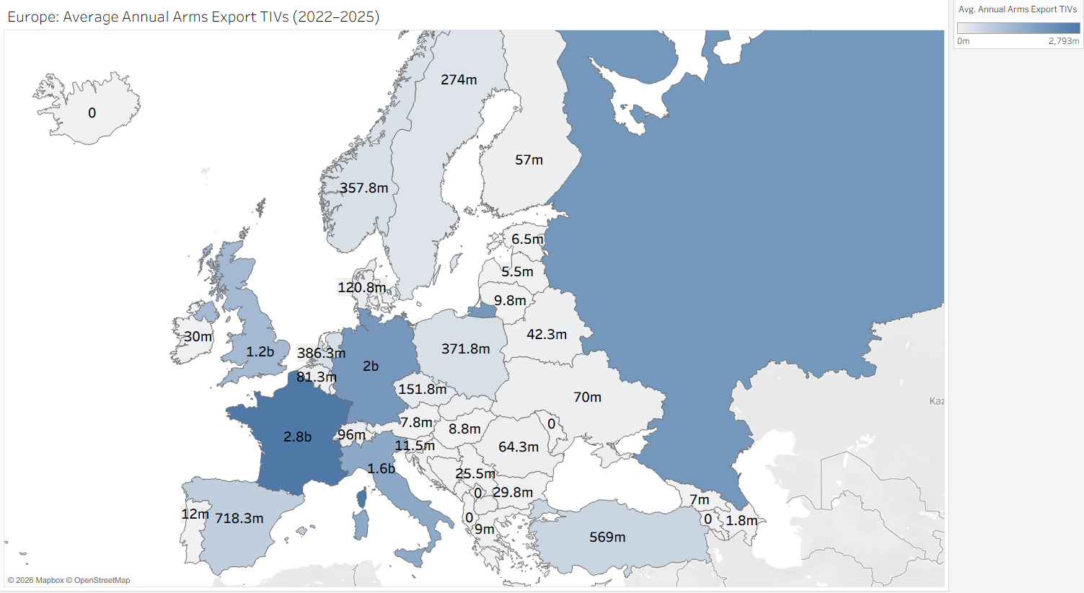

Figure 1. Average annual European arms exports, 2022-2025.
Note. This figure is intended as an interactive map rather than a static image.

Germany, France, Italy, and the United Kingdom are strong European engine economies that have the capacity to develop and export an incredible number of arms. These 4 countries together have had an average annual output of 7.47 billion TIV units since the start of the war. SIPRI compiles a yearly list of the Top 100 Global Defense Companies. Germany, France, Italy, and the United Kingdom have collectively comprised roughly 20% of the companies listed since the outbreak of war in 2022 (SIPRI, n.d.).
Despite tough foreign sanctions and the ongoing domestic needs of immediate warfare, Russia has managed to export an average of 2 billion TIV units a year since the start of the war. Arms sales to countries like India have helped to bolster Russia’s struggling economy (SIPRI, n.d.). On the world market, many of Russia’s most sought-after weapons rely in some small part on small components manufactured in the United States, the United Kingdom, and other Western countries attempting to enforce sanctions and export control restrictions (George & Sandler, 2022). Export control restrictions are meant to throttle Russia’s supply of these dual-use components. Russia’s inability to access advanced computer chip technology is a critical chokepoint affecting Russia’s arms industry (George & Sandler, 2022).

Average Annual European Arms Imports
2022-2025, measured in SIPRI TIV units
Open interactive visualization | Download Tableau workbook
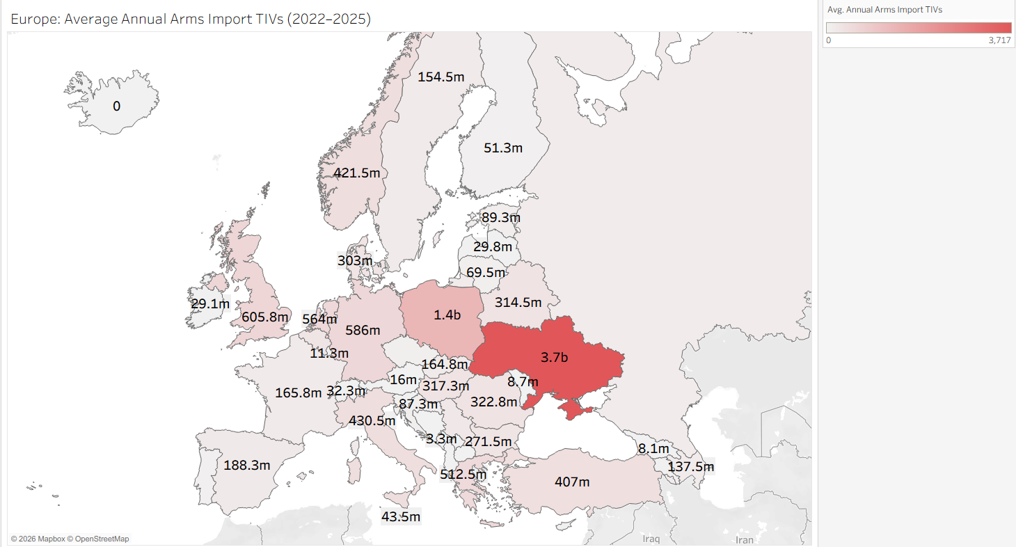
Figure 2. Average annual European arms imports, 2022-2025.
Note. This figure is intended as an interactive map rather than a static image.

Ukraine’s massive annual import of 3.72 billion TIV units worth of arms sits as an outlier, massively tipping the color scale and leaving other countries unsaturated.
Despite this outlier, important information can be gleaned by country shading that isn’t as immediately stark. Poland’s annual average import of 1.38 billion TIV units is reflective of the emerging role that Poland now plays as Europe’s rising military power.

4.2 Fragmentation of the top-supplier network
In Figure 3, we see a remarkable amount of connectedness amongst nearly all European countries and their suppliers. The United States stands out as a giant top supplier for the most countries at 19 supplied. Even Russia is connected in this arms supply network, although for unusual reasons. To our surprise, Russia’s top arms supplier before the outbreak of war was in fact Ukraine. This is due to a concept called dual-use technology, where a technology sold for civilian purposes can be repurposed for military use. SIPRI’s 2018 data shows TIV unit transfers from Ukraine to Russia (SIPRI, n.d.). Though supply contracts were terminated between Russia and Ukraine in 2014, transferred parts (Antonov An-148-100E transport jet parts) assembled in Russia had licensing tied to a defense company based in Ukraine, with the transfer not being recorded by SIPRI until 2018 (UNIAN, 2019). Evidence is unclear as to whether Russia has used these transport jets for military purposes since the start of the invasion, but the example stands as a reminder that dual-use technology creates an incredible amount of overlap between the aerospace and defense industries.
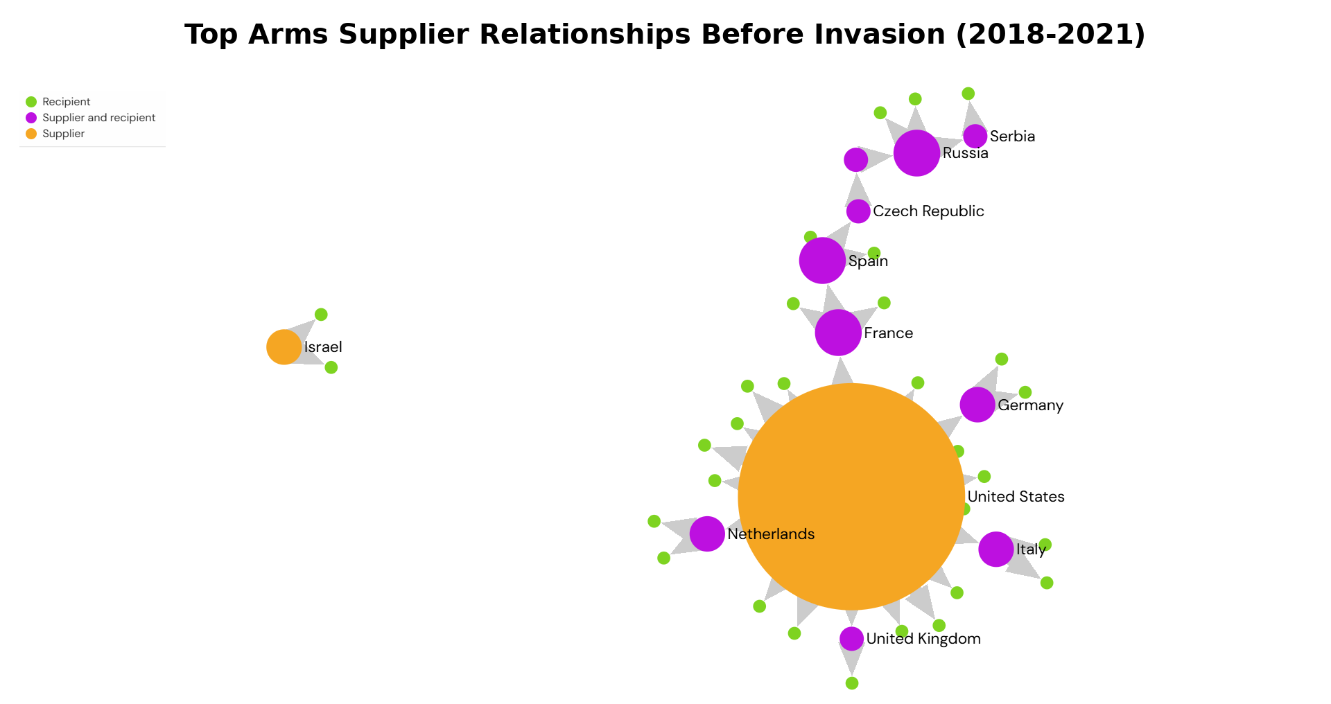
Figure 3. Top arms supplier relationships in Europe before the full-scale invasion, 2018-2021.

Figure 4 shows this same European arms supply network become incredibly fragmented after the outbreak of the full-scale invasion. We see the existence of 7 unconnected networks: the United States, Israel, India, Brazil, Iran, China, and South Korea. The disparity in connectedness between the pre-invasion Figure 3 and the post-invasion Figure 4 shows us a European arms supply network that has splintered, with governments realigning their priorities and alliances.
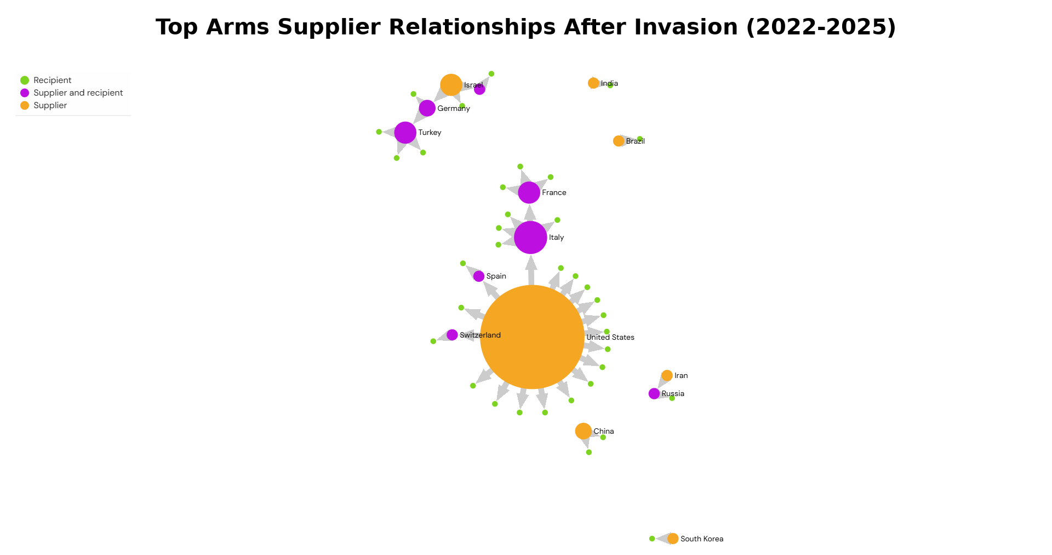
Figure 4. Top arms supplier relationships in Europe after the full-scale invasion, 2022-2025.

4.3 Regression model for military expenditure
Extreme Gradient Boosting proved to be the best performing regression model, with an MAE of 0.0048, MSE of 0.0001, a RMSE of 0.0084, and an R-squared of 0.82. It is important to note that the target, ME_spending_%_GDP, is stored as a proportion: 0.03 meaning 3% of GDP. Therefore, an MAE of 0.0048 means approximately 0.48 percentage points, and not 0.0048 percentage points. The two most influential features were the indicator for calendar year 2023, which accounted for more than 0.80 of feature importance, and aerial distance from Moscow, which accounted for roughly 0.15. The dominance of 2023 is consistent with a one-year budgeting lag: 2022 revealed the strategic shock, whereas 2023 was the first full budget year in which governments could systematically redirect funding priorities.
Table 2. Reported performance of the regression model
Target | Selected model | Reported metrics | Most important reported features
Military Expenditure as a Percentage of GDP | Extreme Gradient Boosting | MAE = 0.0048; MSE = 0.0001; RMSE = 0.0084; R-squared = 0.82 | Calendar year 2023 (>0.80); aerial distance from Moscow (~0.15)
Note. An MAE of 0.0048 corresponds to approximately 0.48 percentage points of GDP.

4.4 Classification models
Table 3. Reported performance of the two classification models
Target | Selected model | Reported metrics | Most important reported features
United States as Top Supplier | Gradient Boosting | Accuracy = 0.74; AUC = 0.81; recall = 0.58; precision = 0.61; F1 = 0.58 | imports (0.18); military expenditure per capita (~0.14)
NATO Membership | AdaBoost | Accuracy = 0.90; AUC = 0.95; recall = 0.89; precision = 0.96; F1 = 0.92 | Aerial distance from Moscow (~0.16); military expenditure per capita (~0.23)
Note. Tuning increased AUC for the United States top-supplier model but reduced accuracy and precision. Tuning did not improve the NATO membership model.
For United States top-supplier status, the best performing model was a Gradient Boosting Classifier. This classifier held an accuracy of 0.74, an AUC of 0.81, a recall of 0.58, a precision of 0.61, and an F1 score of 0.58. When using PyCaret’s tune_model() function, we end up with a classifier with higher AUC, but with slight reductions in accuracy and precision. The two most important features were arms imports (reported in TIV units), which accounted for around 0.18 of feature importance, and military expenditure per capita, which accounted for roughly 0.14.
For NATO membership, the best performing model was an AdaBoost Classifier. In contrast to other tree models like Extra Trees, AdaBoost builds decision trees in a sequence, having each new tree correct earlier classification mistakes. Our AdaBoost Classifier held an accuracy of 0.90, an AUC of 0.95, a recall of 0.89, a precision of 0.96, and an F1 score of 0.92. This NATO Membership AdaBoost Classifier substantially outperformed the top-supplier classifier on every reported metric. The two most important features were military expenditure per capita, which accounted for around 0.23 of feature importance, and aerial distance from Moscow, which accounted for roughly 0.16. When using PyCaret’s tune_model() function, we didn’t see any improvement over our original model.

4.5 Clustering and dimensionality reduction
Table 4. Summary of clustering results
Dimensionality Reduction | Algorithms | Clusters and score | Interpretation of clusters
No dimensionality reduction | K-means; hierarchical agglomerative | Best silhouette = 0.22 (K-means) | Weak and difficult-to-interpret structure.
Linear PCA, 2 components | K-means; hierarchical agglomerative | 3 clusters; best silhouette = 0.54 (K-means) | Major import/export powers; lower-spending countries; Ukraine as a separate outlier cluster.
Nonlinear kernel PCA, 2 components | K-means; hierarchical agglomerative | 3 clusters; best silhouette = 0.65 (tie) | A compact low-import group; a NATO/United States-supplied group; a mixed group containing several major military powers.

The first attempt at clustering did not involve dimensionality reduction. It produced results that were not significant or meaningful. The dendrogram plot is unreadable, and we’re left with our best silhouette score being only 0.22 (a k-means clustering model).
The second clustering attempt used linear PCA as its method of dimensionality reduction with improved results. When reducing our features down to two linear principal components, we get a dendrogram and distortion score elbow plot that favors 3 clusters (in both our k-means clustering model and our hierarchical agglomerative clustering model). When creating 2D scatter plots of the clusters, our k-means model and our hierarchical agglomerative model give us nearly identical results, with the only difference being small border data points between the top-left corner and bottom-left corner clusters. The top-left corner cluster groups together countries known to be major military import or export powers: Russia, France, Turkey, United Kingdom, Poland, Italy, and Germany. The bottom-left corner cluster groups together countries that have relatively low military spending needs: Ireland, Iceland, Malta, Kosovo, etc. Ukraine, (a strong outlier as an active war zone,) becomes its own cluster. The k-means model gives us the slightly better of the two silhouette scores at 0.54.
The third clustering attempt uses nonlinear kernel PCA as its method of dimensionality reduction. When reducing our features down to two nonlinear principal components, we get a dendrogram that favors 3 clusters (in both our k-means model and our hierarchical agglomerative model). When creating 2D scatter plots of the clusters, our k-means model and our agglomerative model once again give us nearly identical results (the main difference being a few United Kingdom data points at the bottom center of both plots).
The top-center of the scatter plot gives us our tightest cluster, composed mostly of smaller countries without much need in terms of military spending: Iceland, Portugal, Malta, Montenegro, etc. Many of these countries have periods of low or no arms imports. The bottom-right cluster includes countries with major military capabilities, (Russia, Ukraine, France, Poland, Turkey) but many additional countries that don’t form clear similarities. In the bottom-left corner, we get a cluster of many NATO members: Norway, Sweden, Lithuania, Netherlands, Slovakia, Germany, etc. Another commonality of this cluster is that most of the countries have the US as their top arms supplier. Both the k-means model and the agglomerative model give us our best resulting silhouette score: 0.65.
It should be noted that Ukraine’s data points were a massive outlier. When forcing the number of clusters to be exactly 2, all 4 of the plotted models preferred clustering Ukraine on its own, with the remaining cluster containing all other European countries. Ukraine is the main warfront, having transformed its economy into an engine to sustain a long-term, grinding war of attrition.

5. Discussion

5.1 Polish arms demand
On the surface, Poland is a country at peace containing many attributes that make war seem incredibly unlikely. A close partner of the United States, Poland is a member of NATO and therefore has considerable shielding due to NATO’s Article 5 collective defense obligation. The bigger picture is that NATO membership alone doesn’t ease or erase recent memory. Unlike most Western European countries, Poland has a recent history of being subjected to Russian occupation and undue influence. Russia, (as its predecessor state, the USSR,) had some sort of troop presence inside Poland’s borders from 1939 to 1993, stretching 54 years of selective leverage (Nawrocki, 2023).
There exists a strong belief in Poland that Russia will use their borders to test the seriousness of NATO’s Article 5. As a country, Poland sits geographically between several pain points: a shared border with Ukraine, a shared border with Russia’s exclave of Kaliningrad, a shared border with Russia’s vassal state Belarus, and the Suwałki Gap corridor connecting the Baltic States to the rest of NATO. Seeing these four fragile border vulnerabilities, Poland has prioritized its territorial integrity, bolstering its military stockpiles in preparation for Russian maneuvering (Tian et al., 2023).
One could surmise from both Figure 1 and Figure 2 that it would make sense for a country like Poland to take the domestic manufacture of arms much more seriously, being that they are both at peace and in a relatively high need for dramatically high imports. This gets to one of the known realities of arms exporting: arms exporting is a tight circle that new countries do not join. Developing economies do not develop arms-making engines alongside their growing industry. A small group of players dominates the arms exporting market with no room for new players. The vast majority of countries in the world will always be importers, while a select few will remain export powerhouses (Lebacher et al., 2021)

5.2 Budget timing and distance from Moscow
As governments create central budgets in the year prior based on geopolitical risks encountered recently, it can be derived that a massive and unpredicted reshuffling of risk in 2022 would be first noticed in most European government spending patterns in calendar year 2023. We see this global reshuffling play out precisely in our regression model. When using military expenditure as a share of GDP as our target, we are left with 2 features that are of the most importance: data from calendar year 2023 (> 80%) and the aerial distance that a European capital sits from Moscow (~15%). With 4 years of war sampled in this dataset, (2022 through 2025,) it would be understandable that the year 2023 would bear the most importance, as it is the first year in which central budgets across Europe were given a chance to plan for and redirect capital toward growing uncertainty in the East.
To explain why our additional feature aerial_distance_moscow_km played significant importance, we need to explain the inspiration behind its inclusion in the dataset. Knezović and Tkalec (2025) posed an observation: For every 100 kilometers that a NATO member’s capital is located farther from Moscow, their average yearly military expenditure as a percentage of GDP has an associated decrease of 0.02 percentage points. Knezović and Tkalec (2025) found that Western NATO members, protected by geography, distance, and buffer states, were much less likely to see the rise of Russian aggression as an immediate threat demanding significant defense budget changes.
Aerial distance from Moscow also played importance in the NATO membership classifier, accounting for roughly 0.16 of importance. It makes sense that distance from Moscow would correlate highly with NATO membership, as NATO was a Western alliance that slowly moved east. Many countries closer to Moscow (Georgia, Ukraine, Moldova, etc.) are not members, as Russia has prevented their acceptance into the alliance by claiming territory within their borders.

5.3 Supplier fragmentation
Figure 3’s pre-war arms network’s surprising connectedness is not coincidental. Students of history may remember the First World War as a confounding conflict with a complicated list of reasons for its beginning. But history teachers hold on to a single foundational axiom that best sums up the powder keg that began the Great War: The system of alliances that had kept Europe at peace had broken down. We can view the remarkable connectedness of the 2018-2021 European arms network modeled in Figure 3 as an individual system of alliances exclusive to weaponry and defense. It cannot be inferred that the fragmentation that is reflected in the post-invasion Figure 4 will begin a global conflict like the First World War. But it is a grave illustration of the seriousness and significance of this current conflict: Europe’s first large, conventional land war since the World War period.

5.4 Interpretation of supervised learning results
Gradient Boosting was uniquely positioned to excel where other regression and classification algorithms failed, as this was a small dataset (only 180 records). Extreme Gradient Boosting and Gradient Boosting are known to handle interactions well. Boosted tree structured models are better at modeling nonlinear relationships, as well as working with the necessary inclusion of outliers, (i.e. Ukraine and Russia,) whereas other regression models could easily be pulled astray.
Decision Tree models usually come out on top when we pit several classification models against each other, but we can infer that the reason AdaBoost triumphed over other decision tree models was that the dataset had 2 very important features that together held a variable importance of around 0.39. With 2 features creating strong thresholds, AdaBoost’s sequential tree design was uniquely suited to pick up on small additional observations missed that were not geographical (aerial distance from Moscow) or financial (military expenditure). To put it simply, all decision tree models picked up on aerial_distance_moscow_km and ME_per_capita_in_USD being the most important features, but AdaBoost was able to find minor tweaks for other features once it understood the major importance of the first two.

6. Conclusion
To assess questions posed in the Introduction:
(1) Where have European arms exports and imports been most concentrated during the post-invasion period? We observe arms exports concentrated in the European engine economies of Germany, France, Italy, and the United Kingdom. We observe significant arms import concentration in Ukraine and Poland.
(2) How did the top-supplier network change between pre-invasion and post-invasion? We observe a pre-invasion supplier-recipient network that appears remarkably connected. We observe a post-invasion network that has broken into 7 unconnected networks, suggesting a significant reshuffling in the European arms supply network.
(3) Which variables were most predictive of military expenditure as a share of GDP, United States top-supplier status, and NATO membership? Calendar year 2023 and aerial distance from Moscow were the most important variables when predicting military expenditure as a share of GDP. Military expenditure per capita and arms import units were the most important variables when predicting United States top-supplier status. Military expenditure per capita and aerial distance from Moscow were the most important variables when predicting NATO membership.
(4) What European country groupings emerged from clustering with dimensionality reduction? The main groupings observed were a low-import group, a major import/export power group, and a Ukraine-alone outlier group.
The findings indicate a substantial post-invasion reorientation of European defense relationships.

Data and Materials Availability
The dataset used in this report can be found here.

References
Bachtiar, M., Ahmad, I., Sahabuddin, Z. A., & Trismadi, T. (2025). A comprehensive meta-analysis of determinants influencing military expenditure: New methodological insights and implications for defence budget allocation. Statistika, Politika i Polityka, 16(1), 87-103. https://doi.org/10.1515/spp-2024-0024
Caldara, D., & Iacoviello, M. (2022). Measuring geopolitical risk. American Economic Review, 112(4), 1194-1225. https://doi.org/10.1257/aer.20191823
Cepparulo, A., & Pasimeni, P. (2024). Defence spending in the European Union (European Economy Discussion Paper No. 199). European Commission, Directorate-General for Economic and Financial Affairs. https://doi.org/10.2765/883426
George, J., & Sandler, T. (2022). NATO defense demand, free riding, and the Russo-Ukrainian war in 2022. Journal of Industrial and Business Economics, 49, 783-806. https://doi.org/10.1007/s40812-022-00228-y
Google. (n.d.). Google Maps. https://maps.google.com
Knezović, S., & Tkalec, M. (2025). Defense spending, conflict and economic growth in Europe. Peace Economics, Peace Science and Public Policy, 31(4), 461-486. https://doi.org/10.1515/peps-2025-0004
Lebacher, M., Thurner, P. W., & Kauermann, G. (2021). A dynamic separable network model with actor heterogeneity: An application to global weapons transfers. Journal of the Royal Statistical Society: Series A (Statistics in Society), 184(1), 201-226. https://doi.org/10.1111/rssa.12620
Nawrocki, K. (2023, September 18). Guardians of foreign interests. Institute of National Remembrance.
Pamp, O., Lebacher, M., Thurner, P. W., & Ziegler, E. (2021). Explaining destinations and volumes of international arms transfers: A novel network Heckman selection model. European Journal of Political Economy, 69, Article 102033. https://doi.org/10.1016/j.ejpoleco.2021.102033
Stockholm International Peace Research Institute. (n.d.-a). SIPRI Arms Industry Database. https://www.sipri.org/databases/armsindustry
Stockholm International Peace Research Institute. (n.d.-b). SIPRI Arms Transfers Database. https://www.sipri.org/databases/armstransfers
Stockholm International Peace Research Institute. (n.d.-c). SIPRI Military Expenditure Database. https://www.sipri.org/databases/milex
Tian, N., Lopes da Silva, D., Béraud-Sudreau, L., Liang, X., Scarazzato, L., & Assis, A. (2023). Developments in military expenditure and the effects of the war in Ukraine. Defence and Peace Economics, 34(5), 547-562. https://doi.org/10.1080/10242694.2023.2221877
UNIAN. (2019, March 19). Ukroboronprom refutes allegations of arms supplies to Russia. https://www.unian.info/economics/10484022-ukroboronprom-refutes-allegations-of-arms-supplies-to-russia.html

