Zeitenwende (historic turning point)
Decline of the Peace Dividend
Hypothesis idea: Which major exporters are Eastern European countries flocking to after the Russian invasion—US, UK, or France?
- The biggest single event in the history of arms trade data is the collapse of the USSR. The USSR could no longer fund proxies, and a gluttony of cheap used weapons entered the market. This event involved Ukraine, as Ukraine possessed an incredible amount of arms that it sold off quickly to buyers regardless of political affiliation. Open with this, relate this key point to Russia’s actions in invading Ukraine.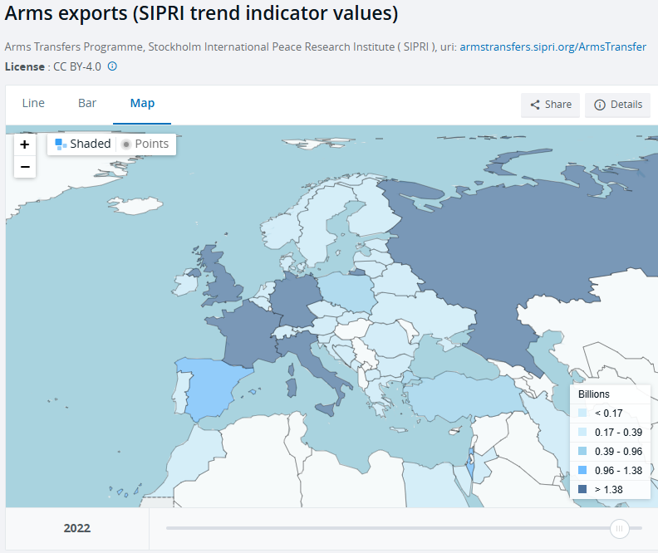 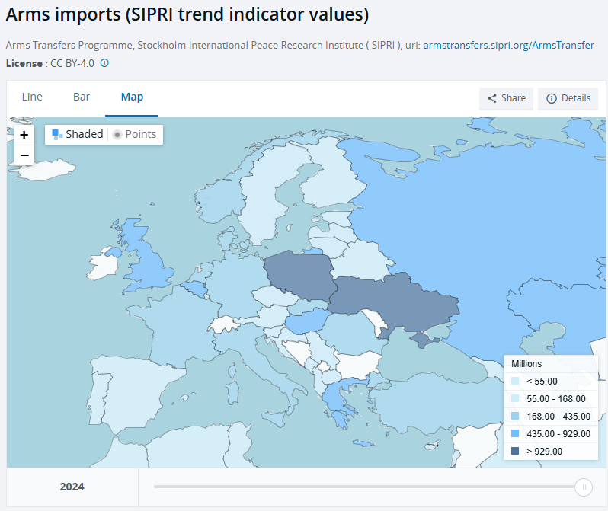
- A dynamic separable network model with actor heterogeneity: An application to global weapons transfers
- Pg 220, Figure 8 importer/exporter Functional PCA
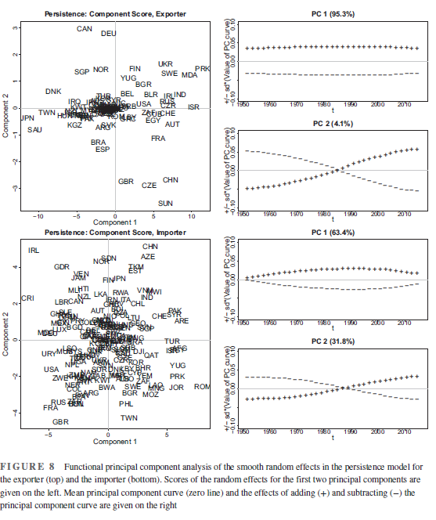
- Pg 206, Figure 1 Node relationships of arms transfers. One graph is 2015. The next is 2016.
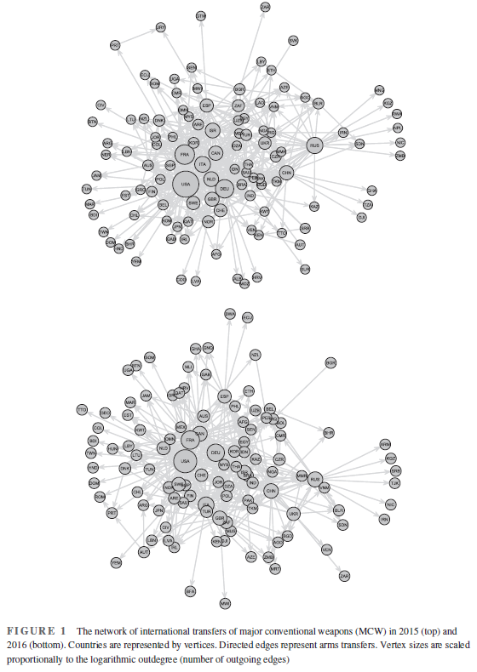
- Uses advanced statistical network modeling to track arms transfers as a dynamic network.
- Gravity model dictates that cost and nearest location (shipping cost) play a role in all economic movement. But they play NO role in arms transfers. Buying arms is a deep, incredibly important act for weaker countries, as it means being tied and reliant on this major power for a LONG time.
- Uses 66 years of SIPRI data.
- The flow of global military power is incredibly centralized: there is no room for new players. Looking at a node map, many little countries remain on the edge of the map with only importing, no exporting.
- 78% of countries do not export weapons.
- US, UK, France, Russia, China, Germany, Italy, Canada are the biggest players
- US exported to 66 different nations in a single year.
- Germany and Indonesia used to be top importers. Now it’s Saudia Arabia and UAE.
- Transitivity – the friend of a friend logic, creating triadic relationships to pool risks and build trust. If country A trusts and sells to country B, and country B trust and sells to country C, country A is likely to let country C into the game.
- Reciprocity – mutual import and export. (NATO, UK and US)
- Shared Suppliers – 2 countries engaging in arms trades because they share the same major tier-1 supplier. Trade is sporadic and not long term.
- Almost 10% of two-way arms trade relationships last over 20 years. 35% last for 5 years.
- In the wake of the Cold War ending and countries like the US or France being less likely to fund movements based on ideology, the driving force that filled that vacuum was cold hard cash. Aligning with democracy or communism was no longer the biggest determinate of the tier 1 supplier structure; it was who was planning to spend. This shapes global alliances and diplomacy.
- The biggest single event in the history of arms trade data is the collapse of the USSR. The USSR could no longer fund proxies, and a gluttony of cheap used weapons entered the market.

- Explaining destinations and volumes of international arms transfers: A novel network Heckman selection model
- Pg 12, Fig 3 probability curve?
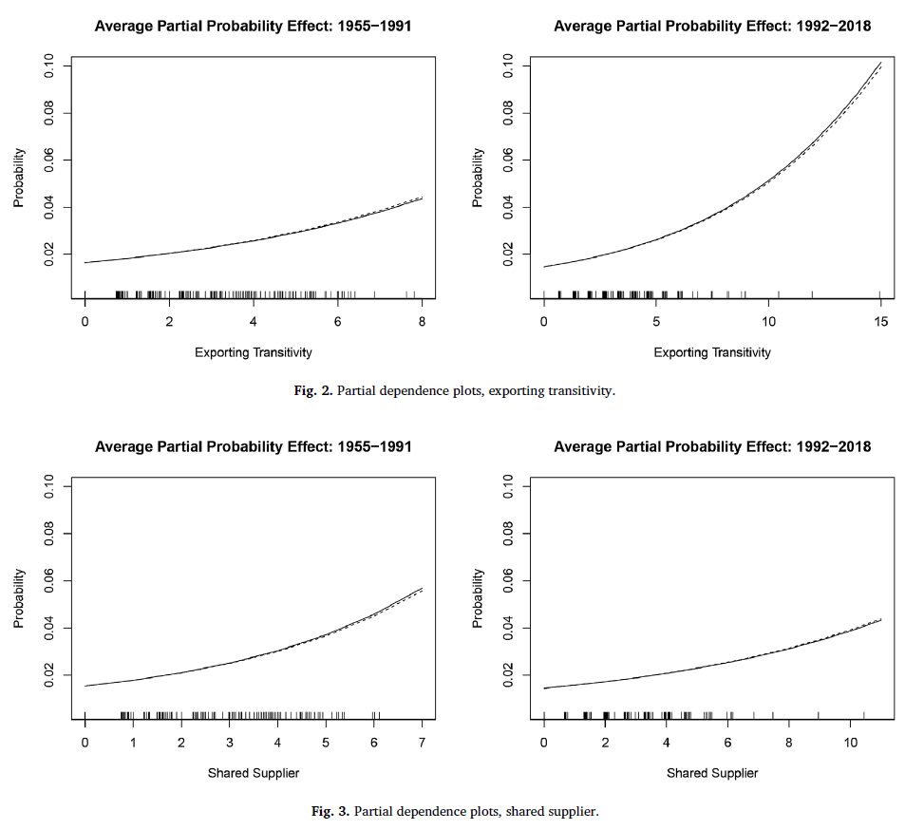
- Heckman Selection Model – separates the decisions of “with whom to trade” from “how much to trade”.
  - 1. Matchmaking phase between countries (exporter and importer)
  - 2. Sizing the deal.
- TIV = Trend Indicator Values – unit of measurement that standardizes production costs. Evaluates raw capability and resources required to build the hardware. There were times in the Cold War where weapons were given away for free. This metric used by SIPRI lets researchers make important insights when money alone isn’t a factor

- Developments in Military Expenditure and the Effects of the War in Ukraine
- European defense investment had been in decline since the end of the Cold War.
- 4 Phases of Military Defense Spending since the Cold War:
  - 1. 1992 Maastricht Treaty establishes security policy for EU.
  - 2. 1998 St. Malo Declaration establishes mechanisms for responding and managing crisis.
  - 3. 2005 Lisbon Treaty begins a decade+ of stagnation and no real security policy agreement.
  - 4. 2016 Crimea annexation begins revived interest in a united EU security policy and defense network.
- EU countries are big on making commitments and public declarations, but these rarely translate into meaningful advancements in military capability.
- The Defense Performance of most EU countries on the Sovereign Index is quite low. France is the only country that scores highly in preparation and resources.
- 48.3% of all EU defense spending goes to military personnel (salaries and pensions). It’s the highest percentage among advanced economies. EU counties are doing this because it immediately stimulates the economy. In terms of long term planning, the EU is missing out on the R&D tech environment that comes with investing in the sector.
- Many EU countries are still using Soviet era equipment. Ammunition stockpiles are low, air and missile defense systems have glaring weaknesses.
- NATO members are always supposed to commit 2% of GDP to defense spending. All pledged to so in 2014, but many EU countries did not follow through. Only 6 EU states were achieving the target when the 2022 invasion began.
- Czechia and Finland are planning massive spending increases on defense.
- 25 to 100 billion EUR is lost every year due to poor defense coordination between EU member states. This includes buying incompatible equipment, working in isolation, running parallel research programs.
- Only 18% of EU defense investment is done collaboratively. The rest is a country-first spending agenda. PESCO (The EU’s defense committee) wants to raise this number to 35%.
- Burden Shifting Theory – the EU countries are able to get closer to their 2% NATO targets by spending heavily on their personnel and ignoring R&D and resource/ammunition procurement.
- Research and Technology budgets for defense capabilities across the EU average at 1.7%.

- A Comprehensive Meta-Analysis of Determinants Influencing Military Expenditure: New Methodological Insights and Implications for Defence Budget Allocation
- This article is a study of studies. Is a meta-analysis of hundreds of studies (428) on the topic of defense spending.
- Random-Effects Model: statistical method synthesizing data while accounting for varying contexts across studies. Makes sure that a given circumstance being observed isn’t a fluke. Translates many different units of calculation into 1 single universal unit.
- The most statistically significant drivers of high defense spending is actual war, external foes, and the presence of past high budget trends. Good governance and national stability show a negative correlation with high defense spending.
- The factors that have no correlation with high or low defense spending are population size, GDP, democracy, type of government regime, trade openness, foreign direct investment, arms exports, alliances.

- NATO defense demand, free riding, and the Russo-Ukrainian war in 2022
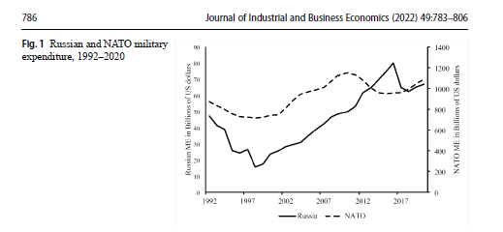
- Pg 786 Fig 1
- 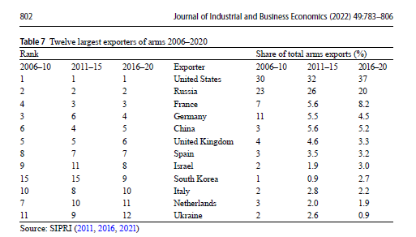
- Pg 802 Table 7
- Russian defense spending plummeted 63% immediately after the end of the Cold War. European NATO allies took this as a sign that they could stop investing in defense and start investing in domestic institutions and social welfare.
- While NATO membership grew during the late 90s and early 2000s (increasing risk as it neared Russia’s border), European defense spending decreased or stagnated.
- Making the club bigger by expanding the alliance didn’t fix the issue of member commitment. It worsened the math. The mathematical incentive to free-ride went up, as there became a larger aggregate pool of defense to rely on without spending your own money.
- Between 2000 and 2020, Russia increased its military spending by 183.4%. In the same timeframe, NATO’s grew by 46.9% (controlling [excluding] for the concept of new countries being added and bringing in their new budget).
- Over the 20+ years of the study, the reality was that members who shared borders with Russia, or had closer capitals to Russia, or were generally nearer to Russia, spent less money. The change in policy direction specific to those Eastern European countries is a recent one that didn’t exist before the 2022 invasion.
- When frontline countries like Poland and the Baltic increased spending, it had a negative affect, as Western European allies decreased spending in response.
- 2014 Wales Summit made every NATO country pledge to spend 2% of GDP. 20% of the 2% was supposed to be dedicated to modern weapons procurement. European countries didn’t honor that pledge until 2022.
- 7 of the top 12 global arms exporters are NATO members.
- Russian arm exports are struggling due to:
  - Sanctions
  - Inability to access computer chips
  - Need to replenish munition losses from ongoing war
- As demand for defense equipment waned after the end of the Cold War, defense companies were eaten by big monopoly conglomerates or exited the market.
- Germany, Netherlands, Poland, and Italy had massive energy trade relationships with Russia that kept them from taking the Russian threat seriously.
- The data showed that adding Sweden and Finland will worsen free riding across the alliance. Both countries have highly capable, well-funded militaries. Western European countries will use this to decrease spending.
- Russia’s most sellable weapons are calibar cruise missilies, e scanner short range ballistic missiles, and TRM2 air defense systems. All of these weapons secretly relied heavily on components manufactured in the US and UK.

- Measuring Geopolitical Risk
- Not usable.

- Defense Spending, Conflict and Economic Growth in Europe

