Our Community Library: Database Design
Matthew Essex and Clayton Greenwell
D532 Applied Database Technologies
4 April 2026

Updates On Our Process:
Between the last milestone and the current milestone, we’ve gotten our hands on more resources and spent a lot more time thinking about how to best construct our community library app.
Our current plan:
- MySQL + Python for data cleaning and database design (this current milestone). At the end of the process, we converted MySQL over to SQLite in preparation for the next phase.
- RSQLite using RStudio for the build out of the Shiny app (future milestones). Our process will closely resemble that of the NYU Shanghai Pineapple Sales Tutorial shared on Canvas.

Conceptual Diagram/Schema for Database:
- Explain the Diagram structure (entities, relations types, objects)
Our schema consists of three tables a patron table, a transaction log, and a books table. The patron table houses the contact information for the patrons of the library, but does not house any information on transactions by that user or books they have borrowed. That information is help strictly on the transaction log table with the only connection to the patron table being the patron id, which is used to track who has checked out which books and when they were due back. The books table houses all of the information on the books the library owns and connects with the transaction log table to identify whether that book is available or not.
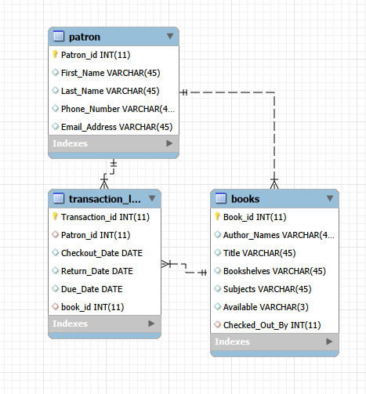

Database:
- Designed constraints to database
- do we need to enforce no null values, uniqueness, or specific formatting
Our database is designed with ease of use in mind, especially in regard to non-technical clients. We opted for a SQLite database so that the users don’t have to worry about hosting a server for the connection. This project is designed with ease of use and minimum technical needs by the librarians. We do not allow for null values on the Transaction_id, Patron information, or the book_id. We made a conscious decision to have every book have its own unique identification number, which means that there will be multiple rows of the same title in the database. This was done intentionally to allow the library to track who has checked out which book in case damage happen to a book. This will result in the library having multiple returns on query for a title, but we have an Available column which only allows for Yes or No options. This Available column could then be sorted to only display Yes values to see how many copies are available for checkout at the given moment.
Character limits

Code: Data Cleaning
Data Cleaning is related to the books table (the Gutenberg Library dataset).
- Cleaning the books data
This script was used to remove unneeded media types that were in the original CSV file as well as to drop unneeded columns from the data before loading it into the books table. We had to remove the original etext number and generate a book id for each row.
# Created by Matthew Essex
import csv

input_file = r"C:\\Users\\mressex\\Desktop\\School\\D532\\Community Library\\gutenberg_metadata.csv" # original CSV (you will need to update this to your own path)
output_file = r"C:\\Users\\mressex\\Desktop\\School\\D532\\Community Library\\Gutenberg_clean.csv" # cleaned + renumbered (CSV you will need to update this to your own path)

# Types to remove
remove_types = {"Collection", "Data Set", "Image", "MovingImage", "Sound", "StillImage"}

with open(input_file, "r", newline="", encoding="utf-8") as infile, \
open(output_file, "w", newline="", encoding="utf-8") as outfile:

reader = csv.DictReader(infile)
rows = []

# Step 1: Filter out non-Text types
for row in reader:
if row["Type"] == "Text":
rows.append(row)

# Step 2: Sort by original Etext Number
rows.sort(key=lambda r: int(r["Etext Number"]))

# Step 3: Renumber sequentially starting at 1
for i, row in enumerate(rows, start=1):
row["Etext Number"] = str(i)

# Step 4: Write final output
writer = csv.DictWriter(outfile, fieldnames=reader.fieldnames)
writer.writeheader()
writer.writerows(rows)

print("Filtering complete and Etext numbers updated to sequential order.")

- Drop 13 Columns from books data
We removed the excess columns from the Gutenberg data that would not be relevant to a library system. While this data could have been left and it would not have impacted the functionality of our program, we deemed the unnecessary data to be more hinderance than help to our users.
# Created by Clayton Greenwell
import mysql.connector

# Connect to the database
conn = mysql.connector.connect(
host='127.0.0.1',
user='root',
password='root',
database='community_library'
)

cursor = conn.cursor()

# Drop several column
alter_query = """
ALTER TABLE books
DROP COLUMN Issued;
DROP COLUMN Language;
DROP COLUMN Read online (web);
DROP COLUMN EPUB3 (E-readers incl. Send-to-Kindle);
DROP COLUMN EPUB (older E-readers);
DROP COLUMN EPUB (no images, older E-readers);
DROP COLUMN Kindle;
DROP COLUMN Kindle (E-readers incl. Send-to-Kindle);
DROP COLUMN Kindle (no images, older E-readers);
DROP COLUMN Plain Text UTF-8;
DROP COLUMN Download HTML(zip);
DROP COLUMN Resource Description Framework (RDF);
DROP COLUMN Other Links;
"""

cursor.execute(alter_query)
conn.commit()

cursor.close()
conn.close()

print("13 Columns have been dropped from the books table.")

- Drop LoCC column from books data
After we removed the other columns we discussed the pros and cons of maintaining the LoCC data. Ultimately we decided that for our use case that the LoCC column was unnecessary so we opted to remove it as well.
# Created by Matthew Essex
import mysql.connector

# Connect to the database
conn = mysql.connector.connect(
host='127.0.0.1',
user='root',
password='root',
database='community_library'
)

cursor = conn.cursor()

# Drop the LoCC column
alter_query = """
ALTER TABLE books
DROP COLUMN LoCC;
"""

cursor.execute(alter_query)
conn.commit()

cursor.close()
conn.close()

print("Column 'LoCC' has been dropped from the books table.")

- Drop the Rights column from the books data
Similar to the LoCC column the Rights column was one that could be useful in certain circumstances and we went back and forth about whether to retain it. What we decided was that it was more important to keep the data clean and concise so we deemed the Rights column not worth keeping.
# Created by Matthew Essex
import mysql.connector

# Connect to the database
conn = mysql.connector.connect(
host='127.0.0.1',
user='root',
password='root',
database='community_library'
)

cursor = conn.cursor()

# Drop the Rights column
alter_query = """
ALTER TABLE books
DROP COLUMN Rights;
"""

cursor.execute(alter_query)
conn.commit()

cursor.close()
conn.close()

print("Column 'Rights' has been dropped from the books table.")

- Delete all non-books (image files, sounds, films, etc.) from the books data
The Gutenberg data came with many different media types. Our library was not designed to house multi-media options so we stripped the data clean of anything that was not a book.
# Created by Clayton Greenwell
import mysql.connector

# Connect to the database
conn = mysql.connector.connect(
host='127.0.0.1',
user='root',
password='root',
database='community_library'
)

cursor = conn.cursor()

# Delete all records that aren't books by filtering Type column
delete_query = """
DELETE FROM books
WHERE Type != 'Text' OR Type IS NULL;
"""

cursor.execute(delete_query)
conn.commit()

cursor.close()
conn.close()

print("All records that are not books have been removed from the books table.")

Code: Database Creation and Normalization
- Import patron data
We needed a sample file of user information that would be readily available. While we could have manually created rows either through Python or SQL we opted to bring in the data from the members of our class instead.
# Created by Matthew Essex
import pandas as pd
import mysql.connector

# Load Excel file
excel_file = r"C:\Users\mressex\Desktop\School\D532\Community Library\patron.xlsx" #<----This will need to be updated to where you have your Excel sheet stored
df = pd.read_excel(excel_file)

# Connect to the database <---- This section will need to be updated your connection criteria
conn = mysql.connector.connect(
host='127.0.0.1',
user='root',
password='root',
database='community_library'
)

cursor = conn.cursor()

# Query to check for duplicates
check_query = """
SELECT COUNT(*)
FROM patron
WHERE Patron_id = %s
"""

# Insert query
insert_query = """
INSERT INTO patron (Patron_id, First_Name, Last_Name, Phone_Number, Email_Address)
VALUES (%s, %s, %s, %s, %s)
"""

# Process each row
for _, row in df.iterrows():
patron_id = int(row["Patron_id"])

# Check if this Patron_id already exists
cursor.execute(check_query, (patron_id,))
exists = cursor.fetchone()[0]

if exists:
print(f"Skipping duplicate Patron_id {patron_id}")
continue

# Insert new patron
cursor.execute(insert_query, (
patron_id,
row["First_Name"],
row["Last_Name"],
str(row["Phone_Number"]),
row["Email_Address"]
))

conn.commit()
cursor.close()
conn.close()

print("Import complete — duplicates skipped.")

- Normalize Database
When we first built our database, we built it with what we thought would be logical. After it was built, we reviewed the chapter on the normalization and tried to remove as much redundant data as we could. This meant dropping columns on multiple tables for things like “checked out”.
# Created by Matthew Essex
import mysql.connector

# Connect to the database
conn = mysql.connector.connect(
host='127.0.0.1',
user='root',
password='root',
database='community_library'
)

cursor = conn.cursor()

#Drop foreign key on patron.Checked_Out
try:
cursor.execute("ALTER TABLE patron DROP FOREIGN KEY checked_out;")
print("Dropped foreign key constraint on patron.Checked_Out.")
except:
print("Foreign key on patron.Checked_Out not found or already removed.")

#Drop the Checked_Out column from patron
try:
cursor.execute("ALTER TABLE patron DROP COLUMN checked_Out;")
print("Dropped column Checked_Out from patron.")
except:
print("Column Checked_Out not found or already removed.")

# Commit and close
conn.commit()
cursor.close()
conn.close()

print("Database normalization complete.")

- Convert MySQL to SQLite
We originally did all of our database configuration as a MySQL database. This would have worked but we wanted to make this program as technologically simple as we could for the end users. As such, we opted to convert the database to a SQLite database that could be installed directly onto a local machine. This meant making some changes to the configurations on the tables for things like the way auto-incrementing primary keys is handled. This conversion will also make our next phase, (building out the shiny app,) much simpler, as it will be done in RStudio using RSQLite.
# Created by Matthew Essex
import mysql.connector
import sqlite3
from sqlite3 import Connection
import re

# CONFIGURATION
MYSQL_CONFIG = {
"host": "127.0.0.1",
"user": "root",
"password": "root",
"database": "community_library"
}

SQLITE_DB_PATH = "community_library.sqlite"

# MYSQL TO SQLITE DATATYPE MAPPING
def map_mysql_type(mysql_type: str) -> str:
"""
Convert MySQL column types to SQLite-compatible types.
SQLite is flexible, but we preserve intent.
"""
t = mysql_type.lower()

if "int" in t:
return "INTEGER"
if "varchar" in t or "text" in t:
return "TEXT"
if "date" in t:
return "TEXT" # SQLite stores dates as ISO strings
if "char" in t:
return "TEXT"

# fallback
return "TEXT"

# SCHEMA DEFINITIONS (from your uploaded images)
def create_sqlite_schema(conn: Connection):
cursor = conn.cursor()

# Enable FK enforcement
cursor.execute("PRAGMA foreign_keys = ON;")

# 1) patron (parent table)
cursor.execute("""
CREATE TABLE patron (
Patron_id INTEGER PRIMARY KEY,
First_Name TEXT,
Last_Name TEXT,
Phone_Number TEXT,
Email_Address TEXT
);
""")

# 2) books (FK: patron)

cursor.execute("""
CREATE TABLE books (
Book_id INTEGER PRIMARY KEY,
Author_Names TEXT NOT NULL,
Title TEXT,
Bookshelves TEXT,
Subjects TEXT,
Available TEXT DEFAULT 'Yes',
Checked_Out_By INTEGER,
FOREIGN KEY (Checked_Out_By) REFERENCES patron(Patron_id)
);
""")

# 3) transaction_log (FK: patron, books)

cursor.execute("""
CREATE TABLE transaction_log (
Transaction_id INTEGER PRIMARY KEY,
Patron_id INTEGER,
Checkout_Date TEXT,
Return_Date TEXT,
Due_Date TEXT,
book_id INTEGER,
FOREIGN KEY (Patron_id) REFERENCES patron(Patron_id),
FOREIGN KEY (book_id) REFERENCES books(Book_id)
);
""")

conn.commit()

# COPY DATA FROM MYSQL TO SQLITE

def copy_table(mysql_cursor, sqlite_conn: Connection, table_name: str):
sqlite_cursor = sqlite_conn.cursor()

mysql_cursor.execute(f"SELECT * FROM {table_name}")
rows = mysql_cursor.fetchall()
col_names = [desc[0] for desc in mysql_cursor.description]

placeholders = ", ".join(["?"] * len(col_names))
insert_sql = f"INSERT INTO {table_name} ({', '.join(col_names)}) VALUES ({placeholders})"

sqlite_cursor.executemany(insert_sql, rows)
sqlite_conn.commit()

print(f"Copied {len(rows)} rows into {table_name}")

# MAIN MIGRATION PROCESS
def migrate():
print("Connecting to MySQL...")
mysql_conn = mysql.connector.connect(**MYSQL_CONFIG)
mysql_cursor = mysql_conn.cursor()

print("Creating SQLite database...")
sqlite_conn = sqlite3.connect(SQLITE_DB_PATH)

print("Creating SQLite schema...")
create_sqlite_schema(sqlite_conn)

print("Copying data in FK-safe order...")
copy_table(mysql_cursor, sqlite_conn, "patron")
copy_table(mysql_cursor, sqlite_conn, "books")
copy_table(mysql_cursor, sqlite_conn, "transaction_log")

print("\nVerifying row counts...")
for table in ["patron", "books", "transaction_log"]:
mysql_cursor.execute(f"SELECT COUNT(*) FROM {table}")
mysql_count = mysql_cursor.fetchone()[0]

sqlite_cursor = sqlite_conn.cursor()
sqlite_cursor.execute(f"SELECT COUNT(*) FROM {table}")
sqlite_count = sqlite_cursor.fetchone()[0]

print(f"{table}: MySQL={mysql_count}, SQLite={sqlite_count}")

mysql_conn.close()
sqlite_conn.close()
print("\nMigration complete! SQLite DB created at:", SQLITE_DB_PATH)

if __name__ == "__main__":
migrate()

Code: Queries
Four query ideas specific to our community library application:
- Create a query that lists all patrons that have a Hotmail account.
-- Created by Clayton Greenwell using DB Browser (SQLite)
SELECT
*
FROM
patron
WHERE
Email_Address LIKE '%hotmail%';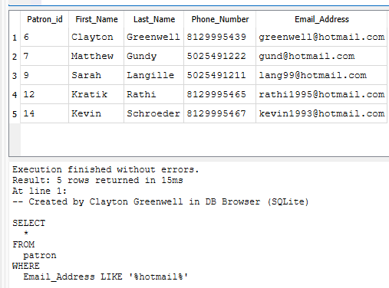

- We have a patron at the library that wants to know more about the Canadian province of Nova Scotia. Create a query that lists all books about Nova Scotia. Check if any of these books are checked out or if all are available.
-- Created by Clayton Greenwell in DB Browser (SQLite)
SELECT
*
FROM
books
WHERE
Subjects LIKE '%Nova Scotia%'
AND Available = 'Yes';
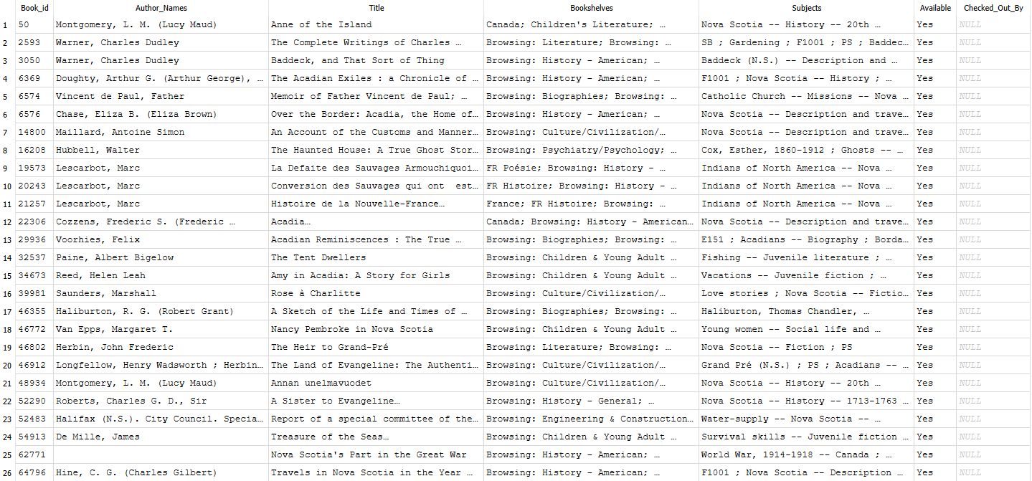
- Create a query that lists all patrons with a 502 (Louisville, Kentucky) area code.
-- Created by Clayton Greenwell in DB Browser (SQLite)
SELECT
*
FROM
patron
WHERE
Phone_Number LIKE '502%';
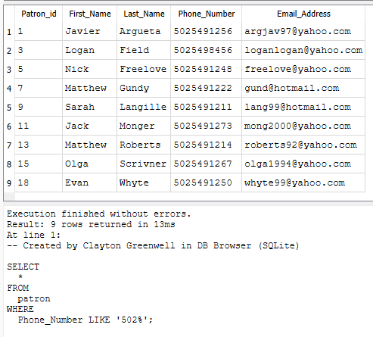
- We have a patron that loves author Victor Hugo. However, she has already read all of Hugo’s prose and would now like to read his poetry. Create a query that lists all books authored by Victor Hugo that belong on a bookshelf that features the word “Poetry”. Check if any of these books are checked out or if all are available.
-- Created by Clayton Greenwell in DB Browser (SQLite)

SELECT
*
FROM
books
WHERE
Author_Names LIKE '%Hugo, Victor%'
AND Bookshelves LIKE '%Poetry%'
AND Available = 'Yes';
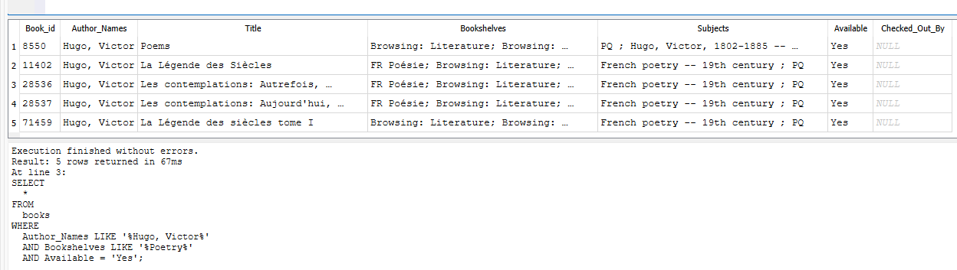

Contributions
The entirety of this project has been collaborative. While the initial scripting for database creation and cleanup was created by Matthew, nothing has been implemented without review and edits by Clayton. Similarly, Clayton has put in tremendous effort in learning about Shiny and preparing a sample that we can edit for this project. Even then a meeting was scheduled where he demonstrated Shiny to Matthew and walked him through the code and process. Clayton created a github page where the code for this project is being uploaded. Once one of us uploads the first version of the code the other one will review the code and make edits and provide a second version. If the second version is reviewed and deemed good enough then that version is used, otherwise it will be edited and a version three is uploaded to the github page. In this way the project has been entirely collaborative. The team is in constant communication via the Teams app and rarely does a day go by where information is not shared or the project discussed.

