[1]

A Modular Cube Satellite Attitude Control System Using Magnetorquers

Clayton B. Jaksha, *United States Military Academy*

*Abstract*—In this work, we create a modular control system with magnetorquers that provides single-axis attitude stability and control for common CubeSat configurations. We achieve this by analyzing the advantages and limitations of magnetorquers for attitude control, simplifying the controller design challenge, determining a low-power control algorithm, and testing the control solution through simulation. Taking into account a limited power budget, we design a rate-based combinational logic controller that provides attitude control on limited power.

*Index Terms*—cube satellites, digital control systems, magnetorquers, attitude control, combinational logic control.

# INTRODUCTION

S

oaring overhead at thousands of miles per hour, satellites inspire in humanity the awe of space and wonder of discovery. As the cost of launching pico- and nano-satellites into low-Earth orbit decreases and the amount of space-based research and educational payloads increases, the need for modular cube satellite buses becomes more pressing. One must assume the users of these buses are not all aerospace engineers, so the bus subsystems must be straight-forward enough to be configured and troubleshot by anyone with a technical background. The brain of any spacecraft bus is its control system and the value of any modular cube satellite bus relies on the robustness of its control architecture.

Though many cube satellite control systems rely on momentum wheels and magnets for control and stability, the weight and power requirements of those systems can sometimes put excessive design constraints on other bus systems or, worse, limit the payload’s ability to perform its mission. Used creatively, magnetorquers have the ability to provide a low-power stability and control to most general cube satellite configurations. By creating a lighter, more modular control system, cube satellites can become more accessible to the researchers that require them and, in doing so, become a platform to advance the state of human knowledge.

# Design Constraints

Previous cube satellite designs typically use magnetorquers as one of a few different types of actuators. References [9] and [10] describe systems where magnetorquers supplement reaction wheels or are backup emergency tumble stabilizers. In this controller design, we use *only* magnetorquers to provide single-axis control and stability using extremely low power. The advantages to this configuration are the decreased weight and power requirements while the greatest disadvantage is the under-actuated nature of magnetorquers in three-dimensional space; [2] fully analyzes the capabilities and shortcomings of magnetorquers.

## Magnetorquers as Actuators

Fundamentally, a magnetorquer (sometimes referred to in literature as a “magnetic torquer” or a “torque rod”) is a large inductor that creates a magnetic moment, torquing the spacecraft so its magnetic moment aligns with the Earth’s magnetic field. Reference [2] provides great detail on different magnetorquer configurations and summarizes the governing equations for magnetorquers in space:

$τ_{sat}=μ_{mt}×B_{earth}$ (1)

$μ_{mt}=\hat{n}NIA_{⊥}$ (2)

where $τ_{sat}$ is the torque on the satellite, $μ_{mt}$ is the magnetic moment created by the magnetorquer, $N$ is the number of coil turns in the magnetorquer, $I$ is current through the magnetorquer, $A_{norm}$ is the area of the coil normal to the magnetic moment, and $B_{earth}$ is the local magnetic field from the Earth. Equation (1) makes for an inherently nonlinear transfer function between the magnetic moment of the magnetorquer to the spacecraft torque.

From (1), we see that magnetorquers are only able to provide stability about $B_{earth}$, but we can choose the direction of $μ_{mt}$, allowing for single-axis control of the satellite. For this reason, a system where control is provided entirely by magnetorquers would be best suited for payloads that do not require three-dimensional stability. A cube satellite designed to test antenna performance would be ideal for magnetorquer control since the antenna’s axis could be kept stable and the rest of the bus could rotate without affecting the antenna’s attitude.

In order to provide stability to any given attitude, our system must use three magnetorquers mounted on orthogonal axes. By providing different currents to each magnetorquer, we are able to form attitude commands for any unit direction. That attitude then works to align itself with the Earth’s magnetic field to provide stability.

## Power Limitations

Other magnetorquer control systems like those in [4] and [9] that utilize linear quadratic regulators (LQR) and classical or discrete PID systems tend to face trouble keeping their control systems under limited power constraints. These types of systems are often designed to prioritize the fidelity of finely tuned control signals that cause optimal control responses. However, relatively low-budget cube satellites for research and education often have rigid power limitations that magnitude-based control signals tend to exceed. Instead, a system that provides repeated torque and counter-torque signals at or under power limitations. Such a system would stay under power limits because its torque and counter-torque signals would come from a pulsed-voltage signal that is inherently limited to a supply voltage. If the voltage drives an actuator circuit with known parameters, we are able to design for the actuator current, and hence, the system power.

TABLE I

Nomenclature

|  |  |  |
| --- | --- | --- |
| Symbol | Parameter | Units |
| *Bmag* | Average magnitude of Earth’s magnetic field | T |
| *d* | Depth of satellite | m |
| *h* | Height of satellite | m |
| *I* | Current through magnetorquer | A |
| *Irot* | Satellite moment of inertia about its planned rotation | kg∙m2 |
| *K* | Controller constant | unitless |
| *L* | Magnetorquer inductance | H |
| *l* | Magnetorquer length | m |
| *m* | Mass of satellite | kg |
| ***µ****i* | Magnetic moment from magnetorquer mounted to axis *i* | A∙m2 |
| *N* | Number of coil turns per magnetorquer | turns |
| **q**act | Satellite’s actual attitude unit vector | 3x1 unitless |
| **q**c | Commanded attitude unit vector | 3x1 unitless |
| **q**i | Estimated satellite attitude unit vector | 3x1 unitless |
| **q**ma | Direction of magnetic moment sensed by magnetometer | 3x1 unitless |
| **q**mo | Estimated direction of magnetorquer magnetic moment | 3x1 unitless |
| *R* | Actuator resistance | Ω |
| *r* | Magnetorquer coil radius | m |
| Δ*t* | Microcontroller processor period | s |
| *τi* | Torque about axis *i* | N∙m |
| *τsat* | Net torque on satellite | N∙m |
| *τp* | Perturbation/disturbance torques | N∙m |
| *θε* | Angle between commanded attitude and actual attitude | rads |
| *Vcc* | Buffer supply voltage | V |
| ***V****u* | Vector of control voltage signals | 3x1 V |
| *w* | Width of satellite | m |

## Processing and Computing Requirements

Attitude control systems like those in [3], [4], and [6] use quaternions and Euler angles in their control processes for computational fluidity. However, in a system where only one dimension is controlled, the matrix algebra might be excessive and unnecessarily complex. To make the control system sufficiently modular, we will instead use combinational logic for the control module and only basic computations elsewhere. This reduces the need for flight computer processing power and also makes the system easy-to-understand for those without a background in controls or astronautics.

## Requirements for Design Modularity

In order for our control system to be of value to the growth of cube satellite accessibility, it must not only work for most common configurations, but it must perform to an expected level of performance given different satellite bus parameters. In many instances, this does not mean we will be able to draw more power or provide more torque to correct for systems with greater inertia. Instead, it means our system must *self*-adjust for its own parameters. The combinational logic thresholds must change given different bus configurations and, in doing so, we are able to make our control system accessible to most common cube satellite platforms.

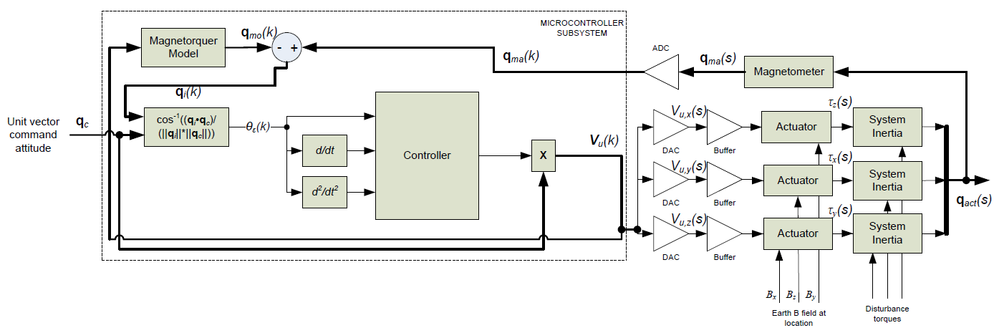

Fig. 1. Three-dimensional modular control system using magnetorquers. The blocks in this system represent physical systems that would be implemented on the satellite bus as opposed to fig. 4, which shows the simplified mathematical model for the control system.

# Control Architecture

Fundamentally, our control architecture depicted in figure 1 utilizes one position feedback loop to correct the difference between the satellite’s current and commanded attitude. Its components and design assumptions are stated below.

## Coordinate System

In order to provide attitude pointing, we must define an orthogonal reference frame in terms of the satellite’s body. Given a standard cube satellite composed of *n* units (cube satellite “units” are a standard sizing method), we define the ***x****-*direction as the direction of the satellite at its tallest point. For example, in a 2-*u* satellite like the one depicted in figure 2, the ***x***-direction is normal to the satellite’s smallest surfaces and parallel to its tallest sides. The other two coordinate directions are determined through (3) and (4):

$z=x×y$ (3)

$y=z×x$ (4)

All vectors, including the local magnetic field of the earth are defined and processed in terms of the {***x***, ***y***, ***z***} coordinate reference frame. It is important to note that one magnetorquer is affixed parallel to each basis so that the magnetorquer’s magnetic moment will be in the direction of the respective basis.

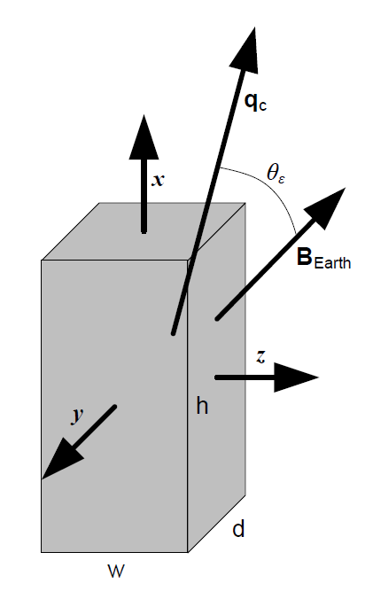

Fig. 2. Satellite local coordinate reference frame. Commanded attitudes and measured magnetic field values are in terms of orthonormal bases ***x***, ***y***, and ***z***. The scalar angle between the commanded attitude and the local magnetic field is denoted as *θε*; the described control system always forces this angle to zero over time to achieve stability.

## Three-Dimensional Control System

The three dimensional control system depicted in figure 1 describes the physical blocks that would be implemented in hardware. This is not meant to be taken as a blueprint for build, but rather as a rough sketch of what might be required in order to adequately process and actuate the control signal. Fortunately, there is not much hardware as most of the blocks are performed by a microcontroller or the magnetometers. However, there are some other components that are important to mention. The magnetometer must be able to measure the magnetic field of the earth and the combined magnetic moment of the magnetorquers in terms of the satellite’s coordinate reference frame. Generally speaking, the analog-to-digital and digital-to-analog converters should provide as great of a fidelity to the analog signal as possible in accordance with individual project limitations (budget, time, available technology, etc.).

## Microcontroller Subsystem

Much of the control processing occurs is done by the microcontroller. The microcontroller takes the commanded attitude and the magnetometer output as inputs and outputs a control voltage signal to each magnetorquer. It achieves this by first using a high-resolution model of the satellite’s magnetorquers to estimate their combined magnetic moment. Then, after subtracting out the estimated magnetorquer magnetic moment from the magnetometer reading, we are left with the direction of the earth’s magnetic field and can determine *θε*from (6), which is derived from (5):

$\left\|q_{c}∙B_{earth}\right\|=\left\|q_{c}\right\|\left\|B_{earth}\right\|\cos{θ_{ε}}$ (5)

$θ_{ε}=\cos^{-1}{\frac{\left\|q_{c}∙B_{earth}\right\|}{\left\|q_{c}\right\|\left\|B_{earth}\right\|}}$ (6)

The estimated error angle is then pushed forward to the controller. The controller also requires the first and second time derivatives of the error angle, so it must store some of the previous values listed in (7) and (8) in order to function.

${\dot{θ}}_{ε}≈\frac{{θ_{ε}}_{k}-{θ_{ε}}_{k-1}}{∆t}$ (7)

${\ddot{θ}}_{ε}≈\frac{{{\dot{θ}}_{ε}}_{k}-{{\dot{θ}}_{ε}}_{k-1}}{∆t}$ (8)

The control algorithm is described in greater detail later in this section. The controller outputs one command voltage that is split to the three actuators by multiplying the command voltage by the respective component of the commanded attitude unit vector. Another way the microcontroller conserves processing requirements is by approximating the satellite’s moment of inertia, *Irot*, given its planned rotation. It accomplishes this by forming a tensor, multiplying by the unit axis of the planned rotation, and then taking the magnitude of that vector:

$I_{rot}\sim \left\|\left[\begin{matrix}I_{x} & 0 & 0 \\ 0 & I_{y} & 0 \\ 0 & 0 & I_{z}\end{matrix}\right]\frac{q_{c}×B_{earth}}{\left\|q_{c}×B_{earth}\right\|}\right\|$ (9)

Although it is not an exact method to calculate the moment of inertia about the axis of rotation, it is computationally simple and allows us to reduce the processing requirements of the control system. Since cube satellites have typically very cubic or rectangular geometries, their mass moments should not be terribly different on each coordinate axis. Equation (9) serves to provide a rough estimate of the rotational inertia to the controller so it can best tune its own systems. High fidelity to the true rotational inertia is not critical to the controller, but a better estimate leads to a better response. However, worse estimation fidelity can be tuned out through other controller adjustments.

## Magnetorquer Subsystem

Each magnetorquer takes a voltage input through a buffer from the microcontroller. To control current, a resistor, *R*, of the same size for each magnetorquer is placed in series with the magnetorquer. If we model each magnetorquer as an air-core solenoid, the Wheeler formulas for inductance reported in [11] allows us to approximate the inductance of the magnetorquer given its physical parameters:

$L≈\frac{r^{2}N^{2}}{9r+10l}$ (10)

Then, treating the magnetorquer as an inductor, we can calculate the voltage across the magnetorquer in discrete time:

$V=L\frac{dI}{dt}≈L\frac{I_{k}-I_{k-1}}{∆t}$ (12)

Using (12), we can solve for the discrete-time current through the magnetorquer:

$I_{k}=\frac{V_{u,j}-L\frac{I_{k}-I_{k-1}}{∆t}}{R}$ (13)

Equation (13) simplifies algebraically to:

$I_{k}=\frac{∆t∙V_{u,j}-L∙I_{k-1}}{∆t∙R+L}$ (14)

Equation (14) is useful as a simulation tool when analyzing the current through the magnetorquer given an input voltage.

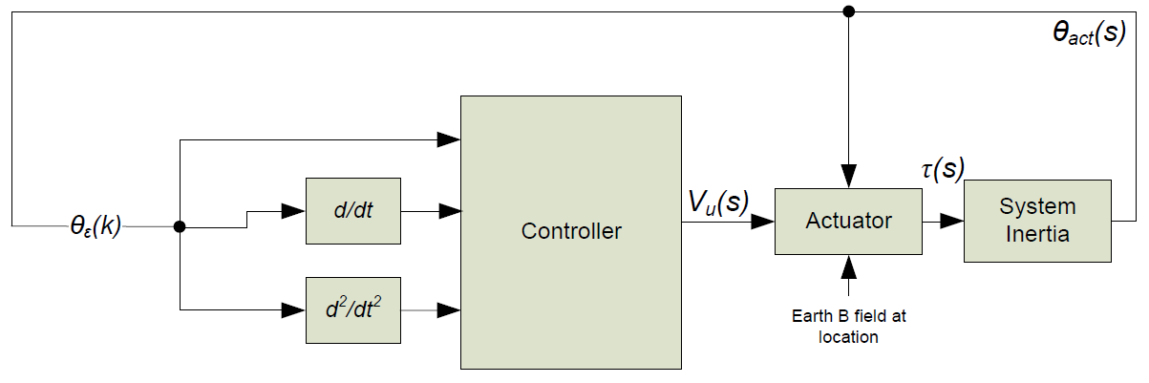

Fig. 4. One-dimensional control system simplification. Spacecraft inertial tensors and attitude commands enable us to make approximations and reduce the angle between the commanded attitude and the local magnetic field as quickly and efficiently as possible.

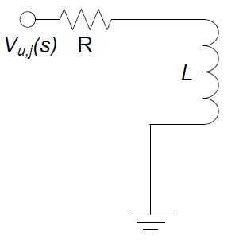

Fig. 3. Magnetorquer configuration. Each magnetorquer is modeled as an inductor, *L*, and current control comes from the control signal voltage for a given axis, *Vu,j*, and the series resistor, *R*.

## Simplified, One-Dimensional Control System

Essentially, the control system depicted in figure 1 aims to control one variable, the angle between the commanded attitude and the direction of the Earth’s magnetic field. Figure 2 depicts this simplified control architecture without any of the hardware components that enable it. It is important to note that any angle between the attitude and field vectors becomes the error angle.

## Controller

The controller at the heart of this system utilizes rapid switching to provide position- and angular velocity-based, rate control that guides the spacecraft to its desired attitude. To provide this control, we must first define a few constants. The following rates are defined in terms of the satellite’s moment of inertia for its given rotational axis, *Irot*, and *K*, which can be lowered for a damped response and raised to create more of an underdamped effect. A *K* value of 1 typically provides a slightly underdamped response and is used for all testing later in this paper.

${\dot{θ}}_{o}=\frac{K}{20000I_{rot}},{\dot{θ}}_{1}=\frac{K}{100000I_{rot}},{\dot{θ}}_{2}=\frac{K}{500000I_{rot}}$ (15)

The constants calculated in (15) are the rates at which the satellite will rotate given its current position. These different rates correspond to ${\dot{θ}}_{k}$ in Table II, the combinational logic that controls the signal switching. If *θε* ≥ 91.67º, then ${\dot{θ}}_{k}$ takes ${\dot{θ}}_{o}$. If 91.67º > *θε* ≥ 68.75º, then ${\dot{θ}}_{k}$ takes ${\dot{θ}}_{1}$. If 68.75º > *θε* ≥ 5.73º, then ${\dot{θ}}_{k}$ takes ${\dot{θ}}_{2}$. Finally, if 5.73º > *θε* ≥ 0 º, then ${\dot{θ}}_{k}$ takes 0-rad/s. One must note from (6) that the computation of *θε* will always be positive since it is calculated from a dot product. Therefore, control laws for angles less than zero do not need to be stated. However, if software requires an individual system to define ${\dot{θ}}_{k}$ for all cases of *θε*, the final logical statement can be extended to an “else” statement.

TABLE II

Controller Truth Table

|  |  |  |
| --- | --- | --- |
| $${\dot{θ}}_{ε}>{-\dot{θ}}_{k}$$ | $${\ddot{θ}}_{ε}>0$$ | $$V_{o}$$ |
| 0 | 0 | $${-V}_{cc}∙θ_{ε}$$ |
| 0 | 1 | $$V_{cc}∙θ_{ε}$$ |
| 1 | X | $$V_{cc}$$ |
|  |  |  |

As previously stated, the switching control is performed through the combinational logic in Table II. We accomplish this by correcting the position concavity so that it is always zero, which produces a constant rate of rotation. We also begin to multiply the output voltage by the current position as a method of power conservation as the satellite reaches steady state. For very small error angles, the controller outputs very small control voltages and consumes very little power to just keep the attitude where it needs to be.

# System Testing and Validation

To test the control system, we utilized MATLAB to conduct an Euler method, fixed-step, discrete-time simulation of the spacecraft response to control inputs. The only difference in implementing the control system from the previous section is that we allow for negative error angles in order to better graphically demonstrate the control response. A negative error angle can be thought of as being on the same plane of rotation as a positive angle, but the attitude has passed the direction of the Earth’s magnetic field. Therefore, the controller had to be modified to handle negative error angles by reversing the signs for logical statements and output voltages. We also assume that the magnitude of the Earth’s magnetic field remains constant throughout the attitude maneuver. Although this is not true all of the time, for a steady altitude orbit with an orbital inclination between 0º and 40º, the assumption should hold largely true. For ease of simulation, we also assume our estimated *Irot* is the actual rotational inertia of the spacecraft about its rotational axis.

## Euler Method, Fixed-Step Discrete System Simulation

In order to begin each simulation, we must first define the time step and the initial values for $θ_{ε}$ and ${\dot{θ}}_{ε}$. We then utilize the control algorithm defined in the previAsous section to determine the current-time command voltage. Using (14), we calculate the current through the magnetorquer (assuming initially the current is 0-A). Since we are concerned with control unit power consumption, we now record the instantaneous power consumption as the product of the command voltage and the magnetorquer current. Taking into account (1) and (2), we calculate the torque on the satellite through (16):

$\left|τ_{sat}\right|=NI_{k}πr^{2}\left\|B_{earth}\right\|\sin{{θ_{ε}}_{k-1}}$ (16)

Given our previously stated assumptions, we use the output from (16) to calculate the satellite’s angular acceleration. In (17), we are also able to add in disturbance torques if necessary during testing.

${{\ddot{θ}}_{ε}}_{k}=\frac{τ_{sat}+τ_{p}}{I_{rot}}$ (17)

Using integral midpoint estimations in (18) and (19) we are able to reach the satellite’s new position:

${{\dot{θ}}_{ε}}_{k}={{\dot{θ}}_{ε}}_{k-1}+\frac{{{\ddot{θ}}_{ε}}_{k}+{{\ddot{θ}}_{ε}}_{k-1}}{2∆t}$ (18)

${θ_{ε}}_{k}={θ_{ε}}_{k-1}+\frac{{{\dot{θ}}_{ε}}_{k}+{{\dot{θ}}_{ε}}_{k-1}}{2∆t}$ (19)

This loop of determining new values for the error angle continues until steady-state is reached.

## Commanded 30° Attitude Turn for Typical Cube Satellite Configuration

In this test, we command the satellite to do a 30º attitude maneuver. The satellite’s physical data is described in Table III. For this test, we used a step size of 0.1-s, $θ_{ε}$ = 30º, and ${\dot{θ}}_{ε}$ = 0-rad/s. Figure 5 displays the time plots for error angle, controller power, and magnetorquer current for this test. We notice the controller is able to bring the satellite to the desired attitude within roughly 1800s of the command being issued, which is probably around half an orbit depending on the specific orbital parameters. This settling time is the result of the very low torque that the magnetorquers are able to produce that is even further constrained by a low power budget. However, the satellite does reach the commanded attitude in less than an orbit and, once it is there, has very little steady-state error and remains there with extremely low power.

TABLE III

Satellite Parameters for “Typical” Configuration

|  |  |  |
| --- | --- | --- |
| Symbol | Parameter | Value |
| *Bmag* | Average magnitude of Earth’s magnetic field | 60 µT |
| *d* | Depth of satellite | 10 cm |
| *h* | Height of satellite | 20 cm |
| *l* | Magnetorquer length | 8 cm |
| *m* | Mass of satellite | 2 kg |
| *N* | Number of coil turns per magnetorquer | 1000 turns |
| *P*max | Maximum controller power consumption | 1.44 W |
| *R* | Actuator resistance | 100 Ω |
| *r* | Magnetorquer coil radius | 2 mm |
| *Vcc* | Buffer supply voltage | 12 V |
| *w* | Width of satellite | 10 cm |

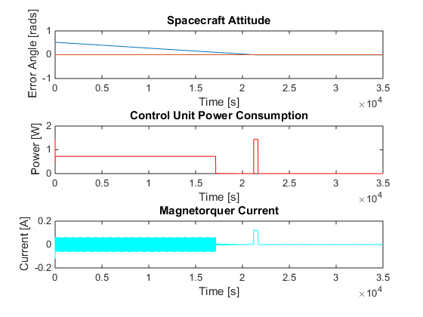

Fig. 5. Plot of error angle, power consumption, and magnetorquer current for commanded 30º attitude maneuver for a “typical” cube satellite configuration. Satellite comes to rest near 1800-s with very little steady-state error.

## Commanded 30° Attitude Turn for High-Inertia Cube Satellite Configuration

In this test, we command the satellite to do a 30º attitude maneuver. The satellite’s physical data is described in Table IV. For this test, we used a step size of 0.1-s, $θ_{ε}$ = 30º, and ${\dot{θ}}_{ε}$ = 0-rad/s. Figure 6 displays the time plots for error angle, controller power, and magnetorquer current for this test. We notice the controller is able to bring the satellite to the desired attitude within roughly 22,000-s of the command being issued, which would likely be over the course of 4-5 orbits depending on the specific orbital parameters. The nature of the response is similar to the “typical” configuration in that both are slightly underdamped, but the settling time is far greater. The likelihood of perturbations interfering with the settling time increases greatly if it is to travel 4-5 orbits before settling, so a magnetorquer control system would probably not be a good control option for cube satellites with high inertia.

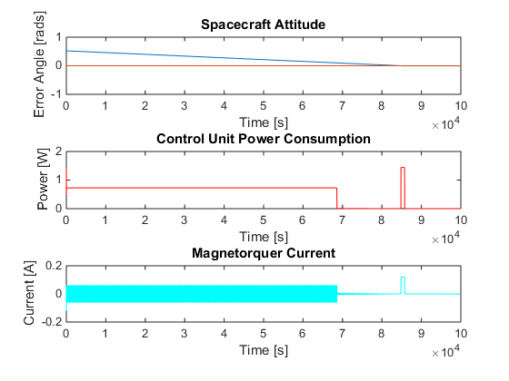

Fig. 6. Plot of error angle, power consumption, and magnetorquer current for commanded 30º attitude maneuver for a “high-inertia” cube satellite configuration. Satellite comes to rest near 22,000-s with very little steady-state error.

TABLE IV

Satellite Parameters for “High-Inertia” Configuration

|  |  |  |
| --- | --- | --- |
| Symbol | Parameter | Value |
| *Bmag* | Average magnitude of Earth’s magnetic field | 60 µT |
| *d* | Depth of satellite | 10 cm |
| *h* | Height of satellite | 30 cm |
| *l* | Magnetorquer length | 8 cm |
| *m* | Mass of satellite | 4 kg |
| *N* | Number of coil turns per magnetorquer | 1000 turns |
| *P*max | Maximum controller power consumption | 1.44 W |
| *R* | Actuator resistance | 100 Ω |
| *r* | Magnetorquer coil radius | 2 mm |
| *Vcc* | Buffer supply voltage | 12 V |
| *w* | Width of satellite | 10 cm |

## 0.01-Second Impulse Perturbation Response

Low-Earth orbit is home to a great number of spacecraft and space “junk.” A small-scale collision or a very light perturbation has the potential to disrupt a cube satellite’s attitude. For this reason we tested a 0.01-s, 100-mN∙m disturbance torque disrupting a “typical” configuration from steady state ($θ_{ε}$ = 0º, and ${\dot{θ}}_{ε}$ = 0-rad/s). Figure 7 displays the time plots for error angle, controller power, and magnetorquer current for this test. It took the satellite roughly 6700-s to return to steady-state stability on its original attitude. While the response time is not particularly fast, it still is able to fully recover which is a feat for a system running on low-torque and low-power.

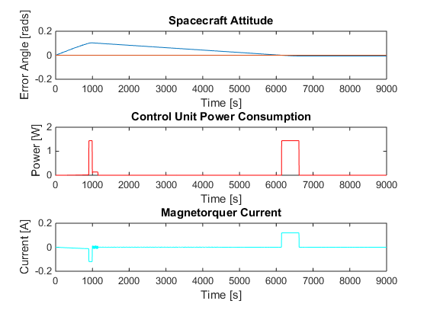

Fig. 7. Plot of error angle, power consumption, and magnetorquer current for for a significant 0.01-s perturbation. Satellite comes to rest near 6700-s with very little steady-state error.

## Constant Disturbance Torque Stability

A number of disturbance torques threaten the static stability and accuracy of our attitude control. Gravity gradient torque and aerodynamic torque are two primary disturbance torque are that are more constant in nature. Aerodynamic torque will not affect cube satellite attitude control as much compared to its effect on the overall lifespan of the satellite and its orbit degradation. However, it is important to note that as the orbit degrades, its eccentricity increases and the effects of gravity gradient torque become more noticeable. For the test, we applied a constant perturbation of 10-nN∙m, which is a very high value considering the highest gravity torque on the geosynchronous transfer orbit in [12] is 34.5-nN∙m. For this test, we used a step size of 0.1-s, $θ_{ε}$ = 0º, and ${\dot{θ}}_{ε}$ = 0-rad/s. Figure 8 displays the time plots for error angle, controller power, and magnetorquer current for this test. We notice that the constant torque briefly overpowers the control system, but eventually the controller is able to recover. Although the response is long, it is still able to achieve stability even if the attitude pointing is not as accurate. Since the test perturbation is much larger than expected, this means the control system should function under most constant disturbance torque conditions. This is critical information for the later parts of the satellite’s lifespan as its orbital eccentricity begins to grow significantly. Stability can still be achieved during those times, though attitude control will likely have steady-state error.

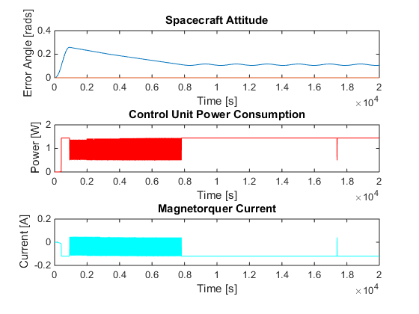

Fig. 8. Plot of error angle, power consumption, and magnetorquer current for commanded for a small, yet constant disturbance torque. Satellite comes to rest near 8000-s with some steady-state error.

## Tumble Recovery

As the spacecraft is released from its delivery vehicle and its control system is not yet online yet, the potential for tumbling exists. In this test, we simulate tumble recovery by setting the initial values at $θ_{ε}$ = 0º, and ${\dot{θ}}_{ε}$ = 0.3-rad/s with a step time of 0.1-s and a “typical” configuration. The spacecraft is able to recover from the tumble after nearly 12 hours, which is by no means ideal for recovery. However, given its ability to remain within power constraints and still recover after a period of time, it still accomplishes its task. For tumble recovery, we are not as concerned with the ending attitude, as that can be corrected with a follow-on maneuver.

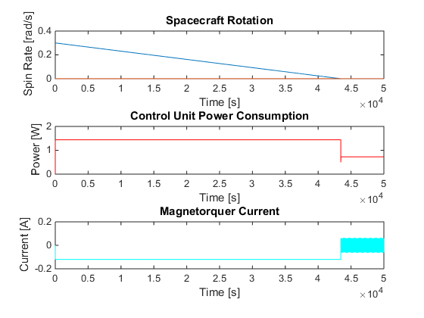

Fig. 9. Plot of spin rate, power consumption, and magnetorquer current for a notional tumble recovery scenario. Satellite ceases tumbling near 43,000-s.

# Conclusion

## A magnetorquer-only control system is certainly not the best option for every cube satellite, but for many it could be the least expensive, require the least power, and weigh the lightest. These factors come into play when considering the types of payloads onboard and the overall project budget. A system like the one described in this paper makes the cube satellite bus more accessible to those who may not have been able to previously afford to put their research into orbit—that is the true value of magnetorquer satellite control. This paper offers a low-power implementation that opens the door even farther, allowing even more payloads the opportunity to explore the final frontier.

References

1. G. Burrow, private communication, May-Aug., 2015.
2. V. François-Lavet, “Study of Passive and Active Attitude Control Systems for the OUFTI Nanosatellites,” M.S. thesis, Faculty of Applied Sciences, Univ. of Liège, Liège, Belgium, 2010.
3. D. V. Guerrant, “Design and Analysis of Fully Magnetic Control for Picosatellite Stabilization,” M.S. thesis, Dept. Aerospace Eng., Calif. Poly. State Univ., San Luis Obispo, California, 2005.
4. F. S. Holberg, “Optimal Attitude Control of a Double CubeSat Using Magnetorquers,” unpublished, Dept. of Eng. Cybernetics, Norwegian University of Technology and Sciences, Trondheim, Norway, 2011 [Online]. Available: http://nuts.iet.ntnu.no/upload/files/2011/fredrik_optimal_control_2011_prosjekt.pdf
5. D. C. Lay, “Vector Spaces,” in *Linear Algebra and its Applications,* 4th ed. Boston: Addison-Wesley, 2012, pp. 189–262.
6. A. M. Si Mohammed, A. Boudjemai, S. Chouraqui, and M. Benyettou (2006, Apr.). Magnetorquer Conrol for Orbital Manoeuvre of Low Earth Orbit Microsatellite. *Proc. Of 5th Int’l Conf. on Applied Computer Science*. pp. 1024-1027.
7. N. S. Nise, “Digital Control Systems,” in *Control Systems Engineering,* 6th ed. Hoboken, NJ: Wiley and Sons, 2011, pp. 723–780*.*
8. C. Savala and M. Karpenko, “Designing a Magnetic Torque Rod for a CubeSat,” unpublished, Control and Optimization Laboratory, Naval Postgraduate School, Monterey, CA [Online]. Available: http://www.nps.edu/Academics/Institutes/Cebrowski/STEM/doc/Christine%20Poster.pdf
9. D. M. Torczynski, R. Amini, and P. Massioni (2010, Apr.). Magnetorquer Based Attitude Control for a Nanosatellite Testplatform. *Proc. Of AIAA Infotech at Aerospace*, Atlanta, GA,2010[Online]. Available: [http://enu.kz/repository/2010/AIAA-2010-3511.pdf](%20http://enu.kz/repository/2010/AIAA-2010-3511.pdf)
10. X. Yi and A. Anvar (2013, Dec.). Small-Satellite Magnetorquer Attitude Control System Modelling and Simulation. *20th Int’l Congress on Modelling and Simulation* [Online]. Available: Available: [http://www.mssanz.org.au/modsim2013/C10/yi.pdf](%20http://enu.kz/repository/2010/AIAA-2010-3511.pdf)
11. H. A. Wheeler, “Simple Inductance Formulas for Radio Coils,” in *Proc. Of the I.R.E.*, 1928, pp. 1398-1400.
12. R. A. Zeledon and M. A. Peck, “Attitude Dynamics and Control of a 3U CubeSat with Electrolysis Propulsion,” in *Proc. Of AIAA-Guidance Navigation and Control Conf.,* Boston, MA*,* 2013 [Online]. Available: http://www.spacecraftresearch.com/files/ZeledonPeckGNC2013.pdf

**Clayton B. Jaksha** is in his fourth year of study for a B.S. in Electrical Engineering from the United States Military Academy (West Point, NY). He is originally from San Diego, CA and will commission as an aviation officer in the United States Army in May, 2016.

Along with the United States Military Academy’s rigorous military and professional training, he has sought out and excelled at intern-level research and development positions with Army Research Laboratory (Adelphi, MD, 2013), the National Reconnaissance Office (Buckley AFB, CO, 2014), and the Boeing Company (Seattle, WA, 2015). He presented his work on networked sensor communications from his time at Army Research Laboratory in a poster presentation at the 2014 ARL-USMA Technical Symposium. He gained experience with classified space operations and system development at the National Reconnaissance Office. At Boeing, he was assigned to the P-8 Poseidon project team where he assisted development of the aircraft control and electrical power systems. His primary research interests are aerospace control systems and architectures that offer robust, unique solutions to control problems with stringent design limitations. He plans on pursuing advanced education in aerospace control systems and contributing to future innovation in the field.

Cadet Jaksha is an active member of USMA’s chapters of IEEE-Eta Kappa Nu, Tau Beta Pi, and Phi Kappa Phi. He has been on the Dean’s List every semester at USMA. He is a recipient of the Society of American Military Engineering’s scholarship to top engineering cadets at West Point for the class of 2016.

1. Paper submitted for review on 12JAN2016 and publication on DDMMYYYY. C. B. Jaksha is a student of the Dept. of Electrical Engineering and Computer Science, United States Military Academy, West Point, NY 10996 USA (e-mail: [clayton.jaksha@usma.edu](mailto:clayton.jaksha@usma.edu)).