Clayton Turner
CSIS 603 – Design Patterns

Singly-Linked List with Iterator Assignment

LinkedList.java
package com.turner;
import java.util.Iterator;
import java.util.NoSuchElementException;
/**
* This class implements a List by means of a linked data structure.
* A List (also known as a <i>sequence</i>) is an ordered collection.
* Elements in the list can be accessed by their integer index. The
* index of the first element in the list is zero.
*/
public class LinkedList<E> implements Iterable<E>
{
private Node<E> head;
private int size;
/**
* A list node contains the data value and a link to the next
* node in the linked list.
*/
private static class Node<E>
{
private E data;
private Node<E> next;
/**
* Construct a node with the specified data value and link.
* No null check on data - you want null data? You got it!
* Null constructor already exists for Node
*/
public Node(E data, Node<E> next)
{
this.data = data;
this.next = next;
}
/**
* Construct a node with the given data value
*/
public Node(E data)
{
this(data, null);
}
}
/**
* An iterator for this singly-linked list.
*/
private static class LinkedListIterator<E> implements Iterator<E>
{
private Node<E> nextElement;
/**
* Construct an iterator initialized to the first element in the list.
*/
public LinkedListIterator(Node<E> head)
{
this.nextElement = head;
}
/**
* Returns true if the iteration has more elements.
*/
@Override
public boolean hasNext()
{
return this.nextElement != null; //&&
//this.nextElement.next != null;
}
/**
* Returns the next element in the list.
*
* throws NoSuchElementException if the iteration has no next element.
*/
@Override
public E next()
{
if(this.hasNext()){
// Proceed as normal
// This looks funky since I'm returning the initial value
// But this follows through in the other methods and
// ultimately results in a functional iterator
// If it ain't broke...
E returnValue = this.nextElement.data;
this.nextElement = this.nextElement.next;
return returnValue;
}
else{
NoSuchElementException e = new NoSuchElementException();
System.out.println("No next element. Throwing exception.");
throw e;
}
}
// Note: Do not have to implement other methods in interface
// Iterator since they have default implementations.
// Unfortunately, IntelliJ throws a fit if I don't
public void remove() {
throw new UnsupportedOperationException();
}
}
/**
* Helper method: Find the node at a specified index.
*
* @return a reference to the node at the specified index
*
* @throws IndexOutOfBoundsException if the index is out of range
* (<tt>index &lt; 0 || index &gt;= size()</tt>)
*/
private Node<E> getNode(int index)
{
if (index < 0 || index >= size)
throw new IndexOutOfBoundsException(Integer.toString(index));
Node<E> node = head;
for (int i = 0; i < index; ++i)
node = node.next;
return node;
}
/**
* Constructs an empty list.
* Null head since we have no elements.
* Size is 0 if no elements are present.
*/
public LinkedList()
{
this.head = null;
this.size = 0;
}
/**
* Appends the specified element to the end of the list.
*/
public void add(E element)
{
if (isEmpty())
head = new Node<E>(element);
else
{
Node<E> lastNode = getNode(size - 1);
lastNode.next = new Node<E>(element);
}
++size;
}
/**
* Inserts the specified element at the specified position in the list.
*
* @throws IndexOutOfBoundsException if the index is out of range
* (<tt>index &lt; 0 || index &gt; size()</tt>)
*/
public void add(int index, E element)
{
if(index > this.size){
IndexOutOfBoundsException e = new IndexOutOfBoundsException();
System.out.println("Index is out of range. Throwing exception.");
throw e;
}
// So we know we fit in the list if we made it this far
if(head == null){
add(element);
}
else {
Node<E> current; // init it for the 0 case
Node<E> toInsert = new Node<E>(element); // init the new node
// So we know the node to insert is next
// This isn't the most elegant path, but it's readable
if (index == 0) {
// edge case => beginning of list
current = getNode(index);
this.head = toInsert;
toInsert.next = current;
} else if (index == size) {
// edge case => end of list
current = getNode(index-1); // So we don't go out of bounds
current.next = toInsert;
} else {
current = getNode(index);
Node<E> previous = getNode(index - 1);
previous.next = toInsert;
toInsert.next = current;
}
size++; // here since head == null case has its own size incrementer
}
}
/**
* Removes all of the elements from this list.
*/
public void clear()
{
while (head != null)
{
Node<E> temp = head;
head = head.next;
temp.data = null;
temp.next = null;
}
size = 0;
}
/**
* Returns the element at the specified position in this list.
*
* @throws IndexOutOfBoundsException if the index is out of range
* (<tt>index &lt; 0 || index &gt;= size()</tt>)
*/
public E get(int index)
{
if (index < 0 || index >= size)
throw new IndexOutOfBoundsException(Integer.toString(index));
Node<E> node = getNode(index);
return node.data;
}
/**
* Replaces the element at the specified position in this list
* with the specified element.
*
* @returns The data value previously at index
* @throws IndexOutOfBoundsException if the index is out of range
* (<tt>index &lt; 0 || index &gt;= size()</tt>)
*/
public E set(int index, E newValue)
{
if(index > this.size){
IndexOutOfBoundsException e = new IndexOutOfBoundsException();
System.out.println("Index is out of range. Throwing exception.");
throw e;
}
E oldDataToReturn = get(index);
Node<E> n = getNode(index);
n.data = newValue;
return oldDataToReturn;
}
/**
* Returns the index of the first occurrence of the specified element
* in this list, or -1 if this list does not contain the element.
*/
public int indexOf(Object obj)
{
int index = 0;
if (obj == null)
{
for (Node<E> node = head; node != null; node = node.next)
{
if (node.data == null)
return index;
else
index++;
}
}
else
{
for (Node<E> node = head; node != null; node = node.next)
{
if (obj.equals(node.data))
return index;
else
index++;
}
}
return -1;
}
/**
* Returns <tt>true</tt> if this list contains no elements.
*/
public boolean isEmpty()
{
if(this.size == 0){
return true;
}
else{
return false;
}
}
/**
* Removes the element at the specified position in this list. Shifts
* any subsequent elements to the left (subtracts one from their indices).
*
* @returns the element previously at the specified position
*
* @throws IndexOutOfBoundsException if the index is out of range
* (<tt>index &lt; 0 || index &gt;= size()</tt>)
*/
public E remove(int index)
{
if(index > this.size){
IndexOutOfBoundsException e = new IndexOutOfBoundsException();
System.out.println("Index is out of range. Throwing exception.");
throw e;
}
E removed_element = get(index);
if(index == 0){
// edge case => beginning of list
if(size == 1){
this.head = null;
}
else{
this.head = getNode(1);
}
}
else if(index == size-1){
// edge case => end of list
Node<E> n = getNode(index-1);
n.next = null;
}
else{
Node<E> previous = getNode(index-1);
Node<E> next = getNode(index+1);
previous.next = next;
}
size--;
return removed_element;
}
/**
* Returns the number of elements in this list.
*/
public int size()
{
int my_size = 0;
// Better readability this way
if(head == null){
return my_size;
}
Node current = head;
while(current != null){
my_size++;
current = current.next;
}
return my_size;
}
/**
* Returns an iterator over the elements in this list in proper sequence.
*/
@Override
public Iterator<E> iterator()
{
return new LinkedListIterator<>(head);
}
/**
* Returns a string representation of this list.
*/
@Override
public String toString()
{
StringBuilder s = new StringBuilder();
s.append("[");
Node current = head;
while(current != null){
s.append(current.data);
s.append(", ");
current = current.next;
}
if(s.length() > 2) {
// so we remove that last comma if we added at least 1 element
s.deleteCharAt(s.length() - 1);
// and the space that comes with it
s.deleteCharAt(s.length() - 1);
}
s.append("]");
return s.toString();
}
/*
* Compares the specified object with this list for equality. Returns true
* if and only if both lists contain the same elements in the same order.
*/
@Override
@SuppressWarnings("rawtypes")
public boolean equals(Object obj)
{
if (obj == this)
return true;
if (!(obj instanceof LinkedList))
return false;
// cast obj to a linked list
LinkedList listObj = (LinkedList) obj;
// compare elements in order
Node<E> node1 = head;
Node node2 = listObj.head;
while (node1 != null && node2 != null)
{
// check to see if data values are equal
if (node1.data == null)
{
if (node2.data != null)
return false;
}
else
{
if (!node1.data.equals(node2.data))
return false;
}
node1 = node1.next;
node2 = node2.next;
}
return node1 == null && node2 == null;
}
/**
* Returns the hash code value for this list.
*/
@Override
public int hashCode()
{
int hashCode = 1;
Node<E> node = head;
while (node != null)
{
E obj = node.data;
hashCode = 31 * hashCode + (obj == null ? 0 : obj.hashCode());
node = node.next;
}
return hashCode;
}
}

TestLinkedList.java
package com.turner;
public class TestLinkedList
{
public static void main(String[] args)
{
LinkedList<String> l = new LinkedList<>();
System.out.println(l.isEmpty() ? "The list is empty." :
"The list is not empty.");
System.out.println(l);
System.out.println();
l.add(0, "John");
l.add(0, "Elvis");
System.out.println(l);
System.out.println();
System.out.println(l.isEmpty() ? "The list is empty." :
"The list is not empty.");
System.out.println();
LinkedList<String> l2 = new LinkedList<String>();
l2.add("Elvis");
l2.add("John");
System.out.println("l.equals(l2) is " + l.equals(l2));
System.out.println();
l.add("Mick");
System.out.println(l);
System.out.println();
l.add(0, "Curly");
l.add(3, "Larry");
l.add(2, "Diana");
System.out.println(l);
System.out.println();
l.add(0, "Moe");
l.set(4, "Bruce");
System.out.println(l);
System.out.println("size = " + l.size());
System.out.println("index of \"Curly\" = " + l.indexOf("Curly"));
System.out.println("index of \"Larry\" = " + l.indexOf("Larry"));
System.out.println("index of \"Moe\" = " + l.indexOf("Moe"));
System.out.println("index of \"Mick\" = " + l.indexOf("Mick"));
System.out.println();
// remove first and last elements plus an element in the middle
System.out.println("Removing " + l.remove(0));
System.out.println("Removing " + l.remove(l.size() - 1));
System.out.println("Removing " + l.remove(3));
System.out.println(l);
System.out.println("size = " + l.size());
System.out.println("index of \"Diana\" = " + l.indexOf("Diana"));
System.out.println("index of \"Bruce\" = " + l.indexOf("Bruce"));
System.out.println();
for (int i = 1; i <= 2; ++i)
System.out.println(l.remove(0));
System.out.println(l);
System.out.println();
l.add(1, "Angela");
l.add(l.size(), "Robert");
System.out.println(l);
System.out.println("size = " + l.size());
System.out.println();
// add a null data value and see if the list can be printed
l.add(null);
System.out.println(l);
System.out.println("size = " + l.size());
System.out.println();
l.clear();
System.out.println("The list has been cleared.");
System.out.println(l.isEmpty() ? "The list is empty." :
"The list is not empty.");
System.out.println("index of \"Larry\" = " + l.indexOf("Larry"));
System.out.println();
try
{
l.remove(0); // should throw an exception
}
catch (Exception e)
{
System.out.println("Exception information to follow:");
e.printStackTrace(System.out);
}
System.out.println();
LinkedList<String> l3 = new LinkedList<>();
l3.add("Paul");
l3.add(0, "Pete");
l3.add(1, "George");
l3.add("John");
l3.add("Stuart");
System.out.println("Let's view the members:");
System.out.println(l3.toString());
System.out.println();
System.out.println("Clearing out the list. 5 Beatles just doesn't work");
l3.clear();
System.out.println();
l3.add("Paul");
l3.add("Ringo");
l3.add("George");
l3.add(2, "John");
int my_size = l3.size();
System.out.println("Added "+String.valueOf(my_size)+" members.
Now we can 'Meet the Beatles'");
System.out.println(l3.toString());
System.out.println();
System.out.println("Unfortunately, John has died, so let's remove him");
l3.remove(2);
System.out.println();
System.out.println("Now let's view our " +
String.valueOf(l3.size()) + " members");
System.out.println(l3.toString());
System.out.println();
System.out.println("Is our band empty? true = Yes. false = No.");
System.out.println(String.valueOf(l3.isEmpty()));
System.out.println();
System.out.println("We removed John by a hard-coded index earlier. " +
"Let's make sure we don't need that");
l3.clear();
System.out.println("Band cleared");
l3.add("Paul");
l3.add("Ringo");
l3.add("George");
l3.add("John");
System.out.println();
System.out.println("Members added back");
System.out.println();
System.out.println("John died again!
Remove him. Luckily we only have one John." +
" We would need last names otherwise.");
l3.remove(l3.indexOf("John"));
System.out.println();
System.out.println("Let's verify by printing out the
living band members after" +
" John's death.");
System.out.println(l3.toString());
}
}

TestLinkedListWithIterator.java
package com.turner;
public class TestLinkedListWithIterator
{
public static void main(String[] args)
{
LinkedList<String> names = new LinkedList<>();
System.out.println(names.isEmpty() ? "The list is empty." :
"The list is not empty.");
System.out.println(names);
System.out.println();
names.add("John");
names.add("Elvis");
names.add("Mick");
names.add("Curly");
names.add("Larry");
names.add("Moe");
names.add("Diana");
for (String s : names)
System.out.println(s);
System.out.println();
// Note that you get a forEach() method for free
// (default method in interface Iterable) that
// allows a lambda expressions as the parameter.
names.forEach(name -> System.out.println(name));
System.out.println();
LinkedList<String> cowboysRunningBacks = new LinkedList<>();
System.out.println("It's 2014 so let's add the bellcow");
cowboysRunningBacks.add(0, "Demarco Murray");
System.out.println(cowboysRunningBacks.toString());
System.out.println();
System.out.println("Let's add the backup!");
cowboysRunningBacks.add("Joseph Randle");
System.out.println(cowboysRunningBacks.toString());
System.out.println();
System.out.println("It's 2015 so let's get a clean slate");
cowboysRunningBacks.clear();
System.out.println(cowboysRunningBacks.toString());
System.out.println();
System.out.println("Owner Jerry Jones has request our hash code!");
System.out.println(String.valueOf(cowboysRunningBacks.hashCode()));
System.out.println();
System.out.println("Now let's add the 2015 running backs so we can " +
"head to training camp!");
cowboysRunningBacks.add("Joseph Randle");
cowboysRunningBacks.add("Darren McFadden");
cowboysRunningBacks.add("Christine Michael");
cowboysRunningBacks.add("Lance Dunbar");
cowboysRunningBacks.add("Tyler Clutts");
System.out.println();
System.out.println(cowboysRunningBacks.toString());
System.out.println();
System.out.println("Jerry Jones actually wanted the hash code for " +
"the 2015 running backs, not an empty list! " +
"We gotta fix this now!");
System.out.println(String.valueOf(cowboysRunningBacks.hashCode()));
}
}

TestLinkedList.java Output
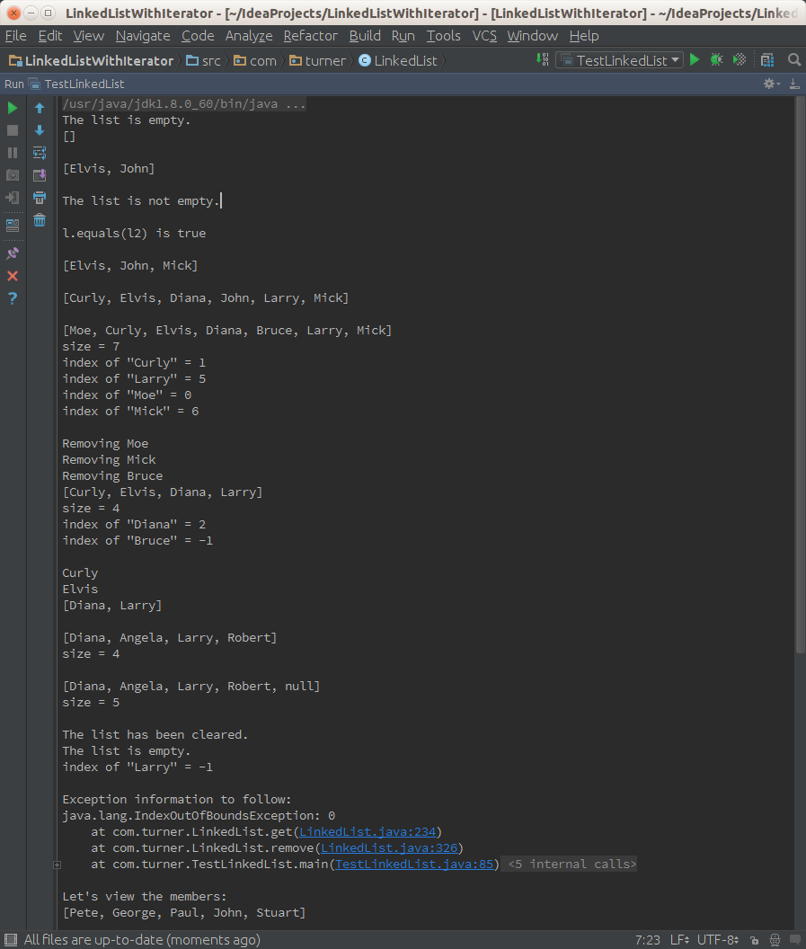
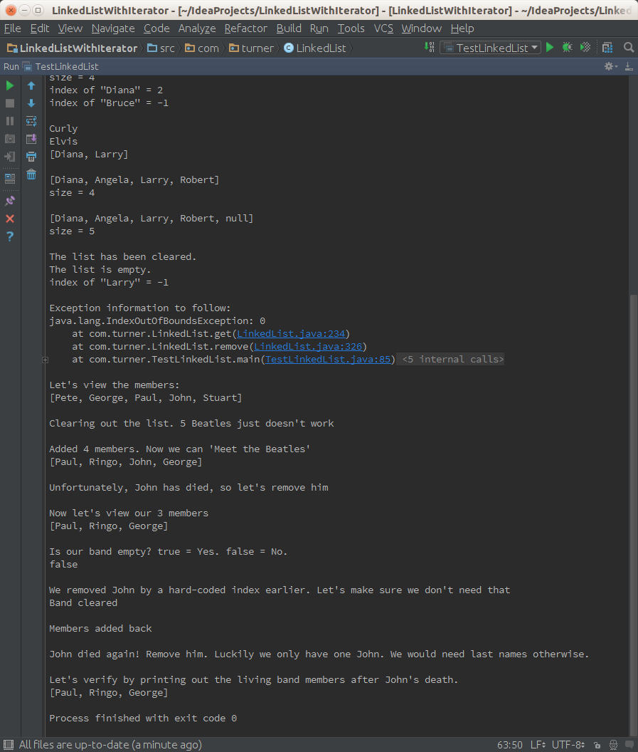
TestLinkedListWithIterator.java Output
