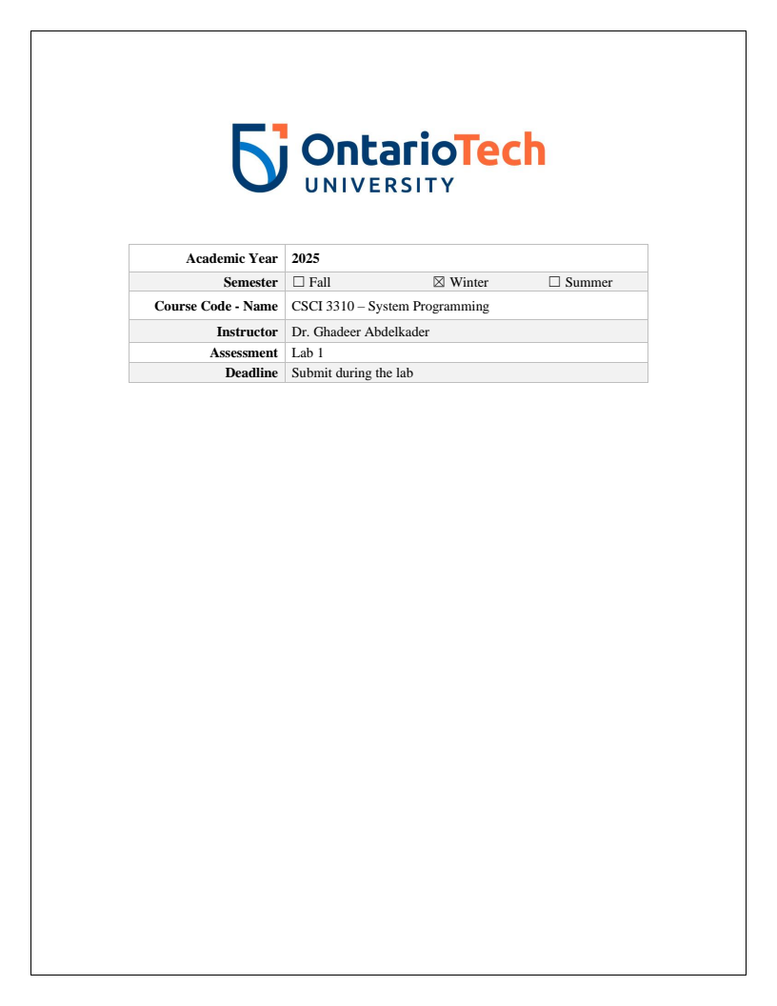
Submission:

9.
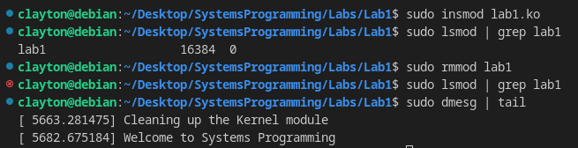

10.
```c
#include<linux/init.h>
#include<linux/module.h>
#include<linux/kernel.h>

MODULE_LICENSE("GPL");
MODULE_AUTHOR("Clayton:100824037 Zachariah::100783192 Alireza::100812651");
MODULE_DESCRIPTION("100824037 100783192 100812651: This is Group2's first Kernel module");

static int __init welcome_function(void)
{
printk("Welcome to Systems Programming\n");
return 0;
}

static void __exit cleaning_up_function(void)
{
printk("Cleaning up the Kernel module");
}

module_init(welcome_function);
module_exit(cleaning_up_function);
```
```Makefile
obj-m += lab1.o

all:
make -C /lib/modules/$(shell uname -r)/build M=$(PWD) modules

clean:
make -C /lib/modules/$(shell uname -r)/build M=$(PWD) clean
```

