Clayton Wong Portfolio website documentation
Bio
When I was working on my portfolio, I started with the bio. This involved talking about my self, mainly my lifestory, to 2 of my classmates and having them take notes so that I will have something to work off. Later, I decided to get help from the Wikihow website, which told me I need at least the following:

* Claim to fame
* What I do for a living
* Important accomplishments
* Humanizing details

From these 4 hints I was able to come up with a short bio that fufils these requirements.
I originally wrote the bio in third person, like the description for Paris based designer Robin Ait-el-alim Noguier from the website Creative Bloq, http://www.creativebloq.com/web-design/top-10-web-design-portfolios-2015-61515099 but on Tue 2017 Sep 5, i decided to change the wording for the bio to be in first person, like one of the sites mentined in Creative Bloq, such as the site of Irene Demetri, https://www.youandigraphics.com/

Design layout and fonts
Although I tried to design for mobile first, the first 2 layout designs were done haphazardly as I haven't received any feedback until after the second design was done. Also, at the time, I was focusing on trying to get inspiration for my color scheme from Pinterest. The feedback for my first 2 designs was:

* No room for expansion
* Too cramped and not enough spacing

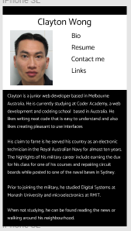
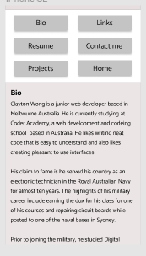

design 1 design 2

On Tuesday 2017 Sep 5, after considering the feedback, I was able to come up with a design that was simple and everything in it was well spaced out. That design included a slide up menu in mobile and tablet modes that allowed room for expansion and is also easier for the user, especially in mobile mode. The idea for the slide up menu came from the smartphone that I use. The HTC Desire Z.
For the desktop mode, I choose to have a nav bar at the top of the screen so that it will be more like other websites and will also make use of the extra space available. Another thing I did to make better use of the extra space on the screen in tablet and desktop modes was I increased the fontsize for those 2 modes.

I also decided to leave out the photos of myself as they make me look unfriendly and uninviting.

When choosing fonts, I originally choose Catamaran because it had a laid back look that was still readable, but later, I choose Roboto because it stands out better.

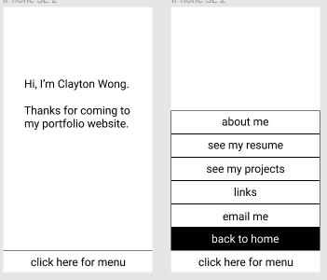

2 screens from design 3

Color scheme
When I first searched for inspiration for a color scheme, I found the mainly black sites from https://www.awwwards.com/websites/portfolio/ , such as Camp Pacific Travel Portfolio http://travel.camppacific.com/ appealing because I liked their use of black, white & grey, becaue to me, their site look sophisticated.

On Tue 2017 Sep 5, I looked at the
Adobe Color CC color schemes. I tried the following schemes because they have 2 of my favorite colors, green and pink.

* Oddend
* Digerati
* Merry Berry And Fresh Lime
* Neons

I also tried a design with different shades of grey called 'Mom Kitchen 4'. In addition, I also experimented with colour schemes that are mainly green and pink but they were quickly discarded as they did not provide good contrast.

On Wed 2017 Sep 6, I took color schemes ‘Merry Berry And Fresh Lime’ and ‘Neons’ off my shortlist because they are too bright and does not reflect what I wear and my personality. Then I also removed ‘Oddend’ and ‘Mom kitchen 4’ off my short-list becaue the contrast of those schemes are not good, as they did not score well on the contrast checker from http://webaim.org/resources/contrastchecker/ I was not insterested in using the Ventana Azul colour scheme. I also thought the Digerati colour scheme was sometimes too strong.
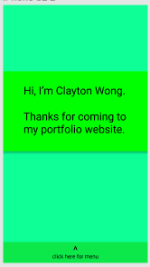
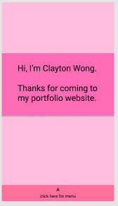
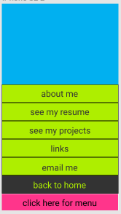

mainly green mainly pink
‘
Oddend

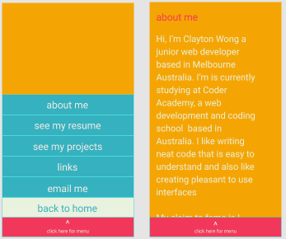
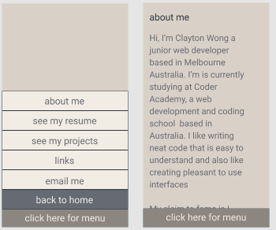

Ventana Azul Mom Kitchen 4

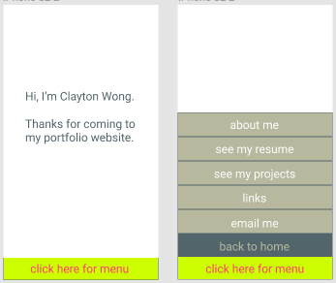

Digerati

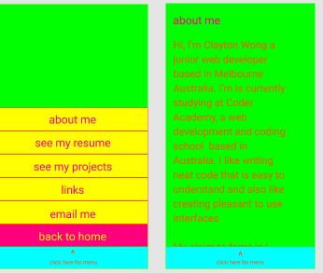
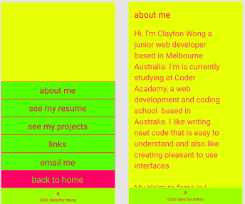

Merry Berry and Fresh Lime Neons

Eventually, I found ‘Zen and Tea’, a colour scheme with black and green that has good contrast and got good scores in the contrast checker. I wanted the font colour to be black because I wanted to make my words readable, especially in light or pale backgrounds.
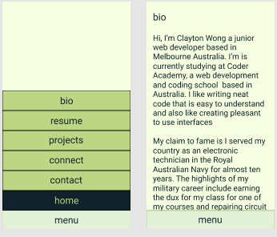

Zen and Tea

Zen & tea Hex values:
10222B (black)
95AB63 (green0
BDD684 (light green)
E2F0D6 (pale green)
F6FFE0 (white)

Other design decisions
On Thu 2017 Sep 7 I changed the text on bottom from ‘click here for menu’ to just ‘menu’ because I do not have the skills to use java script to handle clicks. I find it easier to write css code that deals with the mouse hovering over a button.

I know there are all kinds of people out there. Including stalkers and people that send spam, therefore, I did not include my phone numbers and email addresses. Instead I created a section that allows everybody to give me their name, email address and a message so that I can get back to them later.

On Fri 2017 Sep 8, I change the second sentence of the greeting from ‘Thanks for coming to my portfolio website’ to ‘Welcome to my portfolio website’ because I don’t want to look like I’m begging for something.

On Sun 2017 Sep 10, I’v chosen a headshot photo of the wedgetailed eagle becaues that bird is my favorite animal. The other reason is I did not wish to reuse the favicon from a past coding challenge.
I also created and added a simle personal logo onto the landing page. I choose my initials because it represents me, and I placed the letters in a circle to give it it’s own space.
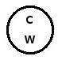

My personal logo.

Difficulties
I had difficulties with the following:

* Implementing the slide up menu.
* Unblocking text that was coved by the bottom menubar.
* Positioning content to make it look at least close to what I had in the design.

To implement the sliding menu, I did the following
1) Found out how to create a drop down menu from w3schools.com
2) Found out how to create a slide up or drop up menu from Stack-overflow
3) Adapted the code I found from those websites to my needs

To unblock text that was covered by the bottom menubar, I had to approad the instructor for help and find the solution on the internet. Eventually, I sended up using a solution that involved placing padding at the bottom of various parts of my code.

To position content in places where I wanted them, I had to use padding and adjust margin values in various parts of my code.

To see more of my designs on Figma, use the following link.
https://www.figma.com/file/MlmBGrWQVEGnExpPOuqw86p0/portfolio

