Problem 1:
If the average velocity is around ~310, and the game runs at 60/fps, then 310 / 60 = ~5.16, so the runner is falling approximately 5 pixels per frame.

Problem 2: 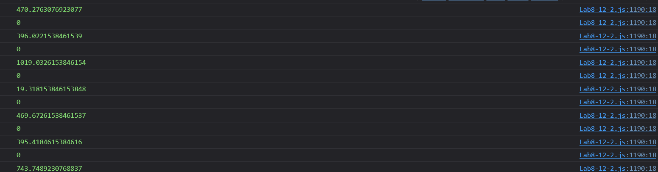
The velocity on falling seems to vary a lot, and occasionally gives values of 0, but I suspect that’s an issue with the engine itself moreso than an accurate reading. It seems to generally be around 400-470, but there’s a couple of spikes where it went far higher, specifically to 1019 and 743. These seem like they’re from larger drops in the game, I think if the game had a farther distance to fall these may reach even higher numbers. Though, considering this is at the START of the falling method, I would think the velocity may be lower initially, rather than higher…

Problem 3:

Even with my laptop running slow, the game didn’t show any majorly different values, still showing on average 310 for initial velocity and around 400-470 for falling velocity, though it did show 377 once is lower than the average we saw before, though it also gave a high reading of 679, so it doesn’t look like it really made any major difference despite running at a, no pun intended, snail’s pace.

Problem 4: 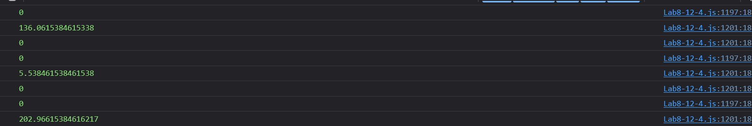
With the slowdown on descent, it does seem to drastically decrease the values for this. I’m guessing that this is due to the engine itself being slowed down, rather than the device running the engine as before, where now the calculations are entirely different due to running at 1/5 speed.

