
Cleaning and Restoration Science Institute
www.carsi.com.au
2-Day Carpet Cleaning Workshop
Participant Take-Home Manual
Carpet · Upholstery · Hard Floors · Stain Removal · Machinery · Business
Trainer: Phill McGurk
CARSI — Australian IICRC-Approved CEC Provider
carsi.com.au
This manual is original CARSI reference material. It summarises the course for future reference and does not reproduce the ANSI/IICRC standards. For the definitive standards text, consult the IICRC-published documents listed in Appendix F.

Contents
How to Use This Manual ................................................. 4
Module 1 — Standards Landscape & Safety ................. 5
Module 2 — Fibre Science ........................................... 7
Module 3 — Chemistry of Cleaning .............................. 10
Module 4 — The Five Cleaning Principles ................... 13
Module 5 — Spot & Stain Removal ............................. 16
Module 6 — Upholstery Theory .................................... 19
Module 7 — Upholstery Methods .................................. 22
Module 8 — Hard-Floor Cleaning & Inspection ............ 25
Module 9 — Machinery Maintenance ........................... 28
Module 10 — Business of Cleaning .............................. 31
Module 11 — The CARSI Expert Council ..................... 34
Appendix A — Fibre-ID Field Card ................................. 36
Appendix B — pH Ranges & Safe Defaults .................... 37
Appendix C — Spot Removal Decision Tree ................. 38
Appendix D — Pre-Inspection Checklist ....................... 39
Appendix E — Machinery Daily/Weekly/Monthly ........... 40
Appendix F — References & Further Reading ............... 41
Appendix G — CARSI CE Pathway ................................ 42

How to Use This Manual
This manual is structured to mirror the two-day course flow. Each module has the same shape: a short theory section, a three-tier take-away card (Newby · Intermediate · Pro), a quick-reference panel, and footnoted source anchors for anyone who wants to read deeper in the IICRC standards.

Three-Tier Learning
Every module in this manual distinguishes what a Newby, an Intermediate and a Professional should take away. Use it as a self-assessment tool: read each tier in a module and ask yourself where you actually are — not where you'd like to be. Honesty here accelerates growth.

NEWBY  Under 12 months in the industry. Focus: vocabulary, fibre ID, the 5 Principles, safe defaults. | INTERMEDIATE  1–5 years, at least CCT-equivalent. Focus: chemistry choices, diagnostic frameworks, troubleshooting. | PRO  5+ years, multiple certs. Focus: edge cases, economics, inspection-grade judgement, training others.

Verifiability Promise
Every technical claim in this manual is anchored to the published ANSI/IICRC standards, the CRI (Carpet and Rug Institute) public guidance, or peer-reviewed industry sources. Footnotes cite the exact standard and section. CARSI does not publish invented data — when a source cannot be provided, the claim is framed as professional judgement, not fact.
A Note on the Boardroom Scenario
The CARSI Expert Council used in Module 11 is made up of seven clearly-labeled composite personas. Each persona is grounded in a real IICRC credential pathway — but no quote, critique or opinion should be attributed to any specific living person. The council exists to surface professional viewpoints as a teaching device.

Module 1 — Standards Landscape & Safety
The IICRC publishes a family of ANSI consensus standards that together define the professional scope of carpet, textile and restoration work. Understanding who governs what is the first step to working inside your scope — and knowing when to call in a specialist.

The Standards Landscape
The cleaning and restoration disciplines most relevant to a carpet cleaning workshop are carved out as follows:
Standard | Scope | Role for the Carpet Tech
ANSI/IICRC S100 | Textile floor coverings — cleaning | Primary reference for carpet cleaning
ANSI/IICRC S300 | Upholstery cleaning | Primary reference for fabric and soft-furniture work
ANSI/IICRC S220 | Hard-surface floor inspection | Inspection scope for tile, stone, resilient, wood
ANSI/IICRC S500 | Water damage restoration | Recognise Cat 1/2/3 water, know when to stop
ANSI/IICRC S520 | Mould remediation | Recognise visible mould — outside CCW scope
ANSI/IICRC S540 | Trauma & crime-scene cleaning | Never within carpet-tech scope without credentials
ANSI/IICRC S700 | Fire & smoke restoration | Soot on carpet — refer to restorer
ANSI/IICRC S800 | Textile floor covering inspection | Inspector's scope; tech supports with documentation
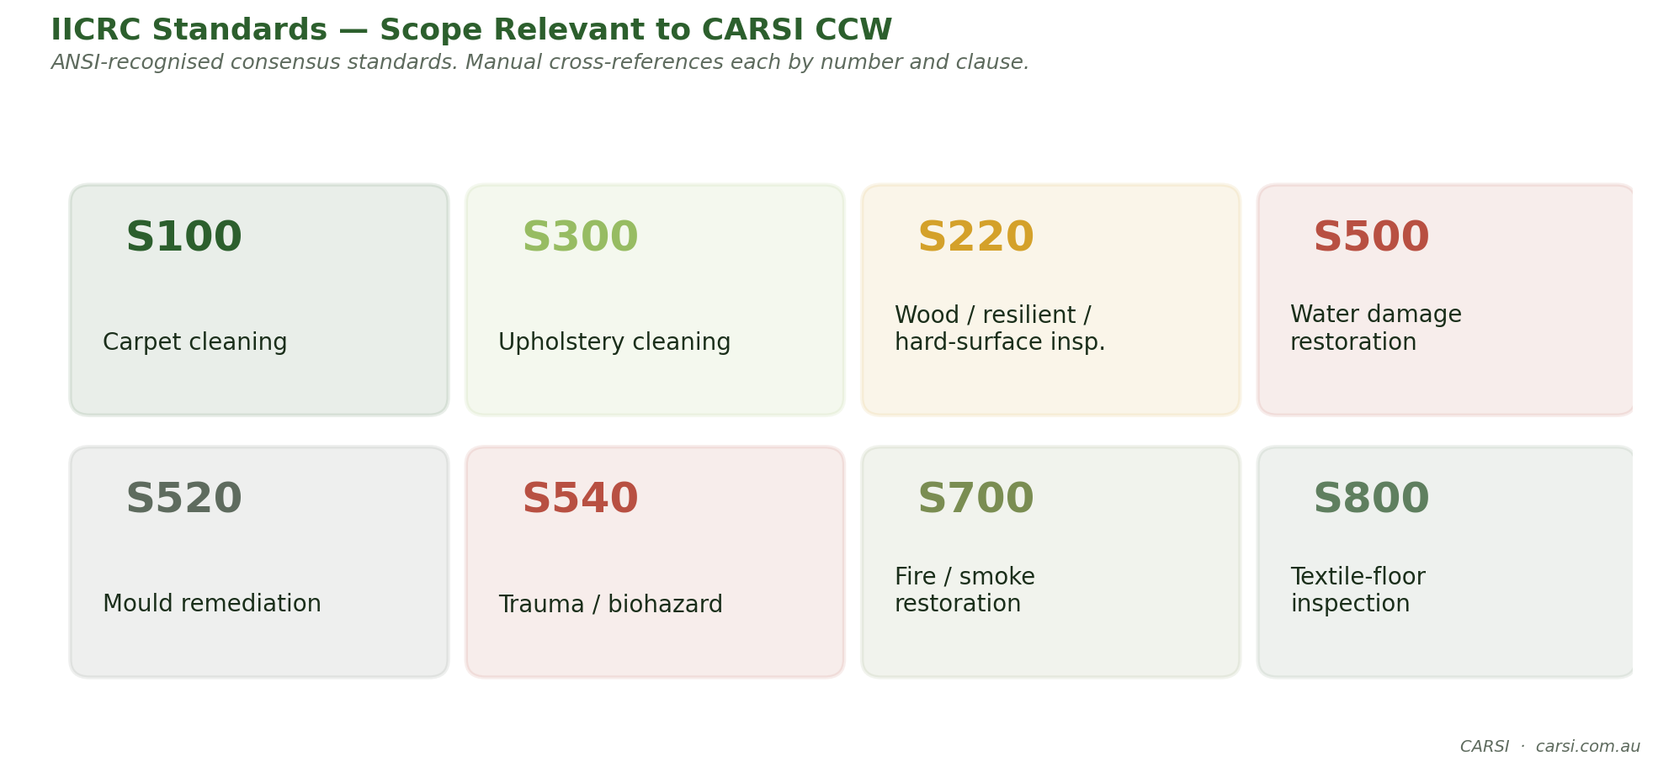
Fig. IICRC Standards — Scope Relevant to CARSI CCW
CARSI EXPERT NUGGET · The ANSI Badge Matters in Court
The "ANSI/IICRC" prefix is not decoration. ANSI accreditation means these standards were written by a balanced consensus panel under ANSI Essential Requirements. Australian and US courts have treated departure from an ANSI-recognised standard as prima facie evidence of negligence in cleaning and restoration claims. A cleaner who can say, on the record, "I followed S100 clause 10 because the ANSI consensus panel settled on that clause" carries far more weight than one who says "that's how I've always done it."

Safety — Non-Negotiables
Every cleaner is a chemical handler. The same alkaline pre-spray that lifts grease off a commercial carpet can blister skin on contact and damage lungs if mist-inhaled for an hour. Safety is the first discipline of the trade — not an optional topic.

Personal Protective Equipment
- Nitrile gloves for chemical handling — minimum. Replace at tears.
- Safety glasses when spraying overhead or using high-pressure wand.
- P2/N95 respirator when atomising stronger alkalines or dry compounds.
- Closed-toe, non-slip footwear — every job, every time.
- Hearing protection around truck-mount operation (typical 85+ dBA).

Hazard Communication
- Safety Data Sheets (SDS) must be on the vehicle for every chemical in use.
- Labels on decanted containers must include product, hazard and date.
- A written Exposure Control Plan identifies likely exposures and PPE for each task.

Electrical & Water
- GFCI/RCD protection on portable extractors — check the test button each job.
- Trip management: signage, cable runs along walls, door wedges.
- Slip management: 'Wet Floor' signs until moisture targets met (see Module 4).
S500 Category 1 / 2 / 3 — Know When to Stop
A carpet-tech can clean Category 1 (clean) water intrusion within scope. Category 2 (grey, containing significant contamination) and Category 3 (grossly contaminated, e.g. sewage) require S500-trained restorers. If in doubt, document, photograph and refer. Working out-of-scope is a liability — not a favour to the customer.

Three-Tier Take-Aways
NEWBY  Know the 7 standard families. Know which PPE goes on before which chemistry. | INTERMEDIATE  Know which standard governs which scope of work. Build an Exposure Control Plan. | PRO  Understand consensus-revision cycles, and how a published 'recommendation' differs from a 'requirement' legally.

Module 2 — Fibre Science
Fibre identification is the single highest-leverage skill in carpet cleaning. Every downstream choice — chemistry, temperature, agitation, drying — is constrained by the fibre in front of you. Misidentify the fibre and you will either (a) under-clean it, or (b) damage it beyond repair.

The Three Fibre Families
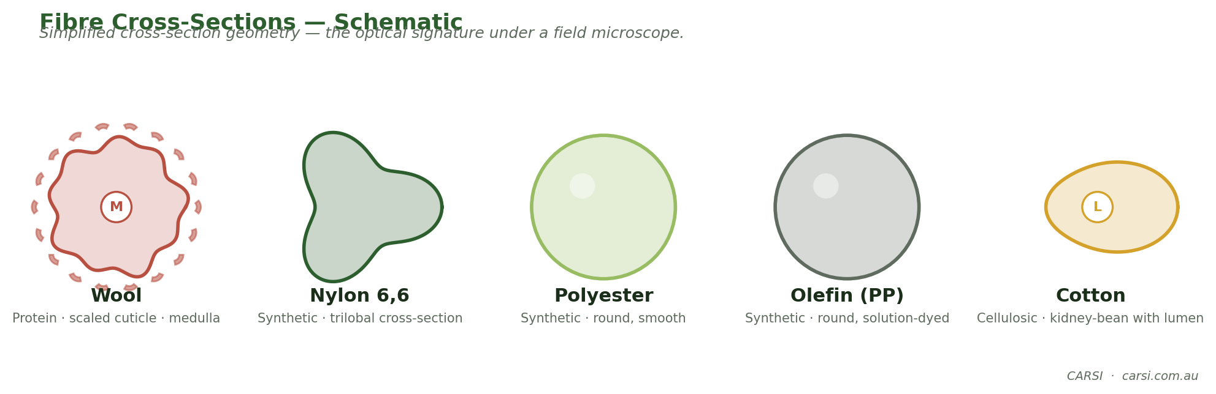
Fig. Fibre Cross-Sections — Schematic

Synthetic (petroleum-based)
- Nylon 6 and Nylon 6,6 — the dominant residential/commercial fibre. Resilient, dye-friendly, pH-sensitive.
- Polyester (PET) — low-cost, hydrophobic, excellent stain resistance, poor resilience.
- Triexta (SmartStrand® etc.) — corn-derived, inherent stain resistance, improving footprint.
- Olefin (polypropylene) — solution-dyed, bleach-safe, poor resilience, low heat tolerance.
- Acrylic — wool-imitating, less common in modern carpets.

Protein (animal)
- Wool — warm hand, self-extinguishing, acidic-preference chemistry, never over-wet.
- Silk — luxurious, very sensitive to moisture and alkaline chemistry. Inspect-and-refer for antique pieces.

Cellulosic (plant)
- Cotton, linen, rayon, acetate, jute, sisal, coir. Rayon loses up to 70% of its strength when wet; minimise moisture and agitation.

Identifying a Fibre — The Field Triad
In the field, the reliable sequence is: hand-feel first, then float/burn to confirm. A burn test on a single tuft plucked from an inconspicuous area is decisive.
Fibre | Burn behaviour | Hand & odour
Wool | Burns slowly, self-extinguishes, leaves crushable black ash | Warm, springy, smells like burnt hair
Silk | Burns slowly, similar to wool, subtle odour | Smooth, cool, subtle lustre
Cotton / linen | Burns freely, after-glow, fluffy grey ash | Matte, absorbs water instantly
Rayon | Burns like cotton, very fast | Soft, weakens dramatically when wet
Nylon | Melts and burns, hard grey/tan bead, celery-like odour | Resilient, springs back
Polyester | Melts and burns, hard black bead, sweet odour | Smooth, low resilience
Olefin | Melts then burns, sooty smoke, wax-like odour | Waxy hand, solution-dyed so even colour
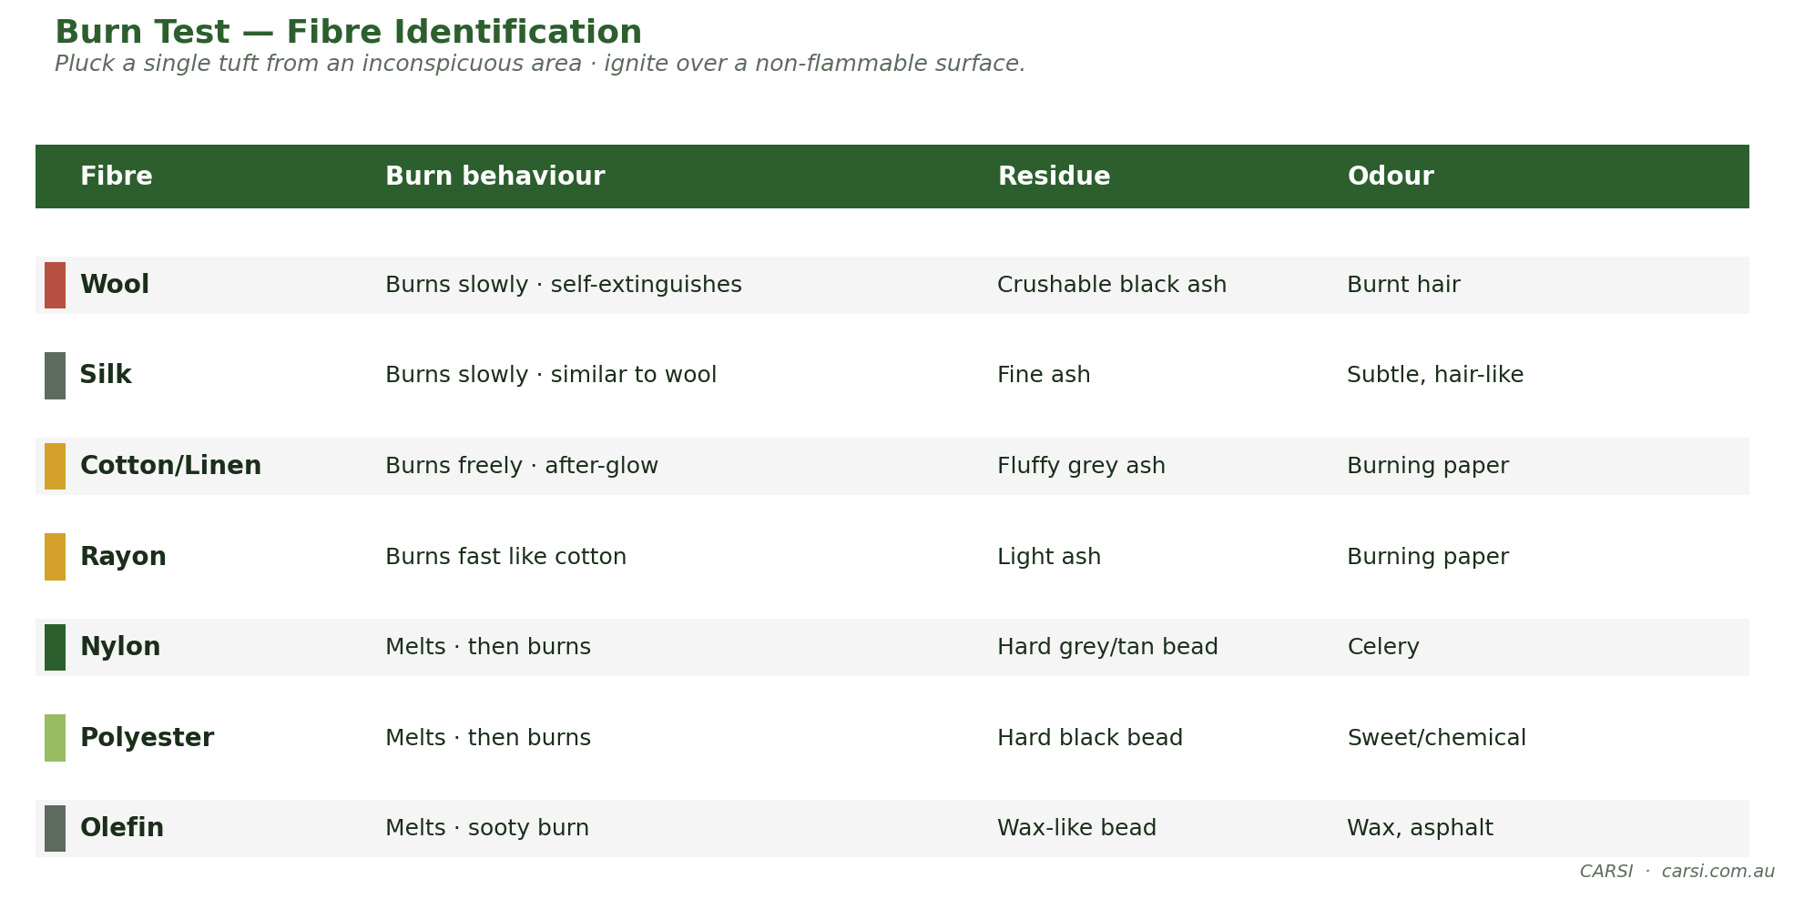
Fig. Burn Test — Fibre Identification
CARSI EXPERT NUGGET · Why Wool Self-Extinguishes — and Why That Matters
Wool is roughly 26% nitrogen by mass. When it burns, the nitrogen forms a foamed, carbonised char layer around the fibre that cuts off oxygen and quenches the flame. This is chemistry, not superstition — wool is the only common carpet fibre with a limiting oxygen index above 25%, the threshold used for inherently flame-retardant textiles (ISO 4589). That same char is why the wool burn test leaves crushable black ash and smells like burnt hair. Trust it: a synthetic "wool look" carpet will not reproduce that signature.

The Fibre Fence — What You May and May Not Do
Every fibre has a chemistry fence. Cross it and you damage the fibre. CARSI's rule of thumb table below is a starting point; always verify with the manufacturer's care instructions when available.
Fibre | pH range | Max water temp | Agitation tolerance
Nylon | 5.5 – 10 (never above 10) | 60–80 °C | Medium–high
Polyester | 5.5 – 10 | 60–80 °C | Medium
Triexta | 5.5 – 10 | 60–80 °C | Medium–high
Olefin | 5.5 – 10 | Max 60 °C (low melt point) | Medium
Wool | 4.5 – 8 (acidic-preferred) | Max 40 °C | Low
Silk | 4.5 – 7.5 | Ambient–35 °C | Very low
Rayon | Neutral 6 – 8 | Ambient–35 °C | Very low (wet-strength loss)
Cotton | 6 – 9 | Ambient–50 °C | Low–medium
The Weakest-Member Rule
On a blended fibre (e.g. 80% wool / 20% nylon), the more delicate fibre governs the chemistry choice. Treat an 80/20 wool-nylon blend as wool. A 50/50 silk-cotton drapery is silk for pH purposes.

Three-Tier Take-Aways
NEWBY  Name 5 fibres by sight and burn-test. Know wool ≠ nylon chemistry. | INTERMEDIATE  Map fibre → pH + temperature + agitation on any carpet in the field. Spot rayon before you wet it. | PRO  Call the weakest-member rule on blends; explain fibre-dye chemistry and why cationic surfactants damage nylon acid-dye blockers.

Module 3 — Chemistry of Cleaning
Cleaning chemistry boils down to four variables, an acronym worth memorising: Chemistry, Heat, Agitation, Time — CHAT. You can trade one for another. Lower pH? Add heat or time. Lower temperature? Increase agitation. Shorter dwell? Increase chemistry strength. The art is knowing which dial to turn on which fibre.

pH in Practice
The pH scale runs 0–14. CARSI uses the following practical zones, consistent with IICRC guidance:
Zone | pH range | Practical meaning
Strong acid | 0 – 3 | Rust removers, acidic dye-set. Use with care.
Mild acid | 4 – 6 | Wool finish rinses, general acidic neutraliser.
Neutral | 6 – 8 | Pre-test default; safe on most fibres.
Mild alkaline | 8 – 10 | General pre-spray zone for synthetic fibres.
Strong alkaline | >10 | Degreasers — never exceed this on nylon.
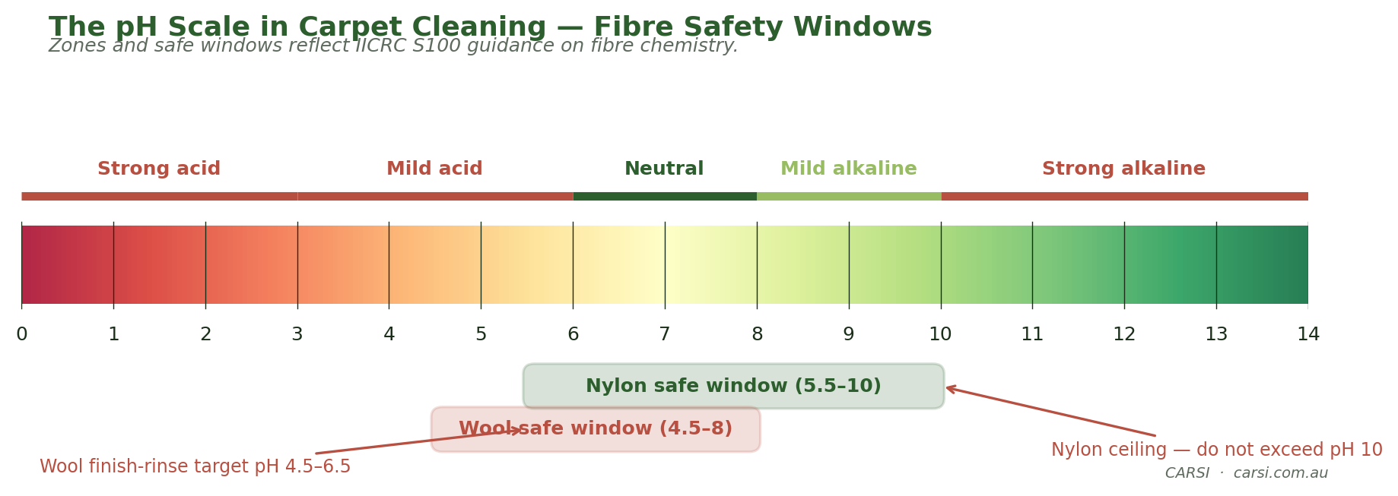
Fig. The pH Scale in Carpet Cleaning — Fibre Safety Windows
Two Rules You Do Not Break
Nylon pH ceiling: 10. Wool preference: acidic finish (pH 4.5–6.5). Break the first and you bleach the acid-dye sites, causing colour loss. Break the second and you yellow the wool and roughen the hand.

Surfactant Families — What They Do
Surfactants are the molecular bridge between water and soil. The chemistry of which surfactant you choose affects not only cleaning power but also residue, re-soiling, and compatibility with the fibre's dye system.
- Anionic — the workhorse. Strong detergency, good foam. Can leave sticky residue if rinsed poorly.
- Cationic — disinfecting and antistatic. Damages nylon acid-dye blockers — avoid on nylon carpet.
- Non-ionic — low-foaming, good solvent compatibility. Common in pre-sprays.
- Amphoteric — changes charge with pH. Gentle; used in wool-safe formulas.

CHAT — The Four Dials
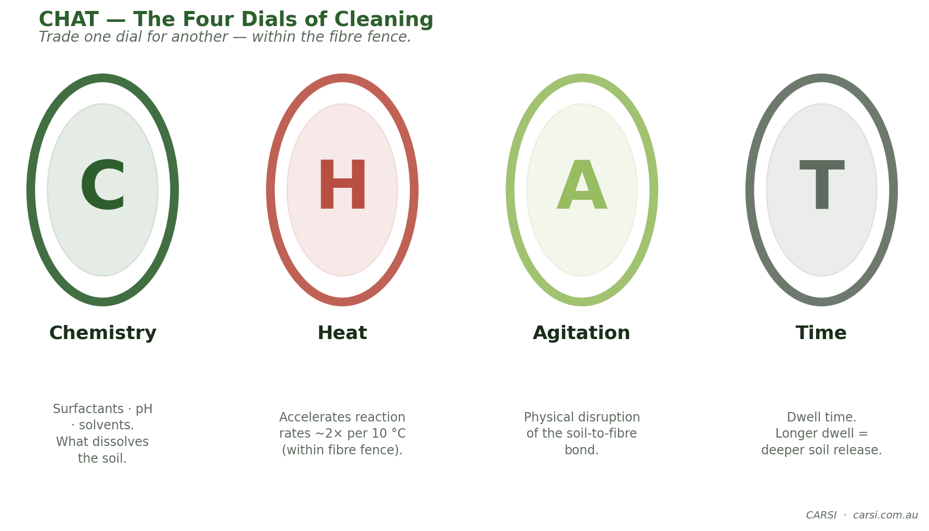
Fig. CHAT — The Four Dials of Cleaning
CHAT is the single most useful mental model in cleaning. Any one variable can compensate for another within the fibre fence. Examples:
- Cold job in winter → increase dwell time + slightly higher pH (within fence) to compensate for heat loss.
- Delicate wool rug → keep pH down, keep heat down → compensate with longer dwell and gentler agitation.
- Heavy commercial grease on nylon → max pH 10 + heat + soft agitation + 8–10 min dwell.
CARSI EXPERT NUGGET · The pH Strip Reads the Substrate — Not Your Solution
Dipping a pH strip into the pre-spray bottle tells you the chemistry of the bottle. Pressing a damp pH strip to the cleaned carpet tells you what the fibre is actually holding — and those numbers are often 1.0–2.0 pH units apart because fibres (especially wool and cotton) buffer acid and alkaline differently. Your customer complaint risk lives in the second number. CARSI's final-rinse verification is always done by pressing a fresh strip to a damp area of the carpet, not by reading the bucket.

Soil Classes
- Water-soluble — sugar, urine salts, beverages. Removed by any aqueous cleaning.
- Solvent-soluble — oils, grease, tar, ink. Requires emulsification or solvent.
- Insoluble — sand, grit, fibres. Removed mechanically (vacuuming, pile-lifter).
Every soiled carpet is a mix of the three. Principle 1 (dry soil removal) handles most of the insoluble. Principle 2 (suspension) lifts water-soluble and solvent-soluble via chemistry.
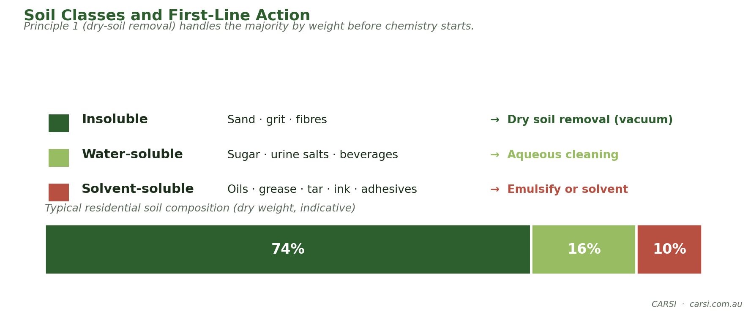
Fig. Soil Classes and First-Line Action

Final-Rinse Target pH
The pH of what you leave behind on the fibre matters more than the pH of what you sprayed on. A final-rinse target between 6.5 and 8.0 on the substrate prevents re-soiling, browning, and yellowing. A sheet of pH paper pressed to a damp spot is the 15-second verification step every pro uses.

WoolSafe® — and the pH-7 Myth
The most common misconception in carpet cleaning is that "pH 7 = wool-safe". It is not. The WoolSafe® Organisation (Otley, UK) is a certification body; "WoolSafe® Approved" means a product has passed 22 ISO-based test methods (CCP 1–22) and the manufacturer holds a current licence to display the certification mark. A product marketed as "wool-safe" or "safe for wool" without the mark is making an uncertified claim — it may still be suitable, but has not passed the test panel.
WoolSafe's criterion is an alkalinity window, not neutral pH. A pre-spray is acceptable if no more than 5 ml of 0.1N HCl is needed to bring 100 ml of working solution from its as-used pH down to pH 7, and no more than 14 ml to reach pH 5.5. An acid-side rinse must stay at pH 2.5 or higher. That lets a WoolSafe-certified pre-spray read as high as pH 9.5–10 at the meter, provided its buffering is low enough. Wool damage is driven by alkalinity × heat × dwell-time, not pH alone.
Practical Rule for Wool Work
For routine residential wool jobs, a low-alkalinity pre-spray at pH 9.5 with warm (not hot) water and a prompt acidic rinse is gentler than a pH 8 product with high residual alkalinity left on for 30 minutes. For insurance-grade, antique, museum, or spec wool jobs, source a product currently on the WoolSafe® Approved register at woolsafe.org and keep a copy of the register entry on file.

Three-Tier Take-Aways
NEWBY  Read a pH strip. Never mix acid and chlorine. Always rinse. | INTERMEDIATE  Choose which CHAT dial to turn for a given soil class on a given fibre. | PRO  Build paired pre-spray + rinse that lands final pH 6.5–8.0; explain why cationic kills nylon blockers.

Module 4 — The Five Cleaning Principles
The Five Principles are the universal spine of carpet cleaning. They apply across every method and every fibre. The order is fixed: you cannot skip a step without paying for it downstream.

The Five Principles, In Order
- Dry particulate soil removal (vacuuming with airflow + agitation).
- Soil suspension (chemistry + heat + agitation + time — the CHAT model).
- Extraction of suspended soil.
- Pile setting / grooming — realign the fibres for even drying and finish.
- Drying — remove residual moisture to below the fibre's safe threshold.
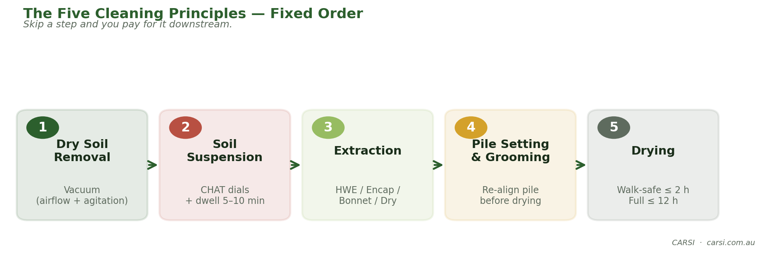
Fig. The Five Cleaning Principles — Fixed Order
CARSI EXPERT NUGGET · The Second Vacuum Pass Is the Cheapest Upgrade in the Trade
CRI (Carpet and Rug Institute) independent testing has repeatedly shown that a second vacuum pass in a cross direction recovers an additional 10–20% of dry soil by weight over a single pass — on the same machine, same carpet, same day. That recovered soil is soil you do not grind into the yarn during Principle 2, soil you do not have to lift with chemistry, and soil that is not left behind as re-soiling bait. The entire "upgrade" costs roughly three extra minutes on a 40-square-metre residential job. No new equipment. No new chemistry. No higher price. Just an extra pass.
Principle 1 is the Multiplier
Independent measurements routinely show that thorough dry-soil removal takes out the majority of visible, weighable soil before any chemistry is applied. Skip Principle 1 and you grind the grit into the yarn during Principle 2. The cheapest upgrade any cleaner can make is a second pass of vacuuming.

Principle 1 — Dry Soil Removal
A quality upright with a beater bar removes ~50–65% of dry particulate on residential carpet in a single pass. A two-way (criss-cross) vacuuming pattern typically adds another 10–20%. Pile lifters further improve removal on heavy-soiled or crushed commercial carpet. Verification: run a clean white cloth along a single row of pile after vacuuming — the result is your baseline.

Principle 2 — Soil Suspension
Chemistry does the separation work between soil and fibre. The CHAT dials (see Module 3) govern how aggressive the suspension needs to be. Dwell time matters: most pre-sprays need 5–10 minutes on the fibre before rinsing to reach full effect.

Principle 3 — Extraction
Extraction removes the suspended soil. The four main methods are: hot-water extraction (HWE), encapsulation, bonnet/absorbent-pad, and dry compound. HWE remains the predominant restorative method and is what the course hands-on builds muscle-memory for.
- Dry-stroke technique — on every wand stroke, the trigger pull is shorter than the vacuum pull. Typical ratio 1:2 (half of the stroke is dry-vacuum only).
- Wand angle — too steep and you leave water behind; too flat and you lose suction. Learn the feel at the training session.
- Overlap — always overlap your strokes by about 25% to avoid stripes.
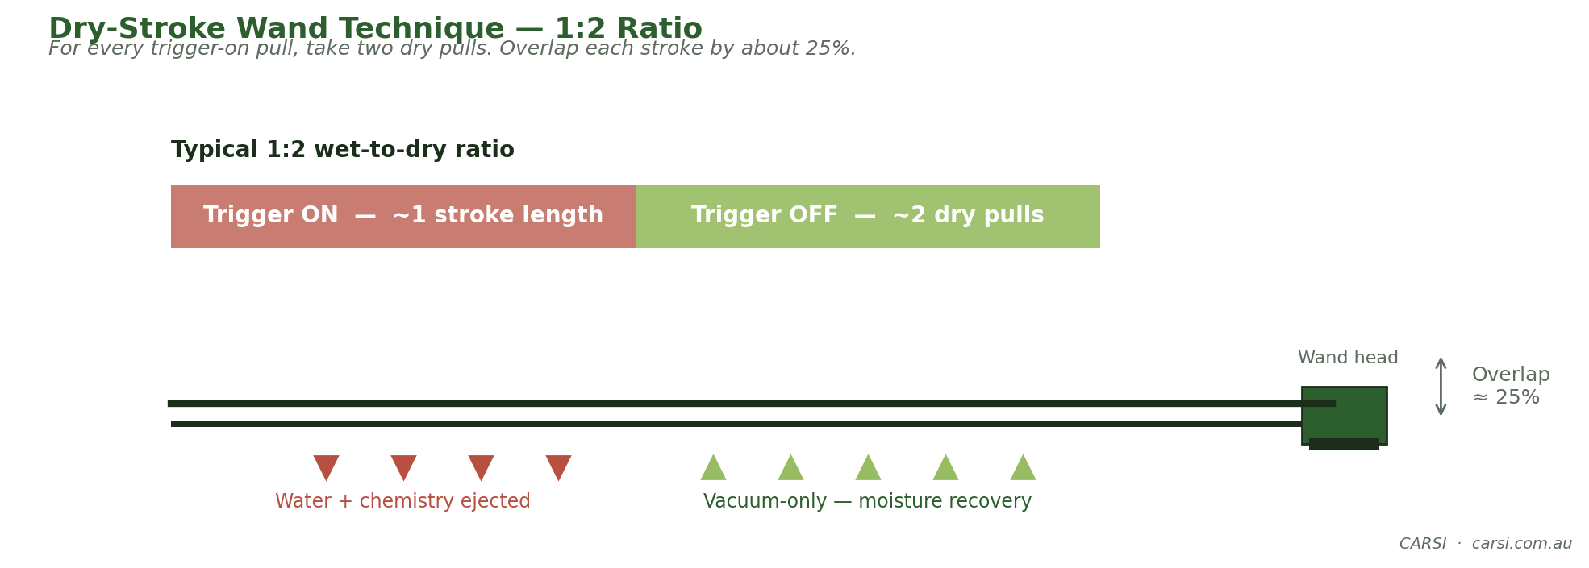
Fig. Dry-Stroke Wand Technique — 1:2 Ratio

Principle 4 — Pile Setting / Grooming
After extraction, the pile is flattened, wet and uneven. Grooming with a pile-setting brush or carpet rake re-establishes the pile direction, speeds drying, and gives the finished carpet its uniform appearance. Skip this step and the carpet dries with visible wand tracks.

Principle 5 — Drying
Moisture left too long causes browning (cellulosic wicking), wicking stains, microbial growth, and customer complaints. CARSI drying targets:
- Commercial: back to service in 8 hours or less.
- Residential: walk-safe within 2 hours; fully dry within 12 hours.
- Accelerate with airmovers (one per 150–250 sq ft), dehumidification in humid climates, and HVAC use where available.
The Drying Trade-Off
Every extra minute of dwell time is minutes of drying time you owe back. Plan wand speed + airmover placement before spraying chemistry — not after.

Three-Tier Take-Aways
NEWBY  Memorise the 5 steps in order. Never skip Principle 1. | INTERMEDIATE  Set drying targets for every job; place airmovers before unpacking chemistry. | PRO  Trade CHAT dials against drying load; explain wicking and how to prevent it.

Module 5 — Spot & Stain Removal
A 'spot' is removable by standard cleaning; a 'stain' has permanently altered the fibre's dye structure. Part of professional judgement is knowing which is which before you spend two hours and a customer's patience trying to remove the irremovable.

Stain Classes
Class | Examples | First-line chemistry
Water-soluble | Sugar, urine salts, most beverages | Water, mild alkaline spotter
Solvent-soluble | Oils, grease, lipstick, tar, gum | Solvent, POG (paint-oil-grease)
Protein | Blood, egg, dairy, vomit | Enzymatic / mild alkaline, cool water
Tannin | Coffee, tea, red wine, tomato | Acidic spotter (wool-compatible when low-alkalinity), then oxidiser if needed
Dye | Kool-Aid, red wine pigment, ink | Heat-assisted reducing agent, dye-stripper
Combination | Most food spills | Address each class in sequence

The Decision Tree
- Identify class (and test in inconspicuous area).
- Blot — never rub.
- Apply cold-chemistry first — work from the outside in.
- If residual, escalate: heat → oxidiser → reducing agent (dye stain).
- Rinse-extract thoroughly. Over-applied spotter becomes tomorrow's re-soiling.
- Dry and re-inspect after 24 hours — some stains wick back.
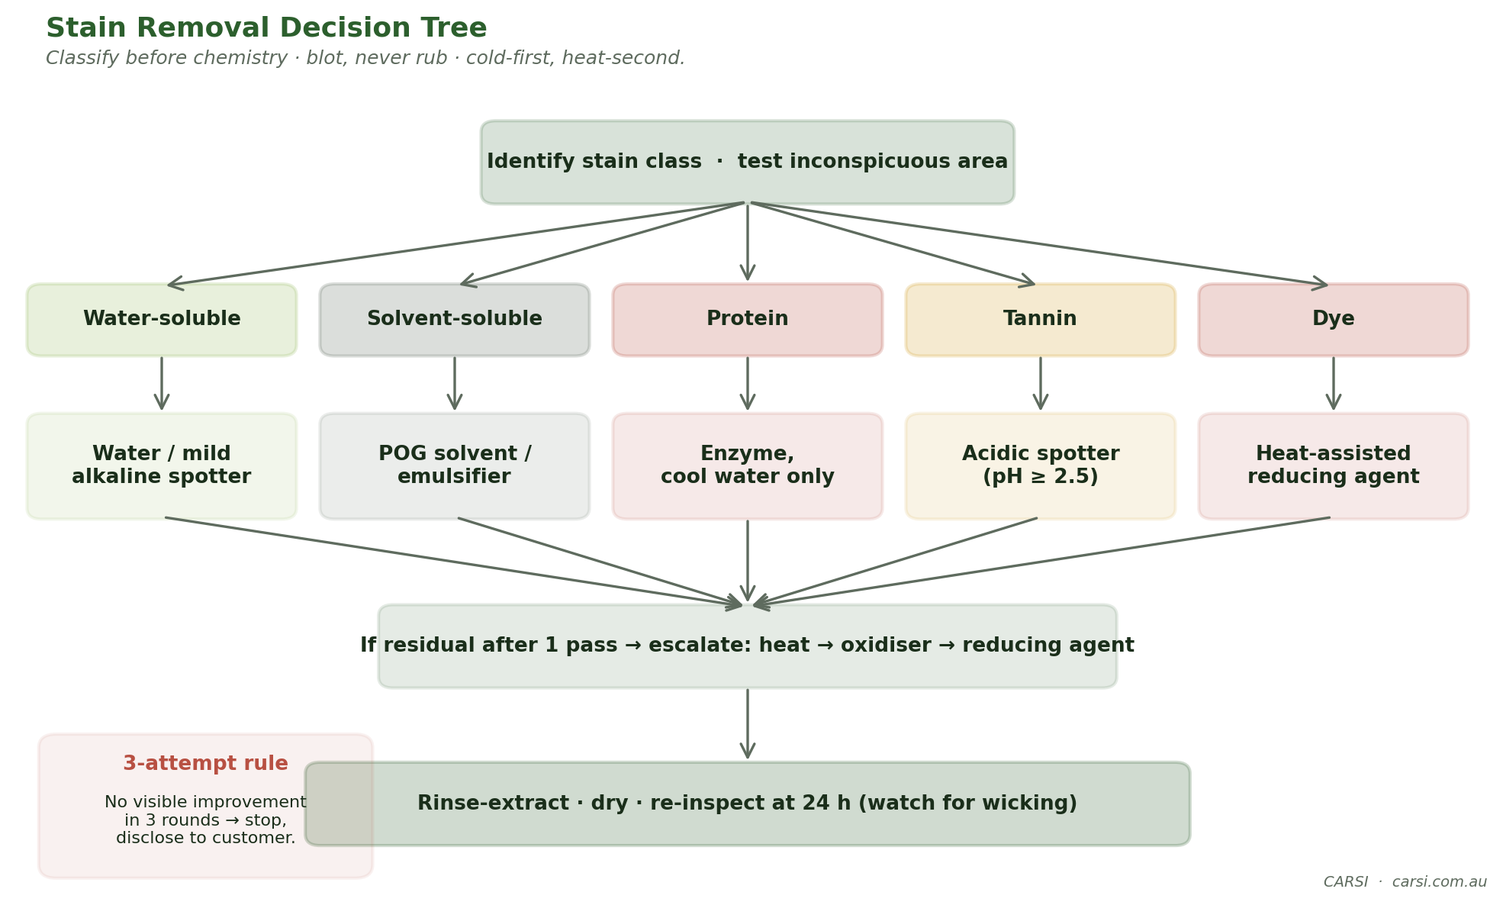
Fig. Stain Removal Decision Tree
CARSI EXPERT NUGGET · Urine pH Rises as It Ages
Fresh urine sits around pH 6. As bacteria metabolise the urea, it breaks down to ammonia — and aged urine can climb to pH 10–12. That is why a fresh urine spot often responds to a general-purpose spotter, while an old yellow stain defies alkaline chemistry and only yields to an acidic-side spotter (which reverses the ammonia reaction and precipitates the urine crystals). If you inherit a three-year-old pet-odour problem and hit it with an alkaline pre-spray, you are adding alkalinity to a substrate that is already strongly alkaline — that is how you set the stain and strip the wool dye in one stroke. Acid-side first on aged urine, always.
The Three-Attempt Rule
If a stain has not visibly improved after three rounds of appropriate chemistry, stop. You are likely attacking a permanent dye stain. Disclose honestly to the customer — 'I can keep working but I risk damage; your choice.' Damaged carpet is always more expensive than a surviving stain.

The Spotting Kit — The Six-Bottle Minimum
- Acid-side spotter (wool-compatible, pH ≥ 2.5) — tannin, urine-set.
- Alkaline-side spotter — general organic.
- Protein / enzyme spotter — blood, dairy, food.
- POG (paint-oil-grease) solvent — adhesives, gum softener.
- Oxidiser (hydrogen peroxide, 3–12% depending on fibre) — stubborn tannin.
- Reducing agent (sulphite or bisulphite-based) — red dye, Kool-Aid.

Blot vs Rub — Live Demo in the Course
Rubbing distorts pile geometry: the pile fibres separate from their natural alignment, and the resulting visible 'bruise' is permanent even after the spot itself is gone. The blot-not-rub rule is not a superstition; it is pile-geometry preservation.

Three-Tier Take-Aways
NEWBY  Blot, don't rub. Identify class before chemistry. Always test. | INTERMEDIATE  Run the 5-step matrix; escalate cold-first, heat-second. | PRO  Know when to stop. Document a dye stain vs. a spot for the customer's records.

Module 6 — Upholstery Theory
Upholstery is not carpet. Face fabrics are often more delicate, backings are unpredictable, glue-bonded trim and latex foam can run or collapse, and frame construction varies wildly. The single most common cause of upholstery damage is assuming 'what works on carpet works on the sofa'. It does not.

Construction Types
- Woven — plain, twill, satin, jacquard. Pattern integrity depends on weave; loose weaves distort under agitation.
- Tufted — yarn tufted into primary fabric; commonly glued. Solvent risk.
- Flocked — short fibres attached to a base by adhesive; often water-sensitive.
- Non-durable constructions — chintz, quilted, moiré, velvet: known to distort, crush, or watermark under moisture.

The Cleaning Code System
Code | Meaning | Starting-point method
W | Water-based cleaning permitted | Wet: dry foam, encapsulation, HWE rinse
S | Solvent-based cleaning only | Dry solvent methods only; no water
WS | Water or solvent permitted | Choose based on soil; wet is typical
X | Professional vacuuming only | Do not attempt cleaning — refer or decline
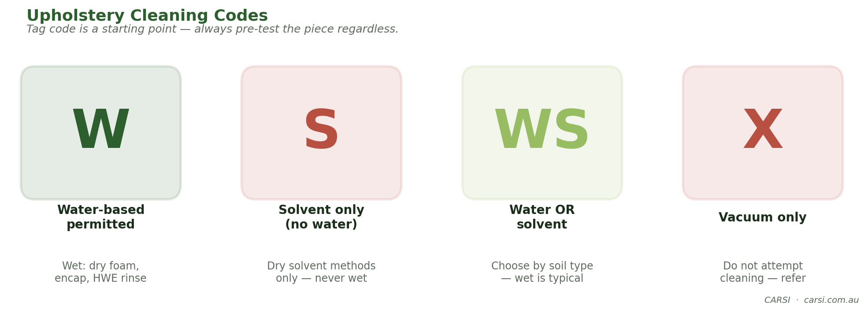
Fig. Upholstery Cleaning Codes
The code is a starting point — not a guarantee. Always pre-test (see §The 4-Test Pre-Inspection below) regardless of what the tag says.

The 4-Test Pre-Inspection — Mandatory
Before spraying any chemistry on any upholstered piece, run four tests in an inconspicuous area. Document each. If any fails, stop and reassess your method.
- Bleed test — a drop of water or pre-spray on a white cloth; press and inspect the cloth for dye transfer.
- Crock test — rub a dry white cloth on the dry fabric; inspect for loose dye transfer.
- Shrink test — apply water to an area ~50×50 mm, let dry; measure for dimensional change.
- Distortion test — apply chemistry + gentle agitation; look for pile matting, weave separation, or glossy spots.
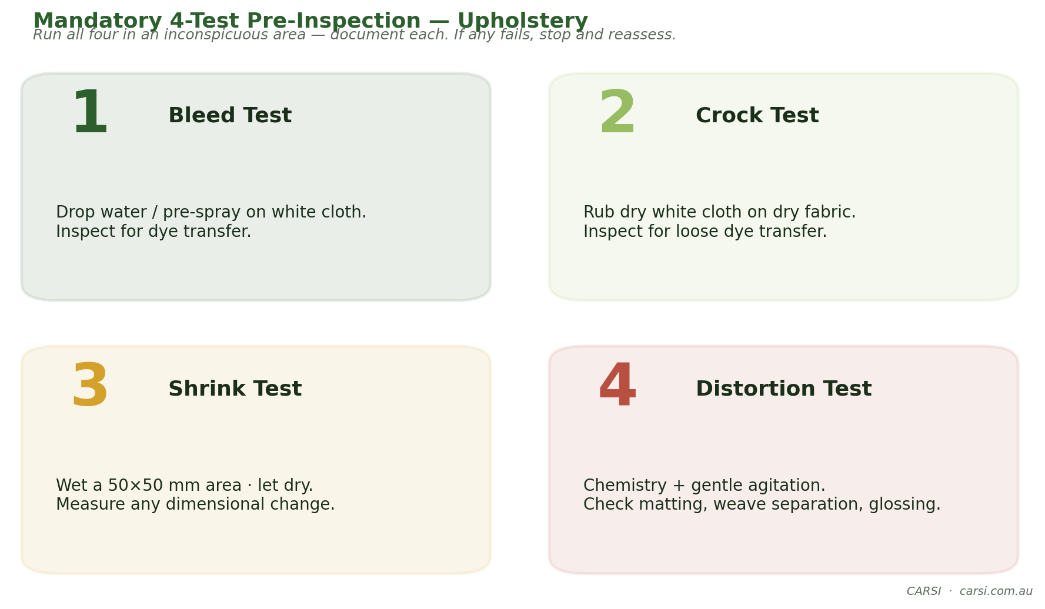
Fig. Mandatory 4-Test Pre-Inspection — Upholstery
CARSI EXPERT NUGGET · The Shrink Test Needs 24 Hours, Not 2
Upholstery fabrics frequently shrink under moisture and then rebound as they dry — partially, sometimes fully. Read the test at 2 hours and a borderline fabric gives a false-positive shrink result; you refuse a cleanable job. Read it at 24 hours and the fabric either snapped back (safe to clean) or is still tight (genuinely unsafe). CARSI's shrink protocol: wet the 50×50 mm test patch, dry it with low airflow, measure at 24 hours — not before. The same protocol catches latex-foam collapse, which is slower to show than weave distortion.
Rayon Lives Here
Upholstery is where rayon appears most often — in decorative throws, pillow covers, and cheaper sofa fabrics. Rayon can lose up to 70% of its tensile strength when wet. On rayon, minimise moisture: use dry compound, dry foam, or HWE with tight dry strokes and speed-drying.

Three-Tier Take-Aways
NEWBY  Never clean without the 4 tests. Respect the X code. | INTERMEDIATE  Match method to fibre and construction. Flag non-durable fabrics before quoting. | PRO  Repair-vs-restore triage: know when a piece is beyond scope and honest refusal is a service.

Module 7 — Upholstery Methods
Six recognised methods, each with its place. The live hands-on session compares all six on identical test sofas so you see the speed, residue and finish differences side-by-side.

The Six Methods
# | Method | Best for | Watch-outs
1 | Dry solvent | S-code fabrics, oily soil | Ventilation; flammability on some products
2 | Dry compound | Delicate fabrics, water-sensitive pieces | Residue management; vacuum fully
3 | Dry foam | Moderately soiled W-code | Control foam moisture; rinse via extraction
4 | Encapsulation | Low-moisture maintenance | Matches well with post-vacuum recovery
5 | Shampoo | Heavily soiled durable fabrics | Residue if not rinsed; rarely first-line today
6 | HWE with water rinse | W / WS robust fabrics | Over-wetting; respect fibre fence
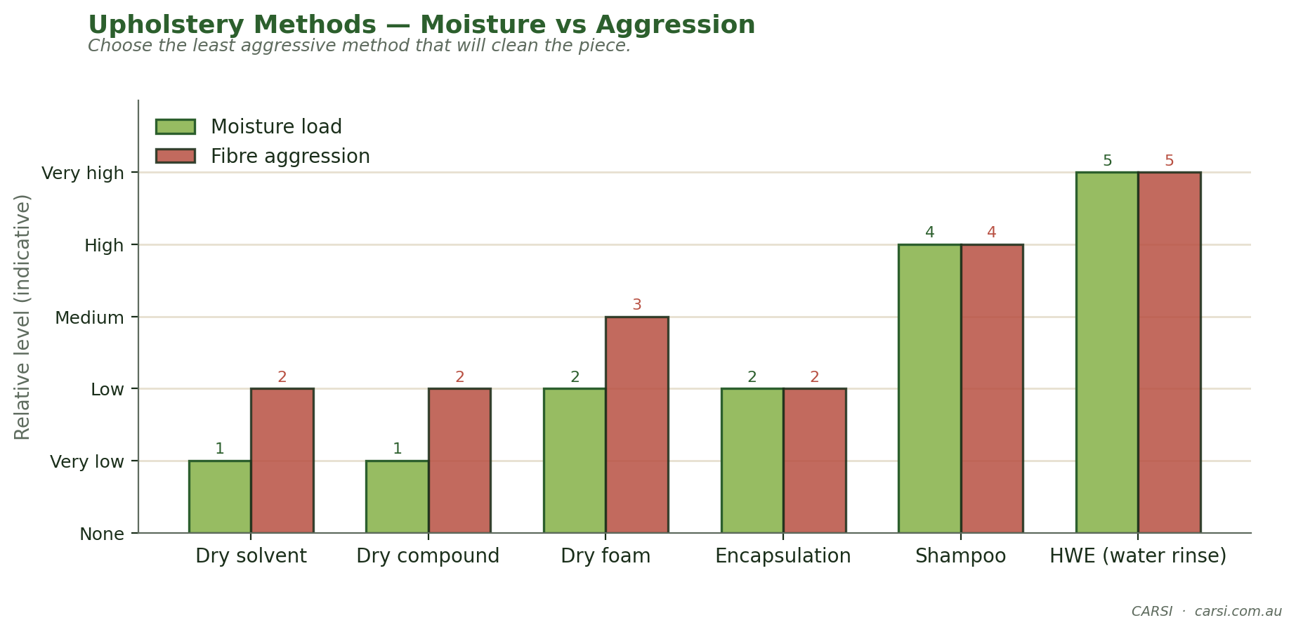
Fig. Upholstery Methods — Moisture vs Aggression
No Live Steam on Upholstery
HWE on upholstery uses heated water — not live steam. True live steam (>100 °C) will damage adhesives, glues and latex foams, and can distort delicate fibres. If a product advertises 'steam', verify the actual temperature at the tool.
CARSI EXPERT NUGGET · Olefin Melts Below Many Truck-Mount Outputs
Polypropylene (olefin) has a melt point of approximately 160 °C (320 °F). Most modern truck-mounts can deliver solution temperatures of 105–120 °C at the wand inlet on a cold boiler day, rising further at the jet. That is already close enough to the olefin softening point (around 130 °C) that a slow wand pass on olefin carpet can permanently flatten and gloss the pile. Rule: dial the machine down on olefin to 60 °C at the jet, keep the wand moving, and never second-pass a hot-spray on a known olefin piece. This is why the six-method chart above rates HWE on olefin as high-aggression even though "HWE on synthetics" sounds forgiving.

Tool Tiers
- Upholstery hand tool (e.g., 4" internal) — everyday staple.
- Stainless hand-wand — higher airflow, rigid for cushion work.
- Air-driven / external-jet tool — fastest, least over-wetting, most expensive.

Speed-Drying Upholstery
- Airflow first — a single axial fan or small airmover placed to move air across — not into — the fabric.
- Reduce humidity — open a window or run a small dehumidifier if ambient RH is over 60%.
- Warm airspeed beats hot still air — moving 30 °C air dries faster than still 60 °C air.
- Target: fabric hand-dry within 2 hours, fully dry within 6 hours on robust W fabrics.

Three-Tier Take-Aways
NEWBY  Six methods exist — pick the least aggressive that will clean the piece. | INTERMEDIATE  Stage a speed-drying plan before chemistry; know your tool-tier trade-offs. | PRO  Rescue-clean and salvage-clean judgement calls; insurance-facing documentation.

Module 8 — Hard-Floor Cleaning & Inspection
Hard floors are a natural upsell for the carpet cleaner — the customer already trusts you. But the chemistry and inspection rules are different, and the failure modes are more expensive. This module is inspection-first: the discipline that keeps you out of litigation.

Five Hard-Surface Families
Family | Examples | Acid sensitivity
Hardwood | Solid, engineered, oiled, sealed | Sensitive to moisture at joints
Laminate | HDF core + image layer | Joints swell catastrophically if saturated
Stone | Marble, limestone, travertine, granite, slate | Calcareous stones etched by acid
Ceramic / porcelain | Tile, glazed and unglazed | Grout is the weak point
Resilient | Vinyl, LVT, linoleum, rubber | Alkaline for grease; watch stripping chemistry
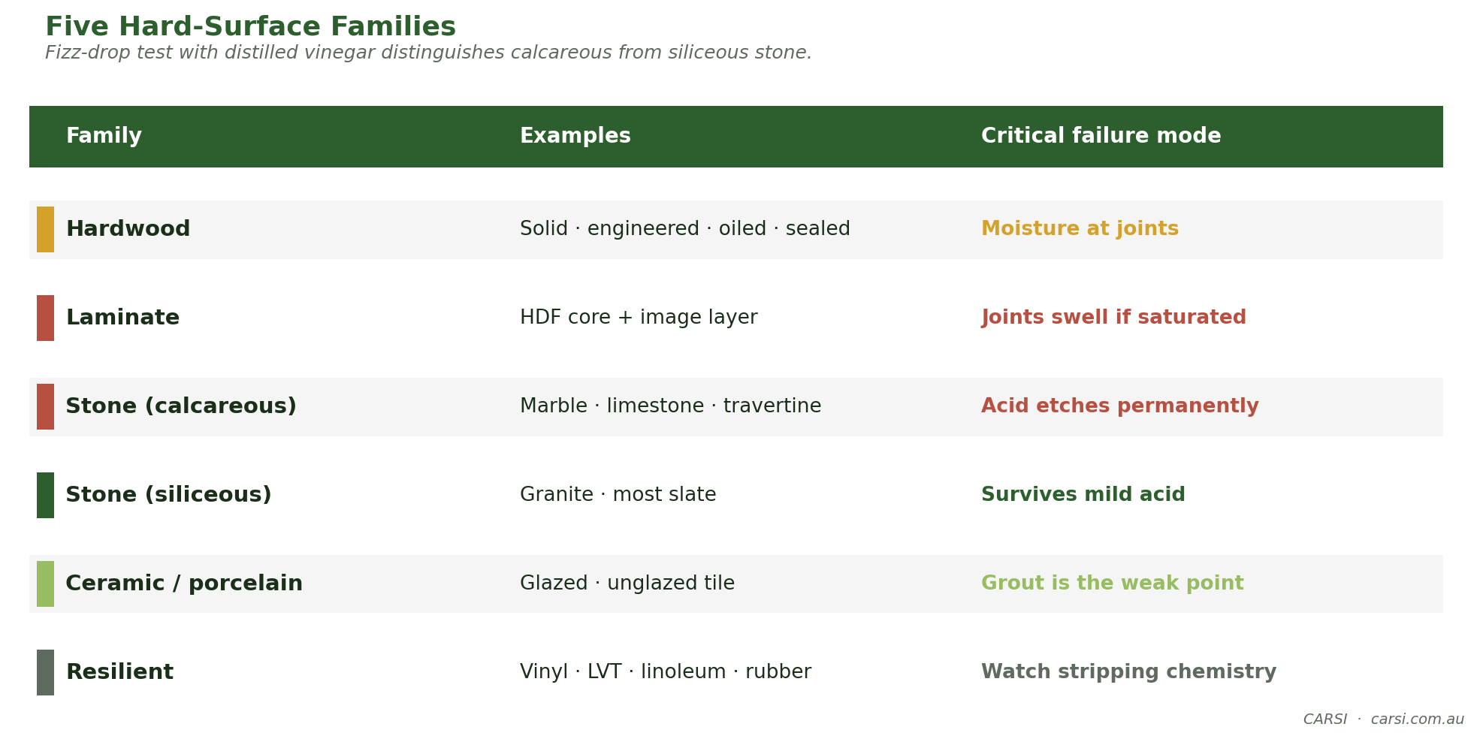
Fig. Five Hard-Surface Families
Calcareous vs Siliceous Stone
Marble, limestone and travertine are calcareous — calcium-based. Any acid etches them, permanently. Granite and most slate are siliceous — silica-based — and survive mild acid. Test with a drop of distilled white vinegar in an inconspicuous area: fizzing = calcareous = never acid.
CARSI EXPERT NUGGET · A Dollar of Vinegar Prevents a $10,000 Claim
The single most expensive mistake a well-meaning cleaner can make on hard floors is using an acidic grout cleaner on marble or travertine. The etch is instant, permanent, and impossible to polish out without professional stone refinishing — a whole-floor resurface can run well into five figures. The vinegar drop test takes thirty seconds, costs roughly a dollar a year in consumables, and gives a binary answer. Fizz means carbonate. Carbonate means never acid. A pro carries a labelled squeeze bottle of distilled white vinegar and a dropper in the inspection kit for exactly this test — and photographs the result with date and location for the job file.

Non-Destructive Inspection Rule
Under the S220 scope, a hard-floor inspection is non-destructive: you can measure, observe, document, photograph, but you do not pry boards, chip tiles, or gouge sealer. The inspection report must be defensible.
- Moisture meter — pin and pinless, calibrated to substrate.
- RH and temperature — ambient conditions at time of inspection.
- pH strips + distilled water — surface chemistry assessment.
- Photographs — dated, scale reference in frame, multiple angles.

Cleaning Chemistry Starters
- Sealed hardwood: neutral pH cleaner, damp-mop only, never saturate joints.
- Laminate: damp microfiber, water kept off seams — laminate swells from edge.
- Marble / limestone: neutral-pH stone-safe cleaner only. No acid. No strong alkaline.
- Ceramic: mild alkaline for grout soil; rinse with clear water.
- Resilient (vinyl / LVT): mild alkaline for general; neutral-maintenance products for gloss protection.

Three-Tier Take-Aways
NEWBY  Never acid on calcareous stone. Always test pH. Never saturate laminate joints. | INTERMEDIATE  Build an inspection report that would withstand cross-examination. | PRO  Correlate moisture + RH + time for cupping, buckling, tenting claims.

Module 9 — Machinery Maintenance
Machines don't break down mysteriously. They degrade measurably — and the cleaner either reads the signs early (preventive) or pays a technician the hard way (reactive). Every dollar spent on preventive maintenance saves roughly $5–10 of emergency repair and lost revenue.

Truck-Mount Preventive Checklist
- Blower oil — check level weekly; change per manufacturer hours interval.
- Belt tension — inspect weekly; retension per specification.
- Heat exchanger — flush annually with descaler; visually inspect for corrosion.
- Vacuum relief valve — test operation monthly.
- Chemical pump — rebuild kit on schedule; watch for output pressure drop.
- Winterise — every autumn in frost-risk climates; anti-freeze through lines.

Portable Extractor Preventive Checklist
- Pump diaphragm — replace at pressure-drop symptom or per hours.
- Filters — clean after every job, replace on schedule.
- Vacuum motors — brush wear shortens life; replace brushes before motor.
- Hoses and fittings — inspect for kinks, weep leaks, cracked cuffs each use.

Rotary / CRB
- Brush replacement cycle — typically 80–120 hours.
- Bearings — greased per schedule.
- Drive belts — check tension + wear.

Wand and Hose Service
- Swivel joints — lubricate monthly; replace seal kits annually.
- Jets — clear blockage with pin; verify spray fan pattern.
- Corner guards — replace when worn to prevent carpet snag.
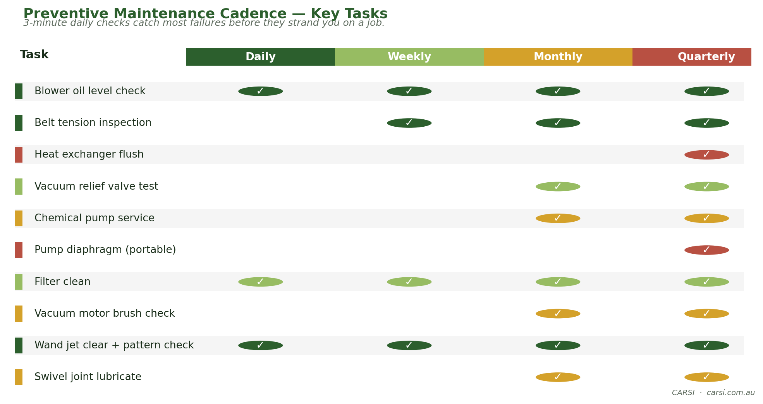
Fig. Preventive Maintenance Cadence — Key Tasks
Daily / Weekly / Monthly — Small Habits, Big Uptime
The daily 3-minute checklist (oil, belt, jet, hose) catches 80% of failures before they strand you on a job. The weekly 15-minute pass covers vibration, sound, suction benchmark. The monthly 45-minute service extends machine life by years.
CARSI EXPERT NUGGET · Replace the Vacuum Motor Brushes — Save the Motor
On portable extractors and upright vacuums, the carbon brushes typically wear out at roughly 60–70% of the motor's full service life. Most technicians run the brushes to failure — which then arcs the commutator, pits the windings, and usually writes off the motor. Replacement brushes cost $15–40 per pair; a replacement bypass-vacuum motor costs ten to fifteen times that. A pro logs vacuum-motor hours, inspects the brushes at 400–500 hours (pulled out, measured against a ruler — new is ~25 mm, condemn at ~8 mm), and replaces them in a ten-minute service. The same discipline applies to CRB motors and rotary drives.

Three-Tier Take-Aways
NEWBY  Run the daily/weekly/monthly checklist. Never cleanly skip a day. | INTERMEDIATE  Troubleshoot low vacuum, low pressure, overheating from first principles. | PRO  Calculate downtime cost vs. preventive cost; plan replacement cycles 12 months out.

Module 10 — Business of Cleaning
Technical excellence without pricing discipline is charity. Customers don't pay for hours — they pay for the transformation and the trust. This module is the pricing, costing and customer-communication framework that CARSI-trained cleaners apply to protect their margins.

Six Lines of Cost
# | Cost line | What it captures
1 | Direct labour | Tech wages + on-costs (super, insurance, leave loading)
2 | Consumables | Chemistry, pads, pre-spray, tank water, detergents
3 | Equipment amortisation | Truck-mount or portable replacement schedule
4 | Vehicle & fuel | Per-km + scheduled service
5 | Fixed overhead | Rent, insurance, software, marketing
6 | Profit margin | What you take home after all of the above
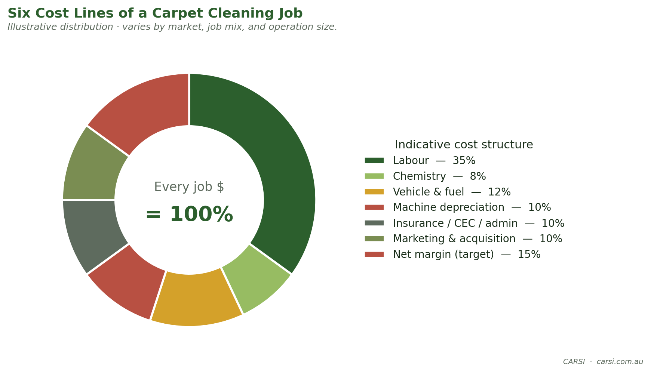
Fig. Six Cost Lines of a Carpet Cleaning Job
CARSI EXPERT NUGGET · Your Callback Rate Is a Pricing Signal
A well-run operation sees a customer-initiated re-work request (callback) on approximately 3–4% of completed residential jobs — not zero, because some wicking and long-dry complaints are physics-driven, not quality-driven. Callback rate above 6% means you are effectively subsidising re-work with your margin — and the fix is usually process (second vacuum pass, longer dwell, verified drying) rather than lower prices. Callback rate below 1% often signals you are over-delivering and under-charging: customers are delighted because the job is priced as if it were standard, but executed as premium. Track callbacks by source (wicking, drying, residue, spot return) for a quarter — it tells you exactly which CHAT dial your pricing is not accounting for.

Three Pricing Models
- Per square metre — transparent, scales with job size; default for commercial.
- Per room — simple for residential; anchors customer psychology to 'rooms'.
- Minimum call-out — covers low-value jobs and protects high-demand time slots.
Most profitable cleaners run all three simultaneously, applying the highest-yielding model to each customer type.

Moisture Addendum — Disclosure
A simple written disclosure, signed at the start of the job, protects both sides. Typical wording:
CARSI Sample Moisture Addendum
The customer acknowledges that carpet may remain damp to the touch for up to 12 hours after cleaning. During this time, walking on the carpet with shoes, placing furniture without protectors, or restricting airflow can extend drying time and in some cases lead to wicking of deeper stains back to the surface. CARSI-trained cleaners will set realistic drying expectations, place airmovers where agreed, and advise re-inspection at 24 hours if any concern arises.

Complaint-Handling — Three Scripts

Slow drying
'Thanks for calling, [customer name] — I'm glad you flagged it early. A few things affect drying time: humidity today, airflow in the room, and whether the carpet is over a timber sub-floor. Can I ask you to feel the carpet in a few spots and tell me if it's wet, damp or just cool? I'll talk you through the next step.'

Wicking return of a stain
'That's a wicking stain — it's a known phenomenon where deeper soil migrates up as the carpet dries. The good news is it confirms the stain was deeper than it looked. I'll come back and do a targeted spot treatment; this is covered under our re-inspection policy at no charge.'

Dye-bleed on upholstery
'Thank you for showing me this. Dye-bleed usually means the fabric's dye wasn't fully set from the factory — it's something we test for before cleaning but some fabrics fail only during full cleaning. Let me document what we're looking at, speak to my senior colleague, and call you back within [x] hours with a remediation plan.'

Three-Tier Take-Aways
NEWBY  Know your break-even per hour. Use the six cost lines. | INTERMEDIATE  Quote a commercial contract using a frequency-and-throughput model. | PRO  Build an upsell pathway: protectant, deodoriser, inspection & report.

Module 11 — The CARSI Expert Council
The CARSI Expert Council is a structured panel-review method that applies seven composite expert personas to any real-world cleaning or restoration case. It is patterned on the Karpathy 'llm-council' multi-perspective framework — three stages, deliberately designed to surface disagreement before converging on judgement.
Verifiability Note
Every council persona below is a clearly-labeled composite — a credentialled archetype, not a real individual. Each persona's credential profile is grounded in real IICRC certifications (Master Textile Cleaner, Master Water Restorer, SCI, UFT, RCT, CCMT). No quote or opinion should be attributed to any specific living person.

The Seven Personas
Role | Credential archetype | Viewpoint bias
Chairperson — Textile Scientist | Master Textile Cleaner (CCT+RCT+CCMT+UFT+OCT+CRT) | 'Fibre chemistry decides the method.'
Restoration Principal | Master Water Restorer + Master Fire & Smoke | 'The carpet tech is often the first responder.'
Equipment Engineer | CCT + CCMT + 20y manufacturing/service | 'Best chemistry can't outrun a worn blower.'
Commercial Maintenance Strategist | CCMT + facility-management background | 'Interim cadence drives restorative economics.'
Inspector | Senior Carpet Inspector + Hard Surface Inspector | 'If you didn't photograph it, it didn't happen.'
Upholstery & Rug Specialist | UFT + RCT + plant experience | 'Tested, tested, and tested again.'
Business & Operations Coach | Certified Firm owner + pricing coach | 'Excellence without pricing is charity.'

The Three Stages
- First Opinions — each council member gives an independent 60-second opinion on the case. No cross-talk.
- Anonymised Peer Review — opinions are stripped of author names and shared with the council. Each member ranks the other six 1–6 and flags weaknesses.
- Chairperson Synthesis — the Chair integrates the strongest points into a single reasoned output. This becomes the council's recommendation.

Continuous-Improvement Cycle
Patterned on the Karpathy 'autoresearch' loop, CARSI runs each curriculum change as a short experiment: deliver the revised module, measure participant comprehension with a one-question quiz, keep the change if comprehension improved, discard if not. Over 10 cohorts this produces evidence-improved content rather than drift.

Using the Council on the Job
In practice, a working cleaner rarely has seven experts on speed dial. But you can still run the method solo: write down the seven viewpoints on seven index cards, walk yourself through each one for 60 seconds on a tricky job, then synthesise. This simple exercise consistently surfaces blind spots that would be invisible from a single perspective.

Appendix A — Fibre-ID Field Card
Print, laminate, carry in the van. Follow top to bottom.
Step | Test | Observation | Likely fibre
1 | Hand-feel | Warm, springy, slight oily | Wool
1 | Hand-feel | Smooth, cool, lustrous | Silk / rayon
1 | Hand-feel | Waxy, solution-dyed even colour | Olefin
1 | Hand-feel | Resilient, springs back | Nylon
2 | Burn (single tuft) | Self-extinguish, burnt-hair odour | Wool / silk
2 | Burn | Hard grey bead, celery odour | Nylon
2 | Burn | Hard black bead, sweet odour | Polyester
2 | Burn | Sooty smoke, waxy odour | Olefin
2 | Burn | Paper-like, fluffy ash | Cotton / cellulose
3 | Float (in cool water) | Floats | Olefin / polypropylene
3 | Float | Sinks | Most other fibres

Appendix B — pH Ranges & Safe-Defaults
Fibre | Pre-spray pH | Rinse pH target | Max water temp
Nylon (most common) | 9 – 10 | 6.5 – 8 | 60–80 °C
Polyester | 9 – 10 | 6.5 – 8 | 60–80 °C
Triexta | 9 – 10 | 6.5 – 8 | 60–80 °C
Olefin | 9 – 10 | 6.5 – 8 | Max 60 °C
Wool | 5 – 7 | 4.5 – 6.5 | Max 40 °C
Silk | 5 – 7 | 5 – 7 | Ambient–35 °C
Rayon | 6 – 8 | 6 – 8 | Ambient–35 °C
Cotton | 7 – 9 | 6 – 8 | Ambient–50 °C

Final-Rinse pH Rule
On any fibre, aim for final substrate pH between 6.5 and 8.0. Test with a strip pressed to a damp spot after extraction. If reading is outside range, re-rinse with a matched pH-corrective product.

Appendix C — Spot Removal Decision Tree
- Identify the stain class — water-soluble, solvent-soluble, protein, tannin, dye, combination.
- Test in an inconspicuous area with the planned chemistry. Observe for bleed, crock or distortion.
- Blot out as much as possible — never rub.
- Apply cold-appropriate chemistry from the outside in. Wait the dwell time.
- Blot out. Re-apply once if partial improvement.
- Escalate: heat, oxidiser (tannin, protein), or reducing agent (dye).
- Rinse-extract thoroughly. Over-applied spotter becomes re-soiling or wicking.
- Dry quickly. Set an airmover.
- Re-inspect at 24 hours. Some stains wick back from deeper fibre layers.
- If no visible improvement after 3 attempts, stop and disclose honestly.

Chemistry Compatibility Safety
Never mix acid spotters with chlorine bleach: produces chlorine gas. Never mix oxidiser with reducing agent: neutralises both and can generate heat. Rinse thoroughly between escalation steps.

Appendix D — Pre-Inspection Checklist
Complete the top half before any chemistry touches the fibre. This form is designed to be used at every hands-on station during the course, and kept as your permanent template thereafter.
Section | Fields
Customer & site | Name · address · date · contact · access notes
Fibre identification | Visible fibre · burn-test result · float/hand-feel · face weight estimate
Construction | Tufted / woven · pile type · backing visible / not
Pre-existing conditions | Wear patterns · stains (photo) · existing damage · odours
Room environment | RH % · temperature · HVAC status · ventilation plan
Planned method | HWE / LM / dry compound · tool · chemistry + pH · target dwell
Drying plan | Airmover count · placement · dehu needed · expected dry time
Customer communications | Moisture addendum signed? · re-entry time communicated?
Post-clean verification | Final substrate pH · moisture-meter reading · photo

Appendix E — Daily / Weekly / Monthly Machinery Checklist

Daily — 3 minutes before first job
- Truck-mount oil level visible in sight glass.
- Belt visible, not glazed, tension thumb-press firm.
- Jet spray pattern — trigger-pull into bucket, check fan.
- Hose cuffs — no cracks, fittings tight.
- RCD/GFCI test button on portable.

Weekly — 15 minutes
- Vacuum test — measure inches of water-lift at wand vs. baseline.
- PSI test — measure pressure at wand vs. baseline.
- Listen — any new vibration or pitch change from blower/pump.
- Clean all filters.
- Lubricate wand swivels.

Monthly — 45 minutes
- Rebuild-kit check on chemical pump if hours met.
- Heat-exchanger inspection.
- Blower bearings — listen, grease per schedule.
- Check all electrical connections for corrosion.
- Update your maintenance log — hours, date, parts replaced.

Appendix F — References & Further Reading

Primary IICRC Standards
- ANSI/IICRC S100 — Professional Cleaning of Textile Floor Coverings (7th Edition, 2021).
- ANSI/IICRC S300 — Professional Upholstery Cleaning Standard and Reference Guide (2025).
- ANSI/IICRC S220 — Inspection of Installed Interior Hard-Surface Floor Coverings.
- ANSI/IICRC S500 — Professional Water Damage Restoration (recognise Cat 1/2/3).
- ANSI/IICRC S800 — Inspection of Installed Textile Floor Coverings.
All IICRC standards can be purchased from the IICRC at iicrc.org. Phill's CARSI library contains the latest editions for course participants' reference during training.

Industry References
- Carpet and Rug Institute (CRI) — maintenance frequency guidance and Seal of Approval programme.
- WoolSafe® — UK-based certification mark for wool-appropriate chemistry; 22 ISO-based test methods; criterion is an alkalinity window (not pH 7). Live register at woolsafe.org.
- IICRC Certified Firm directory — certifications/iicrc.org.
- Australian context: CARSI — carsi.com.au (IICRC-approved CEC provider).

Methodological References
- Karpathy, A. — llm-council (github.com/karpathy/llm-council) — the 3-stage multi-perspective review pattern adapted for the CARSI Expert Council.
- Karpathy, A. — autoresearch (github.com/karpathy/autoresearch) — the iterative experiment-measure-update loop adapted for continuous curriculum improvement.

Appendix G — CARSI Continuing-Education Pathway
A CCW graduate is encouraged to continue along the IICRC certification pathway and stack CARSI CECs to maintain currency. The canonical pathway:
- CCT — Carpet Cleaning Technician — entry IICRC certification; builds on the material in this CCW course.
- UFT — Upholstery & Fabric Cleaning Technician — deep dive into Module 6 and 7 material.
- CCMT — Commercial Carpet Maintenance Technician — programme design and frequency economics.
- RCT — Rug Cleaning Technician — in-plant rug cleaning; wool, silk, and speciality rugs.
- OCT — Odour Control Technician — finishing touch for residential and commercial.
- SCI — Senior Carpet Inspector — inspector's scope; expert-witness capable.
- Master Textile Cleaner — the combination credential. IICRC's published pathway requires CCT (or CCMT), RCT, UFT, OCT, CRT (Color Repair Technician), and RRT (Carpet Repair & Reinstallation Technician).

Why Stack Credentials?
Each certification expands your defensible scope of work, your insurer's risk rating, and your premium-pricing power. A CCT-only tech can clean. A CCT+UFT+OCT tech can clean, upholster and deodorise — and charge for all three on a single visit with documented professional competence.

CARSI CEC Maintenance
CARSI offers over 90 IICRC CEC-approved courses across seven disciplines. The typical cleaner maintains their IICRC credentials by earning CECs each renewal cycle. CARSI's online delivery option means CECs can be earned between jobs and around family commitments — maintaining currency without lost revenue days.

