|  |
| --- |
| Open Batter Saver Application  Setup Environment Document |

Table of contents

A. Introduction: 3

I. Purpose: 3

II. Scope: 3

III. Document structure: 3

B. Revision History 3

C. Setup Environment: 4

I. Software: 4

1. IDE 4

2. Android plugin for EclipsE: 4

3. Android SDK 4

II. Setup: 4

1. Download Eclipse: 4

2. Setup Android plugin for Eclipse and Android SDK 5

3. Setup and run project in Eclipse: 10

# Introduction:

## I. Purpose:

The purpose of this document is to provide all information related to version of IDE tool, version of SDK; guideline step by step of how to integrate Android SDK into Eclipse IDE and setup and run **Open Battery Saver** project

## II. Scope:

Use for setting up environment to run/build and modify source code of **Open Battery Saver** project

## III. Document structure:

See table of content

# Revision History

# Setup Environment:

## I. Software:

### 1. IDE

Full name: Eclipse Java EE IDE for Web Developer

Version: Junior Service Release 1

Build ID: 20120920-0800

(c) Copyright Eclipse contributors and others 2005, 2012. All rights reserved.

Visit <http://www.eclipse.org/webtools>

### 2. Android plugin for Eclipse:

Full name: Android Development Tools for Eclipse written by Google, Inc., Apache 2.0

### 3. Android SDK

Version: 4.0.x

## II. Setup:

### 1. Download Eclipse:

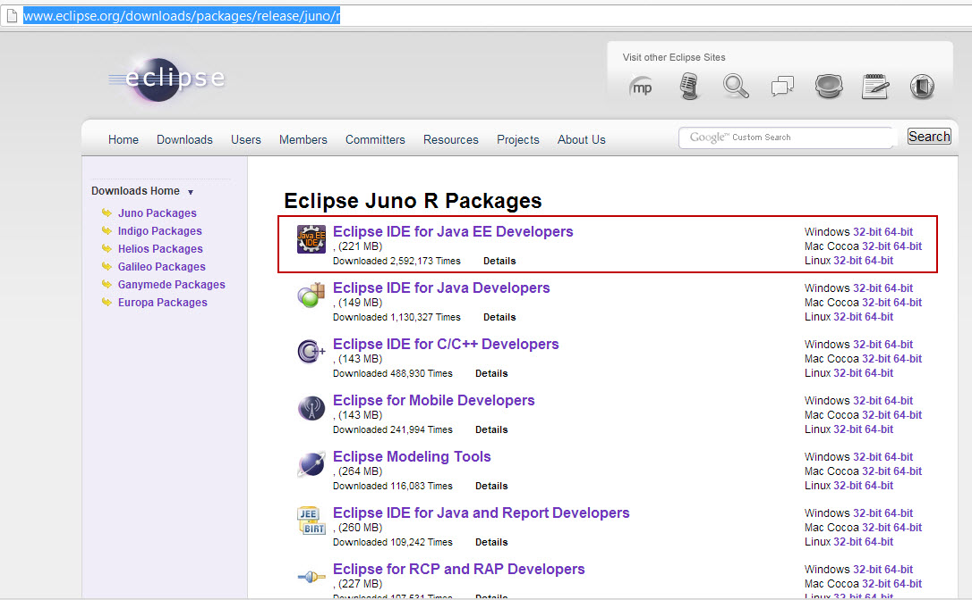

Download suitable version corresponding with the Operation System (Mac or Window or Linux)

Extract Eclipse on one folder on your computer

### 2. Setup Android plugin for Eclipse and Android SDK

Step 1: Open Eclipse

Step 2: Choose Help/Eclipse Market place

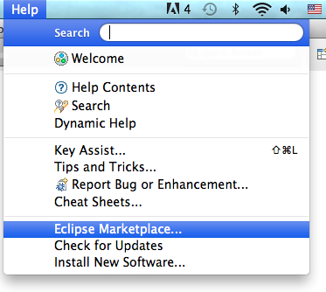

Step 3: Type on “Find” textbox: “Android”

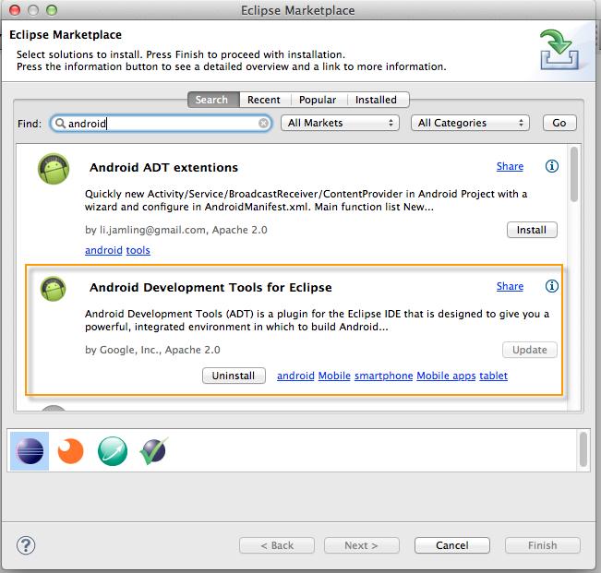

Choose “Android Development Tools for Eclipse” by Google, Inc., Apache 2.0

Note:

At the first time, “Android Development Tools for Eclipse has not been installed yet, clicks the button “Install” and clicks “Accept” for all next.

If this tool has already been integrated with Eclipse, there are 2 button happens: “Update” and “Uninstall” allows user update new version or uninstall this tool.

Step 4: Download Android SDK and extract into your computer

Step 5: Open “Preferences” menu to browser to Android SDK which was already extracted. Image below is example for Mac OS:

Open: Eclipse/Preference, browser to the folder contains Android SDK and then clicks “Apply”

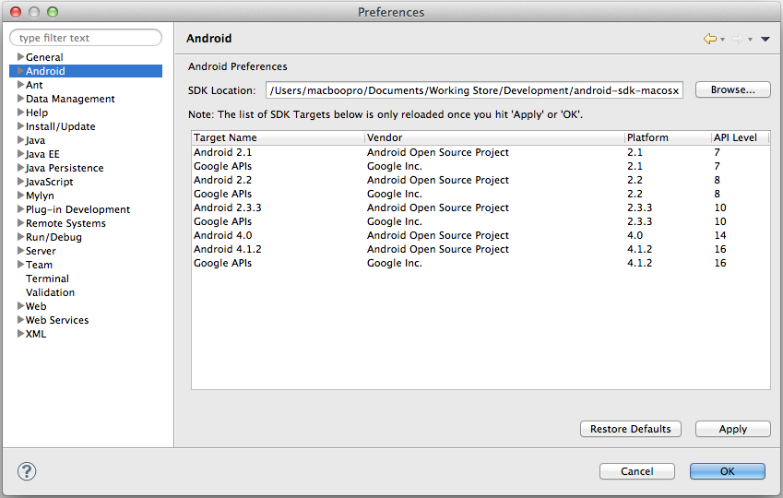

Step 6: Download related packages.

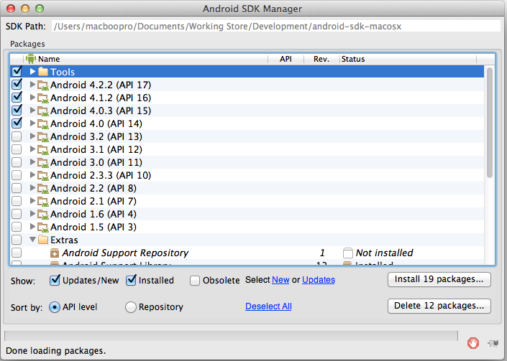

Choose Android SDK version 4.0.x

Step 7: Download support Library:

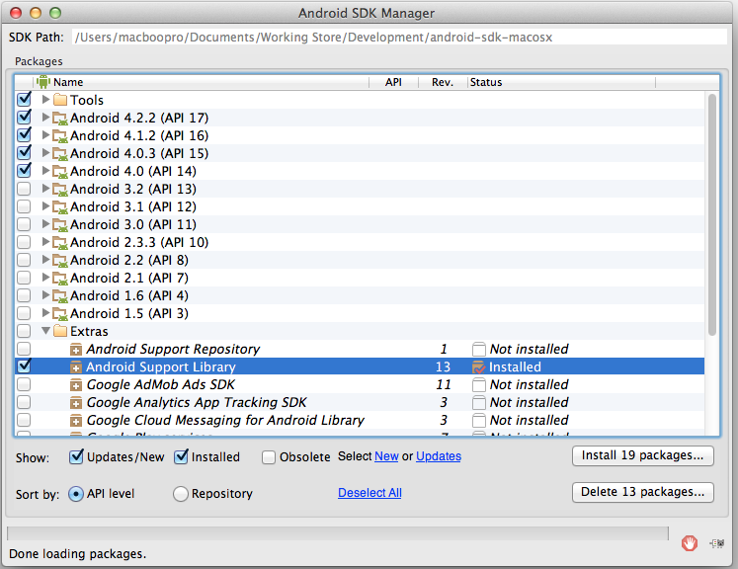

Step 8: Accept Android License

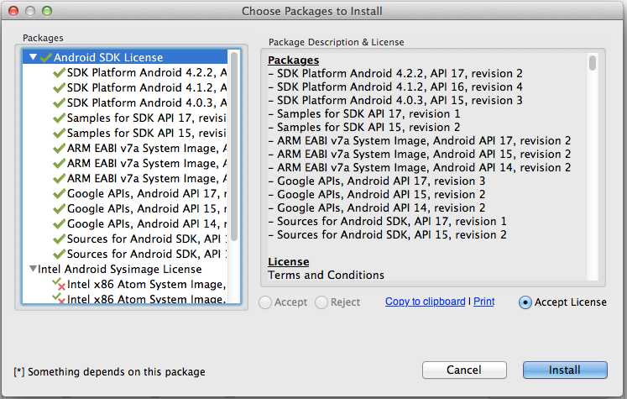

Step 9: Check status of downloading

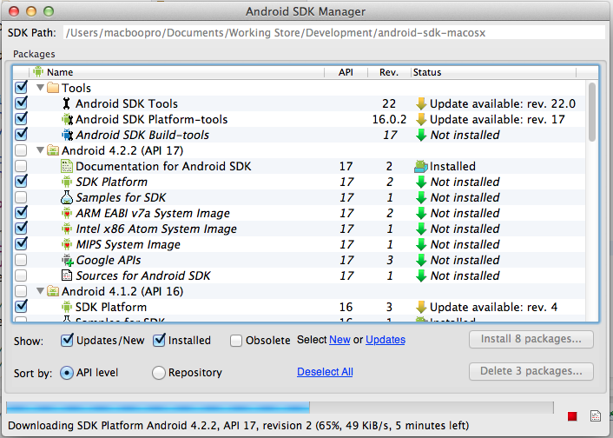

Status:

Installed

Not installed

Update available

### 3. Setup and run project in Eclipse: