Design

----https://www.boichoi.com/ecomerce/image/catalog/demo/product/books_pic/sh_1.jpg

These banners repeated twice . Keep the top one remove the bottom one

-----Book Images has rounded corner, make them Rectangle

---- Publisher Logo Scroll make sections more better . Currently it has two sliding arrow. Remove the other one

----- Where it says Any Question , Order Dispute , make the sections like below.

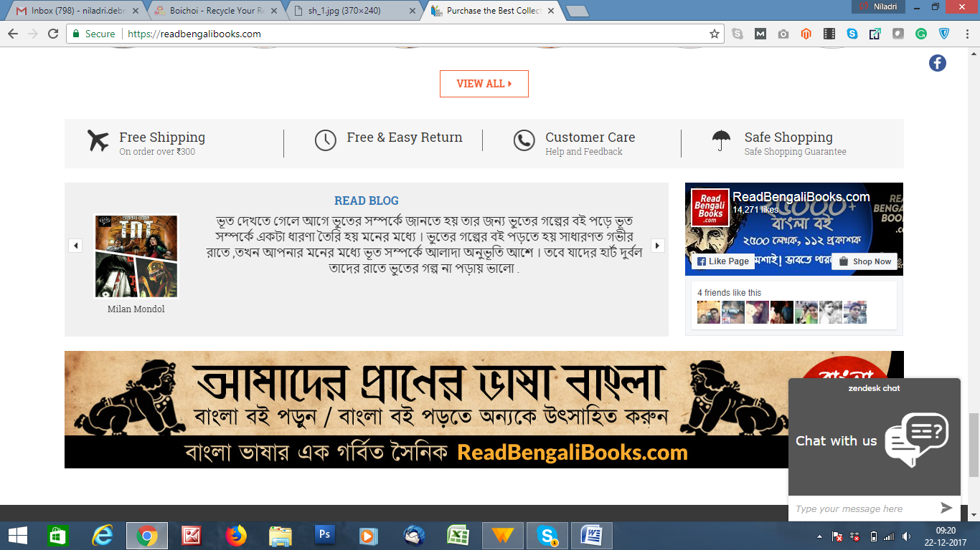

For Our case point will be   
Minimal Shipping ..... All Indian Delivery ...... Call us .... Order Dispute mail us ..... 100% safe

----- Make Footer little Better

------ When Item added in cart see the below box . Close icon overlapping . Make this Box little better. Also Top Sucess Message little better too .  
 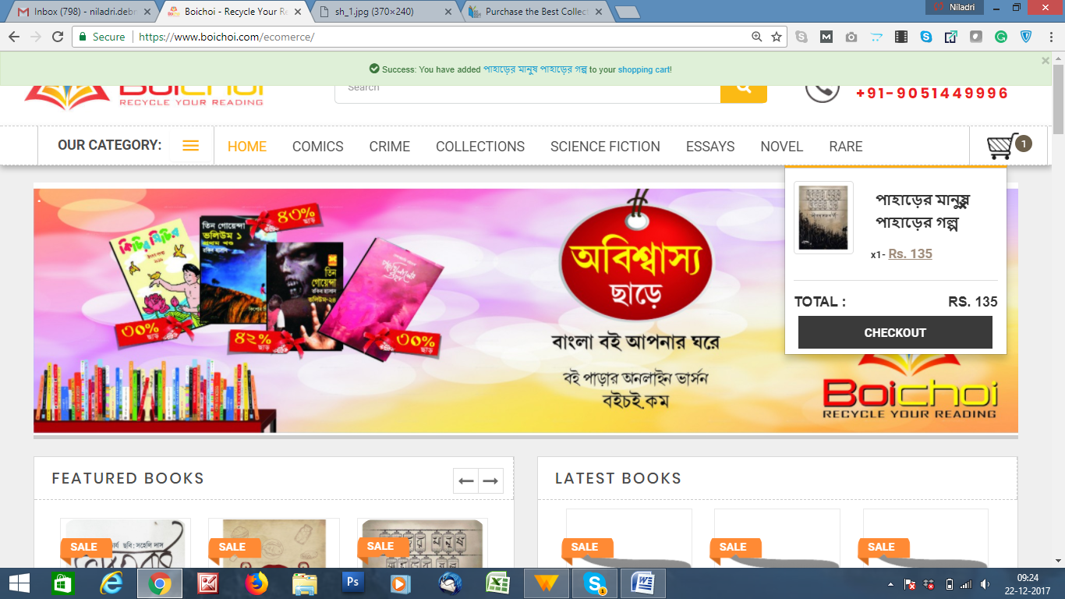

----https://www.boichoi.com/ecomerce/BHARATBORSHO  
 Make the related Books sections much better

----- https://www.boichoi.com/ecomerce/index.php?route=product/manufacturer  
Make this page like https://www.readbengalibooks.com/publisher-list/

----- https://www.boichoi.com/ecomerce/index.php?route=product/manufacturer/info&manufacturer_id=538 in this page please add Publisher Logo like they have added   
https://readbengalibooks.com/index.php/publishers/charchapada.html

ON Home page please swap the sections   
Latest Books and Best Seller . Bring Latest book sections Where Best seller is and Vice versa.

---- Cart / Check out pages has default Opencart design . Need better look n feel

---- https://www.boichoi.com/ecomerce/index.php?route=account/login --- Need better look n feel matching with site theme . Also the left panel color looks bad , please check that .

----- At Last Mobile Responsive Issue for All PAges. I will share ideas on that .