

**HOW TO SWAP XDC and XDCE?**

**Step 1**: Sign in to your Alphaex account.

**Step2**: Then to swap from XDC to XDCE, click on Trade

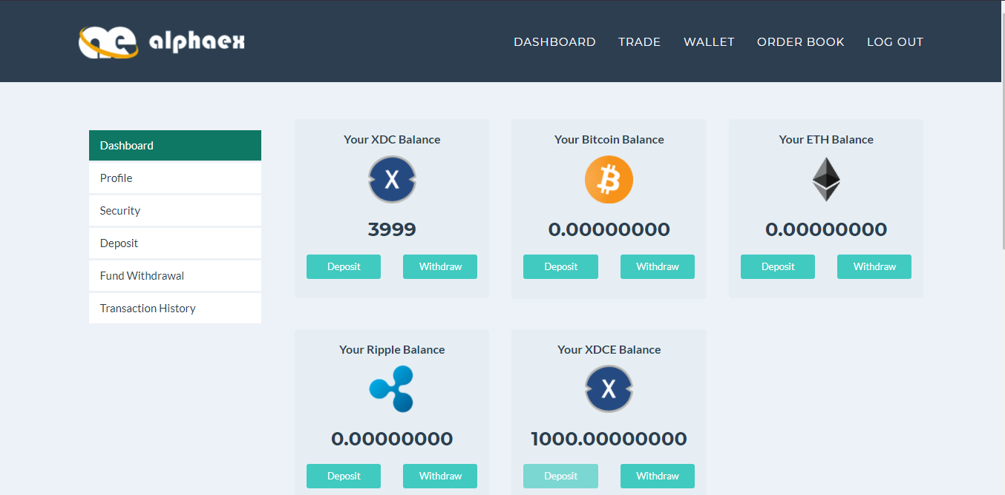

**Navigate to Trade**

**Step 3:** Scroll down select XDC/XDCE for swapping

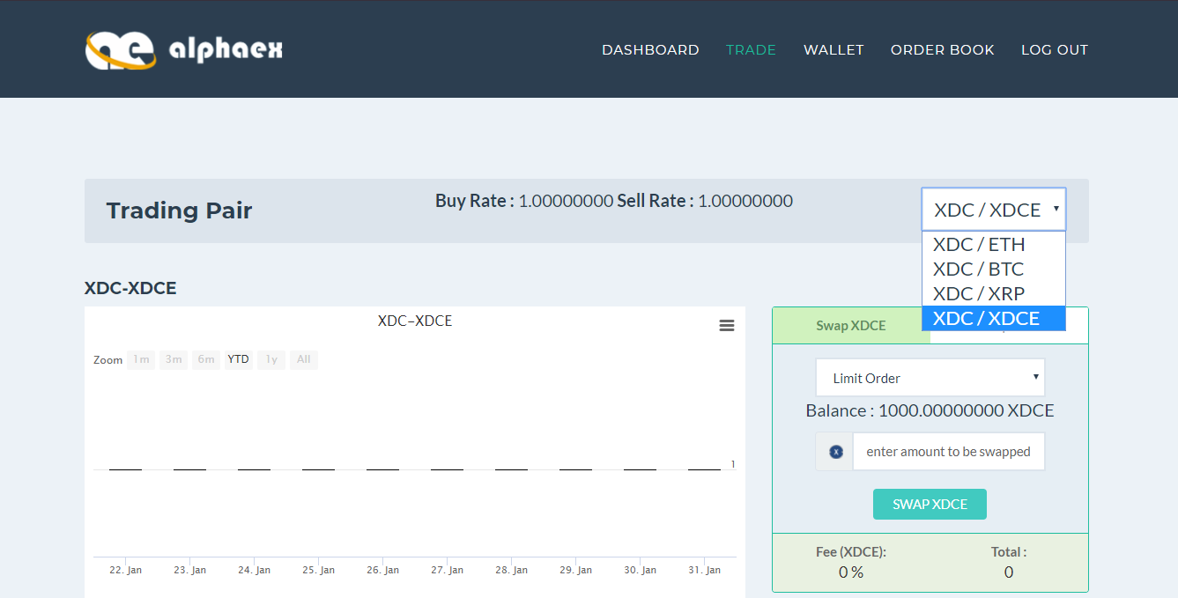

**Drop down to select XDC/ XDCE**

**Step 4:** Navigate to swap XDC for XDCE as shown in image.

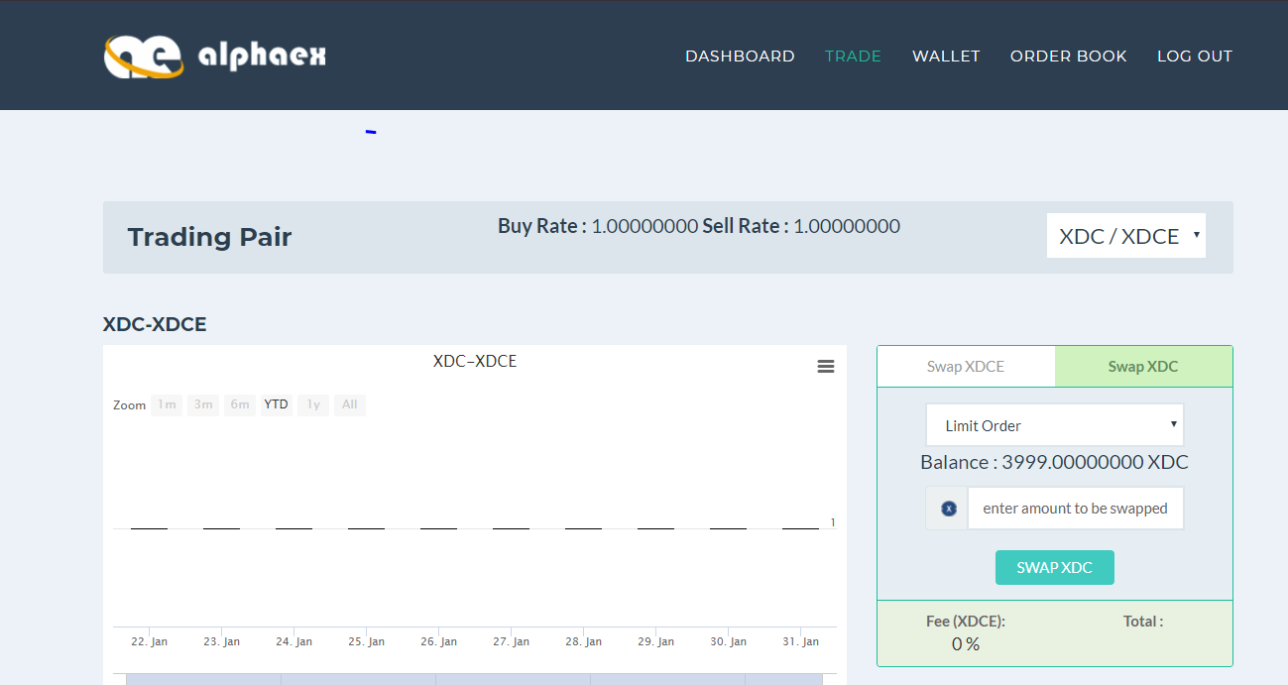

**Navigate here**

**Step 5:** Enter minimum 1000 XDC to get XDCE

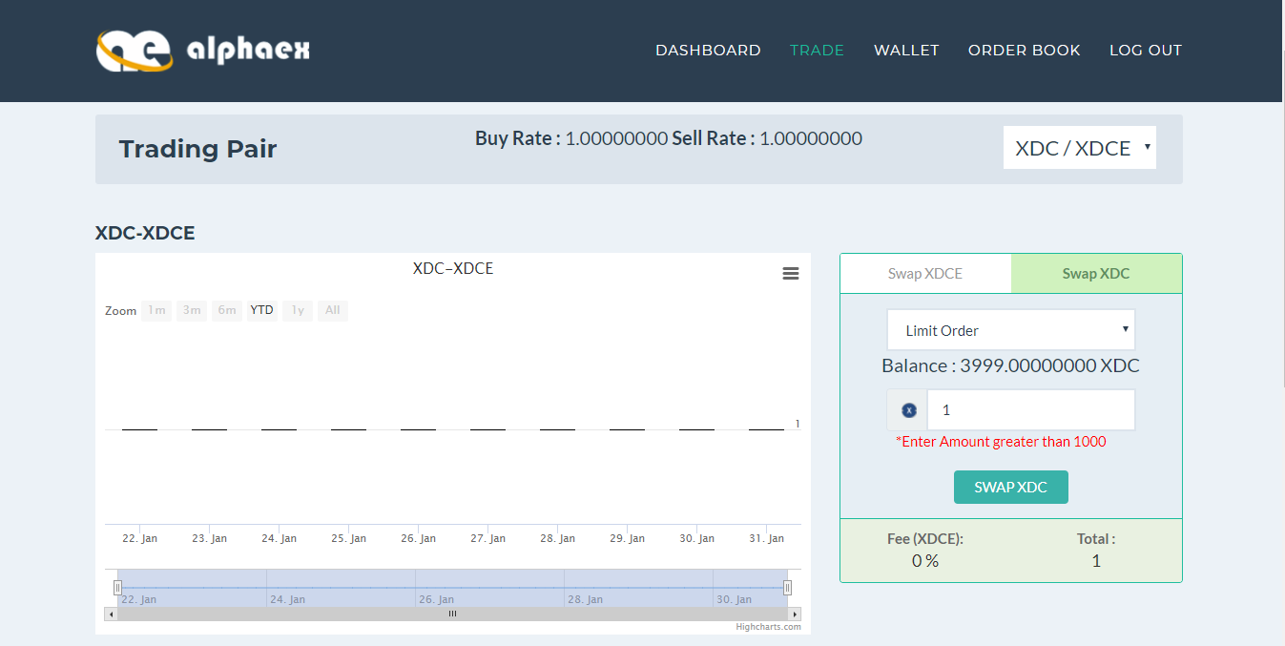

**Enter amount**

**Step 6:** Click on “Swap XDC” and then navigate to Dashboard to check your balance.

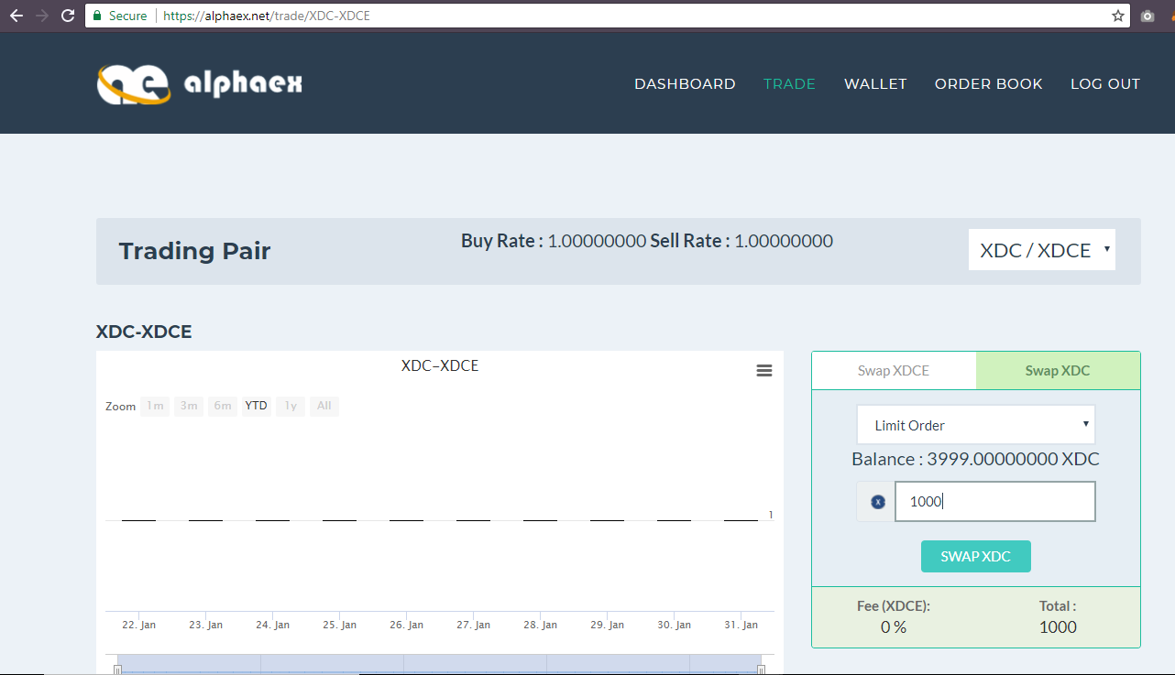

**2.Click Here to visit dashboard**

**1.Click Here**

**Step 7:** Your tokens are reflected here

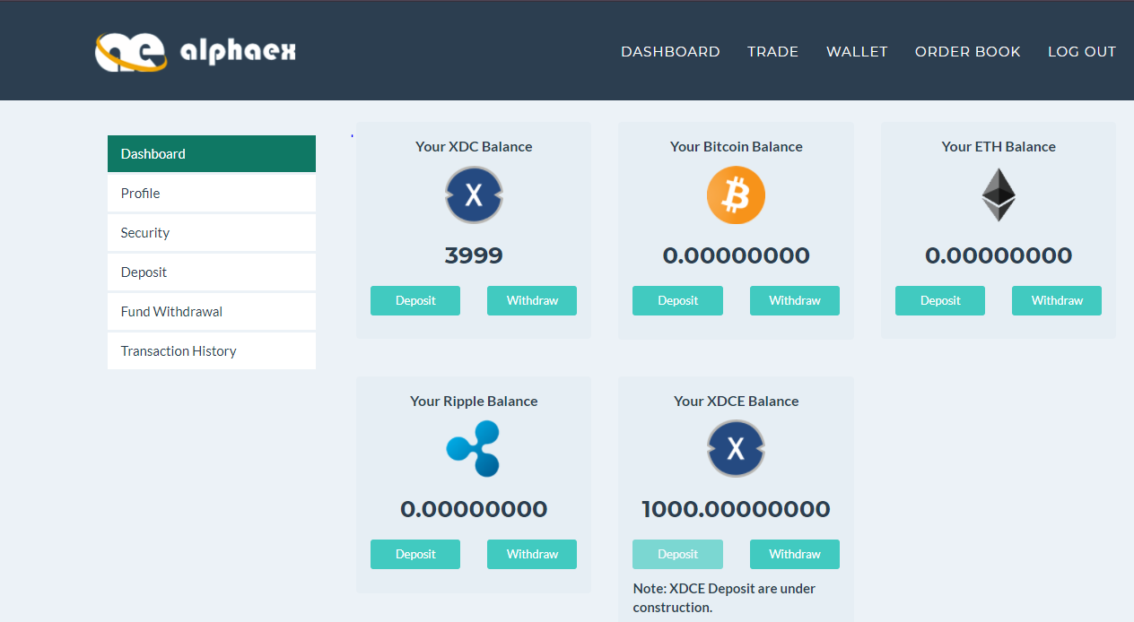

**Reflected Balance**

**Step 8:** Now, navigate to fund withdrawal click on XDCE Transfer for transaction and after filling all the details click on send button.

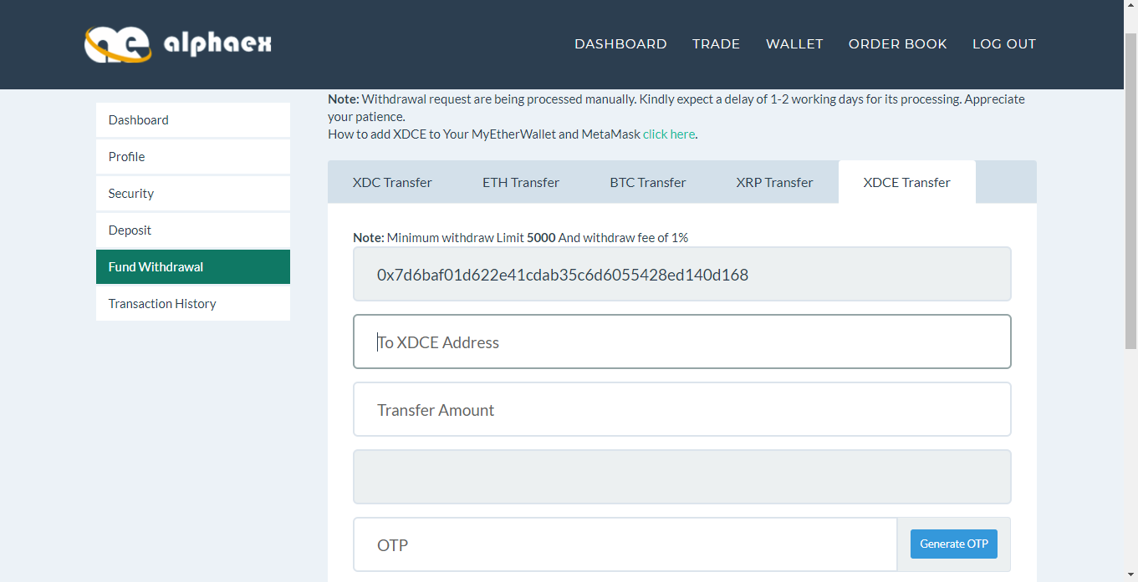

**3.Enter your Metamask or MyEtherWallet address here**

**4.Enter amount**

**2.Click on XDCE Transfer**

**1.Click on fund withdrawal**

**5.Click Here to generate OTP**



**How to load XDCE tokens in MyEtherwallet?**

**“Please Follow the steps one by one to obtain desired outputs”**

**Step 1**: Visit <https://www.myetherwallet.com/>

**Step 2**: To load XDCE token, navigate to “Send Ether & Tokens” Scroll down!! See right side and click on “Add Custom Token”

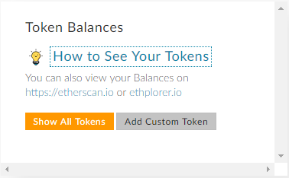

**Click here**

**Step 3**: Enter the fields with following details or visit XinFin.io

“XDCE Token Contract Address: 0x41ab1b6fcbb2fa9dced81acbdec13ea6315f2bf2”

“Token Symbol: XDCE”

“Decimals: 18”

And then click on “save ” button

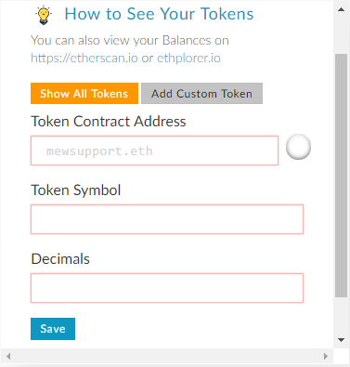

**Step 4**: Click on “Only Show Balances” to view your XDCE balance.

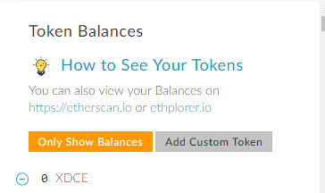

**Click here**

THIS​ ​IS​ ​A​ ​SAMPLE:​ ​Do​ ​not​ ​copy​ ​the​ ​above​ ​fields.

Once​ ​it​ ​is​ ​completed,​ ​you​ ​will​ ​receive​ ​your​ ​XDCE​ ​tokens​ ​to​ ​this​ ​ETH​ ​address​ ​.



# **How to load XDCE tokens in Metamask Wallet?**

Step 1: Visit<https://metamask.io/>and install the Chrome extension.

**Note: If you open other tab or navigate to existing tabs you have to manually click again on Metamask extension located on right corner of your browser**



**Click on Metamask extension**



Step 2: Navigate to Tokens menu and click on “**ADD TOKEN**” to add XDCE tokens to your wallet.

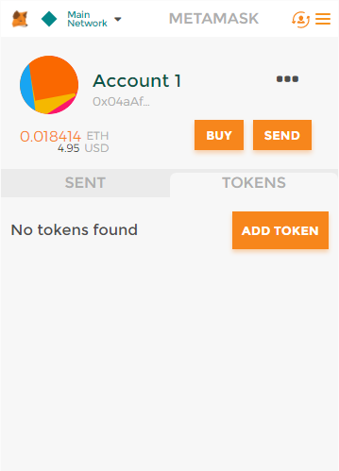

**Navigate here**

**Click here to add tokens**

Step 3: Copy XDCE contract address from the xinfin.io page and paste it in “Token Contract Address” field.

You can also copy details from here

“XDCE Token Contract Address:

**0x41AB1b6fcbB2fA9DCEd81aCbdeC13Ea6315F2Bf2**”

“Token Symbol: **XDCE**”

“Decimals: **18**”

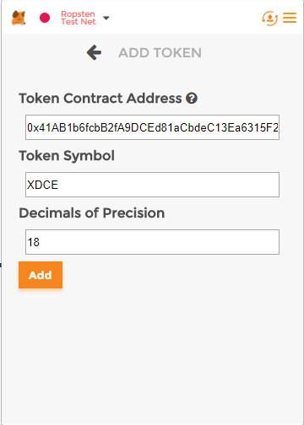

**Click here to ADD Tokens**

Step 4: Your Metamask account will reflect XDCE tokens after you click again on the extension button at the right corner of your browser.

