Rename Study Tool
A plugin for ClearCanvas v1.3
Seth Berkowitz
seth.j.berkowitz@gmail.com
2/2009

DESCRIPTION:

This tool functions similarly to the Anonymize tool included in the ClearCanvas Viewer. However, the Anonymize tool does not let the user keep the same values for PatientID, PatientName, etc. The Anonymize tool also creates a new studyUID (a unique indentification number) for the anonymized study so that it will not overwrite the original study. This tool also allows the user to change the Patient ID, Patient Name, DOB, Study Date, Study Description or Ascension Number. The interface is similar to the Anonymize interface, with the exception that the current field values are displayed by default. Keep in mind that using this tool will OVERWRITE the existing study. In order to see the changed values in the study list, the user needs to click the Search button again.

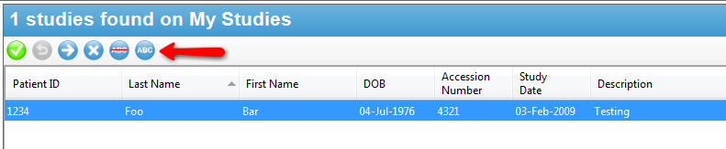
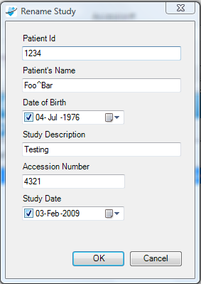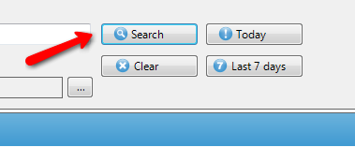

INSTALLATION:

To install the plugin, copy the two files from the \bin directory (RenameStudy.dll and RenameStudy.View.WinForms.dll) into the \ClearCanvas\ClearCanvas Workstation\plugins directory. By default the destination directory will be C:\Program Files\ClearCanvas\ClearCanvas Workstation\plugins.

If you get an error while copying the files, first make sure that the ClearCanvas Viewer is closed. You may also need to stop the ‘ClearCanvas Shred Host’ process from running. To do this, go to Start--> Control Panel --> Administrative Tools --> Services. Find ‘ClearCanvas Shred Host’ in this list, right click and select Stop. Then copy the two files into the plugin directory and restart the service by right clicking and selecting Start.

