Name Ian King Mark _____________________/50

## Brief introduction __/3

My feature is the Infinite Runner mode for Lake Runner. While much of the game will take place in pre-made levels with specified environment, NPC, and item layouts that do not change and lead to a predetermined endpoint, the Infinite Runner mode will allow players to play a never-ending version of the game with randomly generated environment, NPC, and item placements.

## Use case diagram with scenario __14

### Use Case Diagrams

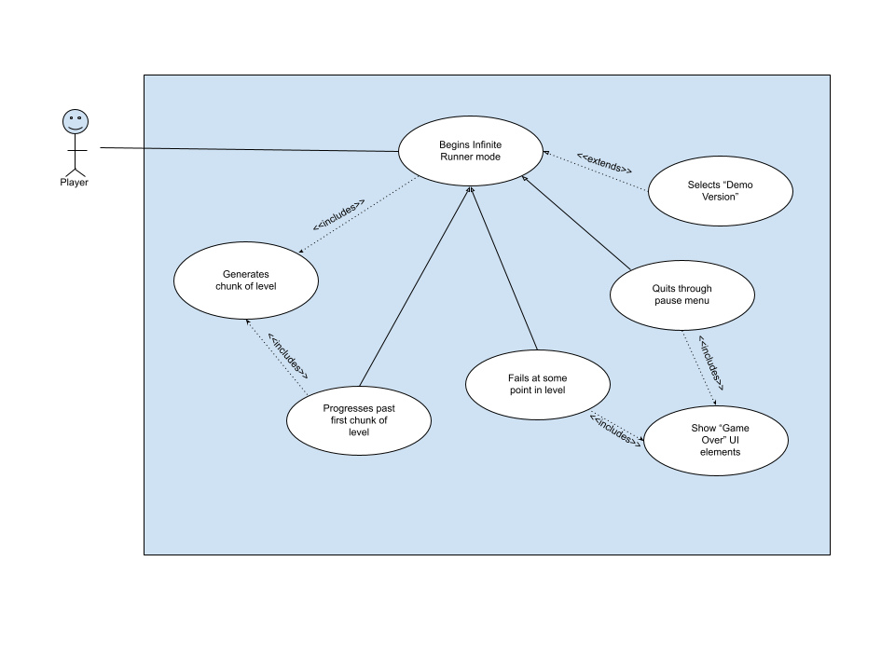

### Scenarios

**Scenario 1**

**Name:** Begin Infinite Runner Mode

**Summary:** The player selects the Infinite Runner game mode from the main menu.

**Actors:** Player.

**Preconditions:** Game is running and player has navigated to the main menu.

**Basic sequence:**

**Step 1:** Begin level, allow input from player to create platforms.

**Step 2:** If player progresses past first chunk, generate another chunk of the

level.

**Step 3:** Continue to accept input until player fails or quits.

**Step 4:** Display Game Over screen.

**Step 5:** Player selects “Restart” or “Quit”.

**Exceptions:**

**Step 1:** Player selects “Demo Mode”: disallow player input, run pre-made demo of the Infinite Runner mode.

**Post conditions:** Player restarts Infinite Runner mode or Main Menu is displayed.

**Priority:** 3

**ID:** C05

## Data Flow diagram(s) from Level 0 to process description for your feature _______14

[Get the Level 0 from your team. Highlight the path to your feature]

Example:

### Data Flow Diagrams

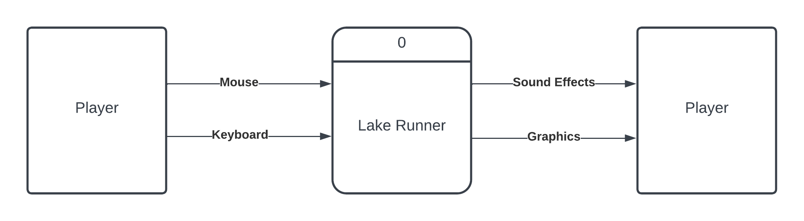

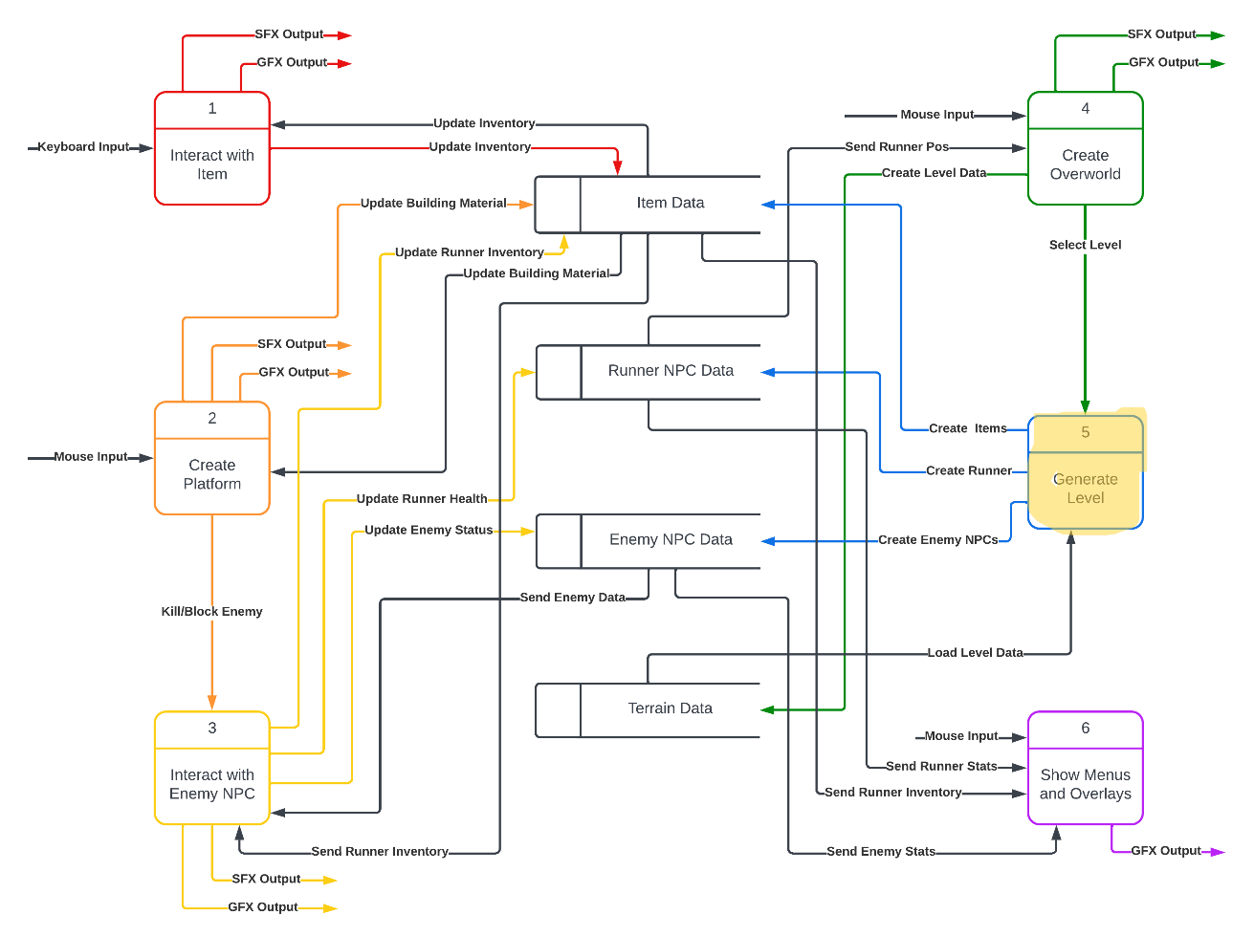

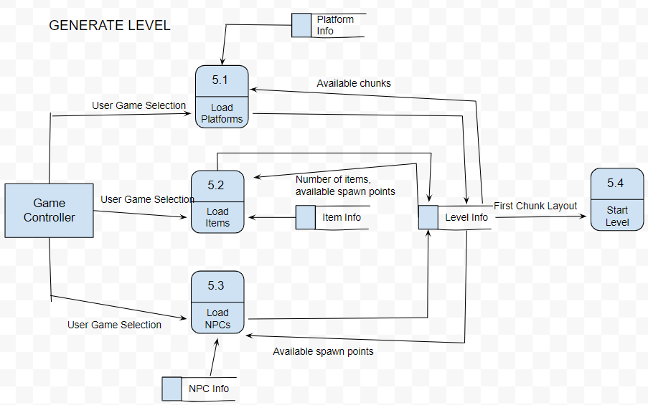

### Process Descriptions

Load Platforms:

WHILE next chunk is not loaded

Randomly select chunk object from platform information

WHILE next chunk is impossible to reach from current chunk

Randomize next chunk

END WHILE

IF chunk has available item or NPC placement areas

Store open coordinates in level information

END IF

END WHILE

Load NPCs:

WHILE next chunk contains open coordinates for an NPC

Randomly select NPC object from NPC information

WHILE NPC can not operate functionally in this location

Randomize NPC selection and check for functionality

END WHILE

END WHILE

Load Items:

WHILE next chunk contains open coordinates for an item

Randomly select item to be placed at coordinate

Increase number of this item in item info so it is less likely to

spawn in the future.

END WHILE

Start Level:

IF first chunk is loaded

Place player at constant starting coordinates

Spawn all loaded objects based on level information

END IF

## Acceptance Tests ________9

**Level Generator: Accuracy Test**

Run the chunk loader 100 times without starting the game and evaluate the scene layout.

The scene will have the following characteristics:

* Chunks of platforms: 100
* No given item should appear more than 5 times
* No given NPC should appear more than 5 times
* Y-difference between each chunk should be no greater than 4x the height of the runner character.
* No gap between level platforms should be greater than half the distance shown by the in-game camera.

**Level Generator: Stress Test**

Run the chunk loader 1000 times before starting the game, then start the game and monitor results.

The scene will have the following characteristics:

* The framerate will be maintained at a similar level to an early Infinite Runner game.
* The chunk generation after this point will continue to run at a similar speed as that of an early Infinite Runner game.

Depending on the result of this test, a destructor will likely need to be implemented to maintain game speed in late-game cases.

## Timeline _________/10

### Work items

|  |  |  |
| --- | --- | --- |
| Task | Duration (Hours) | Predecessor Task(s) |
| 1. Setting Up Unity | 1 | - |
| 2. Requirements Collection | 8 | - |
| 3. Sprite Creation/Gathering | 4 | 2 |
| 4. Create Environment Objects | 10 | 1, 3 |
| 5. Collect Environment Chunks | 2 | 4 |
| 6. Create Generation Functions | 8 | 2, 5 |
| 7. Create Demo Objects | 4 | 6 |
| 8. Generate Demo | 2 | 7 |
| 9. Testing | 4 | 6, 8 |
| 10. Installation | 2 | 9 |

### Pert diagram

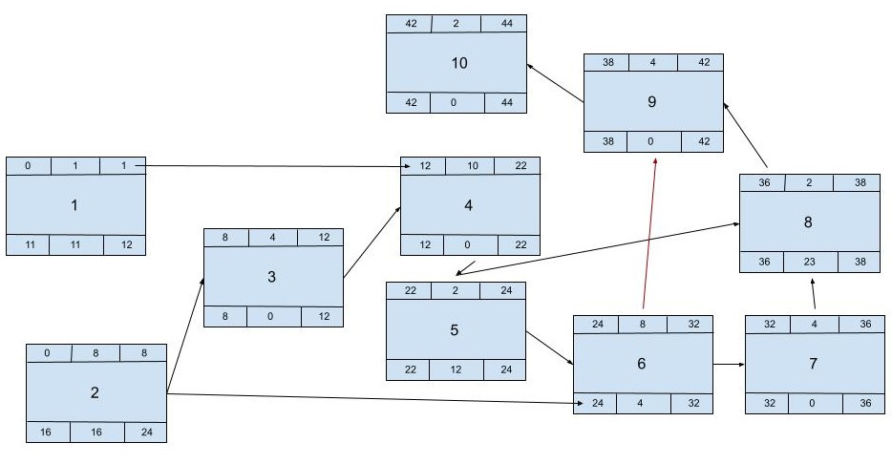

### Gantt timeline

|  |  |  |  |  |  |  |  |  |  |  |  |  |  |  |  |  |  |  |  |  |  |  |  |  |  |  |  |  |  |  |  |
| --- | --- | --- | --- | --- | --- | --- | --- | --- | --- | --- | --- | --- | --- | --- | --- | --- | --- | --- | --- | --- | --- | --- | --- | --- | --- | --- | --- | --- | --- | --- | --- |
| 1 |  |  |  |  |  |  |  |  |  |  |  |  |  |  |  |  |  |  |  |  |  |  |  |  |  |  |  |  |  |  |  |
| 2 |  |  |  |  |  |  |  |  |  |  |  |  |  |  |  |  |  |  |  |  |  |  |  |  |  |  |  |  |  |  |  |
| 3 |  |  |  |  |  |  |  |  | 2 |  |  |  |  |  |  |  |  |  |  |  |  |  |  |  |  |  |  |  |  |  |  |
| 4 |  |  |  |  |  |  |  |  |  |  |  |  | 3 |  |  |  |  |  |  |  |  |  |  |  |  |  |  |  |  |  |  |
| 5 |  |  |  |  |  |  |  |  |  |  |  |  |  |  |  |  |  |  |  |  |  |  | 4 |  |  |  |  |  |  |  |  |
| 6 |  |  |  |  |  |  |  |  |  |  |  |  |  |  |  |  |  |  |  |  |  |  |  |  | 5 |  |  |  |  |  |  |
| 7 |  |  |  |  |  |  |  |  |  |  |  |  |  |  |  |  |  |  |  |  |  |  |  |  |  |  |  |  |  |  |  |
| 8 |  |  |  |  |  |  |  |  |  |  |  |  |  |  |  |  |  |  |  |  |  |  |  |  |  |  |  |  |  |  |  |
| 9 |  |  |  |  |  |  |  |  |  |  |  |  |  |  |  |  |  |  |  |  |  |  |  |  |  |  |  |  |  |  |  |
| 10 |  |  |  |  |  |  |  |  |  |  |  |  |  |  |  |  |  |  |  |  |  |  |  |  |  |  |  |  |  |  |  |
|  | 1 | 2 | 3 | 4 | 5 | 6 | 7 | 8 | 9 | 10 | 11 | 12 | 13 | 14 | 15 | 16 | 17 | 18 | 19 | 20 | 21 | 22 | 23 | 24 | 25 | 26 | 27 | 28 | 29 | 30 | 31 |
|  |  |  |  |  |  |  |  |  |  |  |  |  |  |  |  |  |  |  |  |  |  |  |  |  |  |  |  |  |  |  |  |
| 1 |  |  |  |  |  |  |  |  |  |  |  |  |  |
| 2 |  |  |  |  |  |  |  |  |  |  |  |  |  |
| 3 |  |  |  |  |  |  |  |  |  |  |  |  |  |
| 4 |  |  |  |  |  |  |  |  |  |  |  |  |  |
| 5 |  |  |  |  |  |  |  |  |  |  |  |  |  |
| 6 |  |  |  |  |  |  |  |  |  |  |  |  |  |
| 7 |  | 6 |  |  |  |  |  |  |  |  |  |  |  |
| 8 |  |  |  |  |  | 7 |  |  |  |  |  |  |  |
| 9 |  |  |  |  |  |  |  | 8 |  |  |  |  |  |
| 10 |  |  |  |  |  |  |  |  |  |  |  | 9 |  |
|  | 32 | 33 | 34 | 35 | 36 | 37 | 38 | 39 | 40 | 41 | 42 | 43 | 44 |
|  |  |  |  |  |  |  |  |  |  |  |  |  |  |  |  |  |  |  |  |  |  |  |  |  |  |  |  |  |  |  |  |