Import tool

Product setup guide in Magento
02 November 2017



This document and information cannot be used for any purpose without the express written permission.
Table of Contents
1. Define product types & attributes 2
1.1. Overview & General concepts 2
1.2. ER Diagram 2
1.3. Define an Attribute Set 3
1.4. Define an Attribute 3
1.5. Frontend Properties of Attribute 4
2. Working with Product CSV Files 5
2.1. Import single/configurable product 5
2.2. Options of Dropdown/Multi-select Attribute 5
2.3. Import Multi-value(dropdown) columns and single-value columns 6
2.4. Image Path 6
2.5. Required columns for product creation 7
2.6. Import Products Relation 8
2.7. Required Columns for Product Relation 8
2.8. Remarks 9

Define product types & attributes

Overview & General concepts
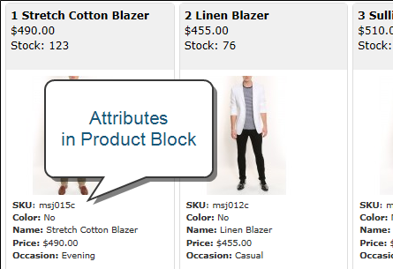
Before the site implementation, it is important to plan the product structure in Magento.
As defined on Magento site, an attribute set is a collection of attributes.
Attributes describe specific characteristics of a product.
E.g. For a store selling a shirt, in addition to the default Magento attributes, you want to show your customers some extra information in the front-end:
- Color
- Shirt Size
- Manufacturer (Brand)
- Material (ex. Cotton, wool, …)

ER Diagram

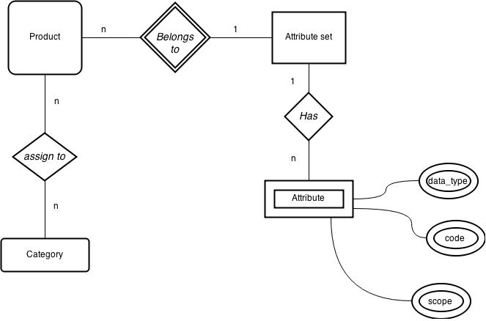

Define an Attribute Set
- Think of attribute set that could clearly distinguish different kinds of products
- To save time and effort select one of the default Attribute sets on the basis of which new set will be created
- When creating Attribute Sets it is important to remember that once the product with the set has been created, it is impossible to change the set to another one.
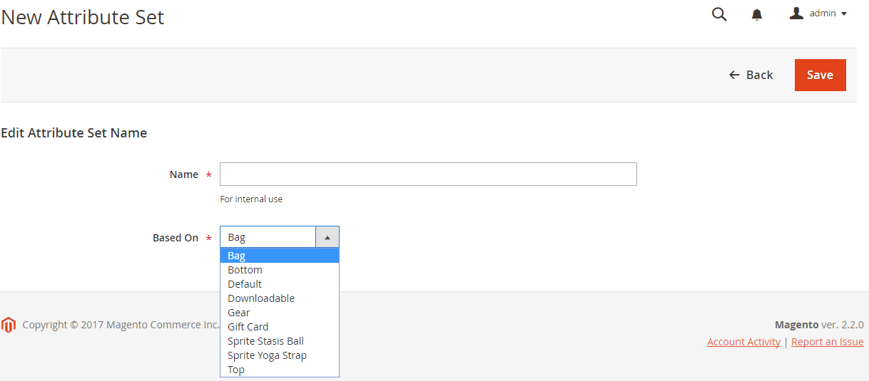

Define an Attribute
When viewed from the Admin, attributes are the fields that you complete when you create a product. The input type that is assigned to an attribute determines the type of data that can be entered and the format of the field or input control.

Input Type | Description
Text Field | A single line input field for text.
Text Area | A multiple-line input field for entering paragraphs of text such as a product description. You can use the WYSIWYG Editor to format the text with HTML tags, or type the tags directly into the text.
Date | Contain date values. Dates can be selected from a popup calendar, or drop-down list. Depending on the configuration,a date can be typed directly into the field, selected from a popup calendar, or drop-down list.
Yes / No | Displays a drop-down with predefined options of “Yes” and “No.”
Dropdown | Displays a drop-down list of values. Only one item can be selected at a time. The Dropdown input type is a key component of configurable products.
Multiple Select | Displays a drop-down list of values. To select more than one option, hold the Ctrl key down and click each item.
Price | Used to create price fields in addition to the predefined attributes, Price, Special Price, Tier Price and Cost. The currency used is determined by your system configuration.
Media Image | Gives you the ability to associate an image with a product, that is something other than a product image. For example, you might include the product logo, care instructions, or an image of the ingredients from a food label. When you add a media image attribute to the attribute set of a product, it becomes an additional image type, along with Base, Small, and Thumbnail. The media image attribute can be excluded from the thumbnail gallery, but is still available to be used.

Frontend Properties of Attribute
- In Magento, the filter sidebar in frontend is called Layered Navigation
- Only attribute with Dropdown or Multi-select type can be shown in the filter

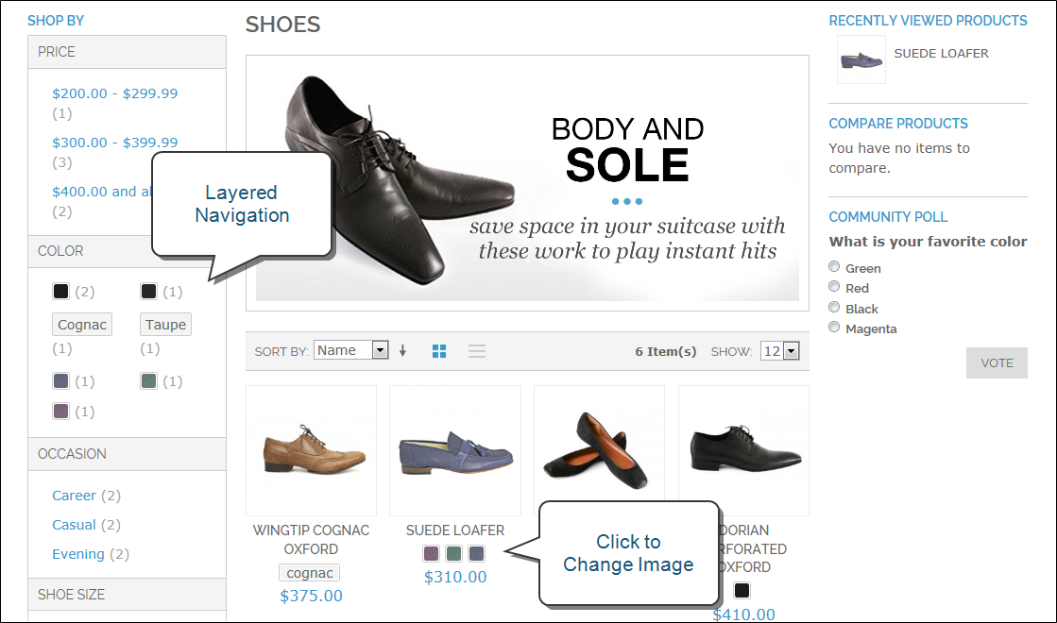

Property | Description
Use in Quick Search | Select “Yes” if you want people to be able to search the catalog based on the value of this attribute. Options include: Yes / No
Search Weight | (Solr Only) Assign a value from 1 – 5 to weight the search.
Use in Advanced Search | Gives shoppers the ability to enter their search criteria through a form. Options include: Yes / No  Using too many attributes can slow down search.
Comparable on Front-end | Select “Yes” to include this attribute as a row in the Compare Products report. Options include: Yes / No
Use In Layered Navigation | (Dropdown, Multiple Select and Price input types only) Includes the attribute as a filter in the “Shop By” section of layered navigation. Options include:
  No | The attribute is not used in layered navigation.
  Filterable (with results) | Lists only products that match the filter value.
  Filterable (no results) | Lists all attribute values, even those that do not apply to any product in the list. Layered navigation appears on a category page only if there are filterable attributes available.
Use In Search Results Layered Navigation | To include the attribute in the layered navigation for search results, select “Yes.” Options include: Yes / No
For details: please refer to
http://docs.magento.com/m2/ee/user_guide/catalog/product-attributes.html

Working with Product CSV Files
Simple product and configurable product can be imported by .csv files which are encoded in utf8.
In the imported file, there are many attributes as column but they could be grouped as:
Columns type | Description
Default attributes | e.g. sku, name  they are included in default attribute set
System attributes | e.g. _product_websites, _attribute_set  they cannot be removed in product creation
Custom attributes | e.g. size & dimension, packing material

When open the sample csv file the following attribute will be seen
Column in red colour is mandatory
Column | Description
sku | Product SKU
store_view_code | Store view code
attribute_set_code | Attribute set name
parent_sku | Enter parent SKU if this product is belonging to a configurable product
product_type | All row should be “simple”(Configurable Product will be generated depend on simple)
product_websites | All row should be “base” if only one website
categories1, categories2, categories3 | for categories one category in one column  for more than one category add more column ex. categories1 categories2 categories3 and so on
name | Product name
description | Product description
short_description | Product short description
weight | Product weight
product_online | Leave empty or input 1 indicate enable product, input 2 indicate disable product
tax_class_name | Tax class
visibility | Four Type:  Not Visible Individually  Catalog  Search  Catalog, Search
price | Product Price
special_price | Product special price
special_price_from_date | special price period
special_price_to_date | special price period
url_key | (SEO)custom url
meta_title | (SEO)Meta title
meta_keywords | (SEO)Meta keywords
meta_description | (SEO)Meta description
base_image | Image file name
base_image_label | Image label
small_image | Small image file name
small_image_label | Small image label
thumbnail_image | Thumbnail image file name
thumbnail_image_label | Thumbnail image label
additional_images1, additional_images2, additional_images3 | Additional image file name  for more than one image add more column ex. additional_images1, additional_images2, additional_images3 and so on
additional_image_labels1, additional_image_labels2,  additional_image_labels3 | Additional image label  for more than one label add more column ex. additional_images_labels1, additional_images_labels2, additional_images_labels3 and so on
swatch_image | Swatch image file name
swatch_image_label | Swatch image label
display_product_options_in | Input “Block after Info Column”
gift_message_available | Input “YES”
new_from_date | Product is new period
new_to_date | Product is new period
map_price | Minimum Advertised Price
msrp_price | Manufacturer's suggested retail price
map_enabled | Enable Minimum Advertised Price
size | Add attribute column depends on your attribute set
brand_id | Add attribute column depends on your attribute set
clinical | Add attribute column depends on your attribute set
product_detail_video | Add attribute column depends on your attribute set
configurable_options | Enter the attribute code you used as configurable option
qty | Inventory level
related_skus1, related_skus2 | Related product sku  for more than one sku add more column ex. related_skus1, related_skus2, related_skus3 and so on
crosssell_skus1, crosssell_skus2 | Cross sell product sku  for more than one sku add more column ex. crosssell_skus1, crosssell_skus2, crosssell_skus3 and so on
crosssell_position | Cross sell product display position
upsell_skus1, upsell_skus2 | Upsell product sku  for more than one sku add more column ex. Upsell_skus1, upsell_skus2, upsell_skus3 and so on
upsell_position | Upsell product display position
associated_skus1, associated_sku2 | Associated product sku  for more than one sku add more column ex. associated_skus1, associated_skus2, associated_skus3 and so on

Options of Dropdown/Multi-select Attribute
If an attribute is defined in dropdown or multi-select type, all options MUST be input to Magento before import, otherwise “value not exists” will be prompted and fails in file validation
e.g. We are going to import products with different color, all color options (Black, Red, etc) appear in the csv file must be added via the Magento backend before import.

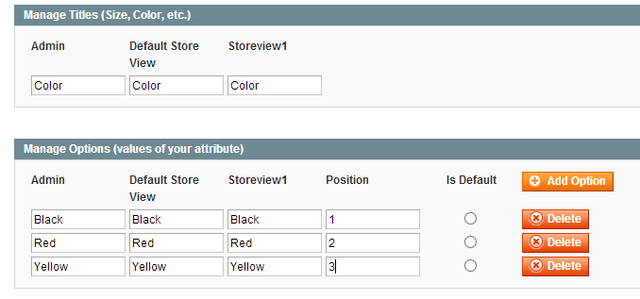

Import Multi-value(dropdown) columns and single-value columns
If the column has only one value, e.g. each product has only 1 sku, then it is said to be a single-value column
If the column has more than one values, e.g. each product may belongs to few categories, then it is said to be a multi-value column

Remarks
- To fill multi-value column, insert the “multi” value in the next row ( at the same column) and leave the remaining columns empty.
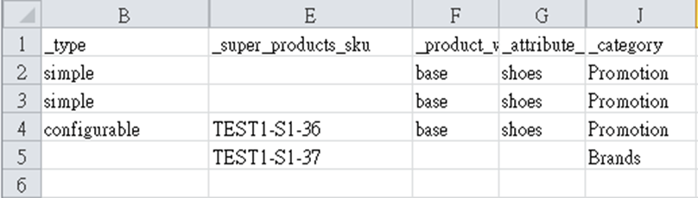
(in row 4, the configurable product belongs to 2 categories: Promotion, Brands, and associate with 2 SKUs: TEST1-S1-36, TEST1-S1-37)

Image Path
Prepare image in any folder levels you want
*Must start with a slash “/”
[magento root]/media/import directory contains all product images. Upload new product images here (should match with the name in csv)
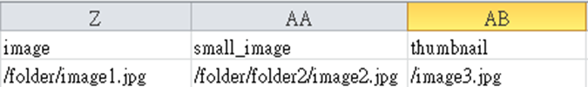

Remarks
- Make sure you understand “append” or “replace” import mode, create new or update products
- Suggest to upload the product list FIRST, and then upload the related product list
- Image path in csv MUST start with slash (/)
- Keep the file name all in lowercase,
- abc.jpg | X abc.JPG
- If the new product has some new attribute value e.g. a new brand name, add the option in magento first
- Avoid any extra space at the end of the field
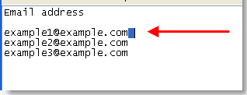

Usage
After Finish the CSV File upload it to {admin_url}/cleargocsv/index/

Use the CSV Generated to import in System > Import > Product

Select Entity Type : Product

Import Behaviour : Add/Update

Allowed Errors Count : input a bigger number ex: 99999

Field separator: ,

Multiple value separator: |

Fields enclosure: checked

