Import tool

Product setup guide in Magento
06 November 2017



This document and information cannot be used for any purpose without the express written permission.
Table of Contents
1. Define product types & attributes 2
1.1. Overview & General concepts 2
1.2. ER Diagram 2
1.3. Define an Attribute Set 3
1.4. Define an Attribute 3
1.5. Frontend Properties of Attribute 4
2. Working with Product CSV Files 5
2.1. Configuration options 7
2.2. Options of Dropdown/Multi-select Attribute 7
2.3. Import Multi-value(dropdown) columns and single-value columns 7
2.4. Image Path 7
2.5. Import multiple store view value / multiple language 8
2.6. Remarks 8
2.7. Usage 8
3. Import the CSV Files 9

Define product types & attributes

Overview & General concepts
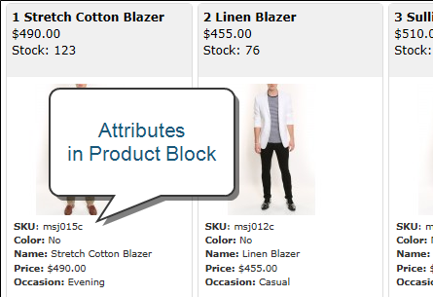
Before the site implementation, it is important to plan the product structure in Magento.
As defined on Magento site, an attribute set is a collection of attributes.
Attributes describe specific characteristics of a product.
E.g. For a store selling a shirt, in addition to the default Magento attributes, you want to show your customers some extra information in the front-end:
- Color
- Shirt Size
- Manufacturer (Brand)
- Material (ex. Cotton, wool, …)

ER Diagram

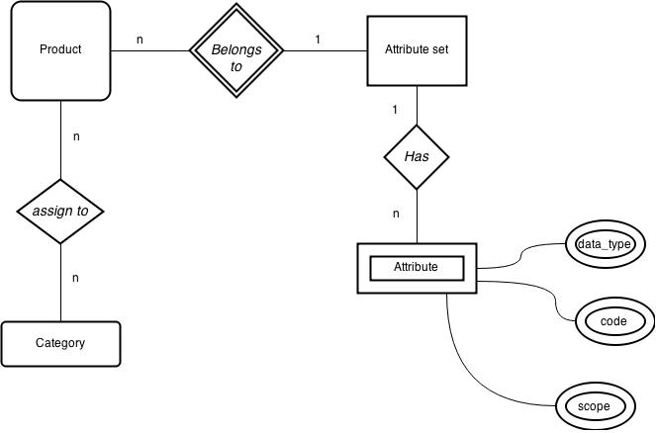

Define an Attribute Set
- Think of attribute set that could clearly distinguish different kinds of products
- To save time and effort select one of the default Attribute sets on the basis of which new set will be created
- When creating Attribute Sets it is important to remember that once the product with the set has been created, it is impossible to change the set to another one.
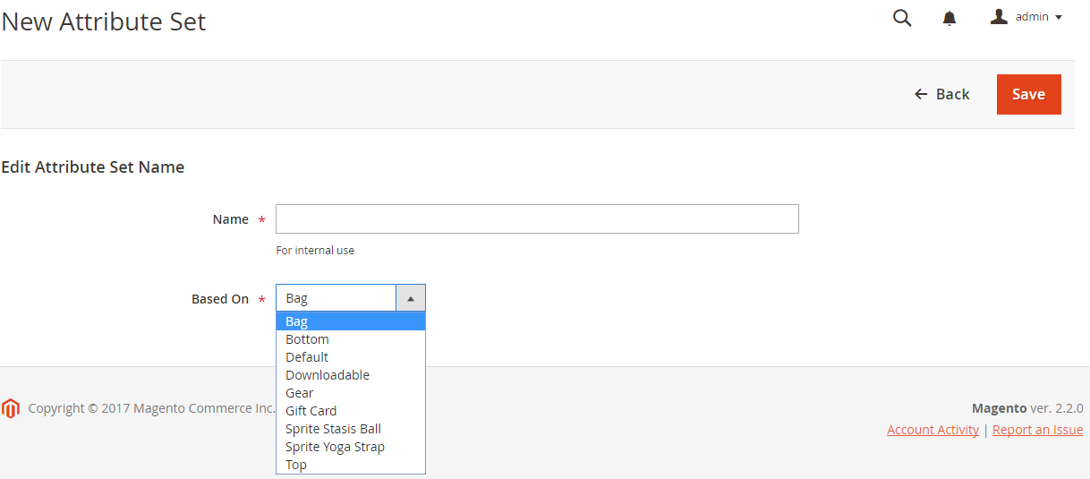

Define an Attribute
When viewed from the Admin, attributes are the fields that you complete when you create a product. The input type that is assigned to an attribute determines the type of data that can be entered and the format of the field or input control.

Input Type | Description
Text Field | A single line input field for text.
Text Area | A multiple-line input field for entering paragraphs of text such as a product description. You can use the WYSIWYG Editor to format the text with HTMLtags, or type the tags directly into the text.
Date | Date values can be entered by making a selection from a drop-down list, or popup calendar (). Depending on your system configuration, dates can be typed directly into a field, or selected from the calendar or list. To format date and time values, see: Date & Time Custom Options.
Yes/No | Displays a drop-down list with pre-defined options of “Yes” and “No.”
Dropdown | Displays a drop-down list of values. Only one item can be selected at a time. The Dropdown input type is a key component of configurable products.
Multiple Select | Displays a drop-down list of values. To select more than one option, hold the Ctrl key down and click each item.
Price | This input type is used to create price fields that are in addition to the predefined attributes, Price, Special Price, Tier Price and Cost. The currency used is determined by your system configuration.
Media Image | Associates an additional image with a product, such as a product logo, care instructions, or ingredients from a food label. When you add a media image attribute to the attribute set of a product, it becomes an additional image type, along with Base, Small, and Thumbnail. The media image attribute can be excluded from the media gallery.
 | .0
Fixed Product Tax | Lets you define FPT rates based on the requirements of your locale.
Visual Swatch | Displays a swatch that depicts the color, texture, or pattern of a configurable product. A visual swatch can be filled with a hexadecimal color value, or display an uploaded image that represents the color, material, texture, or pattern of the option.
Text Swatch | A text-based representation of a configurable product option that is frequently used for size. Text swatches can also include hexadecimal color values.

Frontend Properties of Attribute
- In Magento, the filter sidebar in frontend is called Layered Navigation
- Only attribute with Dropdown or Multi-select type can be shown in the filter
Layered Navigation
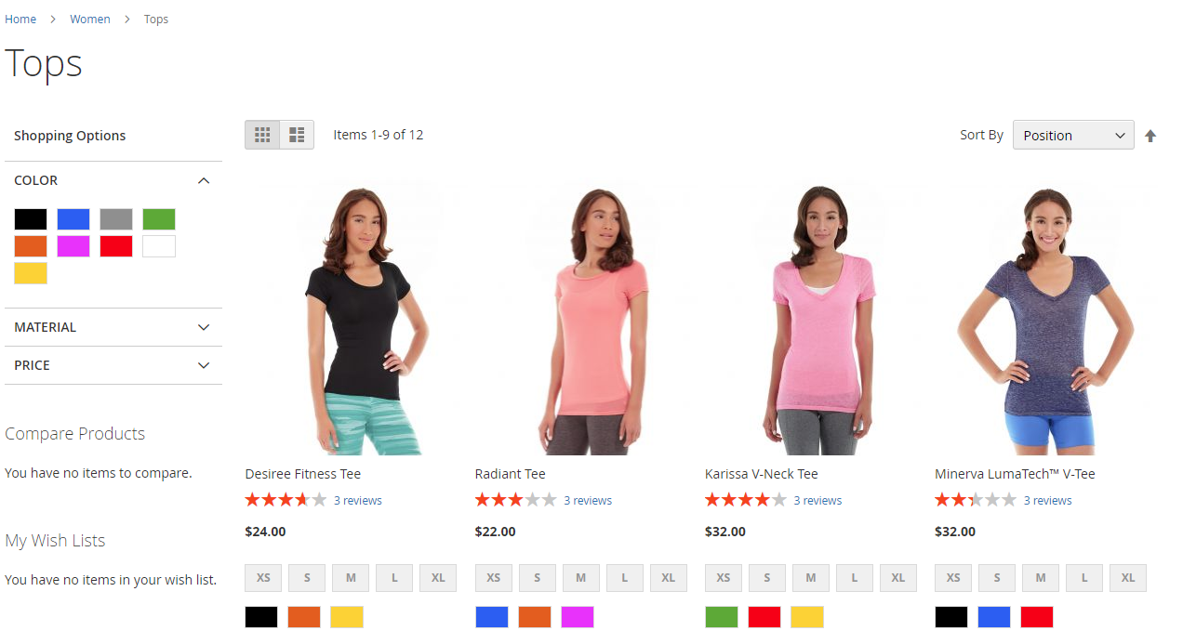
Click to change image

Property | Description
Use in Quick Search | Select “Yes” if you want people to be able to search the catalog based on the value of this attribute. Options include: Yes / No
Search Weight | (Solr Only) Assign a value from 1 – 5 to weight the search.
Use in Advanced Search | Gives shoppers the ability to enter their search criteria through a form. Options include: Yes / No  Using too many attributes can slow down search.
Comparable on Front-end | Select “Yes” to include this attribute as a row in the Compare Products report. Options include: Yes / No
Use In Layered Navigation | (Dropdown, Multiple Select and Price input types only) Includes the attribute as a filter in the “Shop By” section of layered navigation. Options include:
  No | The attribute is not used in layered navigation.
  Filterable (with results) | Lists only products that match the filter value.
  Filterable (no results) | Lists all attribute values, even those that do not apply to any product in the list. Layered navigation appears on a category page only if there are filterable attributes available.
Use In Search Results Layered Navigation | To include the attribute in the layered navigation for search results, select “Yes.” Options include: Yes / No
For details: please refer to
http://docs.magento.com/m2/ee/user_guide/catalog/product-attributes.html

Working with Product CSV Files
Simple product and configurable product can be imported by .csv files which are encoded in utf8.
In the imported file, there are many attributes as column but they could be grouped as:
Columns type | Description
Default attributes | e.g. sku, name  they are included in default attribute set
System attributes | e.g. store_view_code, attribute_set_code, product_type, product_websites, product_online, visibility, price  they cannot be removed in product creation
Custom attributes | e.g. size, brand_id, clinical  these are additional attribute in attribute set

When open the sample csv file the following attribute will be seen
Column in red colour is mandatory
Column | Description
sku | Product SKU
store_view_code | Store view code
attribute_set_code | Attribute set name
parent_sku | Enter parent SKU if this product is belonging to a configurable product
product_type | All row should be “simple”(Configurable Product will be generated depend on simple)
product_websites | All row should be “base” if only one website
categories1 | for categories one category in one column  for more than one category add more column ex. categories1 categories2 categories3 and so on  enter category id in this field
categories2
categories3
name | Product name
description | Product description
short_description | Product short description
weight | Product weight
product_online | Leave empty or input 1 indicate enable product, input 2 indicate disable product
tax_class_name | Tax class
visibility | Four Type:  Not Visible Individually  Catalog  Search  Catalog, Search
price | Product Price
special_price | Product special price
special_price_from_date | special price period
special_price_to_date | special price period
url_key | (SEO)custom url
meta_title | (SEO)Meta title
meta_keywords | (SEO)Meta keywords
meta_description | (SEO)Meta description
base_image | Image file name
base_image_label | Image label
small_image | Small image file name
small_image_label | Small image label
thumbnail_image | Thumbnail image file name
thumbnail_image_label | Thumbnail image label
additional_images1 | Additional image file name  for more than one image add more column ex. additional_images1, additional_images2, additional_images3 and so on
additional_images2
additional_images3
additional_image_labels1 | Additional image label  for more than one label add more column ex. additional_images_labels1, additional_images_labels2, additional_images_labels3 and so on
additional_image_labels2
additional_image_labels3
swatch_image | Swatch image file name
swatch_image_label | Swatch image label
display_product_options_in | Input “Block after Info Column”
gift_message_available | Input “YES”
new_from_date | Product is new period
new_to_date | Product is new period
map_price | Minimum Advertised Price
msrp_price | Manufacturer's suggested retail price
map_enabled | Enable Minimum Advertised Price
size | Add attribute column depends on your attribute set
brand_id | Add attribute column depends on your attribute set
clinical | Add attribute column depends on your attribute set
product_detail_video | Add attribute column depends on your attribute set
configurable_options | Enter the attribute code you used as configurable option
qty | Inventory level
related_skus1 | Related product sku  for more than one sku add more column ex. related_skus1, related_skus2, related_skus3 and so on  the position will be generated depends on the sku sequence
related_skus2
crosssell_skus1 | Cross sell product sku  for more than one sku add more column ex. crosssell_skus1, crosssell_skus2, crosssell_skus3 and so on  the position will be generated depends on the sku sequence
crosssell_skus2
upsell_skus1 | Upsell product sku  for more than one sku add more column ex. Upsell_skus1, upsell_skus2, upsell_skus3 and so on  the position will be generated depends on the sku sequence
upsell_skus2

Configuration options

The Converter first will scan csv into array then will look into “parent_sku” field then group all row contain the parent_sku.
Then generate a row which is for configurable product and generate a field configurable_variations depend on child “configurable_options” and their sku.
Eg:
Configurable Product Child (Simple Product which contain parent_sku and configurable_options) Visibility Should be “Not Visible Individually” and “configurable_options” should contain the attribute_code you used to create variation eg size, color. For more than one attribute use comma to separate them

Options of Dropdown/Multi-select Attribute
If an attribute is defined in dropdown or multi-select type, all options MUST be input to Magento before import, otherwise “value not exists” will be prompted and fails in file validation
e.g. We are going to import products with Sleeve , all sleeve options (Sleeve, Long-Sleeve, etc) appear in the csv file must be added via the Magento backend before import.

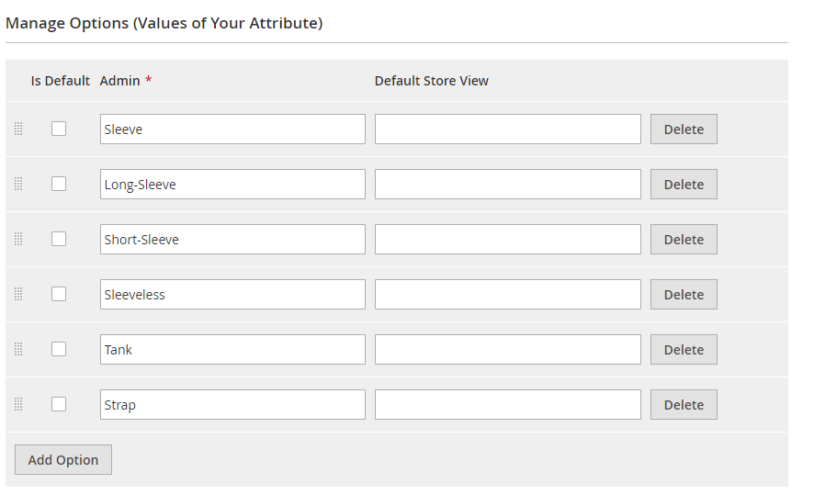

Import Multi-value(dropdown) columns and single-value columns
If the column has only one value, e.g. each product has only 1 sku, then it is said to be a single-value column
If the column has more than one values, e.g. each product may belongs to few categories, then it is said to be a multi-value column

Remarks
- To fill multi-value column, create new column after the column and enter value eg.
Insert a column named “categories2” after categories1.
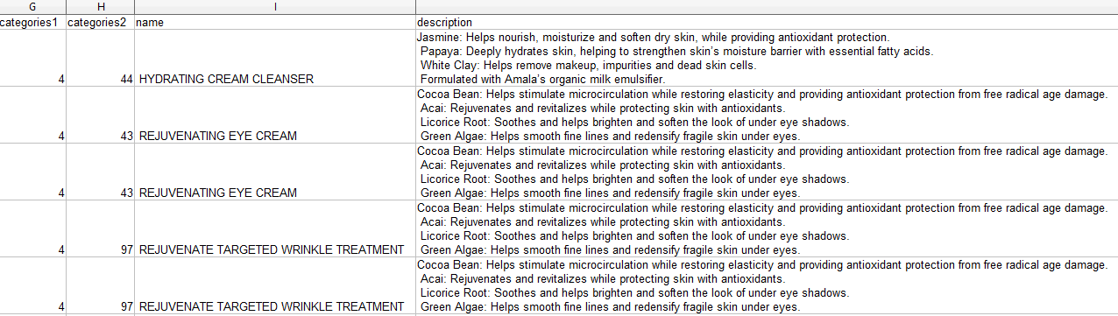
(in column G and H, the product belongs to 2 categories: Category id 4 and 44)

Image Path
Prepare image in any folder levels you want

[magento root]/pub/media/import directory contains all product images. Upload new product images here (should match with the name in csv)

Import multiple store view value / multiple language
After
convert the csv open the csv you should see below
Copy the row and insert to the next row as new row
Change the store code “en_us” to your store view code eg the store code is en_hk

Remarks
- Make sure you understand “append” or “replace” import mode, create new or update products
- Suggest to upload the product list FIRST, and then upload the related product list

- Keep the file name all in lowercase,
- abc.jpg | X abc.JPG
- If the new product has some new attribute value e.g. a new brand name, add the option in magento first
- Avoid any extra space at the end of the field
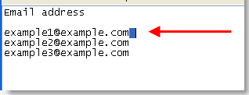

Usage
After Finish the CSV File upload it to {admin_url}/cleargocsv/index/

Use the CSV Generated to import in System > Import > Product

Select Entity Type : Product

Import Behaviour : Add/Update

Allowed Errors Count : input a bigger number ex: 99999

Field separator: ,

Multiple value separator: |

Fields enclosure: checked

Import the CSV Files
Choose file and click submit:
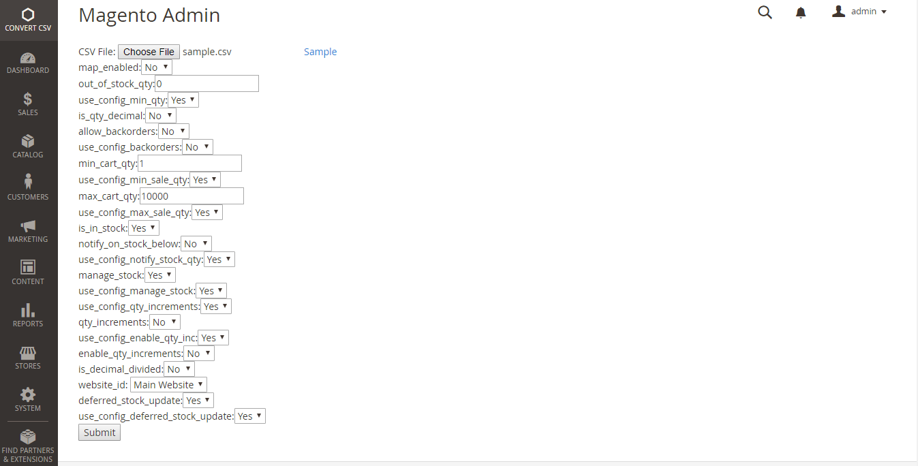
After download the file:
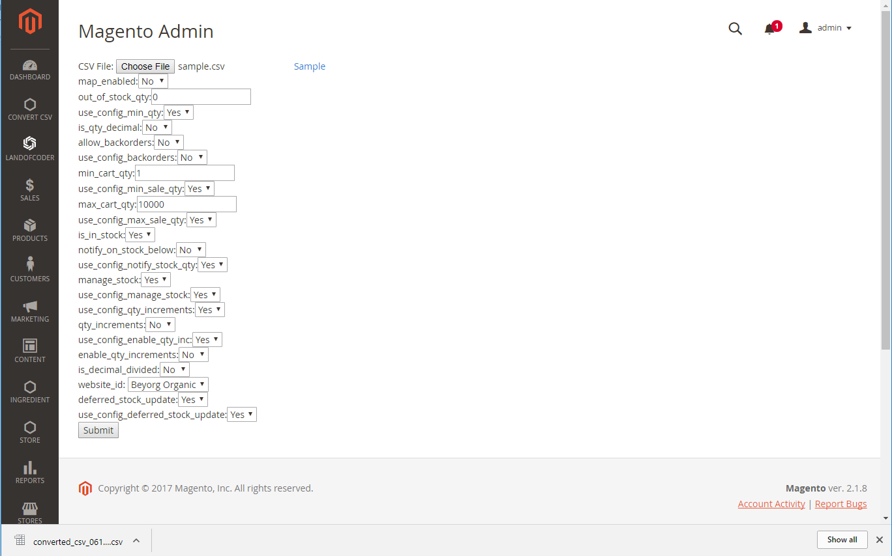
Go to System > Data Transfer > Import:
Select Product And choose the option as below
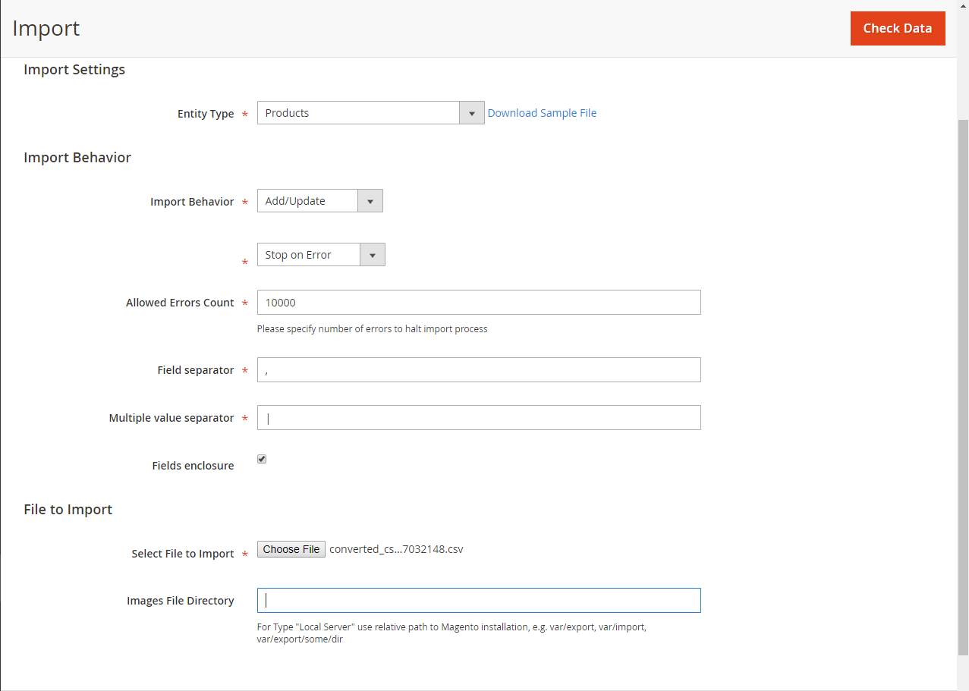
Click check Data:
If the csv file is valid the below box should be shown:
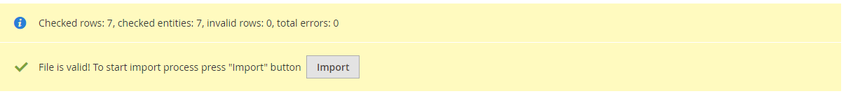
Click Import to start import.

