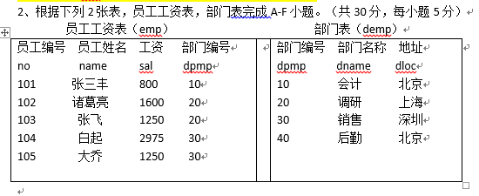
- Select avg(sal) from emp
- Select * from emp
right join demp on
emp .dpmp = demp. dpmp order by sal desc limit 1;
- Select name from emp where dpmp = 20;
- Select name from emp where sal > (Select avg(sal) from emp);
- Select * from emp e right join demp d on
e.dpmp=d.dpmp where dname =’销售’；
- F. Select dname from emp e right join demp d on
e.dpmp=d.dpmp where name is null ;

